
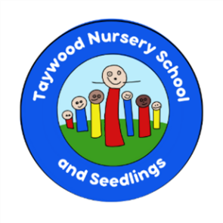
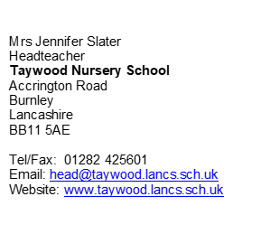NURSERY SCHOOL UNIFORM POLICY

As a maintained nursery school, we aim to prepare our children for primary school in as many ways as possible. Wearing a school uniform helps to promote independence and allows children to fully engage in the curriculum, both indoors and outdoors.

The Governing Body of Taywood Nursery School require all children in Orchard and Willow (from 2 years) to wear a school uniform. Babies and children in Seedlings do not need to wear a school uniform.

Wearing a school uniform benefits children in many ways. Children who are toilet training will be able to manage clothing independently. Physical activities and Forest School sessions are part of our curriculum. When children wear inappropriate clothing, they cannot join in fully with the sessions. Fancy dress clothing and princess dresses for example, restrict children and they will become dirty or damaged when learning outdoors.

From September, nursery school logo sweatshirts (£8.50) and cardigans (£9.00) are required and can be purchased from Moonline on Standish Street in Burnley. They also stock school logo polo-shirts for £6.00, although non-logo items may be purchased from supermarkets or other retailers, along with other uniform items.

We provide a ‘pre-loved’ service and would appreciate your donations of uniform that your child may have grown out of. This will be offered to families for a voluntary donation.

If you are concerned about purchasing a new uniform, please speak with Mrs Slater directly and we may be able to help.

Please see our new Taywood Nursery School uniform below:
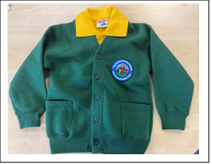

- Green school sweatshirt or cardigan  - Plain yellow polo-shirt (logo or no logo)  - Black or grey trousers/ shorts (No denim)  - Sensible shoes with Velcro fastening | - Green school sweatshirt or cardigan  - Plain yellow polo- shirt (logo or no logo)  - Black or grey trousers, leggings, skirt, pinafore or shorts (No denim)  - Yellow school dress  - Sensible shoes with Velcro fastening

Children should not wear jewellery. Some jewellery items can be a safeguarding risk to children if they become broken. Jewellery can also get caught on objects or on another child and cause injury.

Headbands and headwear should be appropriate.

Please note that footwear should be suitable for the weather and physical activity. Sandals, slip on shoes and laced shoes restrict children, and wellies are not suitable to be worn all day long.

Children should not wear makeup to school.

Please ensure your child has a coat with a hood, as children learn outside in all weather conditions.

Nature Club Clothing

We do have waterproof trousers for children to use, but require a warm, waterproof coat from home please. Parents are required to provide a pair of named wellington boots. Please name all items.

Please ensure your child has warm clothes for their Nature Club session (a warm coat, gloves, hat, and scarf.)

Should you have any questions about our uniform policy, please speak with the Headteacher directly or email head@taywood.lancs.sch.uk

