Zero-Tolerance Policy
Royles Brook Primary School

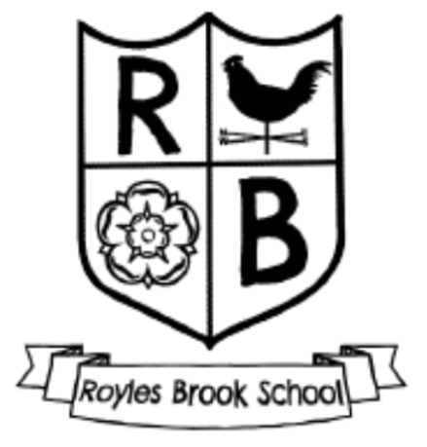

Approved by: Mrs J. McKinnon Date: September 2026
Last reviewed on: September 2026
Next review due by: September 2027

Relating to the behaviour of adults in school

Introduction

Royles Brook Primary School encourages close links with parents and the community. We believe that pupils benefit when the relationship between home and school is a positive one. Parents and visitors are welcome to come into school to discuss matters of concern with members of staff. Any meetings held in school are by mutual consent and will take place in an atmosphere of mutual respect and trust.

The vast number of parents, carers and others visiting our school are keen to work with us and are supportive of the school. However, on the rare occasions when a negative attitude towards the school is expressed, this can result in aggression, verbal and or physical abuse towards member of school staff and the wider community.

The governing board of Royles Brook Primary School expects and requires its members of staff to behave professionally in these difficult situations and attempt to defuse the situation where possible, seeking the involvement as appropriate of other colleagues. However, all members of staff have the right to work without fear of violence and abuse, and the right, in an extreme case, of appropriate self-defence.

We expect parents and other visitors to behave in a reasonable way towards members of school staff. This policy outlines the steps that will be taken where behaviour is unacceptable.

Types of behaviour that are considered serious and unacceptable and will not be tolerated:

- shouting at members of the school staff, either in person or over the telephone
- physically intimidating a member of staff, eg standing very close to him/her
- the use of aggressive hand gestures
- threatening behaviour
- shaking or holding a fist towards another person
- swearing
- pushing
- hitting
- breaching the school’s security procedures.

This is not an exhaustive list but seeks to provide illustrations of such behaviour.

Procedure to be followed
If a parent/carer behaves in an unacceptable way towards the school community, they may be asked to leave the premises to avoid any further confrontation.

The headteacher or appropriate senior member of staff will seek to resolve the situation through discussion and mediation.

If necessary, the school’s complaints procedures should be followed.

Where all procedures have been exhausted, and aggression or intimidation continue, or where there is an extreme act of unacceptable behaviour, a parent or carer may be banned by the headteacher from the school premises for a period of time, subject to review.

In imposing a ban, the following steps will be taken:

- The headteacher will seek advice and guidance from the local authority legal team
- The parent/carer will be informed, in writing, that he/she is banned from the premises, subject to review, and what will happen if the ban is breached, eg that police involvement or an injunction application may follow
- Where an assault has led to a ban, a statement indicating that the matter has been reported to the local authority and the police will be included
- The chair of governors/local authority will be informed of the ban
- Where appropriate, arrangements for pupils being delivered to, and collected from the school gate will be clarified.
- A record will be maintained in school of all incidents involving intimidating or threatening behaviour towards staff.

Unacceptable behaviour may result in the local authority and the police being informed of the incident.

