Relationship and Sex Education Policy
Royles Brook Primary School

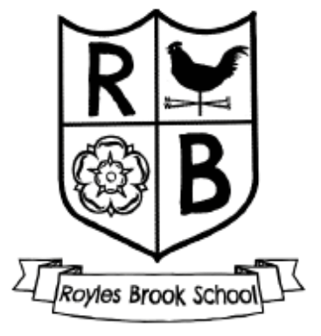

Approved by: | Mrs C. Mitchell | Date: September 2026
Last reviewed on: | September 2026
Next review due by: | September 2027

Contents
1. Aims 2
2. Statutory requirements 2
3. Policy development 3
4. Definition 3
5. Curriculum 3
6. Delivery of RSE 3
7. Use of external organisations and materials 5
8. Roles and responsibilities 5
9. Parents’ right to withdraw 6
10. Training 6
11. Monitoring arrangements 6
Appendix 1: Curriculum map 8
Appendix 2: By the end of primary school pupils should know 9
Appendix 3: Parent/carer form: withdrawal from sex education within RSE 11

1. Aims
The aims of relationships and sex education (RSE) at our school are to:
- Provide a framework in which sensitive discussions can take place
- Prepare pupils for puberty, and give them an understanding of sexual development and the importance of health and hygiene
- Help pupils develop feelings of self-respect, confidence and empathy
- Create a positive culture around issues of sexuality and relationships
- Teach pupils the correct vocabulary to describe themselves and their bodies

2. Statutory requirements
As a maintained primary school, we must provide relationships education to all pupils under section 34 of the Children and Social Work Act 2017.
We are not required to provide sex education, but we do need to teach the elements of sex education contained in the science curriculum.
In teaching RSE, we must have regard to guidance issued by the secretary of state, as outlined in section 403 of the Education Act 1996.
We must also have regard to our legal duties set out in:
- Sections 406 and 407 of the Education Act 1996
- Part 6, chapter 1 of the Equality Act 2010
- The Public Sector Equality Duty (as set out in section 149 of the Equality Act 2010). This duty requires public bodies to have due regard to the need to eliminate discrimination, advance equality of opportunity and foster good relations between different people when carrying out their activities.
At Royles Brook, we teach RSE as set out in this policy.

3. Policy development
This policy has been developed in consultation with staff, pupils and parents/carers. The consultation and policy development process involved the following steps:
- Review – a member of staff or working group pulled together all relevant information including relevant national and local guidance

- Staff consultation – all school staff were given the opportunity to look at the policy and make recommendations

- Parent/stakeholder consultation – parents/carers and any interested parties were invited to share views about the policy

- Pupil consultation – we investigated what exactly pupils want from their RSE

- Ratification – once amendments were made, the policy was shared with governors and ratified

4. Definition
RSE is about the emotional, social and cultural development of pupils, and involves learning about relationships, sexual health, sexuality, healthy lifestyles, diversity and personal identity.
RSE involves a combination of sharing information, and exploring issues and values.
RSE is not about the promotion of sexual activity.

5. Curriculum
Our RSE curriculum is set out as per Appendix 1, but we may need to adapt it as and when necessary.
We have developed the curriculum in consultation with parents/carers, pupils and staff, and taking into account the age, developmental stage, needs and feelings of our pupils. If pupils ask questions outside the scope of this policy, teachers will respond in an appropriate manner so that pupils are fully informed and don’t seek answers online.
We will share all curriculum materials with parents and carers upon request.
Primary sex education will focus on:
- Preparing boys and girls for the changes that adolescence brings
- How a baby is conceived and born
For more information about our curriculum, see our curriculum map in Appendix 1.

6. Delivery of RSE
RSE is taught within the personal, social, health and economic (PSHE) education curriculum. Biological aspects of RSE are taught within the science curriculum, and other aspects are included in religious education (RE).

Relationships education focuses on teaching the fundamental building blocks and characteristics of positive relationships including:
- Families and people who care for me
- Caring friendships
- Respectful relationships
- Online relationships
- Being safe
For more information about our RSE curriculum, see Appendices 1 and 2.
These areas of learning are taught within the context of family life, taking care to make sure that there is no stigmatisation of children based on their home circumstances (families can include single parent families, LGBT parents, families headed by grandparents, adoptive parents and foster parents/carers, amongst other structures), along with reflecting sensitively that some children may have a different structure of support around them (for example, looked-after children or young carers).

We will also be mindful of the law and legal requirements, taking care not to condone or encourage illegal political activity, such as violent action against people, criminal damage to property, hate crime, terrorism or the illegal use of drugs.

  - Inclusivity
We will teach about these topics in a manner that:
- Considers how a diverse range of pupils will relate to them
- Is sensitive to all pupils’ experiences
- During lessons, makes pupils feel:
  - Safe and supported
  - Able to engage with the key messages
We will also:
- Make sure that pupils learn about these topics in an environment that’s appropriate for them, for example in:
  - A whole-class setting
  - Small groups or targeted sessions
  - 1-to-1 discussions
  - Digital formats
- Give careful consideration to the level of differentiation needed

  - Use of resources
We will consider whether any resources we plan to use:
  - Are aligned with the teaching requirements set out in the statutory RSE guidance
  - Would support pupils in applying their knowledge in different contexts and settings
  - Are age-appropriate, given the age, developmental stage and background of our pupils
  - Are evidence-based and contain robust facts and statistics
  - Fit into our curriculum plan
  - Are from credible sources
  - Are compatible with effective teaching approaches
  - Are sensitive to pupils’ experiences and won’t provoke distress

7. Use of external organisations and materials
We will make sure that an agency and any materials used are appropriate and in line with our legal duties around political impartiality.
The school remains responsible for what is said to pupils. This includes making sure that any speakers, tools and resources used don’t undermine the fundamental British values of democracy, the rule of law, individual liberty, and mutual respect and tolerance of those with different faiths and beliefs.
We will:
- Make appropriate checks and engage with external agencies to make sure that their approach to teaching about RSE is balanced, and it and the resources they intend to use:
  - Are age-appropriate
  - Are in line with pupils’ developmental stage
  - Comply with:
    - This policy
    - The Teachers’ Standards
    - The Equality Act 2010
    - The Human Rights Act 1998
    - The Education Act 1996
- Only work with external agencies where we have full confidence in the agency, its approach and the resources it uses
- Make sure that any speakers and resources meet the intended outcome of the relevant part of the curriculum
- Review any case study materials and look for feedback from other people the agency has worked with
- Be clear on:
  - What they’re going to say
  - Their position on the issues to be discussed
- Ask to see in advance any materials that the agency may use
- Know the named individuals who will be there, and follow our usual safeguarding procedures for these people
- Conduct a basic online search and address anything that may be of concern to us, or to parents and carers
- Check the agency’s protocol for taking pictures or using any personal data they might get from a session
- Remind teachers that they can say “no” or, in extreme cases, stop a session
- Make sure that the teacher is in the room during any sessions with external speakers
- Share all external materials with parents and carers
We won’t, under any circumstances:
- Work with external agencies that take or promote extreme political positions
- Use materials produced by such agencies, even if the material itself is not extreme

8. Roles and responsibilities
8.1 The governing board
The governing board will approve the RSE policy, and hold the headteacher to account for its implementation.
8.2 The headteacher
The headteacher is responsible for ensuring that RSE is taught consistently across the school, for sharing resources and materials with parents and carers, and for managing requests to withdraw pupils from [non-statutory/non-science] components of RSE (see section 9).
8.3 Staff
Staff are responsible for:
- Delivering RSE in a sensitive way
- Modelling positive attitudes to RSE
- Monitoring progress
- Responding to the needs of individual pupils
- Responding appropriately to pupils whose parents/carers wish them to be withdrawn from the [non-statutory/non-science] components of RSE
Staff do not have the right to opt out of teaching RSE. Staff who have concerns about teaching RSE are encouraged to discuss this with the headteacher.
Staff who are responsible for teaching RSE are the teachers and support staff.
8.4 Pupils
Pupils are expected to engage fully in RSE and, when discussing issues related to RSE, treat others with respect and sensitivity.

9. Parents’ right to withdraw
Parents/carers have the right to withdraw their child from the [non-statutory/non-science] components of sex education within RSE.
Requests for withdrawal should be put in writing using the form found in Appendix 3 of this policy and addressed to the headteacher.
Alternative school work will be given to pupils who are withdrawn from sex education.

10. Training
Staff are trained on the delivery of RSE as part of their induction and it is included in our continuing professional development calendar.
The headteacher will also invite visitors from outside the school, such as school nurses or sexual health professionals, to provide support and training to staff teaching RSE.

11. Monitoring arrangements
The delivery of RSE is monitored by the PSHE lead through:
- Pupil / Parent/ Staff Voice
- Curriculum monitoring
- Book looks
- Lesson observations
- Team teaching
- Phase Meetings/ Staff meetings
- Staff questionnaire
- Training

Pupils’ development in RSE is monitored by class teachers as part of our internal assessment systems.
This policy will be reviewed by PSHE Lead and Curriculum Lead annually.
At every review, the policy will be approved by the Headteacher and the schools governing body.

Appendix 1: Curriculum map
Relationships and sex education curriculum map

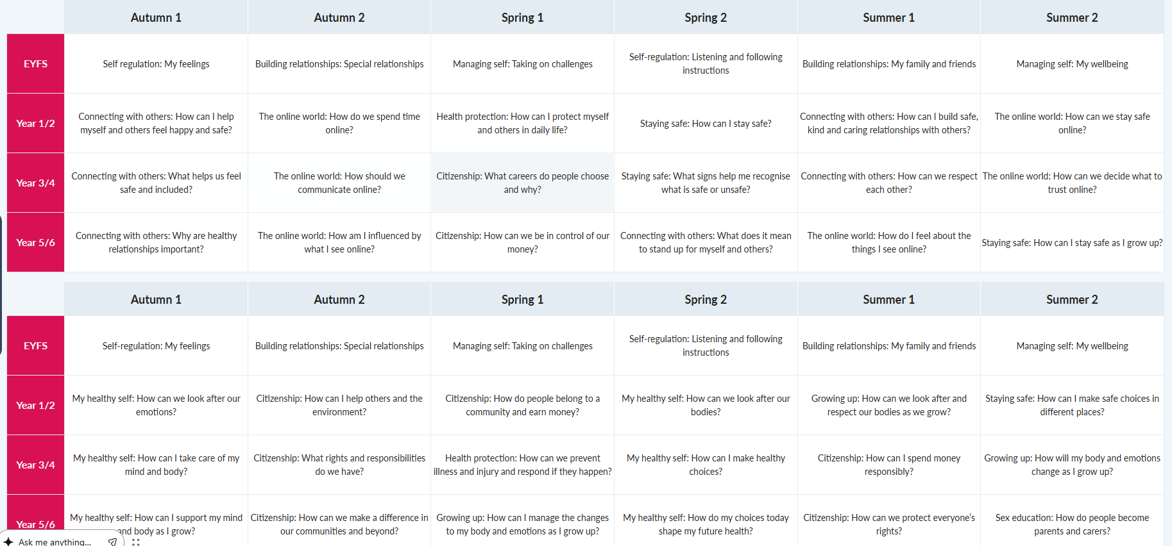

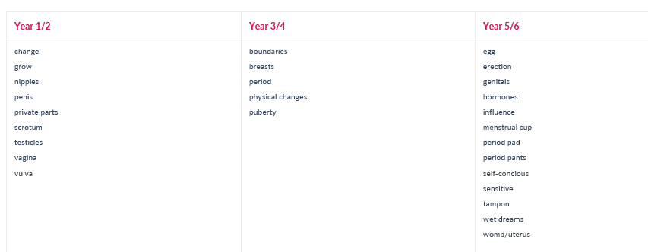

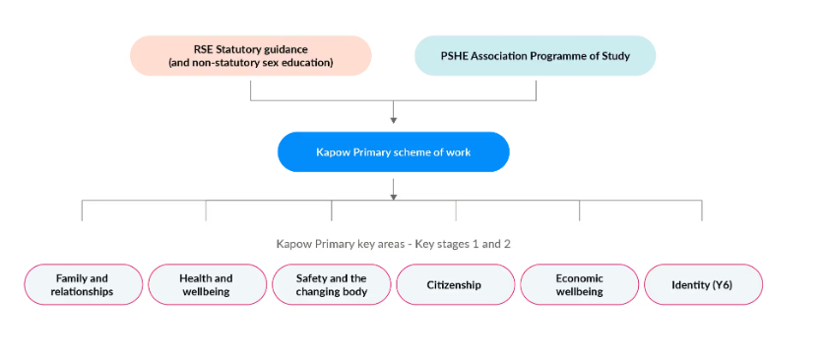

Appendix 2: By the end of primary school pupils should know

C:\Users\cselwayhall\OneDrive - Thornton Cleveleys Royles Brook Primary School\Curriculum\PSHE\P_Statutory-guidance-coverage-RSE-PSHE-25.05.26 (1).pdf

C:\Users\cselwayhall\OneDrive - Thornton Cleveleys Royles Brook Primary School\Curriculum\PSHE\Relationships_education_relationships_and_sex_education__RSE__and_health_education__for_intro_1_September_2026_.pdf

Appendix 3: Parent/carer form: withdrawal from sex education within RSE

To be completed by parents/CARERS
Name of child |  | Class
Name of parent/carer |  | Date
Reason for withdrawing from sex education within relationships and sex education
Any other information you would like the school to consider
Parent signature

To be completed by the school
Agreed actions from discussion with parents/carers

