Art | 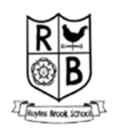
Long Term Map
Cycle A

 | Autumn | Spring | Summer
EYFS | Me & My World | Castles, Knights & Dragons | Where We Live
Year 1 & 2 | Drawing | Collage | Painting
Year 3 & 4 | Drawing | Painting | Sculpture
Year 5 & 6 | Drawing | Painting | Printing

Art

Long Term Map
Cycle B

 | Autumn | Spring | Summer
EYFS | Me & My World | Castles, Knights & Dragons | Where We Live
Year 1 & 2 | Painting & Collage | Drawing | Sculpture
Year 3 & 4 | Drawing | Printing | Collage
Year 5 & 6 | Collage | Sculpture | Drawing

