EYFS: Reception Long Term Plan 2026-2027


In Rainford Brook Lodge, planning will be adjusted according to the interests and needs of the children.
Throughout all learning, we will ensure activities and interactions support the Characteristics of Effective Learning.

- Playing and exploring – Engagement: Finding out and exploring, playing with what they know, being willing to ‘have a go’.
- Active learning – Motivation: Being involved and concentrating, keeping trying, enjoying achieving what they set out to do.
- Creating and thinking critically – Thinking: Having their own ideas, making links, choosing ways to do things.

Best Start in Life
At Rainford Brook Lodge, our Reception curriculum is underpinned by the government's Best Start in Life principles. We recognise that the early years are fundamental in shaping children's future learning, wellbeing and development. Through high-quality interactions, a language-rich environment and carefully planned experiences, we ensure that every child develops the knowledge, skills and confidence needed to thrive.

We place a strong emphasis on:
- Developing communication and language through meaningful conversations, stories, songs and vocabulary-rich learning opportunities.
- Fostering positive relationships to ensure children feel safe, secure, valued and ready to learn.
- Promoting children's personal, social and emotional development, supporting resilience, self-regulation and independence.
- Providing opportunities for active play and physical development to build strength, coordination, wellbeing and confidence.
- Encouraging curiosity, exploration and a love of learning through engaging and purposeful experiences.
- Working in partnership with families to ensure every child receives the support they need to flourish.

By embedding these principles throughout our curriculum and daily practice, we aim to give every child the very best start to their education and prepare them for future success.

Through our commitment to giving every child the Best Start in Life, we strive to develop MAGIC children who are motivated and aspirational; children who grow in independence and confidence every single day.

At Rainford Brook Lodge, we want MAGIC children. Children who are motivated and aspirational; children who grow in independence and confidence every single day! As children start their journey with us, we aim to ensure that our children are happy, feeling safe and secure in an environment where they can thrive, grow and learn. We believe that happy children learn best and so it is in the forefront of our minds to ensure that our children settle in positively, interacting with friends appropriately, understanding rules and expectations whilst showing respect for others and their surroundings. We encourage curiosity and so aim to develop curious minds in lots of different ways. We promote communication and we ensure that we give the time to listen and engage in meaningful conversations therefore supporting, developing or extending their thoughts and questions. Many of our children enter Reception above average in general but not always in Personal, Social and Emotional Development. It is therefore our job; our dedication and commitment to nurture this and whilst doing so prepare our children for the next chapter of their educational journey.

‘Catering for Every Child’s Needs Every Day’

 | Autumn 1 | Autumn 2 | Spring 1 | Spring 2 | Summer 1 | Summer 2
Topic | Marvellous Me!   | 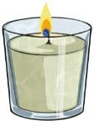  Sparkle and shine! | 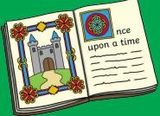  Once upon  a time! | 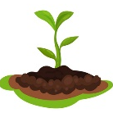  Sowing a seed | 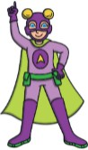  Superheroes! | 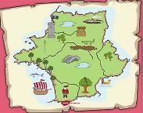  Go Getters!
The Big Question | How am I special? | How do people celebrate special times? | What makes a good story? | How can I care for nature? | Who is a real-life superhero? | What can we see and hear at the seaside?
Interests/Lines of Enquiry  These themes may be adapted at various points to allow for children’s interests to flow through the provision. | Starting school/settling in  My new class  School routines  New Beginnings  My family/My pets  Being kind  Autumn  Celebrating Difference  What makes me special  Like and dislikes | Bonfire Night  Remembrance Sunday  Diwali  Advent & Christmas | Investigating a crime scene - who did it?  Exploring the settings for different stories,  Building dens / houses using different materials. Which one  is strongest / waterproof? How can we check? | Lifecycles of plants and minibeasts  Bug Hunt  What are insects?  Habitats  Animals around the world  Climates / Hibernation  Down on the Farm  Mini Beasts  Animals on the Farm  Night and day animals | Emergency Services  Heath Care Workers  School Staff  Council Workers  Hospitality Workers  Transport Workers | Off on holiday /clothes  Where in the world shall  we go?  Send me a postcard!  Marine life  Fossils – Mary Anning  Seasides in the past  Compare: Now and then!  Seaside art
Cultural capital and enrichment | School tour  Harvest festival  Y6 Buddies  Library visit (come into school) | Tree dressing ceremony  Nativity  All Saints Church visit | Fairytale day  Chinese New Year  Valentines day | Wormery or ant farm  Pancake day  World Book Day  Mother’s Day assembly | Trip to Imagine That  Posting letters  Visits from real life superheroes  Superhero day | Sports day
Roleplay areas | Home corner  Building site outside  Pumpkin patch | Home corner- Christmas theme | Cosy cottage  Three little pigs’ houses outside | Vets  Farm | Doctors  School | Travel agents  Pirate ship
Personal, Social and Emotional Development  Self-regulation  Managing Self  Building Relationships | We will be learning to…  Recognise that we are an important person in our class.  Be a good friend to others and know what that means and involves.  Manage own needs e.g. fastening coat, putting on shoes, putting on wellies.  Develop confidence to try new activities and show independence. (link with challenges in provision).  Identify and name emotions. Link book character’s emotion to own experiences.  Begin to set own goals and show resilience and in the face of challenge. (link to characteristics of success).  Become independent when managing our own personal hygiene including going to the toilet and washing our hands. | We will be learning to…  Recognise that we are an important person in our class and school.  Be a good friend to others and know what that means and involves.  Begin to identify and moderate own feelings socially and emotionally e.g Focus on keeping calm, being patient, waiting for a turn, sharing, tidying up after themselves  Think about the perspectives of others. Eg how do you think X feels when this happens?  Manage our own personal hygiene including going to the toilet and washing our hands. | We will be learning to…  Know and talk about what makes us mentally and physically healthy including food and drink choices, sleep, exercise and brushing our teeth.  Be resilient and persevere when we find an activity challenging when working in the inside and outside learning environment.  Form positive relationships with adults and friendships with peers.  Manage own self-care needs.  . | We will be learning to…  Consider and talk about how others may be feeling or what they might be thinking during different activities.  Explain the reasons for rules, know right from wrong and try to behave accordingly (ready, respectful, safe).  Work and play cooperatively and take turns with others.  Show sensitivity to their own and to others’ needs.  Identify and moderate own feelings socially and emotionally  Continue to see self as a valuable individual. | We will be learning to…  Set and work towards simple goals, being able to wait for what they want and control their immediate impulses when appropriate.  Be confident to try new activities and show independence, resilience and perseverance in the  face of challenge.  Know and talk about the different factors that support their overall health and wellbeing e.g. sensible amounts of ‘screen time’, having a good sleep routine, being a safe pedestrian. | We will be learning to…  Be resilient and persevere when we find an activity challenging when working in the inside and outside learning environment.  Give focused attention to what the teacher says, responding appropriately even when engaged in activity, and show an ability to follow instructions involving several ideas or actions.  Manage their own basic hygiene and personal needs, including dressing, going to the toilet and  understanding the importance of healthy food choices.
Physical Development  Gross Motor Skills Fine Motor Skills | We will be learning to…  Stand still, wait and walk in a line during different activities throughout the school day.  Sit at a table or on the floor to complete an activity.  Consolidate tripod grip.  Develop small motor skills so that they can use a range of tools competently, safely and confidently (pencils for drawing and writing, paintbrushes, scissors, knives, forks and spoons) | We will be learning to…  Develop our ability to move with confidence and control in a variety of ways when in the EYFS outdoor area, outdoor classroom and during PE sessions.  Developing ability to control a ball without using hands.  Develop confidence in use of tools to consolidate actions such as twist, pinch, grip, grab, squeeze. | We will be learning to…  Continue to refine the fundamental movement skills they have already acquired  Develop overall body strength, balance, co-ordination and agility.  Continue to develop small motor skills so that they can use a range of tools competently, safely and confidently. (pencils for drawing and writing, paintbrushes, scissors, knives, forks and spoons) | We will be learning to…  Control a ball confidently and accurately when throwing, catching, kicking and aiming with it.  Link sequences of movement with confidence, control and fluency. | We will be learning to…  Confidently and safely use a range of large and small apparatus indoors and outside in the EYFS outdoor area. | We will be learning to…  Confidently and safely use a range of large and small apparatus indoors and outside in the EYFS outdoor area.
Physical Development  Gross Motor Skills Fine Motor Skills | Throughout the year we will…  Take part in ‘funky fingers’ activities so that we can use a range of tools with care, control and confidence.  Develop our tripod grip when using a pencil or pen.  Hold and use scissors with increasing confidence and control.

Communication and Language  Listening, attention and understanding  Speaking |  | We will be learning to…  Understand how to listen carefully and why listening is important.  Ask questions to find out more and to check we understand what has been said to us.  Learn new vocabulary linked to daily routine / theme (tidy up time, snack, playtime, outdoors, indoors, team names)  Say “Good morning”, and other social phrases, to friends and adults.  Take part in whole class and small group story times.  Begin to ask questions to find out more and to check they understand what has been said to them. Model & encourage questions after instructions. Eg, should I go in the outdoor area? Is it time for read, write inc? | We will be learning to…  Connect one idea to another using a range of connectives.  Use talk to help work out problems and organise thinking and activities, and to explain how things work and why they might happen.  Begin to articulate their ideas and thoughts in well-formed sentences. This can be done by expressing and sharing ideas to friends and book talk.  Develop social phrases around routines of the day, greetings and friendship (Please can I play with you? Can I have a turn next? Would you like to play in the X with me?)  Begin to retell a simple story, once they have developed a deep familiarity with the text; some as exact repetition and some in their own words. Use focused & linked texts | We will be learning to…  Listen attentively and respond to what they hear with relevant questions, comments and actions when being read to and during whole class discussions and small group interactions.  Make comments about what they have heard and ask questions to clarify their understanding.  Participate in small group, class and one-to-one discussions, offering their own ideas, using recently introduced vocabulary. | We will be learning to…  Engage in non-fiction books about animals, learning and using new vocabulary from them.  Begin to understand humour e.g. nonsense rhymes/jokes  Describe events in some detail. (Linked to books e.g. life cycle).  Use talk to help work out problems, organise thinking & activities explain how things work/why things happen (e.g. I am going to do a challenge every day, so I have got through them all by the end of the week.)  Develop and use social phrases with confidence (e.g. let's play this together.) | We will be learning to…  Use new vocabulary in different activities and areas of learning.  Engage in non-fiction books about ‘People who Help Us’, learning and using new vocabulary from them.  Hold conversation when engaged in back-and-forth exchanges with their teacher and peers.  Use new vocabulary in different contexts.  Ask questions to find out more and to check they understand what has been said to them.  Articulate their ideas & thoughts in well-formed sentences. (Encourage use of sentences.) | We will be learning to…  Engage in non-fiction books about transport, learning and using new vocabulary from them.  Hold conversation when engaged in back-and-forth exchanges with their teacher and peers.  Understand humour more readily e.g. nonsense rhymes/jokes.  Offer explanations for why things might happen, making use of recently introduced vocabulary from stories, non-fiction, rhymes and poems when appropriate.  Express ideas and feelings about their experiences using full sentences, including use of past, present and future tenses and making use of conjunctions, with modelling and support.
Literacy | Talk 4 Writing  Focus Text:  The Rainbow Fish  Additional Texts:  Colour Monster goes to School  Come to school Blue Kangaroo  Boris starts school  I am too absolutely small for school  In every house in every street  My 5 senses  When’s my birthday? |  | Talk 4 Writing  Focus Text  The Gruffalo  Additional texts:  Bonfire night/ Guy Fawkes  Thanksgiving story  The First Christmas  Little Glow: explores religious and cultural festivals, including Diwali, Hanukkah, Ramadan and  Chinese New Year.  The Christmas Pine by Julia Donaldson  Hello autumn/winter  Rama and Sita  Meet the weather  The Nativity  Leaf man | Talk 4 Writing  Focus Text  The Gingerbread Man  Additional Texts:  The Three Little Pigs  The Little Red Hen  Goldilocks  Rapunzel: A Rebel Fairytale  The three little pigs  There is no dragon in this story  Little Red: A Rebel Fairytale | Talk 4 Writing  Focus Text  I Will Not Ever, Never Eat A Tomato  Additional Texts:  What the Ladybird heard  The Very Hungry Caterpillar  Aghh Spider!  The great pet sale  The girl who loves bugs | Talk 4 Writing  Focus Text  So Much  The Night Pirates  Additional Texts:  Supertato  My Mum is a superhero  My Dad is a superhero  A superpower like mine  Eliot midnight superhero | Talk 4 Writing  Focus Text  Oi Frog!  Izzy Gizmo  Additional Texts:  Martha Maps it Out  Clean Up  Lighthouse Keeper’ s Lunch  Billy’s Bucket  Commotion in the Ocean  Pirates love Underpants
Nursery Rhymes | Incy wincy spider  Rainbow song (colours of the rainbow)  Head, shoulders, knees and toes  One finger one thumb keep moving  Humpty Dumpty  Big Red Combine Harvester  Old Macdonald had a farm  Farmers in his den |  | Twinkle twinkle little star  The Gruffalo song  1, 2, 3, 4, 5, Once I caught a fish alive  Farmers in his den  Wheels on the bus  5 little speckled frogs  Polly put the kettle on | 5 currant buns in a bakers shop  London bridge is falling down  It’s raining, it’s pouring the old man is snoring  When Goldilocks went to the house of the bears  I hear thunder  Hickory dickory dock | Baa Baa Black sheep  5 little ducks little went swimming one day  Animals went in two by two  5 little monkeys jumping on the bed  We went to the Animal fair | Dr Foster went to Gloucester  Miss Polly had a dolly  1 Potato, 2 potato, 3 potato 4  Jack and Jill went up the hill  Grand old Ducke of York  5 little men in a flying saucer  Down in the jungle | 10 green bottles  10 in a bed  The big ship sails through the aily aily oh  Goosey goosey gander  Here we go round the Muberry bush  Horsey horsey don’t you stop
Diversity Texts  To be read throughout the year during story time session. | Different Families  Big Idea: Families can look different, but all families provide love, care and belonging. |  | Belonging, Kindness & Inclusion  Big Idea: Everyone belongs and everyone deserves kindness. | Culture, Heritage & Religion  Big Idea: People have different traditions, languages and beliefs and celebrations. | Gender Equality & Challenging Stereotypes  Big Idea: Everyone can follow their interests and dreams. | Physical Disability & Accessibility  Big Idea: People move, communicate and access the world in different ways. | Neurodiversity  Big Idea: People think, lean and experience the world in different ways.
 | Anchor Text:  The Great Big Book of Families by Mary Hoffman  Additional Texts:  And Tango makes Three by Justin Richardson & Peter Parnell  Every Family is Different by Fiona Bleach  Heather has Two Mummies by Leslea Newman  Vocabulary: family, belong, care, love, relationship, different, same, unique, community, support, celebrate |  | Anchor Text:  All are Welcome by Alexandra Penfold  Additional Texts:  The Invisible Boy by Trudy Ludwig  The Big Umbrella by Amy June Bates  We Are All Neighbours by Alexandra Penfold  Vocabulary: welcome, include, friendship, kindness, respect, fair, cooperation, feelings empathy, considerate | Anchor Text:  The Proudest Blue by Ibtihaj Muhammad  Additional Texts:  Our Favourite Day of the Year by A.E Ali  Rama and Sita by Malachy Doyle  Golden Domes and Silver Lanterns by Hena Khan  Vocabulary: culture, heritage, tradition, festival, celebration, belief, faith, identity, values | Anchor Text:  Amazing Grace by Mary Hoffman  Additional Texts:  Julian is a Mermaid by Jessica Love  Princesses Wear Hiking Boots by Carmela LaVigna Coyle  William’s Doll by Charlotte Zolotow  Vocabulary: stereotype, equality, ambition, talent, confident, achievement, choice, independence, determination, courageous | Anchor Text:  Susan Laughs by Jeanne Wills  Additional Texts:  We Move Together by Kelly Fritsch  My Three Best Friends and Me Zulay by Cari Best  Rescue and Jessica by Jessica Kensky  Vocabulary: disability, accessibility, independence, adapt, equipment, mobility, communicate, barrier, support, capability. | Anchor Text:  All My Stripes by Shaina Rudolph  Additional Texts:  A Friend Like Simon by Kate Gaynor  Can I Tell You About Autism? By Jude Welton  The Brain Forest by Sandhya Menon  Vocabulary: neurodiversity, concentration, sensory, routine, anxiety, strengths, differences, understanding, focus
RWInc | We will be learning to…  Hear and identify initial sounds in words.  Use Fred Talk to orally blend simple words.  Recognise some taught graphemes. |  | We will be learning to…  Read simple CVC words by blending sounds.  Recognise some taught Red Words.  Read simple captions matched to taught sounds. | We will be learning to…  Read words containing taught digraphs.  Blend unfamiliar words independently.  Read simple sentences using phonics. | We will be learning to…  Read a wider range of Green Words automatically.  Apply taught sounds to decode unfamiliar words.  Read decodable texts with increasing confidence. | We will be learning to…  Read words and simple sentences fluently.  Use phonic knowledge independently to decode.  Recognise an increasing number of Red Words on sight. | We will be learning to…  Say sounds for all taught graphemes and digraphs.  Read words consistent with phonic knowledge through blending.  Read simple books accurately, fluently and with understanding.  Recognise common exception words automatically.
Comprehension  Word Reading  Writing | We will be learning to…  Comprehension  Children will independently look at a book, hold it the correct way and turn pages.  Word Reading  Begins to recognise individual sounds and orally blend words. Starts linking sounds to graphemes.  Writing  Children will give meanings to the marks they make. |  | We will be learning to…  Comprehension  Children will engage and enjoy an increasing range of books.  Word Reading  Reads simple CVC words by blending. Recognises some common exception words. Begins reading simple captions.  Writing  Children will form letters correctly. | We will be learning to…  Comprehension  Children will act out stories using recently introduced vocabulary.  Word Reading  Reads words containing digraphs using phonics. Blends independently and accurately. Reads simple sentences.  Writing  Children will write words  representing the sounds with a letter/letters. | We will be learning to…  Comprehension  Children will be able to talk about the characters in the books they  are reading.  Word Reading  Applies phonic knowledge to a wider range of words. Develops automaticity when reading familiar words.  Writing  Children will write labels/phrases  representing the sounds with a letter/letters. | We will be learning to…  Comprehension  Children will retell a story using vocabulary influenced by their  book.  Word Reading  Reads words consistent with taught phonic knowledge with increasing fluency and confidence.  Writing  Children will write words which are spelt phonetically | We will be learning to…  Comprehension  Children will be able to answer questions about what they have read.  Word Reading  Reads simple books and sentences accurately and fluently. Recognises common exception words automatically and meets the EYFS Word Reading ELG.  Writing  Children will write simple phrases  and sentences using recognisable  letters and sounds.
Comprehension  Word Reading  Writing | Throughout the year we will…  Read and re-read familiar texts with words, simple phrases and sentences made up of words with known letter–sound correspondences and a few exception words.  Form lower-case and capital letters correctly.
Mathematics  Mastering Number | We will be learning to…  • Identify when a set can be subitised and when counting is needed.  • Subitise different arrangements, both unstructured and structured, including using the Hungarian number frame.  • Make different arrangements of numbers within 5 and talk about what they can see, to develop their conceptual subitising skills.  • Spot smaller numbers ‘hiding’ inside larger numbers.  • Connect quantities and numbers to finger patterns and explore different ways of representing numbers on their fingers.  • Hear and join in with the counting sequence and connect this to the ‘staircase’ pattern of the counting numbers, seeing that each number is made of one more than the previous number.  • Develop counting skills and knowledge, including: that the last number in the count tells us ‘how many’ (cardinality); to be accurate in counting, each thing must be counted once and once only and in any order; the need for 1:1 correspondence; understanding that anything can be counted, including actions and sounds.  • Compare sets of objects by matching.  • Begin to develop the language of ‘whole’ when talking about objects which have parts. |  |  | We will be learning to…  • Continue to develop their subitising skills for numbers within and beyond 5 and increasingly connect quantities to numerals.  • Begin to identify missing parts for numbers within 5.  • Explore the structure of the numbers 6 and 7 as ‘5 and a bit’ and connect this to finger patterns and the Hungarian number frame.  • Focus on equal and unequal groups when comparing numbers.  • Understand that two equal groups can be called a ‘double’ and connect this to finger patterns.  • Sort odd and even numbers according to their ‘shape’.  • Continue to develop their understanding of the counting sequence and link cardinality and ordinality through the ‘staircase’ pattern.  • Order numbers and play track games.  • Join in with verbal counts beyond 20, hearing the repeated pattern within the counting numbers. |  | We will be learning to…  • Continue to develop their counting skills, counting larger sets as well as counting actions and sounds.  • Explore a range of representations of numbers, including the 10-frame, and see how doubles can be arranged in a 10-frame.  • Compare quantities and numbers, including sets of objects which have different attributes.  • Continue to develop a sense of magnitude, e.g. knowing that 8 is quite a lot more than 2, but 4 is only a little bit more than 2.  • Begin to generalise about ‘one more than’ and ‘one less than’ numbers within 10.  • Continue to identify when sets can be subitised and when counting is necessary.  • Develop conceptual subitising skills including when using a rekenrek.
Understanding the World  Past and Present  People, Culture and Communities  Natural World | Our History questions: How have I changed? Who is in my family?  Our Geography question: Where in the world do I live?  Our Science questions: What are my senses?  Anchor Text: What the Jackdaw Saw.  Can you find another way to feel sounds using your senses? (Science Talk) |  | Our RE questions: Why are some places special? How are special celebrations different for different people?  Our Science questions:  Anchor Text: The Gruffalo’s Child  Can you help the mouse make a big shadow to scare away the Gruffalo’s child? (Science Talk)  Anchor Text: Look Up!  Can you use the stars to find your way around the night sky? (Science Talk) | Our Geography questions: Where in the world do people live? What are homes and lives like in different countries? How do children live, learn and play in different countries?  Our Science questions:  Anchor Text: The Princess and the Pea  Can you make a soft bed for the princess to hide the hard pea? (Science Talk)  Anchor Text: The Three Little Pigs.  Can you build a strong house for the three little pigs? (Science Talk)  ENP – Emotional Responses to Nature: Understand the effect of nature on Health and Wellbeing. | Our Geography question: Where do animals live?  Our Science question: How do animals grow and change?  ENP – Living Books: Owl Babies: Use imagination, create artwork from recyclable materials in your chosen outdoor location.  ENP – How to water plants: recognise that plants need water to grow.  ENP – Habit Hero: close observations of nature, noticing similarities and differences between types of habitats.  ENP – Guess the Habitat: Identify a range of microhabitats in the school grounds. | Our History question: What made Mary Anning and Mary Seacole special? How was Amelia Earhart a real-life superhero? What can we learn from these real-life superheroes?  Our Geography question: What jobs do people have in my community?  Our Science question: Who helps me to keep my body healthy?  Anchor Text: Dachy’s Deaf  Can you help Dachy’s friend find out about loud and quiet sounds? (Science Talk) | Our History question: How have vehicles changed?  Our Geography questions:  How are places around the world the same and different? Where did you go on holiday?  Anchor Text: My Ocean is Blue.  Can you make an ocean in a bottle? (Science Talk)  Our Science question: How do toy vehicles work? What is happening to my ice lolly?
Throughout the year we will…

Explore the natural world around us and talk about what we see, hear and feel whilst outside.

Understand the effect of changing seasons on the natural world around us.
ENP – Water Permeability: Observe the weather and seasons as part of their daily routine e.g. measure rainfall and use to water plants, wind chimes or sun dial to investigate weather.

Expressive Art and Design  Creating with Materials  Being Imaginative and Expressive | Art question  Can I identify and incorporate a variety of colours in my artwork?  DT question  Can I create a memory box? | Art question  How will I print my own celebration wrapping paper?  DT question  What do I need to create a Christmas decoration? |  | Art question  How can I use what I find in the garden to create a picture?  DT question  How will I build a den? |  | Art question  Which artists have painted pictures of animals?  DT question  How will I create a ‘hatching’ animal? |  | Art question  How will I create a superhero cityscape?  DT question  How will I create a model of an emergency vehicle? |  | Art question  Which artists have painted pictures of the seaside?  DT question  How will I make a fruit-smoothie ice lolly?
Music | Charanga unit- Me! | Nativity |  | Charanga unit- My Stories |  | Charanga unit- Everyone! |  | Charanga unit- Our World |  | Charanga unit- Big Bear Funk
PE | Fundamental movement skills (Moving)  Body Control | Fundamental movement skills (Playing)  Object Control |  | Fundamental movement skills (Playing) |  | Fundamental movement skills (Competing)  Object Control |  | Sports Day events (Competing) |  | Intro to games (Competing)
PE | Animal Boogie Yoga (Moving) | Movement to Music (Moving) |  | Gymnastics (Moving) |  | Intro to racket sports (Playing) |  |  |  | Intro to games (Competing)
British Values  Where this might be  seen in EYFS: | Mutual respect  Sharing outside area; School rules; Visitors to talk to children such as a Hindu or Sikh; Festivals and celebrations such as Diwali and Chinese New Year; Links to our Core Values; supporting charities |  | Mutual Tolerance  In addition to previous:  Anti-bullying week; Celebrations from all cultures; Children in Need |  | Rule of law  In addition to  previous: School rules;  Class rules; Encouraging  cooperation; Nursery and  Reception working as one unit; People who Help Us;  stranger danger;  safeguarding; Team games  in PE or outside |  | Individual liberty  In addition to  previous: Exploring our differences; How we are all unique | Democracy  In addition to  previous: Collective worship; speaking and listening during social times, carpet times, lunch times; developing social skills | British Values  In addition to previous: Focusing on our world

Early Learning Goals – For the End of the Year – Best Fit Judgement!
  Communication and Language |   Personal, Social, Emotional Development |   Physical Development |   Literacy | 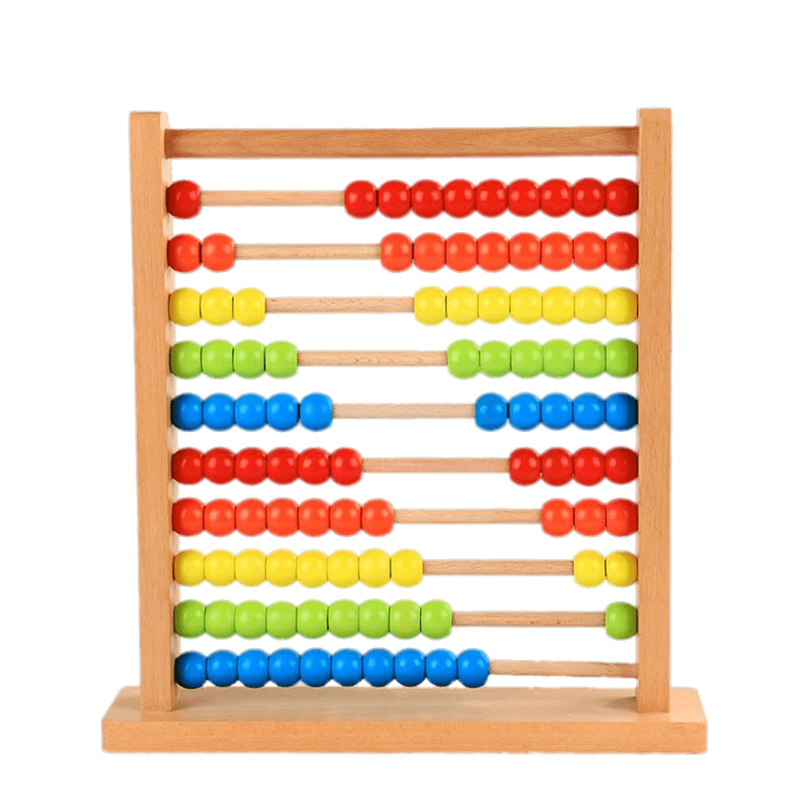  Maths |   Understanding of the World |   Expressive Arts and Design
ELG: Listening, Attention and Understanding  Listen attentively and respond to what they hear with relevant questions, comments and actions when being read to and during whole class discussions and small group interactions;  Make comments about what they have heard and ask questions to clarify their understanding;  Hold conversations when engaged in back-and-forth exchanges with their teacher and peers.  ELG: Speaking  Participate in small group, class and one-to-one discussions, offering their own ideas using recently introduced vocabulary;  Offer explanations for why things might happen, making use of recently introduced vocabulary from stories, non-fiction, rhymes and poems when appropriate;  Express their ideas and feelings about their experiences using full sentences, including use of past, present and future tenses and making use of conjunctions, with modelling and support from their teacher. | ELG: Self-regulation  Show an understanding of their own feelings and those of others and begin to regulate their behaviour accordingly;  Set and work towards simple goals, being able to wait for what they want and control their immediate impulses when appropriate;  Give focused attention to what the teacher says, responding appropriately even when engaged in activity, and show an ability to follow instructions involving several ideas or actions.  ELG: Managing Self  Be confident to try new activities and show independence, resilience and perseverance in the face of challenge;  Explain the reasons for rules, know right from wrong and try to behave accordingly;  Manage their own basic hygiene and personal needs, including dressing, going to the toilet and understanding the importance of healthy food choices.  ELG: Building Relationships  Work and play cooperatively and take turns with others;  From positive attachments to adults and friendships with peers;  Show sensitivity to their own and to others’ needs. | ELG: Gross Motor Skills  Negotiate space and obstacles safely, with consideration for themselves and others;  Demonstrate strength, balance and co-ordination when playing;  Move energetically, such as running, jumping, dancing, hopping, skipping and climbing.  ELG: Fine Motor Skills  Hold a pencil effectively in preparation for fluent writing – using the tripod grip in almost all cases;  Use a range of small tools, including scissors, paint brushes and cutlery;  Begin to show accuracy and care when drawing. | ELG: Comprehension  Demonstrate understanding of what has been read to them by retelling stories and narratives using their own words and recently introduced vocabulary;  Anticipate – when appropriate – key events in stories;  Use and understand recently introduced vocabulary during discussions about stories, non-fiction, rhymes and poems during role-play.  ELG: Word Reading  Say a sound for each letter in the alphabet and at least 10 digraphs;  Read words consistent with their phonic knowledge by sound-blending;  Read aloud simple sentences and books that are consistent with their phonic knowledge, including some common exception words.  ELG: Writing  Write recognisable letters, most of which are correctly formed;  Spell words by identifying sounds in them and representing the sounds with a letter or letters;  Write simple phrases and sentences that can be read by others. | ELG: Number  Have a deep understanding of numbers to 10, including the composition of each number;  Subitise (recognise quantities without counting) up to 5;  Automatically recall (without reference to rhymes, counting or other aids) number bonds to 5 (including subtraction facts) and some numbers to 10, including double facts.  ELG: Numerical Patterns  Verbally count beyond 20, recognising the pattern of the counting system;  Compare quantities up to 10 in different contexts, recognising when one quantity is greater than, less than or the same as the other quantity;  Explore and represent patterns within numbers up to 10, including evens and odds, double facts and how quantities can be distributed equally. | ELG: Past and Present  Talk about the lives of the people around them and their roles in society;  Know some similarities and differences between things in the past and now, drawing on their experiences and what has been read in class;  Understand the past through settings, characters and events encountered in books read in class and storytelling.  ELG: People, Culture and Communities  Describe their immediate environment using knowledge from observation, discussion, non-fiction texts and maps;  Know some similarities and differences between different religious and cultural communities in this country, drawing on their experiences and what has been read in class;  Explain some similarities and differences between life in this country and life in other countries, drawing on knowledge from stories, non-fiction texts and – when appropriate – maps.  ELG: The Natural World  Explore the natural world around them, making observations and drawing pictures of animals and plants;  Understand some important processes and changes in the natural world around them, including the seasons and changing states of matter. | ELG: Creating with Materials  Safely use and explore a variety of materials, tools and techniques, experimenting with colour, design, texture, form and function;  Share their creations, explaining the process they have used;  Make use of props and materials when role playing characters in narratives and stories.  ELG: Being Imaginative and Expressive  Invent, adapt and recount narratives and stories with peers and their teacher;  Sing a range of well-known nursery rhymes and songs;  Perform songs, rhymes, poems and stories with others, and – when appropriate – try to move in time in music.

