Art Curriculum  Impact Statement 2025 |  | 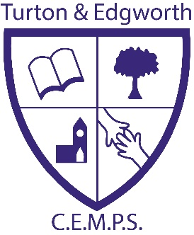
Overall synopsis / developments:  This year, each year group has taught three different Art topics. This has worked well, however, we have identified further areas of improvement. Eg- not all teaching the same topic at the same time as it was difficult to share the Art resources between the whole school.  Art continues to be displayed in lots of different areas around school, this enables us to showcase the children’s work.  Art in school continues to be good. | Art in the EYFS:  Expressive Art and Design in the EYFS is good. Art is everywhere in the EYFS classroom, for example, on the Art display and hung on washing lines across the classroom. The Art area is always available in continuous provision for the children to access. There is also an outdoor easel.
Data overview for Art

Percentage of children at the Expected Standard or better (age appropriate)
Reception | Key Stage 1 | Key Stage 2 | Whole school
100% | 100% | 91.5% | 94.4%

* Subject in EYFS = Expressive Art and Design

Highlights / Life in all its fullness:

Nov 2024- Remembrance day Art competition held for all year groups.

Nov 2024-Christmas craft club ran by Miss P and BH, held for Year 2.

Jan 2025- Drawing club was a success. It was ran by Miss P over a 6 week period, for Year 3 and Year 4 children.

June 2025- Art ambassadors planned and created the Year 6 VIP signs which were displayed at the summer disco.
Subject leadership - CPD, Monitoring and books:

Autumn term- monitoring of sketch books to prepare for the year ahead

Autumn term- new action plan for Art

Autumn term- CP meet Art gov AR

Summer term- Review of the year and changes made ready for the next academic year
Pupil voice (including ambassadors)

“We love doing Art but we think it should be taught more at school.”

