Talk and Learn: Dinosaurs Topic Summary

Things to Talk About and Find Out:
- What do you know about dinosaurs?
- How would you describe…?
- Are all dinosaurs the same?
- What types of dinosaurs can you name?
- What would you like to find out about dinosaurs?
- What do you think happened to dinosaurs?
- How do we know about dinosaurs?
- What do you think it was like when dinosaurs were alive?
- What did dinosaurs eat?
- What is a fossil? Have you ever seen a fossil?
- What body parts can you name on a dinosaur?
- Can you show me how a dinosaur might have moved?
- Where might dinosaurs have lived?
- I wonder what you notice about these pictures.

Topic Words

First, I can try to use these words:

Dinosaur, Tyrannosaurus rex, Stegosaurus, Triceratops, Pterodactyl, Velociraptor, Allosaurus, Apatosaurus, Ankylosaurus, mouth, teeth, tail, legs, horns, scales, claws, walk, run, swim, fly, eggs, bones.

Then, I can try to use these words:
Fossils, extinct, herbivore, carnivore, omnivore, volcano, reptile, prehistoric, palaeontologist, diet, habitat, predator, triassic period, jurassic period, cretaceous period, artefact, skeleton.

Diary dates and special days:

Things I Will Learn
I can name some dinosaurs.
I can name some body parts of dinosaurs.
I can talk about what dinosaurs used to eat.
I can talk about how we know about dinosaurs.
I can talk about some ways that dinosaurs are the same and some ways that they are different.

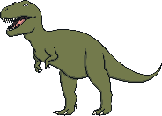
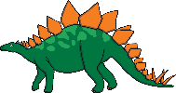
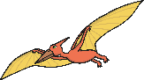
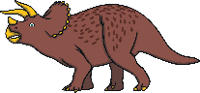
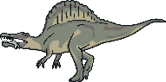
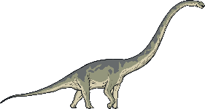
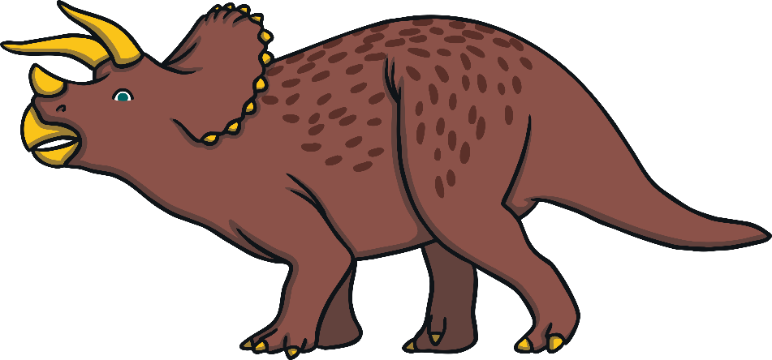
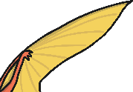
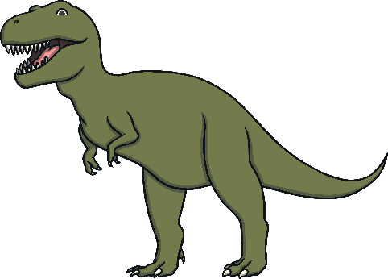
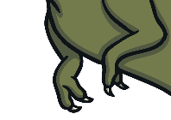
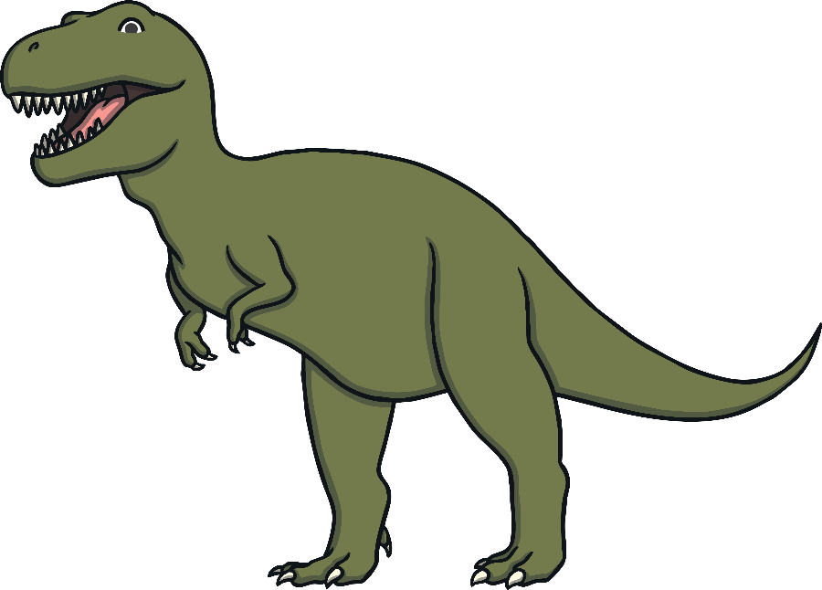
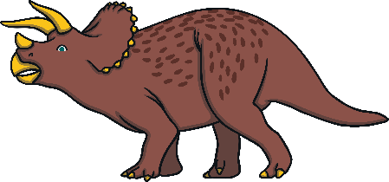
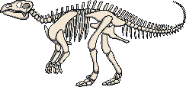
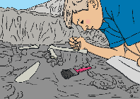
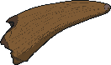
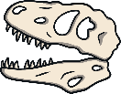
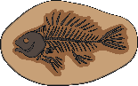
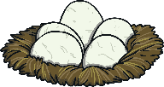
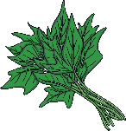
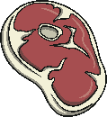
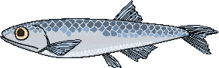

Diplodocus

Pterodactyl

plants
meat
fish
fossils

bones

palaeontologists
skeletons
teeth
eggs
horn

tail

wings

legs
claws

teeth

Spinosaurus

Triceratops

Tyrannosaurus rex

Stegosaurus

Stories, songs and rhymes:

