This term our topic is Turrets and Tiaras
We will be learning all about dragons, royalty and the role of castles.
How have things changed in the last 500 years?
What do you know about castles?
What would you say to a dragon if you met one?
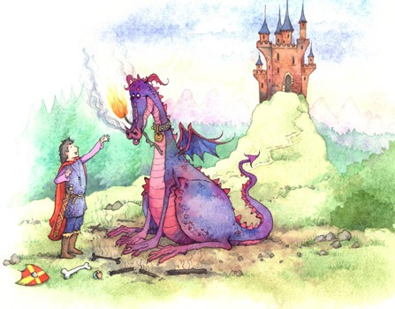
Forest school is on every other Tuesday- starting 8th September 2026, bring something warm, waterproof and bring wellies!
PE this term is on Wednesday’s and Friday’s.

Amethyst Class
Information for Autumn Term

