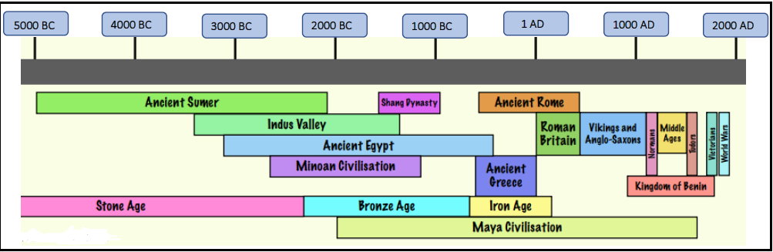
Knowledge Organiser –
Canals and Rivers
Ruby & Diamond

Sticky Knowledge:
I know:
- Canals are manmade they were built to carry goods by boat from one place to another.
- The canals were built as a route to London (an important cloth market). This is one reason why they were built.
- Locks help boats to climb up slopes because water cannot flow upwards.
- Navvies and leggers helped to build and run the canal boats.
- As roads and railways became a cheaper and quicker way to deliver goods, canals were used less often. By the 1930s, many had become overgrown and derelict. Others were built over.

Key Vocabulary
Canal: | an artificial waterway constructed to allow the passage of boats
Locks: | A lock is a device used for raising and lowering boats
Navvies | a labourer employed to construction a canal.
Leggers | a person who moves a canal boat through a tunnel by lying on their back and walking their feet along the tunnel roof or walls
Man - made | made or caused by human beings (as opposed to occurring or being made naturally).
Aerial view | Birds eye view usually on a map.
Physical features | Physical features like seas, mountains and rivers are natural. They would be here even if there were no people around.
Human features | Human features are things like houses, roads and bridges. They have been built by people.

Canals were used to transport goods and people, in the same way our roads and railways are used now. The demand for goods grew during the 18th century. Canals were seen as being an easy way of moving goods. Most canals were built during the Victorian period and the Industrial Revolution

