Railway Revolution Year 3/4 Homework—Summer Term
Homework in Years 3 and 4 will consist of weekly spellings, as well as reading at home and learning multiplication tables, using TT Rockstars and Doodle Maths, both of which are ongoing activities.
The grid below contains extra activities, ideally one homework every two weeks to be shared on a Monday.

Make a model of a steam train or train station and bring it in!  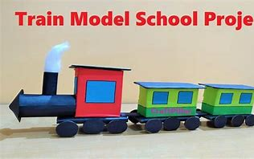 | Go on the train to Gloucester. Take some pictures or draw what you saw and tell us about your trip as a diary entry.  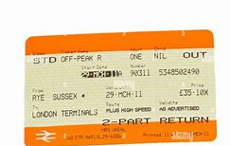 | 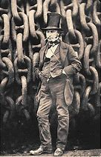  Make a stovepipe hat (the type that Isambard Kingdom Brunel wore) out of old cardboard | Go down to Capel Mill by the canal and take a pencil and pad with you. Draw the amazing viaduct with the canal underneath  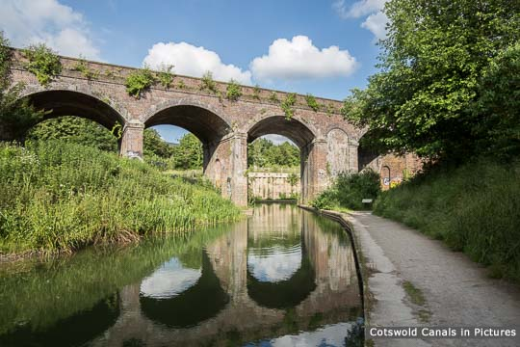
Visit Nationalrail.co.uk and research which stations you would go through if you were to go all the way to London Paddington. Write a timetable to show when and where it stops.  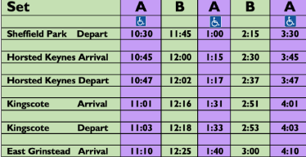 | Recreate a classic GWR poster about a place you could visit on the railway.  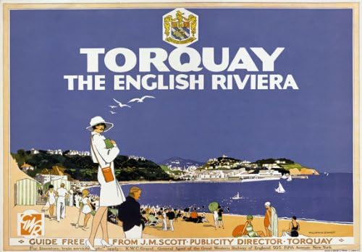 | Research how Stephenson’s Rocket changed the world and label a diagram about how it worked  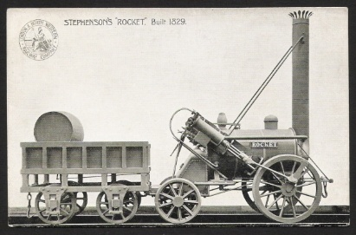 | Draw a map of where you could go to on the train from Stroud. Why not pop down to the station to get help from the ticket office?  