

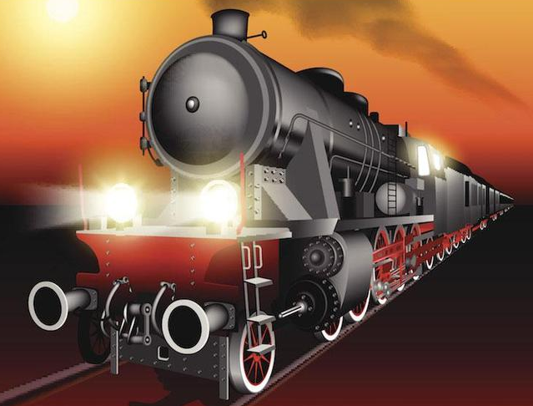
English
We will be focussing on these Non-fiction units:
Persuasion
Biographies (Isambard Kingdom Brunel)

Maths
Fractions (counting in tenths and hundredths & Decimals (dividing by 10 & 100)
Money
Music
Recorders with a focus on rhythm pitch and tempo
RE
How and why do people try to make the world a better place?
PE
Circuits
Handball
Year 3 swimming
PSHE
Safety and the changing body
History
- In 1760 the Industrial revolution began and lasted 80 years until 1840.
- The invention of the steam engine changed the world.
- Steam engines burnt coal
- Steam engines were powered by water wheels or by hand.
- Travelling by rail commenced in 1830.
- The railway revolution changed how people worked and socialised.
- Electricity changed how the railway was used.

Science
Y3 Animals including humans & Plants
Y4 Electricity
DT
Mechanisms
Levers and linkages
Railway Revolution
Ruby & Diamond

