Bawtry Mayflower Primary School EYFS Policy

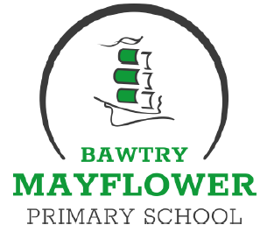

Within this document, the term Early Years Foundation Stage (EYFS) is used to describe children who are in Nursery or Reception.

Vision
Throughout their time in the Foundation Stage at Bawtry Mayflower we want our children to grow and develop into lifelong learners who have the skills to continue learning, not just through school, but through the rest of their lives. We recognise the importance of developing strong, secure relationships with the children and their families and believe that this is crucial to our work.

We promote the skills that the children need to develop independence, resilience, self-motivation, resourcefulness, and creativity. We want our children to achieve their very best and support every child in doing this through open-ended, exciting, challenging and purposeful play. The adults in our setting nurture the innate drive in children to learn and try out new things through modelling, scaffolding, questioning, problem posing, and through shared thinking. We will offer opportunities for our children to explore, engage, persevere, take risks, self-challenge, evaluate, develop their thinking, and solve problems. Strong partnerships with parents, carers and other settings mean that we have a fully rounded view of the child, what they can do and what they need to be able to do next.
At Bawtry Mayflower we are committed to ensuring that children become effective learners, the characteristics of effective learning play a central role in this. The three characteristics of effective learning are:
•Playing and exploring - children investigate and experience things, and ‘have a go’
•Active learning - children concentrate and keep on trying if they encounter difficulties, and enjoy achievements
•Creating and thinking critically - children have and develop their own ideas, make links between ideas, and develop strategies for doing things
These elements underpin how we reflect on each child’s development and adjust our practice accordingly. Supporting children in their individual learning behaviour and observing the context of children’s play is essential. We ensure that children are given continual opportunities to develop the characteristics of effective learning through teacher led sessions and opportunities for purposeful play.
Purposeful Play & Direct Teaching
Teachers select the most appropriate method for teaching based on their knowledge of the children’s, the curriculum and evidence based research e.g. EEF Early Years Toolkit.
Children‛s play reflects their wide ranging and varied interests and preoccupations. We believe that playing with peers is important for children‛s development. Through play our children explore and develop learning experiences, which help them make sense of the world. They practise and build up ideas, and learn how to control themselves and understand the need for rules. They have the opportunity to think creatively alongside other children and they communicate with others as they investigate and solve problems.
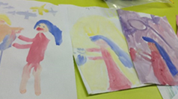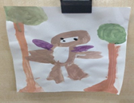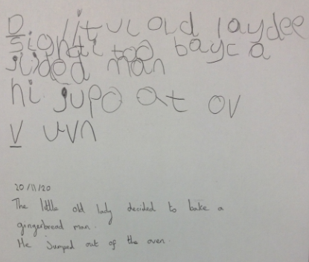
Aims

As outlined in the Statutory Framework for the Early Years Foundation Stage 2021:

‘Every child deserves the best possible start in life and the support that enables them to fulfil their potential. Children develop quickly in the early years and a child’s experiences between birth and age five have a major impact on their future life chances. A secure, safe and happy childhood is important in its own right. Good parenting and high quality early learning together provide the foundation children need to make the most of their abilities and talents as they grow up.’

At Bawtry Mayflower Primary School we aim to provide the highest quality care and education for all our children thereby giving them a strong foundation for their future learning. We create a safe and happy environment with motivating and enjoyable learning experiences that enable children to become confident and independent learners. We value the individual child and work alongside parents and carers to help every child reach their full potential. As part of our practice at Bawtry Mayflower we:

•Promote the value of learning through play and exploration, extending and enhancing the natural curiosity of the child
•Provide a firm foundation for life-long learning
•Promote independence
•Provide structured activities
•Provide opportunities to learn through first-hand experiences
•Provide opportunities for children to build on what they already know
•Develop confidence and self-esteem, enabling each child to develop as an individual
•Promote learning as an exciting and enjoyable experience
•Provide a smooth transition between Nursery, Reception and Year One.
Objectives
To achieve our aims we will: -
•Provide a stimulating, interesting environment which encourages learning through play and exploration, using all the senses
•Provide high quality teaching and facilitate high quality learning through exciting, first hand experiences
•Value and build on previous experiences
•Allow time for children to produce work of depth and quality
•Acknowledge that how children learn is as important as the content taught
•Provide a foundation for positive attitudes (‘I Can‛)
•Celebrate achievements
•Deliver the curriculum using a variety of teaching strategies

A Unique Child
At Bawtry Mayflower Primary School we recognise that every child is a competent learner who can be resilient, capable, confident and self-assured. We recognise that children develop in individual ways, at varying rates. We use praise and encouragement, as well as celebration/ sharing assemblies, the recognition board and show and tell to encourage children to develop a positive attitude to learning.
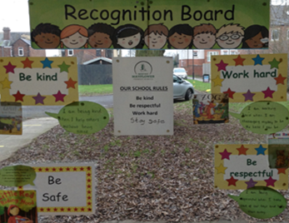
Overarching Principles
Inclusion
All children and their families are valued within our school and we value the opportunities that diversity brings.
We give our children every opportunity to achieve their best. We do this by taking account of our children‛s range of life experiences when planning. We set realistic and challenging expectations that meet the needs of our children. We achieve this by planning to meet the needs of all groups through:
•Individual planning opportunities that build upon and extend children‛s knowledge, experience and interests, and develop their self-esteem and confidence.
•Using a wide range of teaching strategies based on children‛s learning needs.
•Providing a wide range of opportunities to motivate and support children and to help them to learn effectively.
•Providing a safe and supportive learning environment in which the contribution of all children is valued.
•Using resources which reflect diversity and are free from discrimination and stereotyping.
•Planning challenging activities for children whose ability and understanding are in advance of their language and communication skills.
•Monitoring children‛s progress and taking action to provide support as necessary.
We teach children about boundaries, rules and limits and to help them understand why they exist. We provide children with choices to help them develop this important life skill. This enables children to learn how to take risks while understanding how to recognise and avoid hazards.
SEND Co-ordinator- Mrs Walker, Mrs Wood

Health, Welfare and Keeping Safe
Children learn best when they are happy, healthy, safe and secure, when their individual needs are met and when they have positive relationships with the adults caring for them.
At Bawtry Mayflower Primary School we recognise that children learn to be strong and independent from secure relationships. We aim to develop caring, respectful, professional relationships with the children and their families.
At Bawtry Mayflower Primary School we support wellbeing through:
•Promoting hygiene, preventing the spread of infection and taking appropriate action when children are ill.
•Managing behaviour effectively in a manner appropriate for the children‛s stage of development and individual needs. Children are taught to share, take turns, be kind and to make the “right” choices.
•Ensuring all adults are suitable to work with children.
•Ensuring that the premises, furniture and equipment is safe and suitable for purpose
•Ensuring that every child receives enjoyable and challenging learning and development experiences tailored to meet their needs.
•Maintaining records, policies and procedures required for safe efficient management of the setting.
•Carrying out risk assessments regularly reporting maintenance requirements when necessary.
•Ensuring that staff have appropriate paediatric first aid training.
•Follow all school policies and procedures for medicines in school and for reporting safeguarding concerns.
Positive Relationships
At Bawtry Mayflower Primary School we recognise that children learn to be strong and independent from secure relationships. We aim to develop caring, respectful, professional relationships with the children and their families.
Parents and Carers as Partners and Supporting Learning
We recognise that parents and carers are children‛s first and most enduring educators and we value the contribution they make. We recognise the role that parents have played, and their future role, in educating the children. We do this through:
- Giving children the opportunity to spend time with their teacher before starting school during transition times.
- Inviting all parents/carers to an induction meeting during the term before their child starts school.
- Meeting with parents/carers prior to children starting school and offering regular opportunities to talk about their child‛s progress throughout the year.
- Having an open door policy encouraging parents/carers to talk to the child‛s teacher if there are any concerns.
- Sharing information about learning via the website and newsletter.
- Arranging a range of activities throughout the year that encourage collaboration between child, school and parents/carers e.g. family activities, sports day etc.

Supporting Learning and Key Person
All staff involved with the EYFS work with and form secure relationships with all children. Every child is also designated a ‘key person‛ who provides the reassurance to feel safe and cared for whist building a secure relationship with their parents.
The Foundation Stage Curriculum
We plan an exciting and challenging curriculum based on our observation of children’s needs, interests, and stages of development across the seven areas of learning to enable the children to achieve the early learning goals. All of the seven areas of learning and development are important and interconnected. Three areas are particularly crucial for igniting children's curiosity and enthusiasm for learning, and for building their capacity to learn, form relationships and thrive.
These three areas are the prime areas:
• Communication and Language - Listening, Attention and Understanding and Speaking
• Physical Development – Gross Motor Skills and Fine Motor Skills
• Personal, Social and Emotional Development – Self-Regulation, Managing Self, Building Relationships
Children are also supported through the four specific areas, through which the three prime areas are strengthened and applied. The specific areas are:
• Literacy – Comprehension, Word Reading, Writing
• Mathematics – Number, Numerical Patterns
• Understanding the World – Past and Present, People, Culture and Community, The Natural World
• Expressive Arts and Design – Creating with Materials, Being Imaginative and Expressive
Children are provided with a range of rich, meaningful first-hand experiences in which children explore, think creatively and are active. We aim to develop and foster positive attitudes towards learning, confidence, communication and physical development.
The curriculum is delivered using a play-based approach as outlined by the EYFS. ‘Each area of learning and development is to be implemented through planned, purposeful play and through a mix of adult-led and child-initiated activities’. We plan a balance between children having time and space to engage in their own child-initiated activities and those that are planned by the adults. During children’s play, early years practitioners interact to stretch and challenge children further. In planning and guiding children's activities, we reflect as practitioners on the different ways that children learn and reflect these in our practice.
Observation, Assessment and Planning
We have created a long term plan and medium term plans based on a series of topics each of which offers experiences in all seven areas. These plans then inform our short term weekly planning, alongside our observations, which remains flexible for unplanned circumstances or children’s responses. Children have whole group and small group times which increases as they progress through the EYFS.
Within the Early Years Foundation Stage there are two statutory assessments for children in Reception:
The Reception Baseline Assessment (RBA) The Reception Baseline Assessment (RBA) is a short assessment, taken in the first six weeks in which a child starts reception.
The Early Years Foundation Stage Profile (EYFSP) In the final term each child’s level of development must be assessed against the seventeen early learning goals. Practitioners must indicate whether children are meeting expected levels of development (expected), or if they are not yet reaching expected levels (‘emerging’).
We make regular assessments of children‛s learning and we use this information to ensure that planning reflects identified needs. Assessment in the EYFS is carried out through planned and incidental observation of the children during child initiated and adult led activities. This involves all of the EYFS staff as appropriate. These observations are recorded and may also contain information provided by parents and other settings.
Samples of children‛s work are kept in individual children‛s learning journals that help to track the progress that a child is making during the foundation stage. On completion of the foundation stage an EYFS profile will be completed for each child including a short commentary on each child‛s skills and abilities in relation to the characteristics of effective learning.
All assessments are shared during the transition process with Key Stage 1 teachers.
The Learning Environment
The EYFS unit, both inside and outside, is organised to allow children to explore and learn securely and safely. There are areas where the children can be active and areas where they can be quiet. The classroom is set up in learning areas, where children are able to find and locate equipment and resources independently. Being outdoors offers opportunities for doing things in different ways and on a larger scale. It offers the children the opportunity to explore, use their senses and be physically active and exuberant. We plan activities and resources for the children to access outdoors that help the children to develop in all areas of their learning.
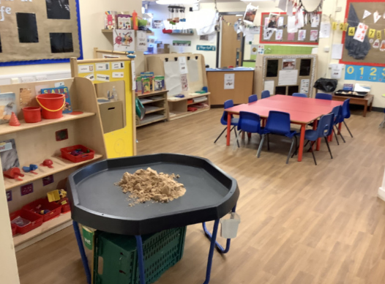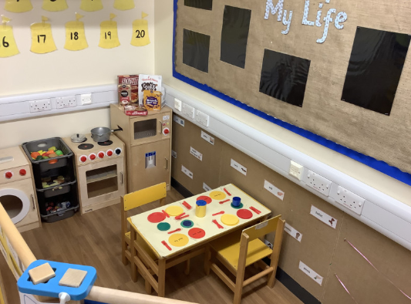
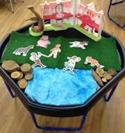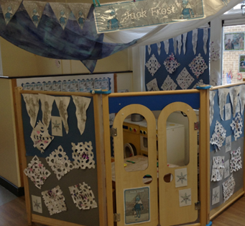

Wider Contexts
At Bawtry Mayflower Primary School, we endeavour to form and build relationships with other settings, organisations and services. We believe that through sharing expertise, listening and involving the children, we can achieve positive contributions both to our school and the wider community.
Transition – Nursery through to Reception
At Bawtry Mayflower Primary School transition is carefully planned for and time is given to ensure continuity of learning. We acknowledge the child’s needs and establish effective partnerships with those involved with the child and other settings, including nurseries. The EYFS has close links with the rest of the school. In order to ease these transitions we do the following:
• Children attend introductory sessions to Nursery and Reception to develop familiarity with the setting and practitioners.
- Parents/Carers receive a pack containing photos and information prior to their child staring school that allows the child and parents/carers to familiarise themselves with the school routines and EYFS setting.
- Nursery and Reception children are taught in our Foundation Stage Unit.
• Reception children join whole school events and assemblies where appropriate.
• Early year’s teachers provide parental guides and workshops to support with the progress of reading skills.

Transition – Reception through to Key Stage 1

Throughout the Reception year there are opportunities for the pupils to take part in activities with the other classes in school. In the summer term the Year 1 teacher will meet with the Reception staff and discuss each child's development against the Early Learning Goals in order to support a smooth transition into Year 1. This discussion helps the Year 1 teacher to plan an effective, responsive and appropriate curriculum that will meet the needs of all children. In order to ease these transitions we do the following:
•Ensure that year 1 teachers have a range of opportunities to visit the children within the foundation stage setting.
- The children regularly visit the Year 1 classrooms at the end of the summer term.
• Key Stage 1 teachers and the Early Years teachers have a transition meeting to discuss children‛s progress towards the early learning goals and to set their next steps for the beginning of year 1.
- In the Summer term the Year 1 teachers hold a welcome to key stage 1 meeting for parents to attend.

List of Appendices:
- Link to the Statutory Framework for Early Years Foundation Stage 2021
https://assets.publishing.service.gov.uk/government/uploads/system/uploads/attachment_data/file/974907/EYFS_framework_-_March_2021.pdf
- Link to Development Matters
https://assets.publishing.service.gov.uk/government/uploads/system/uploads/attachment_data/file/1007446/6.7534_DfE_Development_Matters_Report_and_illustrations_web__2_.pdf

Policy updated: September 2021

