
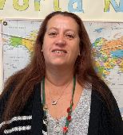
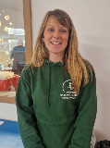

Maths
In Mathematics this term, we will be focusing on:
Shape
Problem solving using Addition, subtraction, multiplication and division
Measures
Fractions

In each area, children will develop fluency and reasoning skills..
They will develop their understanding through the use of concrete apparatus (Dienes, counters, numicom, cubes, etc.), pictorial images (arrays, number lines, place value charts, etc.), and abstract methods (written methods).
In addition to our maths lessons, we will continue to work on developing our arithmetic skills. We do regular arithmetic sessions with the children, where they practise applying strategies and skills that they have learnt previously. We also do a number of the day, where children apply their knowledge of place value, and the four operations.

In addition to this, we are regularly practising the children’s recall of the 2, 3, 4, 5, 6, 10 and 11 times tables. The children must be confident in their knowledge of these times tables facts.
Meet the Team
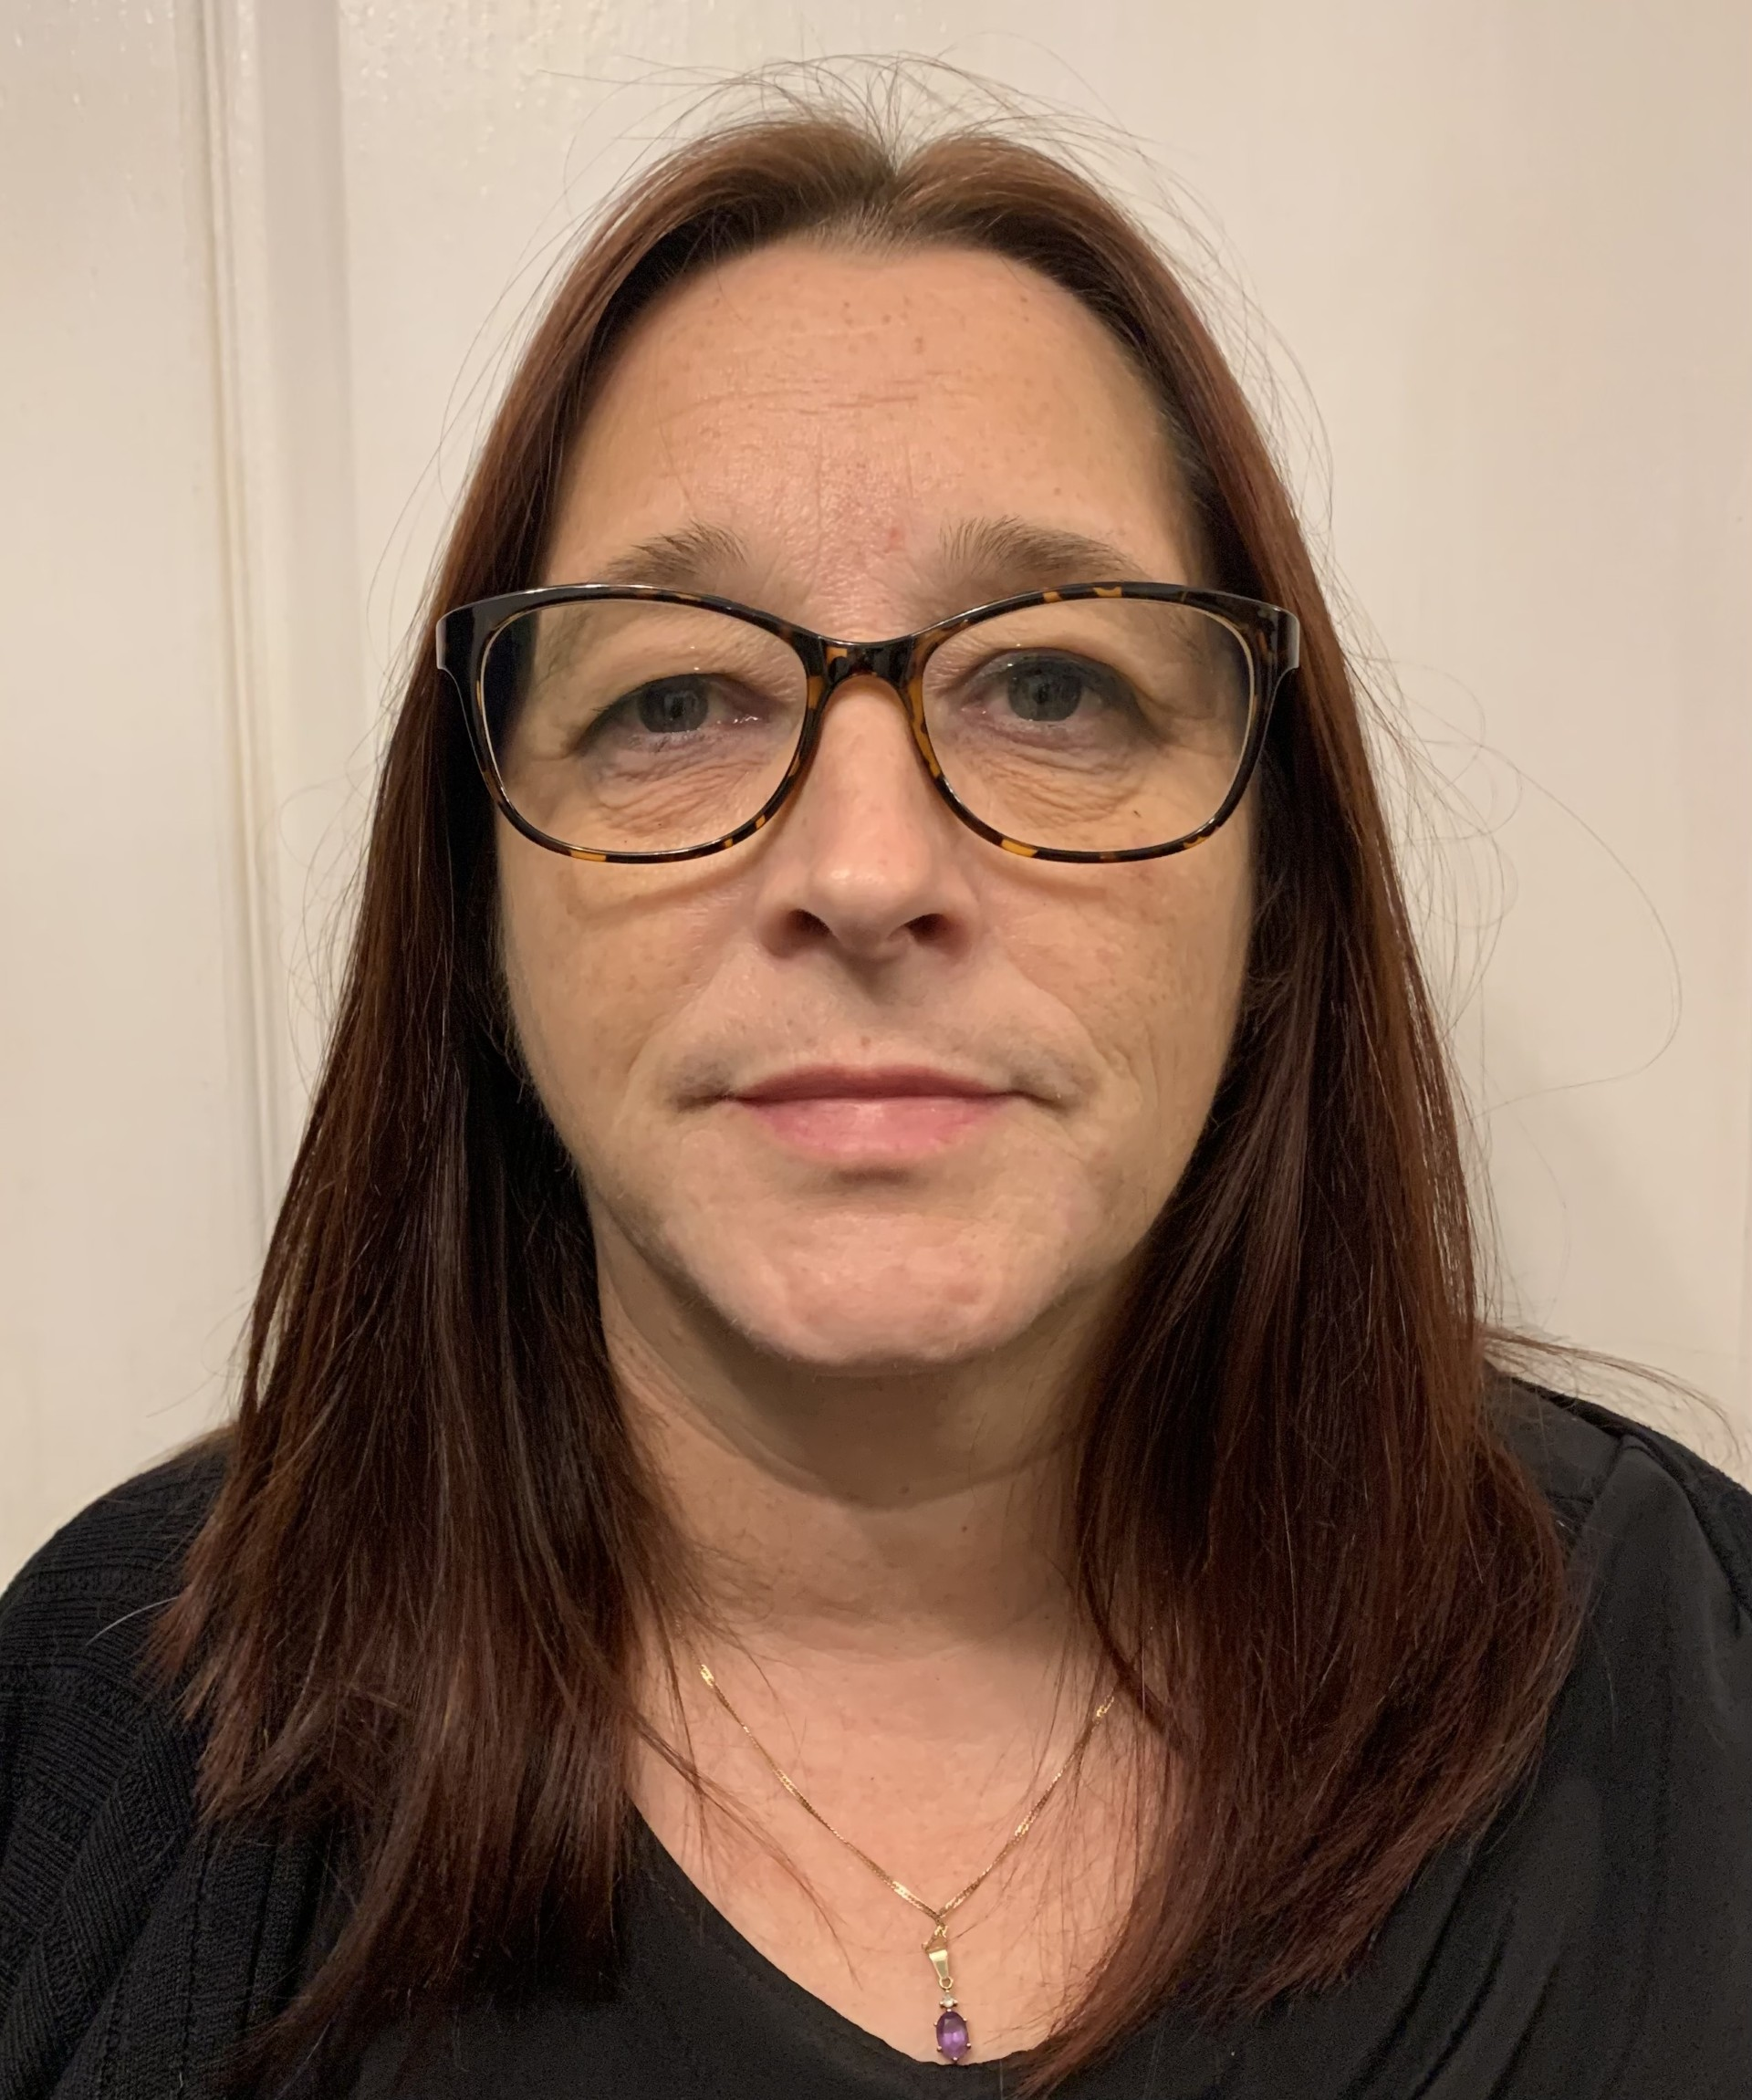
Reading
In reading, we will be using various age appropriate texts as a stimulus for our lessons. The children will work on their skills of fluency.
Each week, the children will decode unfamiliar vocabulary using a range of strategies.
They will also continue to build on their skills of retrieval, inference, summarizing and predicting.

Some of the texts that we are using this term are:
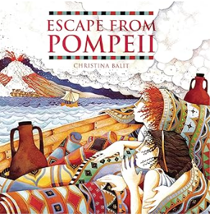

Mrs Sturrock
Mrs Ronan
Mrs Wood
Science
In Science, we will be focusing on the topic ‘Animals including humans’. The children will learn about nutrition to be healthy and learn about skeletons and muscles. The children will also learn about ‘Light’ where we will work scientifically to investigate shadows and to understand that light is needed in order to see.
As part of our humanities learning, our topic this term is The Romans in Britain.

Geography
Working as geographers, the children will name and locate counties and cities of the United Kingdom, look at geographical regions and their identifying human and physical characteristics, identify key topographical features (including hills, mountains, coasts and rivers), and land-use patterns; and understand how some of these aspects have changed over time. They will name and locate countries of Europe and identify their main physical and human characteristics. They will learn about the changes in land use and settlement from Roman times compared to now.
History
Working as historians, the children will learn about the Roman Empire and its impact on Britain. They will describe changes that have happened in the locality of the school throughout history as well as describing the social, ethnic, cultural or religious diversity of past society. They will develop and extend their understanding of chronology using date and terms to describe events. A variety of sources of evidence will be used to gain an accurate understanding of history.

Please don’t hesitate to contact a member of the team about any questions, worries or concerns you or your child may have.
Someone from the Year 3 team will always be available to help if needed or you can contact the office at admin@bawtrymayflower.doncaster.sch.uk

Always here to help…

Computing
Throughout this term we will be focusing on ‘Desktop Publishing’ and ‘Events and Actions in Programs’.
We will focus on combining text and images to communicate a message in Desktop Publishing. In the second topic, we will explore movement and then design and code a maze tracing program.

PSHE
In Summer term, we will be focusing on the topics ‘Relationships and ‘Changing Me’.
Relationships will focus on making friends, solving problems and understanding how others feel.
Changing Me will focus on expressing their feelings and understanding and respecting change in themselves and others.

Dates for your diary
Tuesday 19th May – Austerfield Residential Parents Meeting 3.10 – 3.40
Monday 25th May to Friday 29th May – half term
Monday 1st June – Training Day – school closed
Tuesday 9th June to Wednesday 10th June - Year 3 residential to Austerfield Study Centre
Wednesday 17th June - choir taking part in Sing Out concert
Thursday 18th June - Sports Day - times to be confirmed
Friday 19th June - PTA Gifts for a loved one shop during the school day
Monday 22nd June - Year 3 class assembly 10.15am - parents/carers
Wednesday 24th June - Rocksteady & Guitar/Woodwind/Brass concert 2pm
Wednesday 24th June - PTA Summer Fair
Tuesday 14th July - Big Talk Education in school
Wednesday 15th July - PTA Colour Run
Friday 17th July - last day at school before Summer holidays

Art/ Design Technology
In Art, we will be focusing on our skills of sculpture and collage using the work of Sonia King as inspiration.
In Design Technology (DT), we will be looking at Electrical posters.

Year 3 Curriculum Newsletter

Summer Term - ‘The Romans in Britain’
PE
This term we will be focusing on Cricket and Athletics during PE.

Our PE day: Wednesday
Children will need to bring their PE kit to school with them. This should include trainers, dark tracksuit bottoms or shorts, and a white t-shirt. If your child has their ears pierced, these must be covered prior to coming to school with tape/plasters or your child must be able to remove these by themselves. Long hair must be tied back with a bobble.

Religious Education
In RE, we will be exploring the questions ‘What faiths and beliefs can be found in our country and out community’ This will be advancing our understanding of the religions that we have previously learnt about during our journey through school.

Writing
This term, we will further develop our skills as writers by writing for a range of purposes and audiences.
The children will apply their learning about paragraphing, organizing ideas around a theme and sequencing their ideas chronologically and further develop their understanding of the using different types of sentences appropriately for clarity and effect.
They will also continue to work on techniques used by authors to create effective characters and settings.
The children will continue to learn new spelling rules and will apply these in their independent writing.

