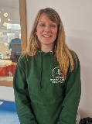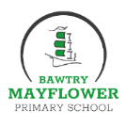



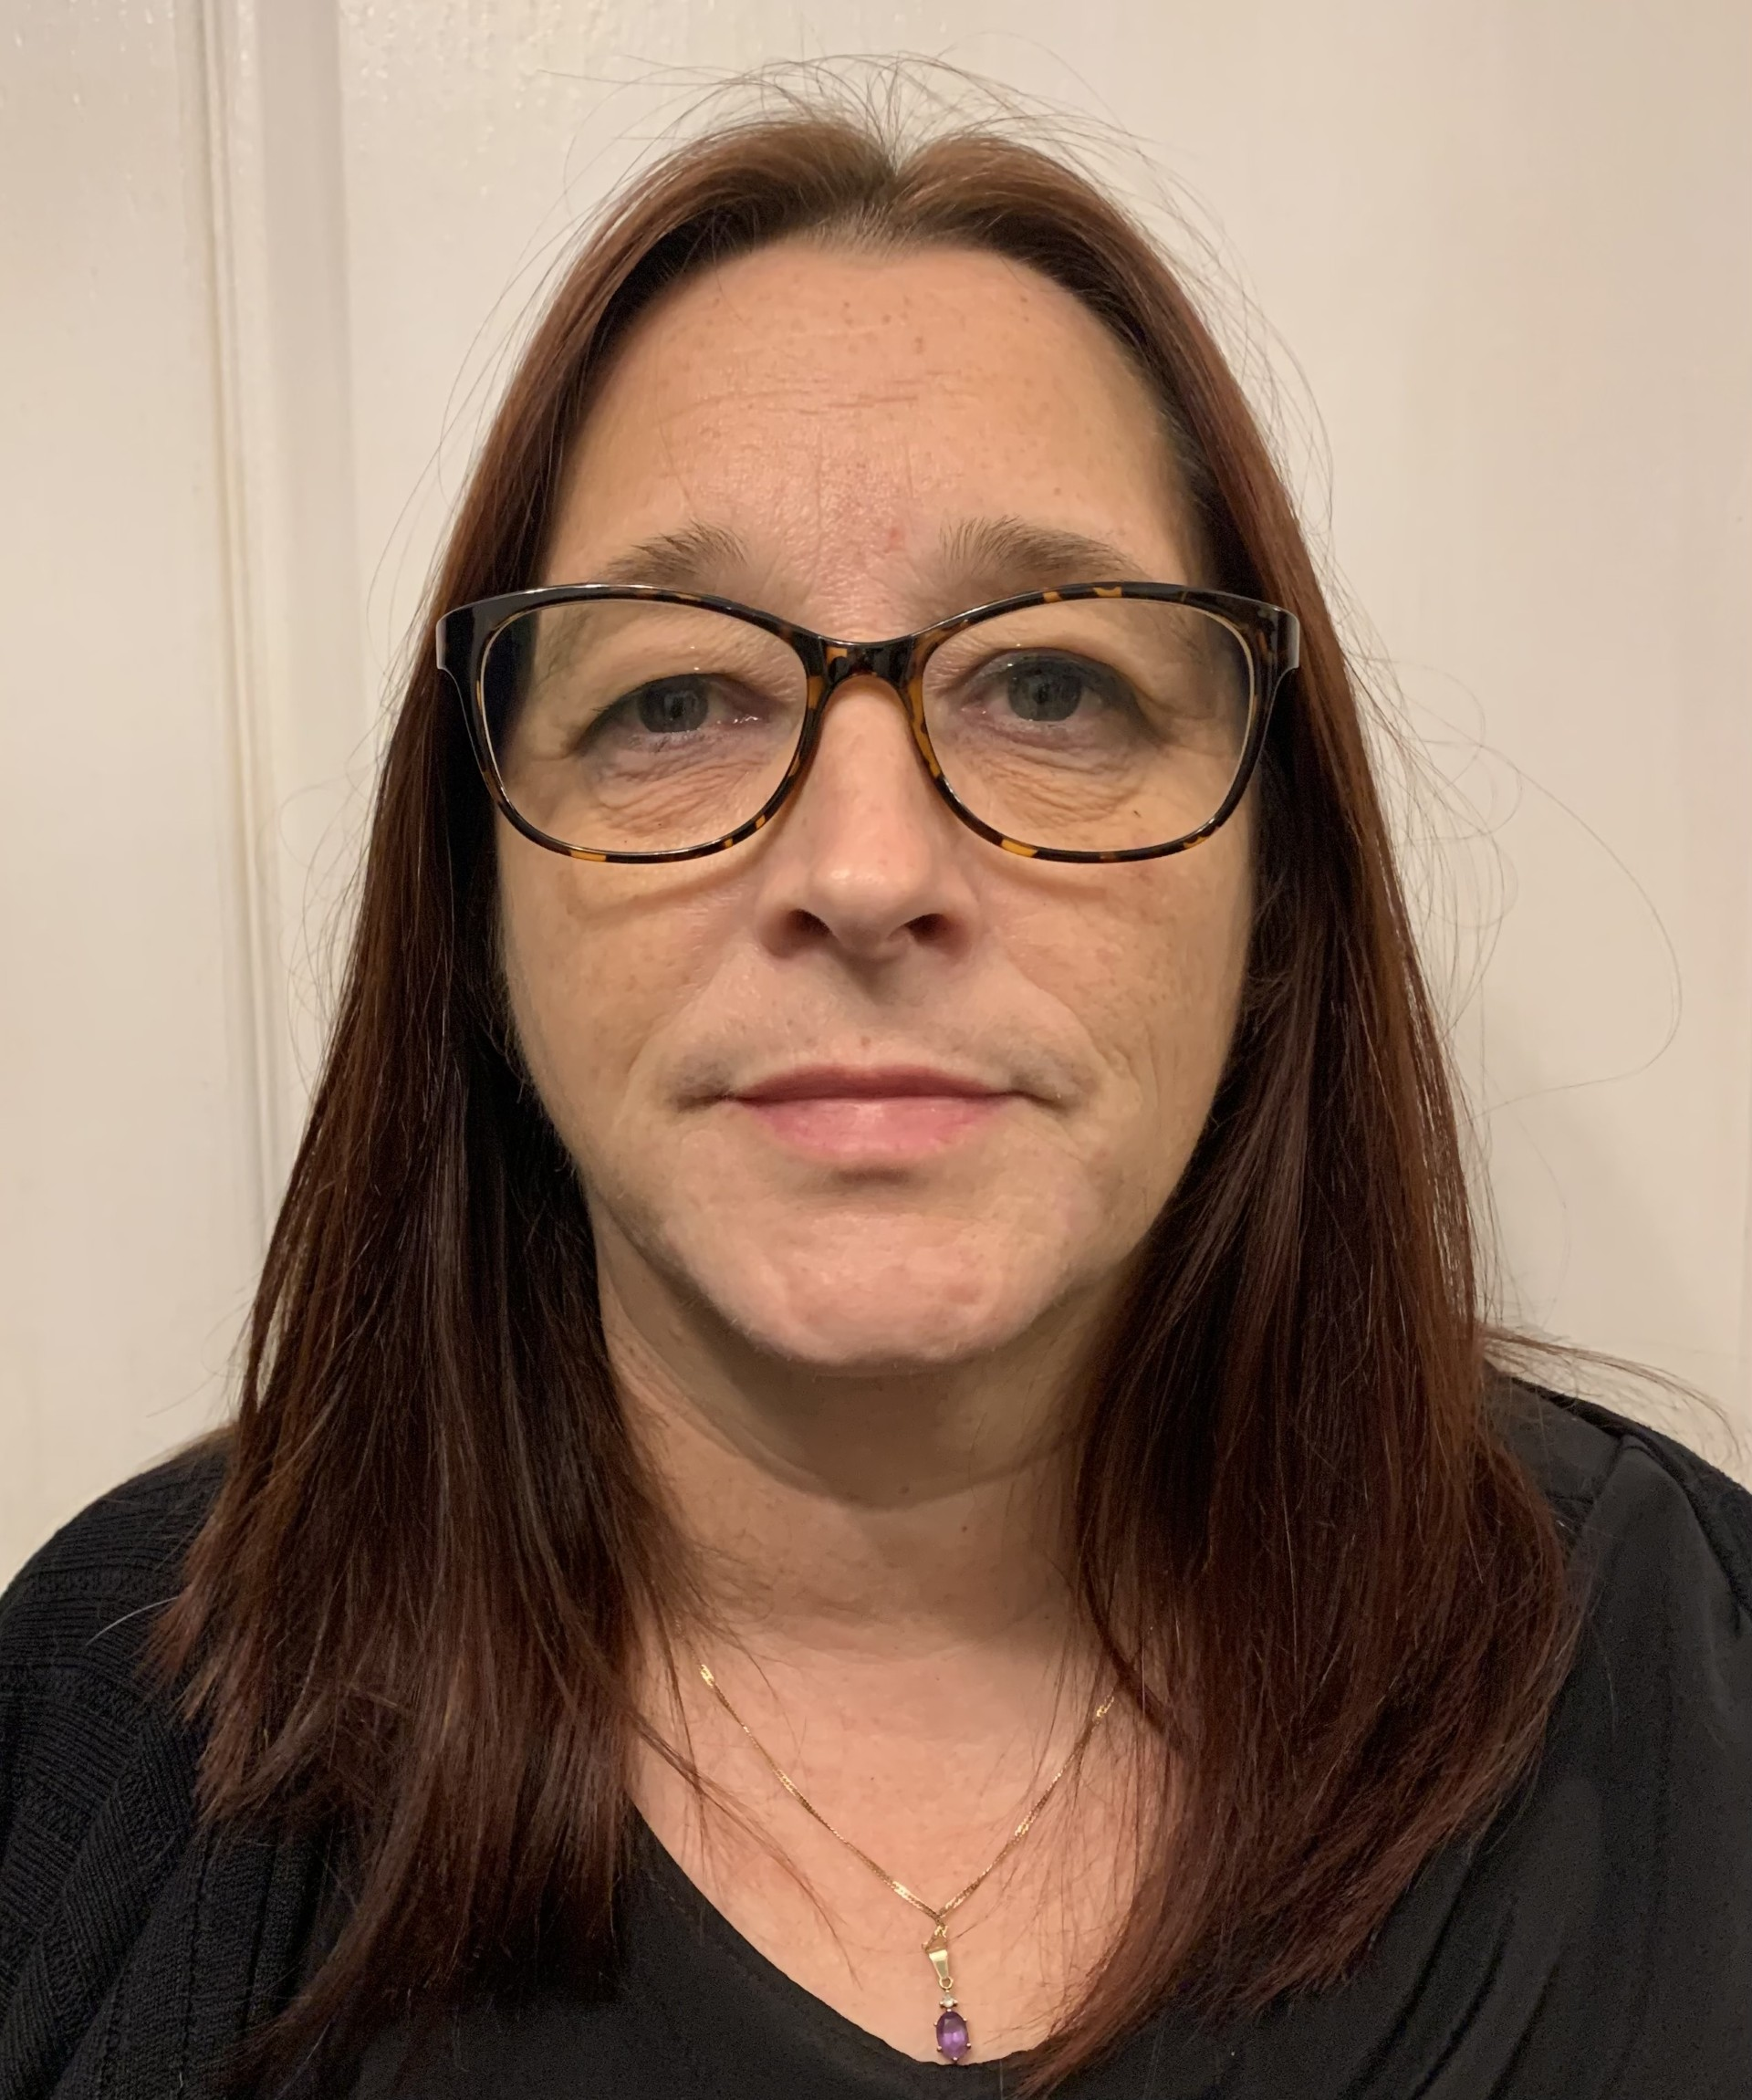

**Mrs Sturrock**

**Mrs Ronan**

**Mrs Wood**

**Science**

In Science, we will be focusing on the topic ‘Plants’. We will be identifying and describing the functions of different parts of a plant as well as exploring the requirements of plants for growth. We will also work scientifically to investigate the way in which water is transported within plants.

As part of our humanities learning, our topics this term are ‘Local Field Study’ and ‘Stone Age to Iron Age’.

**Geography**

Working as geographers, the children will investigate their local area. They will use fieldwork skills to observe and record the human and physical features in the local area using a range of methods including sketch maps, plans and graphs and digital technologies. In addition to this, they will investigate patterns by looking at how the area has changed over time and suggest reasons for this.

**History**

Working as historians, the children will investigate the past by looking at the changes in Britain from the Stone Age to the Iron Age. They will use different sources of evidence to ask and answer historical questions. They will develop their skills of chronology by creating timelines, accurately using dates and terms to describe events. They will develop their overview of World History by describing the characteristic features of the past, including ideas, beliefs, attitudes and experiences of men, women and children.

**Reading**

In reading, we will be using various age appropriate texts as a stimulus for our lessons. The children will work on their skills of fluency.

Each week, the children will decode unfamiliar vocabulary using a range of strategies.

They will also continue to build on their skills of retrieval and inference.

Some of the texts that we are using this term are: The Night Gardener, The Nothing to See Here Hotel, The Iron Man and Stone Age Boy.

**Maths**

In Mathematics this term, we will be focusing on:

Place value of three digit numbers

Addition

Subtraction

Multiplication

Division

In each area, children will develop fluency and reasoning skills..

They will develop their understanding through the use of concrete apparatus (Dienes, counters, numicom, cubes, etc.), pictorial images (arrays, number lines, place value charts, etc.), and abstract methods (written methods).

In addition to our maths lessons, we will continue to work on developing our arithmetic skills. We do regular arithmetic sessions with the children, where they practise applying strategies and skills that they have learnt previously. We also do a number of the day, where children apply their knowledge of place value, and the four operations.

In addition to this, we are regularly practising the children’s recall of the 2, 3, 4, 5 and 10 times tables. The children must be confident in their knowledge of these times tables facts.

Please don’t hesitate to contact a member of the team about any questions, worries or concerns you or your child may have.

Someone from the Year 3 team will always be available to help if needed or you can contact the office at [admin@bawtrymayflower.doncaster.sch.uk](mailto:admin@bawtrymayflower.doncaster.sch.uk)

**Always here to help…**

**Computing**

Throughout this term we will be focusing on **‘Computing Systems and Networks- Connecting Computers’** and **‘Stop frame animation**. We will focus on developing an understanding of digital devices, with a focus on inputs, processes and outputs. In the second topic, we will learn about a range of techniques needed to create a stop-frame animation using tablets.

**PSHE**

In Autumn term, we will be focusing on the topics ‘Being Me in My World’ and ‘Celebrating Difference’. The first topic will focus on setting goals and targets for a positive year, how to contribute to a positive learning environment. The second topic will focus on celebrating our differences and the importance of inclusion.

**Dates for your diary**

**Wednesday 1st October -** Individual and sibling photograph

**Friday 10th October –** Hello Yellow non uniform for World Mental Health Day

**Wednesday 22nd October-**Harvest Church Service

**Tuesday 11th November** – Flu vaccinations

**Tuesday 16th December -** Christmas Service at St. Nicholas’ Church

Christmas Dinner Day

**Art/ Design Technology**

In Art, we will be focusing on warp and weft weaving, specifically looking at the work of Michael Crompton as inspiration for our own products.

In Design Technology (DT), we will be looking at and creating our own pneumatic toys.

**Year 3 Curriculum Newsletter**

**Autumn Term - ‘Stone Age to Iron Age’**

**PE**

This term we will be focusing on Football and Netball

**Our PE day is Wednesday**

Children will need to bring their PE kit to school with them. This should include trainers, dark tracksuit bottoms or shorts, and a white t-shirt. If your child has their ears pierced, these must be covered prior to coming to school with tape/plasters or your child must be able to remove these by themselves. Long hair must be tied back with a bobble.

**Religious Education**

In RE, we will be exploring the questions ‘**How do Jews remember God’s covenant?’**

This will be advancing our understanding of the religions that we have previously learnt about during our journey through school.

**Writing**

This term, we will be developing our skills as writers by writing for a range of purposes and audiences.

The children will begin to use simple, compound and complex sentences. They will also learn about fronted adverbials and how to punctuate these accurately. The children will begin to use similes in their writing to enhance their descriptions. In addition to this, the children will begin to use direct speech accurately when writing.

They will also learn new spelling rules and apply these independently to their writing.

-

–