PE Pupil Voice Survey Report – 2024-2025

Total responses: 42 pupils from Years 3 to 6
- Year 3: 4 pupils
- Year 4: 12 pupils
- Year 5: 15 pupils
- Year 6: 11 pupils
This report summarises the responses of Bishop Wilson CE school children to the PE Pupil Voice Survey. The aim is to capture pupil enjoyment, understanding, confidence and participation in PE and physical activity opportunities across the school.

Enjoyment of PE
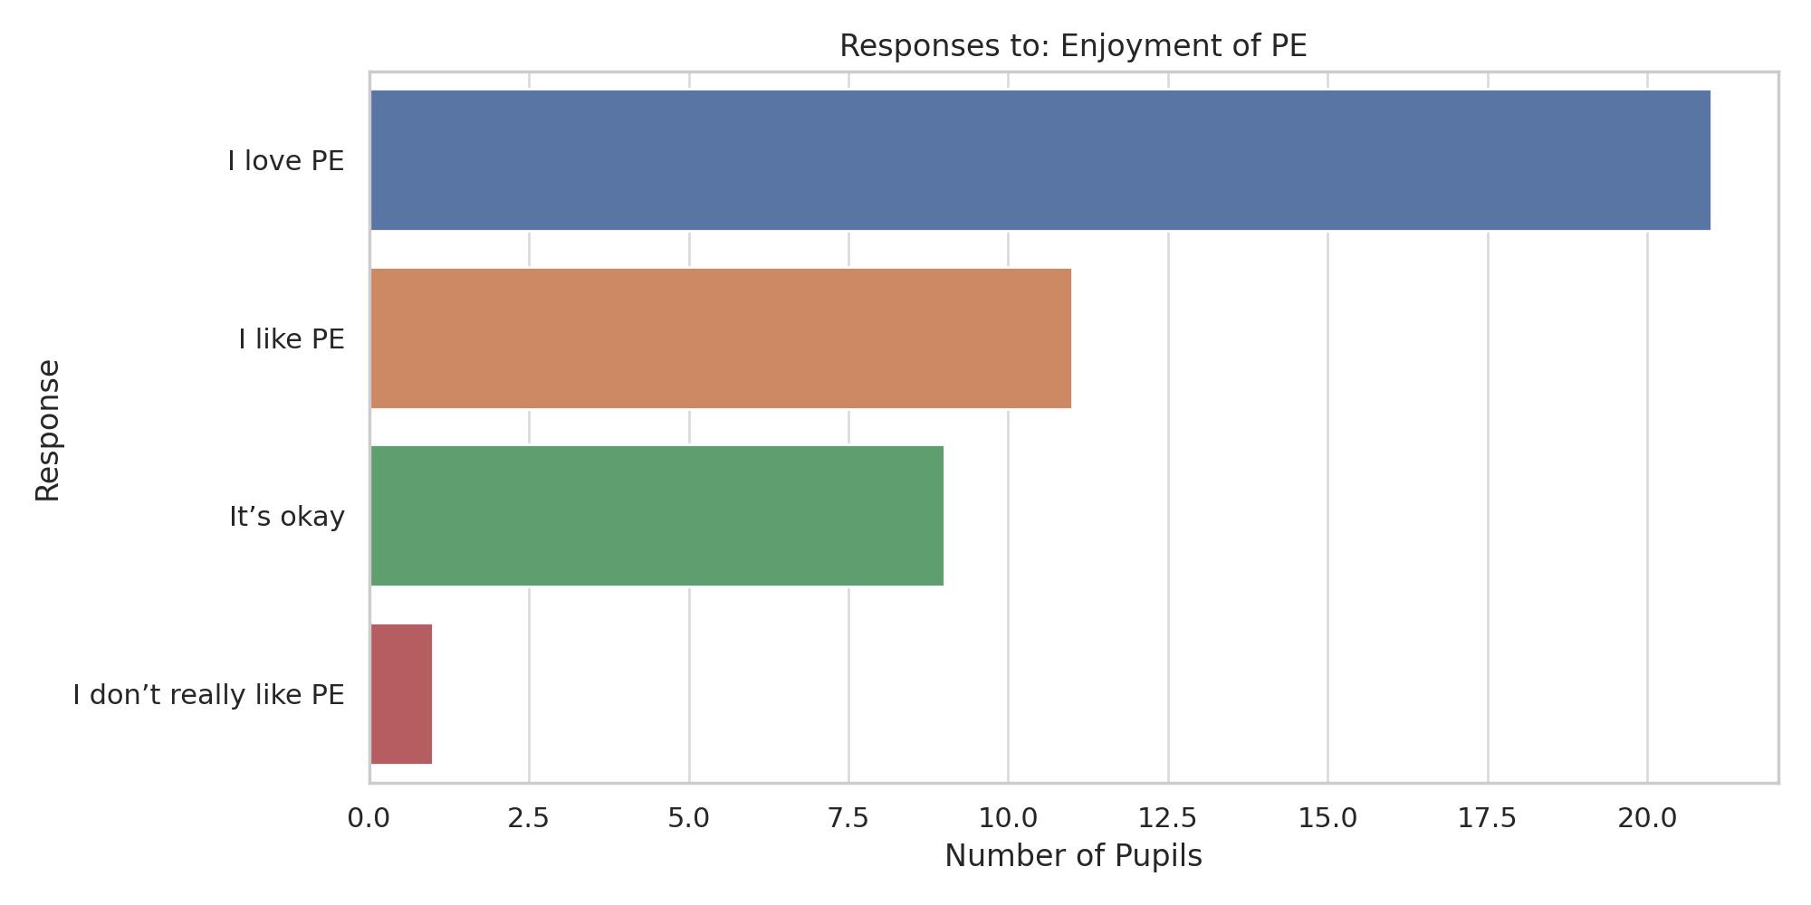

Understand Learning
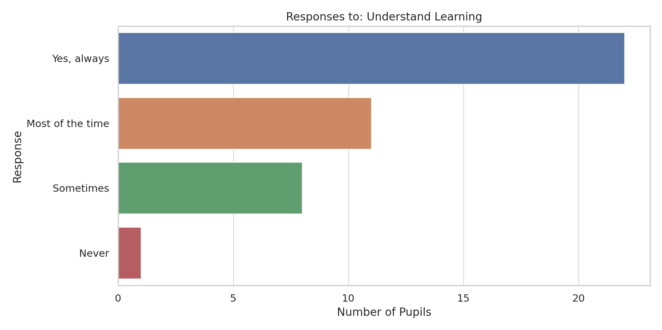

Confidence Gained
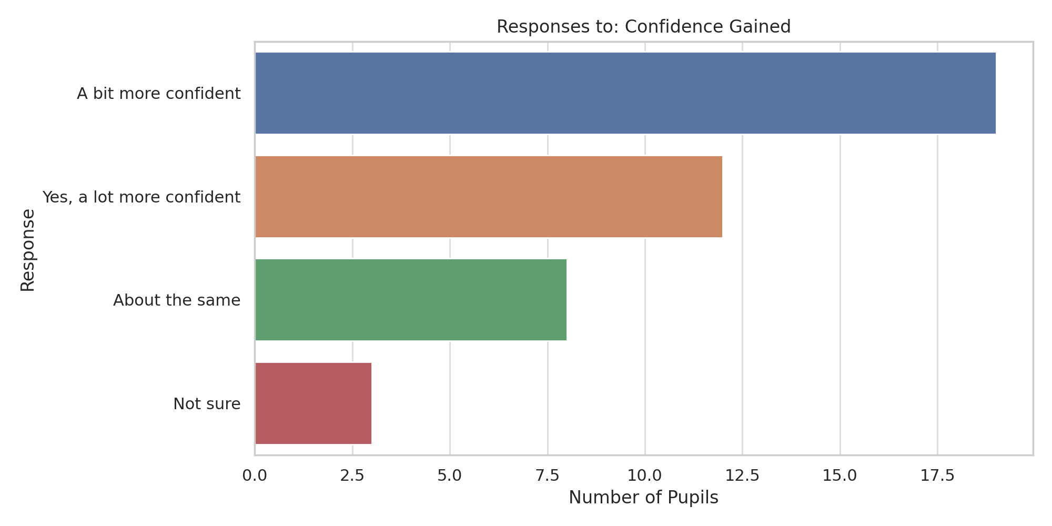

Lunchtime Activity
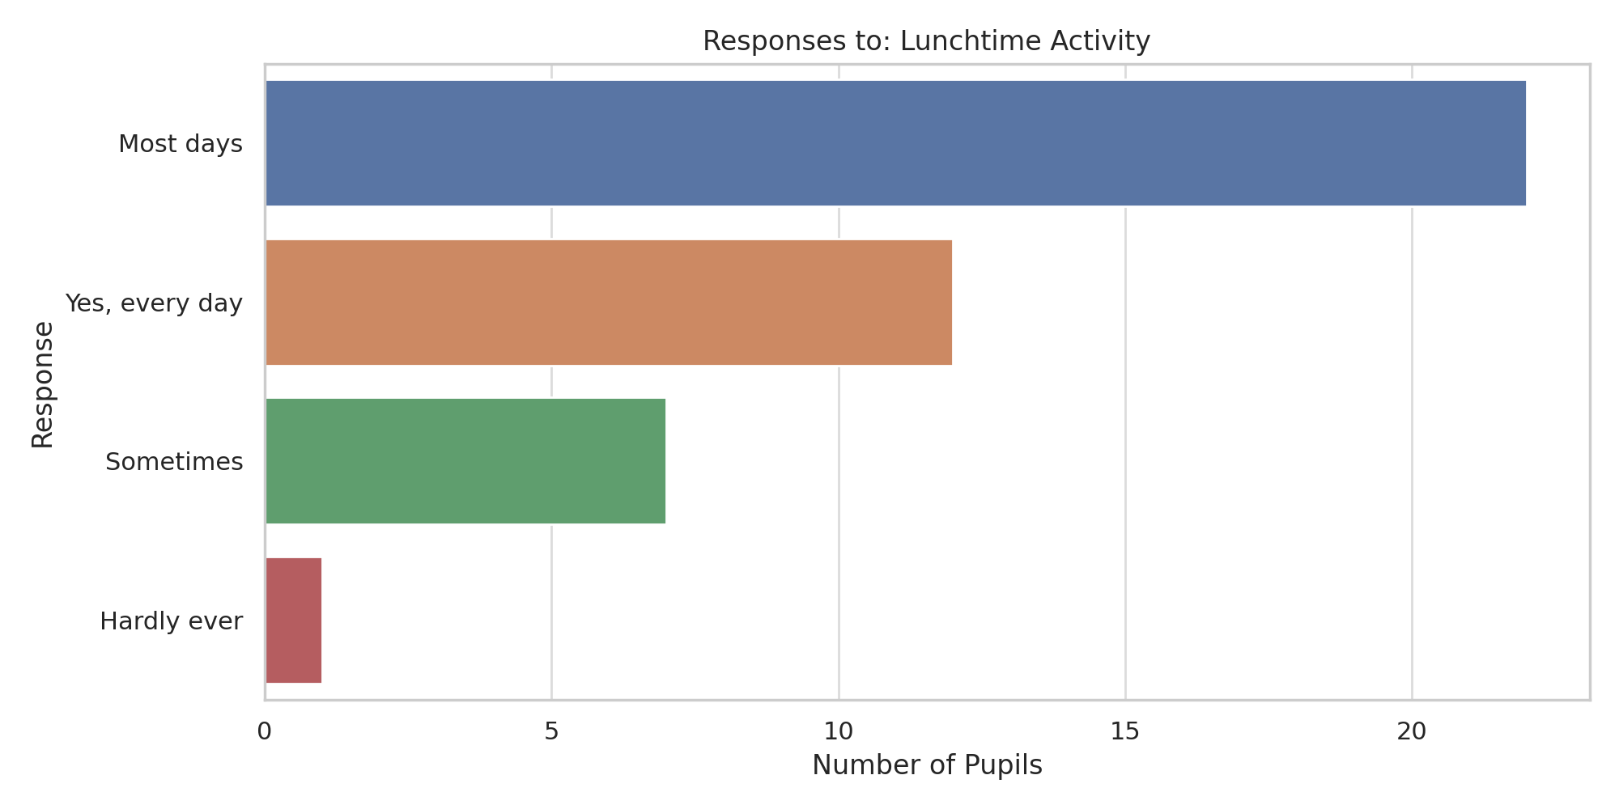

Club Participation
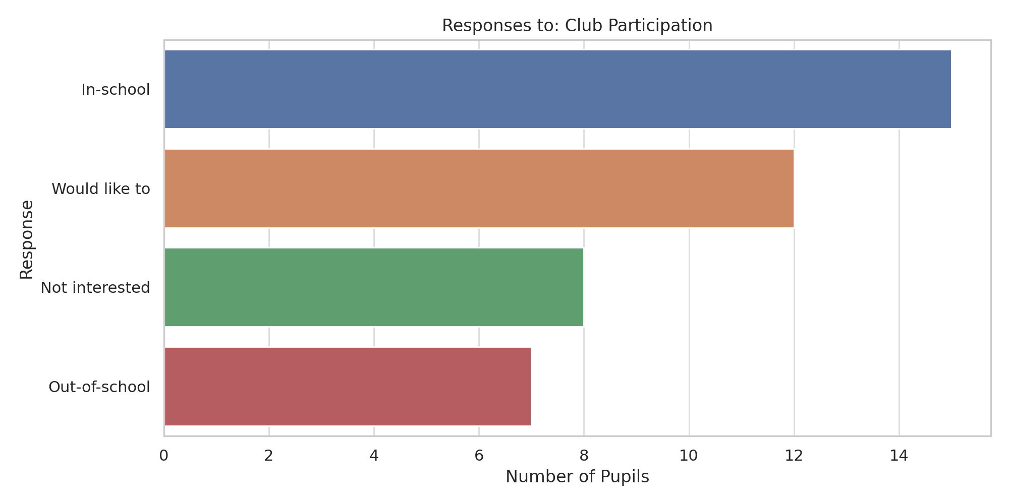

Feel Included
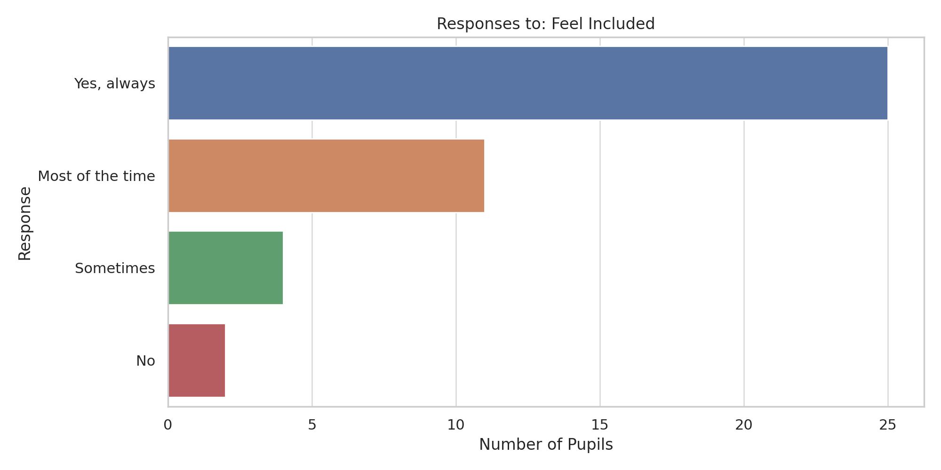

Wants to Lead
