

SAFEGUARDING AND CHILD PROTECTION POLICY

Approved by: Karen Bramwell | Date: 08.09.2025
Last reviewed on: 11.08.2025
Next review due by: 31.08.2026

Table of Contents
Updates and amendments made from the safeguarding and Child protection Policy 2024-25 4
Important contacts 5
1.Aims 7
2. Legislation and statutory guidance 7
3.Definitions 8
4.Equality Statement 9
5.Roles and Responsibilities 9
5.1 All Staff 10
5.2 The designated safeguarding lead (DSL) 10
5.3 The governing board 11
5.4 The Headteacher 12
5.5 Virtual School Heads 12
6. Confidentiality 12
7. Recognising abuse and responding to a disclosure 13
7.1 If a child is suffering or likely to suffer harm, or in immediate danger. 13
7.2 If a child makes a disclosure to you. 13
7.3 If you discover that FGM has taken place or a pupil is at risk of FGM 14
7.4 If you have concerns about a child (as opposed to believing a child is suffering or likely to suffer from harm, or is in immediate danger) 14
Early help assessment 15
Referral 15
7.5 If you have concerns about extremism 15
7.6 If you have a concern about mental health 16
7.7 Concerns about a staff member, supply teacher, volunteer, or contractor 18
7.8 Allegations of abuse made against other pupils 18
7.9 Sharing of nudes and semi-nudes (‘sexting’) 20
7.10 Reporting systems for our pupils 22
8.Online safety and the use of mobile technology 22
9. Notifying parents or carers 23
10. Pupils with special educational needs, disabilities, or health issues 24
10.1 Alternative Provision 24
11. Pupils with a social worker 25
12. Looked-after and previously looked-after children 25
13. Complaints and concerns about school safeguarding policies 25
13.1 Complaints against staff 25
13.2 Other complaints 25
13.3 Whistle-blowing 25
14 Record-keeping 25
15 Training 26
15.1 All staff 26
15.2 The DSL and deputy/deputies 27
15.3 Governors 27
15.4 Recruitment-interview panels 27
15.5 Staff who have contact with pupils and families 27
16. Monitoring arrangements 27
17. Links with other policies 27
Appendix 1: types of abuse 29
Appendix 2: safer recruitment and DBS checks – policy and procedures 30
Appendix 3: allegations of abuse made against staff 35
Appendix 4: Specific safeguarding issues 43
APPENDIX 5 Body Map Guidance 52
APPENDIX 6 Home incident or injury form 57
APPENDIX 7 – Information CP File/guidance 59
APPENDIX 8 Chronology of significant events guidance 61
APPENDIX 9: Transfer of safeguarding records guidance 62
APPENDIX 10 : Managing professional allegations flow chart 63
APPENDIX 11: Tracking form – allegation/concern raised against staff 64
APPENDIX 12 – Role of designated teacher 68
APPENDIX 13 Referral quick guide 69
Appendix 14 Encompass flow chart 70
Appendix 15 Child on Child Abuse Flowchart 71
Appendix 16 FGM Flow Chart 72
Appendix 17 Statement of Staff Commitment to the Forward As One Safeguarding & Child Protection Policy 73
Appendix 18 Criminal records self-declaration form 74

Updates and amendments made from the safeguarding and Child protection Policy 2024-25
Policy section | What’s changed? | Why?
Section 2 | Updated text ‘KCSIE 2024’ to ‘KCSIE 2025’ and associated live link. | To reflect publication of latest version of KCSIE 2024.
Section 2 | Changed document title and live link from ‘Governance Handbook’ to ‘Academy Trust Governance Guide’. | Governance Handbook was withdrawn on 07/03/24. This has been replaced with Academy Trust Governance Guide.
Section 2 | Addition of Rochdale safeguarding partnership website link. | Rochdale is now one of our safeguarding partnerships.
Section 5.5 | Addition of link to ‘promoting the education of children with a social worker and children in kinship care arrangements’ and reference to kinship care. | To reflect updates in KCSIE 2025 regarding the non-statutory role of the virtual school head for children in kinship care.
Section 8 | Updated to clarify misinformation, disinformation and conspiracy theories are safeguarding harms. | To reflect publication of latest version of KCSIE 2025.
Section 8 | Link added to the DfE’s ‘plan technology for your school’ service. | To reflect publication of latest version of KCSIE 2025 and so that schools can use to assess themselves against the filtering and monitoring standards and receive personalised recommendations on how to meet them.
Section 10.1 | Addition of alternative provision guidance for schools. | To reflect new statutory guidance regarding AP in KCSIE 2025.
Appendix 1 | Addition of link to Centre of Expertise on Child Sexual Abuse. | To reflect publication of latest version of KCSIE 2025.
Appendix 4 | Link added for ‘Working Together to Improve School Attendance’ and clarification that it is now statutory guidance. | To reflect update in KCSIE 2025.
Appendix 18 | Addition of appendix 18 – Self-declaration form. | Recommendation by Ofsted during a school inspection.

Important contacts
Role/organisation | Name | Contact details
Designated safeguarding lead (DSL) | Louise Bonter | info@stj.fa1.uk  0161 694 8096
Deputy DSL | Lindsay Rylands  Lucy Crossley | info@stj.fa1.uk  0161 694 8096
Local authority designated officer (LADO) | Collette Morris | 0161 770 8870  Colette.Morris@oldham.gov.uk
Chair of Governors | Janet Yarwood | info@stj.fa1.uk  0161 694 8096
Safeguarding Governor | Mike Power | info@stj.fa1.uk  0161 694 8096
Trust Safeguarding Lead | Lynsey Coleman | colemanl@sta.fa1.uk
Designated teacher for CLA | Elizabeth Earle | info@stj.fa1.uk  0161 694 8096
Mental Health Lead | Louise Bonter | info@stj.fa1.uk  0161 694 8096
Prevent Lead | Louise Bonter | info@stj.fa1.uk  0161 694 8096
Channel helpline |  | 020 7340 7264
Children’s Social Care/Integrated Front Door/MASH/EHASH... |  | 0161 770 7777  Option1, option 3

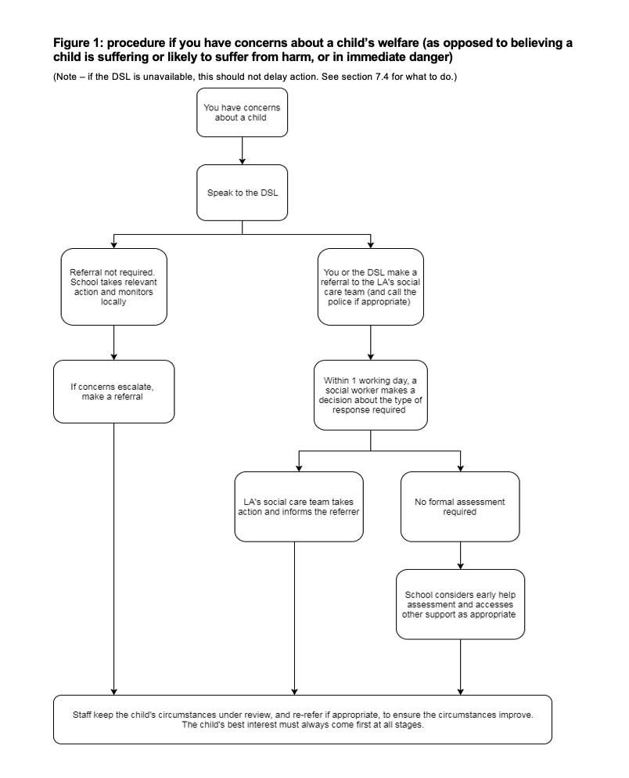

1.Aims
As a family of schools within Forward As One CE MAT we strive to ensure that all pupils remain safe and free from harm and we are committed to playing a full and active part in the Multi-Agency response to Child Protection concerns. We recognise that we are an important part of the wider safeguarding system for children and young people. The purpose of this document is to ensure that all our staff are aware of the arrangements that we have in place for safeguarding and promoting the welfare and safety of our students. It provides guidance to help staff who may have concerns about the safety or welfare of a child or young person and sets out our position in relation to all aspects of the Safeguarding and Child Protection process. It is important that:
- Appropriate action is taken in a timely manner to safeguard and promote children’s welfare
- All staff are aware of their statutory responsibilities with respect to safeguarding
- Staff are properly trained in recognising and reporting safeguarding issues

2. Legislation and statutory guidance
This policy is based on the Department for Education’s (DfE’s) statutory guidance Keeping Children Safe in Education (2025) and Working Together to Safeguard Children (2023), and the Academy Trust Governance Guide. We comply with this guidance and the arrangements agreed and published by the 3 local safeguarding partners as stated in KCSIE (see section 3).
This policy is also based on the following legislation:
- Part 3 of the schedule to the Education (Independent School Standards) Regulations 2014, which places a duty on academies and independent schools to safeguard and promote the welfare of pupils at the school
- The Children Act 1989 (and 2004 amendment), which provides a framework for the care and protection of children
- Section 5B(11) of the Female Genital Mutilation Act 2003, as inserted by section 74 of the Serious Crime Act 2015, which places a statutory duty on teachers to report to the police where they discover that female genital mutilation (FGM) appears to have been carried out on a girl under 18
- Statutory guidance on FGM, which sets out responsibilities with regards to safeguarding and supporting girls affected by FGM
- The Rehabilitation of Offenders Act 1974, which outlines when people with criminal convictions can work with children
- Schedule 4 of the Safeguarding Vulnerable Groups Act 2006, which defines what ‘regulated activity’ is in relation to children and the DfE’s factual note on Regulated Activity in Relation to Children: Scope, which describes work that a barred person must not do
- Statutory guidance on the Prevent duty, which explains schools’ duties under the Counter-Terrorism and Security Act 2015 with respect to protecting people from the risk of radicalisation and extremism
- The Human Rights Act 1998, which explains that being subjected to harassment, violence and/or abuse, including that of a sexual nature, may breach any or all of the rights which apply to individuals under the European Convention on Human Rights (ECHR)
- The Equality Act 2010, which makes it unlawful to discriminate against people regarding particular protected characteristics (including disability, sex, sexual orientation, gender reassignment and race). This means our governors and headteacher should carefully consider how they are supporting their pupils with regard to these characteristics. The Act allows our school to take positive action to deal with particular disadvantages affecting pupils (where we can show it is proportionate). This includes making reasonable adjustments for disabled pupils. For example, it could include taking positive action to support girls where there is evidence that they are being disproportionately subjected to sexual violence or harassment
- The Public Sector Equality Duty (PSED), which explains that we must have due regard to eliminating unlawful discrimination, harassment and victimisation. The PSED helps us to focus on key issues of concern and how to improve pupil outcomes. Some pupils may be more at risk of harm from issues such as sexual violence; homophobic, biphobic or transphobic bullying; or racial discrimination.
- The Childcare (Disqualification) and Childcare (Early Years Provision Free of Charge) (Extended Entitlement) (Amendment) Regulations 2018 (referred to in this policy as the “2018 Childcare Disqualification Regulations”) and Childcare Act 2006, which set out who is disqualified from working with children.
- This policy also meets requirements relating to safeguarding and welfare in the statutory framework for the Early Years Foundation Stage
This policy also complies with our funding agreement and articles of association.
Our 5 local safeguarding partners are:
Bolton https://www.boltonsafeguardingchildren.org.uk
Bury https://burysafeguardingpartnership.bury.gov.uk/
Lancashire https://www.safeguardingpartnership.org.uk
Oldham https://www.olscb.org/
Rochdale https://rochdalesafeguarding.com/rbsp
Tameside https://www.tameside.gov.uk/Tameside-Safeguarding-Children-Partnership

3.Definitions
Safeguarding and promoting the welfare of children means:
- Providing help and support to meet the needs of children as soon as problems emerge
- Protecting children from maltreatment, whether that is within or outside the home, including online
- Preventing impairment of children’s mental and physical health or development
- Ensuring that children grow up in circumstances consistent with the provision of safe and effective care
- Promoting the upbringing of children with their birth parents, or otherwise their family network through a kinship care arrangement, whenever possible and where this is in the best interests of the children
- Taking action to enable all children to have the best outcomes in line with the outcomes set out in the Children’s social Care National Framework.
Definition taken from Working Together to Safeguard Children (2023)
Child protection is part of this definition and refers to activities undertaken to prevent children suffering, or being likely to suffer, significant harm.
Abuse is a form of maltreatment of a child and may involve inflicting harm or failing to act to prevent harm. Appendix 1 explains the different types of abuse.
Neglect is a form of abuse and is the persistent failure to meet a child’s basic physical and/or psychological needs, likely to result in the serious impairment of the child’s health or development. Appendix 1 defines neglect in more detail.
Exploitation (CCE and CSE) Both CCE and CSE are forms of abuse that occur where an individual or group takes advantage of an imbalance in power to coerce, manipulate or deceive a child into taking part in criminal or sexual activity. It may involve an exchange for something the victim needs or wants, and/or for the financial advantage or increased status of the perpetrator or facilitator and/or through violence or the threat of violence.
Sharing of nudes and semi-nudes (also known as sexting or youth produced sexual imagery) is where children share nude or semi-nude images, videos, or live streams.
Early help is support for children of all ages that improves a family’s resilience and outcomes or reduces the chance of a problem getting worse.
Children includes everyone under the age of 18.
The following 3 safeguarding partners are identified in Keeping Children Safe in Education (and defined in the Children Act 2004, as amended by chapter 2 of the Children and Social Work Act 2017). They will plan to work together to safeguard and promote the welfare of local children, including identifying and responding to their needs:
- The local authority (LA)
- An Integrated Care Board for an area within the LA
- The chief officer of police for a police area in the LA area
The children Act 1989 and 2004, states a child is anyone who has not reached their 18th birthday. The commitment to safeguarding and promoting the welfare of children however will extend to all children and young people who visit Forward As One schools as well as our own pupils.

4.Equality Statement
Some children have an increased risk of abuse, both online and offline, and additional barriers can exist for some children with respect to recognising or disclosing it. We are committed to anti-discriminatory practice and recognise children’s diverse circumstances. We ensure that all children have the same protection, regardless of any barriers they may face.
We give special consideration to children who:
- Have special educational needs and/or disabilities (SEND) or health conditions (see section 10)
- Are young carers
- May experience discrimination due to their race, ethnicity, religion, gender identification or sexuality
- Have English as an additional language.
- Are known to be living in difficult situations – for example, temporary accommodation or where there are issues such as substance abuse or domestic abuse
- Are at risk of FGM, sexual exploitation, forced marriage, or radicalisation
- Are asylum seekers
- Are at risk due to either their own or a family member’s mental health needs
- Are looked after or previously looked after (see section 12)
- Are missing or absent from education for prolonged periods and/or repeat occasions
- Whose parent/carer has expressed an intention to remove them from school to be home educated

5.Roles and Responsibilities
Safeguarding and child protection is everyone’s responsibility. This policy applies to all staff, volunteers and governors in the school and is consistent with the procedures of the 3 safeguarding partners. Our policy and procedures also apply to extended school and off-site activities.
The school plays a crucial role in preventative education. This is in the context of a whole-school approach to preparing pupils for life in modern Britain, and a culture of zero tolerance of sexism, misogyny/misandry, homophobia, biphobia, transphobia, and sexual violence/harassment. This will be underpinned by our:
- Behaviour policy
- Pastoral support system
- Planned programme of relationships, sex and health education (RSHE), which is inclusive and delivered regularly, tackling issues such as:
  - Healthy and respectful relationships
  - Boundaries and consent
  - Stereotyping, prejudice, and equality
  - Body confidence and self-esteem
  - How to recognise an abusive relationship (including coercive and controlling behaviour)
  - The concepts of, and laws relating to, sexual consent, sexual exploitation, abuse, grooming, coercion, harassment, rape, domestic abuse, so-called honour-based violence such as forced marriage and FGM and how to access support.
  - What constitutes sexual harassment and sexual violence and why they are always unacceptable.

5.1 All Staff
All staff will:
- Read and understand part 1 and annex B of the Department for Education’s statutory safeguarding guidance, Keeping Children Safe in Education, and review this guidance at least annually
- Sign a declaration at the beginning of each academic year to say that they have reviewed the guidance
- Sign a declaration – Annual DBS
- Reinforce the importance of online safety when communicating with parents and carers. This includes making parents and carers aware of what we ask children to do online (e.g. sites they need to visit or who they will be interacting with online)
- Provide a safe space for pupils who are LGBTQ+ to speak out and share their concerns
All staff will be aware of:
- Our systems which support safeguarding, including this child protection and safeguarding policy, the staff code of conduct, the role and identity of the designated safeguarding lead (DSL) and deputies, online safety policy the behaviour policy, and the safeguarding response to children who go missing from education
- The early help assessment process (sometimes known as the common assessment framework) and their role in it, including identifying emerging problems, liaising with the DSL, and sharing information with other professionals to support early identification and assessment
- The process for making referrals to local authority children’s social care and for statutory assessments that may follow a referral, including the role they might be expected to play
- What to do if they identify a safeguarding issue or a child tells them they are being abused, neglected or exploited, including specific issues such as FGM, and how to maintain an appropriate level of confidentiality while liaising with relevant professionals
- The signs of different types of abuse, neglect and exploitation, as well as specific safeguarding issues, such as child-on-child abuse, child sexual exploitation (CSE), child criminal exploitation (CCE), indicators of being at risk from or involved with serious violent crime, FGM, radicalisation and serious violence (including that linked to county lines)
- The importance of reassuring victims that they are being taken seriously and that they will be supported and kept safe
- The fact that children can be at risk of harm inside and outside of their home, at school and online
- The fact that children who are (or who are perceived to be) lesbian, gay, bi or gender questioning (LGBTQ+) can be targeted by other children
- What to look for to identify children who need help or protection
Section 15 and appendix 4 of this policy outline in more detail how staff are supported to do this.

5.2 The designated safeguarding lead (DSL)
The DSL is a member of the senior leadership team. Our DSL is Miss Louise Bonter. The DSL takes lead responsibility for child protection and wider safeguarding in the school. This includes online safety and understanding our filtering and monitoring processes on school devices and school networks to keep pupils safe online.
During term time, the DSL will be available during school hours for staff to discuss any safeguarding concerns.
When the DSL is absent, the deputies– Mrs Lindsay Rylands and Mrs Lucy Crossley will act as cover.
If the DSL and deputies are not available, Miss Elizabeth Earle/ Miss L Coleman will act as cover (for example, during out-of-hours/out-of-term activities).
The DSL will be given the time, funding, training, resources, and support to:
- Provide advice and support to other staff on child welfare and child protection matters
- Take part in strategy discussions and inter-agency meetings and/or support other staff to do so
- Contribute to the assessment of children
- Refer suspected cases, as appropriate, to the relevant body (local authority children’s social care, Channel programme, Disclosure and Barring Service, and/or police), and support staff who make such referrals directly
- Have a good understanding of harmful sexual behaviour
- Have a good understanding of the filtering and monitoring systems and processes in place at our school
The DSL will also:
- Keep the headteacher informed of any issues
- Liaise with local authority case managers and designated officers for child protection concerns as appropriate
- Discuss the local response to sexual violence and sexual harassment with police and local authority children’s social care colleagues to prepare the school’s policies
- Be confident that they know what local specialist support is available to support all children involved (including victims and alleged perpetrators) in sexual violence and sexual harassment and be confident as to how to access this support
- Be aware that children must have an ‘appropriate adult’ to support and help them in the case of a police investigation or search
- Liaise with and seek advice from the Forward As One Trust Safeguarding lead as appropriate; this includes engagement with professional supervision
The full responsibilities of the DSL and deputies are set out in their job description.

5.3 The governing board
The governing board will:
- Facilitate a whole-school approach to safeguarding, ensuring that safeguarding and child protection are at the forefront of, and underpin, all relevant aspects of process and policy development
- Evaluate and approve this policy at each review, ensuring it complies with the law, and hold the headteacher to account for its implementation
- Be aware of its obligations under the Human Rights Act 1998, the Equality Act 2010 (including the Public Sector Equality Duty), and our school’s local multi-agency safeguarding arrangements
- Appoint a senior board level (or equivalent) lead to monitor the effectiveness of this policy in conjunction with the full governing board. This is always a different person from the DSL.
- Ensure all staff undergo safeguarding and child protection training, including online safety, and that such training is regularly updated and is in line with advice from the safeguarding partners
- Ensure that the school has appropriate filtering and monitoring systems in place and review their effectiveness. This includes:
  - Making sure that the leadership team and staff are aware of the provisions in place, and that they understand their expectations, roles and responsibilities around filtering and monitoring as part of safeguarding training
  - Reviewing the DfE’s filtering and monitoring standards, and discussing with IT staff and service providers what needs to be done to support the school in meeting these standards
- Make sure:
  - The DSL has the appropriate status and authority to carry out their job, including additional time, funding, training, resources and support
  - Online safety is a running and interrelated theme within the whole-school approach to safeguarding and related policies
  - The DSL has lead authority for safeguarding, including online safety and understanding the filtering and monitoring systems and processes in place
  - The school has procedures to manage any safeguarding concerns (no matter how small) or allegations that do not meet the harm threshold (low-level concerns) about staff members (including supply staff, volunteers, and contractors). Appendix 3 of this policy covers this procedure.
  - That this policy reflects that a child with SEND, or certain medical or physical health conditions, can face additional barriers to any abuse, neglect or exploitation being recognised
- Where another body is providing services or activities (regardless of whether the children who attend these services/activities are children on the school roll):
  - Seek assurance that the other body has appropriate safeguarding and child protection policies/procedures in place and inspect them if needed
  - Make sure there are arrangements for the body to liaise with the school about safeguarding arrangements, where appropriate
  - Make sure that safeguarding requirements are a condition of using the school premises, and that any agreement to use the premises would be terminated if the other body fails to comply
The chair of governors will act as the ‘case manager’ if an allegation of abuse is made against the headteacher, where appropriate (see appendix 3).
All governors will read Keeping Children Safe in Education in its entirety.
Section 15 of this policy has information on how governors are supported to fulfil their role.

5.4 The Headteacher
The headteacher is responsible for the implementation of this policy, including:
- Ensuring that staff (including temporary staff) and volunteers:
  - Are informed of our systems which support safeguarding, including this policy, as part of their induction
  - Understand and follow the procedures included in this policy, particularly those concerning referrals of cases of suspected abuse, neglect and exploitation
- Communicating this policy to parents/carers when their child joins the school and via the school website
- Ensuring that the DSL has appropriate time, funding, training, and resources, and that there is always adequate cover if the DSL is absent
- Acting as the ‘case manager’ in the event of an allegation of abuse made against another member of staff or volunteer, where appropriate (see appendix 3)
- Making decisions regarding all low-level concerns, though they may wish to collaborate with the DSL on this
- Ensuring the relevant staffing ratios are met, where applicable
- Making sure each child in the Early Years Foundation Stage is assigned a key person
- Overseeing the safe use of technology, mobile phones, and cameras in the setting

5.5 Virtual School Heads
Virtual school heads have a non-statutory responsibility for the strategic oversight of the educational attendance, attainment, and progress of pupils with a social worker and those in kinship care. See Promoting the education of children with a social worker for further guidance.
They should also identify and engage with key professionals, e.g. DSLs, special educational needs co-ordinators (SENCOs), social workers, mental health leads and others.

6. Confidentiality
All staff are aware of our systems that support safeguarding, and these are explained to them as part of staff induction and staff are provided with this policy along with the following:
- Part one of Keeping Children Safe in Education (2024) or a condensed part one where we think it is more appropriate for our staff not working directly with children
- The Staff Code of Conduct
- Online safety training and information
- The identity of the Designated Safeguarding Lead and any deputies

Please also refer to the Data Protection Policy and Cyber Security Policy.
These policies note that:
- Timely information sharing is essential to effective safeguarding
- Fears about sharing information must not be allowed to stand in the way of the need to promote the welfare, and protect the safety, of children
- The Data Protection Act (DPA) 2018 and UK GDPR do not prevent, or limit, the sharing of information for the purposes of keeping children safe
- If staff need to share ‘special category personal data’, the DPA 2018 contains ‘safeguarding of children and individuals at risk’ as a processing condition that allows practitioners to share information without consent if it is not possible to gain consent, it cannot be reasonably expected that a practitioner gains consent, or if to gain consent would place a child at risk
- Staff should never promise a child that they will not tell anyone about a report of abuse, as this may not be in the child’s best interests
- The government’s information sharing advice for safeguarding practitioners includes 7 ‘golden rules’ for sharing information, and will support staff who have to make decisions about sharing information
- If staff are in any doubt about sharing information, they should speak to the designated safeguarding lead (or deputy)
- Confidentiality is also addressed in this policy with respect to record-keeping in section 14, and allegations of abuse against staff in appendix 3

7. Recognising abuse and responding to a disclosure
Staff, volunteers, and governors must follow the procedures set out below in the event of a safeguarding issue.
Please note – in this and subsequent sections, you should take any references to the DSL to mean “the DSL (or deputy DSL)”.

7.1 If a child is suffering or likely to suffer harm, or in immediate danger.
Make a referral to children’s social care and/or the police immediately if you believe a child is suffering or likely to suffer from harm or is in immediate danger. Anyone can make a referral.
Tell the DSL (see section 5.2) as soon as possible if you make a referral directly.
https://www.gov.uk/report-child-abuse-to-local-council

7.2 If a child makes a disclosure to you.
If a child discloses a safeguarding issue to you, you should:
- Listen to and believe them. Allow them time to talk freely and do not ask leading questions
- Stay calm and do not show that you are shocked or upset
- Tell the child they have done the right thing in telling you. Do not tell them they should have told you sooner.
- Explain what will happen next and that you will have to pass this information on. Do not promise to keep it a secret.
- Write up and record your conversation as soon as possible in the child’s own words on CPOMS. Stick to the facts, and do not put your own judgement on it.
- Alert the DSL to the incident via CPOMS and also in person.
- Alternatively, if appropriate, make a referral to children’s social care and/or the police directly (see 7.1), and tell the DSL as soon as possible that you have done so. Aside from these people, do not disclose the information to anyone else unless told to do so by a relevant authority involved in the safeguarding process.
Bear in mind that some children may:
- Not feel ready or know how to tell someone that they are being abused, exploited or neglected
- Not recognise their experiences as harmful
- Feel embarrassed, humiliated, or threatened. This could be due to their vulnerability, disability, sexual orientation and/or language barriers.
None of this should stop you from having a ‘professional curiosity’ and speaking to the DSL if you have concerns about a child.

7.3 If you discover that FGM has taken place or a pupil is at risk of FGM
Keeping Children Safe in Education explains that FGM comprises “all procedures involving partial or total removal of the external female genitalia, or other injury to the female genital organs”.
FGM is illegal in the UK and a form of child abuse with long-lasting, harmful consequences. It is also known as ‘female genital cutting’, ‘circumcision’ or ‘initiation’.
Possible indicators that a pupil has already been subjected to FGM, and factors that suggest a pupil may be at risk, are set out in appendix 4 of this policy.
Any teacher who either:
- Is informed by a girl under 18 that an act of FGM has been carried out on her; or
- Observes physical signs which appear to show that an act of FGM has been carried out on a girl under 18 and they have no reason to believe that the act was necessary for the girl’s physical or mental health or for purposes connected with labour or birth
Must immediately report this to the police, personally. This is a mandatory statutory duty, and teachers will face disciplinary sanctions for failing to meet it.
Unless they have been specifically told not to disclose, they should also discuss the case with the DSL and involve children’s social care as appropriate.
Any other member of staff who discovers that an act of FGM appears to have been carried out on a pupil under 18 must speak to the DSL and follow our local safeguarding procedures.
The duty for teachers mentioned above does not apply in cases where a pupil is at risk of FGM or FGM is suspected but is not known to have been carried out. Staff should not examine pupils.
Any member of staff who suspects a pupil is at risk of FGM or suspects that FGM has been carried out should speak to the DSL and follow our local safeguarding procedures.

7.4 If you have concerns about a child (as opposed to believing a child is suffering or likely to suffer from harm, or is in immediate danger)
Figure 1 below, before section 7.7, illustrates the procedure to follow if you have any concerns about a child’s welfare.
Where possible, speak to the DSL first to agree a course of action.
If in exceptional circumstances the DSL is not available, this should not delay appropriate action being taken. Speak to a member of the senior leadership team/Trust Safeguarding lead and/or take advice from local authority children’s social care. You can also seek advice at any time from the NSPCC helpline on 0808 800 5000. Share details of any actions you take with the DSL as soon as practically possible.
Make a referral to local authority children’s social care directly, if appropriate (see ‘Referral’ below). Share any action taken with the DSL as soon as possible.

Early help assessment
If an early help assessment is appropriate, the DSL will generally lead on liaising with other agencies and setting up an inter-agency assessment as appropriate. Staff may be required to support other agencies and professionals in an early help assessment, in some cases acting as the lead practitioner.
We will discuss and agree, with statutory safeguarding partners, levels for the different types of assessment, as part of local arrangements.
The DSL will keep the case under constant review and the school will consider a referral to local authority children’s social care if the situation does not seem to be improving. Timelines of interventions will be monitored and reviewed.

Referral
If it is appropriate to refer the case to local authority children’s social care or the police, the DSL will make the referral or support you to do so.
If you make a referral directly (see section 7.1), you must tell the DSL as soon as possible.
The local authority will make a decision within 1 working day of a referral about what course of action to take and will let the person who made the referral know the outcome. The DSL or person who made the referral must follow up with the local authority if this information is not made available, and ensure outcomes are properly recorded.
If the child’s situation does not seem to be improving after the referral, the DSL or person who made the referral must follow local escalation procedures to ensure their concerns have been addressed and that the child’s situation improves.
This needs to be in writing and directed to the Service Manager at Oldham MASH. If you feel a child is at immediate risk of harm then please dial 999.
Oldham: https://www.olscb.org/professionals/policies/

7.5 If you have concerns about extremism
If a child is not suffering or likely to suffer from harm, or in immediate danger, where possible speak to the DSL first to agree a course of action.
If in exceptional circumstances the DSL is not available, this should not delay appropriate action being taken. Speak to a member of the senior leadership team, Trust Safeguarding Lead and/or seek advice from local authority children’s social care. Make a referral to local authority children’s social care directly, if appropriate (see ‘Referral’ above). Inform the DSL or deputy as soon as practically possible after the referral.
Where there is a concern, the DSL will consider the level of risk and decide which agency to make a referral to. This could include Channel, the government’s programme for identifying and supporting individuals at risk of being drawn into terrorism, or the local authority children’s social care team.
The DfE also has a dedicated telephone helpline, 020 7340 7264, which school staff and governors can call to raise concerns about extremism with respect to a pupil. You can also email counter.extremism@education.gov.uk. Note that this is not for use in emergency situations.
In an emergency, call 999 or the confidential anti-terrorist hotline on 0800 789 321 if you:
- Think someone is in immediate danger
- Think someone may be planning to travel to join an extremist group
- See or hear something that may be terrorist related

7.6 If you have a concern about mental health
Mental health problems can, in some cases, be an indicator that a child has suffered or is at risk of suffering abuse, neglect or exploitation.
Staff will be alert to behavioural signs that suggest a child may be experiencing a mental health problem or be at risk of developing one.
If you have a mental health concern about a child that is also a safeguarding concern, take immediate action by following the steps in section 7.4.
If you have a mental health concern that is not also a safeguarding concern, speak to the DSL to agree a course of action.
Refer to the Department for Education guidance on mental health and behaviour in schools for more information.

7.7 Concerns about a staff member, supply teacher, volunteer, or contractor
If you have concerns about a member of staff (including a supply teacher, volunteer, or contractor), or an allegation is made about a member of staff (including a supply teacher, volunteer, or contractor) posing a risk of harm to children, speak to the headteacher as soon as possible. If the concerns/allegations are about the headteacher, speak to the chair of governors.
The headteacher/chair of governors will then follow the procedures set out in appendix 3, if appropriate.
Where you believe there is a conflict of interest in reporting a concern or allegation about a member of staff (including a supply teacher, volunteer, or contractor) to the headteacher, report it directly to the local authority designated officer (LADO).
If you receive an allegation relating to an incident where an individual or organisation was using the school premises for running an activity for children, follow our school safeguarding policies and procedures, informing the LADO, as you would with any safeguarding allegation.
Where appropriate, the school will inform Ofsted of the allegation and actions taken, within the necessary timescale (see appendix 3 for more detail).

7.8 Allegations of abuse made against other pupils
We recognise that children can abuse their peers. Abuse will never be tolerated or passed off as “banter”, “just having a laugh” or “part of growing up”, as this can lead to a culture of unacceptable behaviours and an unsafe environment for pupils.
We also recognise the gendered nature of child-on-child abuse. However, all child-on-child abuse is unacceptable and will be taken seriously.
Most cases of pupils hurting other pupils will be dealt with under our school’s behaviour policy, but this child protection and safeguarding policy will apply to any allegations that raise safeguarding concerns. This might include where the alleged behaviour:
- Is serious, and potentially a criminal offence
- Could put pupils in the school at risk
- Is violent
- Involves pupils being forced to use drugs or alcohol
- Involves sexual exploitation, sexual abuse, or sexual harassment, such as indecent exposure, sexual assault, upskirting or sexually inappropriate pictures or videos (including the sharing of nudes and semi-nudes)
See appendix 4 for more information about child-on-child abuse
Procedures for dealing with allegations of child-on-child abuse
If a pupil makes an allegation of abuse against another pupil:
- You must record the allegation and tell the DSL, but do not investigate it
- The DSL will contact the local authority children’s social care team and follow its advice, as well as the police if the allegation involves a potential criminal offence
- The DSL will put a risk assessment and support plan into place for all children involved (including the victim(s), the child(ren) against whom the allegation has been made and any others affected) with a named person they can talk to if needed. This will include considering school transport as a potentially vulnerable place for a victim or alleged perpetrator(s)
- The DSL will contact the children and adolescent mental health services (CAMHS), if appropriate
If the incident is a criminal offence and there are delays in the criminal process, the DSL will work closely with the police (and other agencies as required) while protecting children and/or taking any disciplinary measures against the alleged perpetrator. We will ask the police if we have any questions about the investigation.
Creating a supportive environment in school and minimising the risk of child-on-child abuse
We recognise the importance of taking proactive action to minimise the risk of child-on-child abuse, and of creating a supportive environment where victims feel confident in reporting incidents.
To achieve this, we will:
- Challenge any form of derogatory or sexualised language or inappropriate behaviour between peers, including requesting or sending sexual images
- Be vigilant to issues that particularly affect different genders – for example, sexualised or aggressive touching or grabbing towards female pupils, and initiation or hazing type violence with respect to boys
- Ensure our curriculum helps to educate pupils about appropriate behaviour and consent
- Ensure pupils can easily and confidently report abuse using our reporting systems (as described in section 7.10 below)
- Ensure staff reassure victims that they are being taken seriously
- Be alert to reports of sexual violence and/or harassment that may point to environmental or systemic problems that could be addressed by updating policies, processes and the curriculum, or could reflect wider issues in the local area that should be shared with safeguarding partners
- Support children who have witnessed sexual violence, especially rape or assault by penetration. We will do all we can to make sure the victim, alleged perpetrator(s) and any witnesses are not bullied or harassed.
- Consider intra-familial harms and any necessary support for siblings following a report of sexual violence and/or harassment
- Ensure staff are trained to understand:
  - How to recognise the indicators and signs of child-on-child abuse, and know how to identify it and respond to reports
  - That even if there are no reports of child-on-child abuse in school, it does not mean it is not happening – staff should maintain an attitude of “it could happen here”
  - That if they have any concerns about a child’s welfare, they should act on them immediately rather than wait to be told, and that victims may not always make a direct report. For example:
    - Children can show signs or act in ways they hope adults will notice and react to
    - A friend may make a report
    - A member of staff may overhear a conversation
    - A child’s behaviour might indicate that something is wrong
  - That certain children may face additional barriers to telling someone because of their vulnerability, disability, gender, ethnicity and/or sexual orientation
  - That a pupil harming a peer could be a sign that the child is being abused themselves, and that this would fall under the scope of this policy
  - The important role they have to play in preventing child-on-child abuse and responding where they believe a child may be at risk from it
  - That they should speak to the DSL if they have any concerns
  - That social media is likely to play a role in the fall-out from any incident or alleged incident, including for potential contact between the victim, alleged perpetrator(s) and friends from either side
The DSL will take the lead role in any disciplining of the alleged perpetrator(s). We will provide support at the same time as taking any disciplinary action.
Disciplinary action can be taken while other investigations are going on, e.g., by the police. The fact that another body is investigating or has investigated an incident does not (in itself) prevent our school from coming to its own conclusion about what happened and imposing a penalty accordingly. We will consider these matters on a case-by-case basis, considering whether:
- Taking action would prejudice an investigation and/or subsequent prosecution – we will liaise with the police and/or local authority children’s social care to determine this
- There are circumstances that make it unreasonable or irrational for us to reach our own view about what happened while an independent investigation is ongoing

7.9 Sharing of nudes and semi-nudes (‘sexting’)
This is a suggested approach based on guidance from the UK Council for Internet Safety for all staff and for DSLs and senior leaders
This is defined as the sending or posting of nude or semi-nude images, videos or live streams online by young people under the age of 18. Nudes and semi-nudes can be shared online via social media, gaming platforms, chat apps, forums, or involve sharing between devices using offline services. The motivations for taking and sharing nude and semi-nudes are not always sexually or criminally motivated.
The DSL or equivalent should refer to the full 2024 guidance from the UK Council for Internet Safety (UKCIS), Sharing nudes and semi-nudes: advice for education settings working with children and young people, for managing incidents.
Producing and sharing nudes and semi-nudes of under 18s is illegal.
Although the production of such images will likely take place outside of education settings, sharing can take place and the impacts of an incident are often identified or reported here. Education settings need to be able to respond swiftly and confidently to make sure children and young people are safeguarded, supported, and educated.
Your responsibilities when responding to an incident:
If you are made aware of an incident involving the consensual or non-consensual sharing of nude or semi-nude images/videos/live streams (also known as ‘sexting’ or ‘youth produced sexual imagery’), you must report it to the DSL immediately.
You must not:
- View, copy, print, share, store or save the imagery yourself, or ask a pupil to share or download it (if you have already viewed the imagery by accident, you must report this to the DSL)
Note: In exceptional circumstances, it may be necessary for the DSL (or equivalent) only to view the image to safeguard the child or young person. That decision should be based on the professional judgement of the DSL (or equivalent).
If you have already viewed the imagery by accident (e.g. if a young person has showed it to you before you could ask them not to), report this to the DSL (or equivalent) and seek support.
- Delete the imagery or ask the pupil to delete it
- Ask the pupil(s) who are involved in the incident to disclose information regarding the imagery (this is the DSL’s responsibility)
- Share information about the incident with other members of staff, the pupil(s) it involves or their, or other, parents and/or carers.
- Say or do anything to blame or shame any young people involved.
You should explain that you need to report the incident and reassure the pupil(s) that they will receive support and help from the DSL.
Initial review meeting
Following a report of an incident, the DSL will hold an initial review meeting with appropriate school staff – this may include the staff member who reported the incident and the safeguarding or leadership team that deals with safeguarding concerns. This meeting will consider the initial evidence and aim to determine:
- Whether there is an immediate risk to pupil(s)
- If a referral needs to be made to the police and/or children’s social care
- If it is necessary to view the image(s) to safeguard the young person (in most cases, images or videos should not be viewed)
- What further information is required to decide on the best response
- Whether the image(s) has been shared widely and via what services and/or platforms (this may be unknown)
- Whether immediate action should be taken to delete or remove images or videos from devices or online services
- Any relevant facts about the pupils involved which would influence risk assessment
- If there is a need to contact another school, college, setting or individual
- Whether to contact parents or carers of the pupils involved (in most cases parents/carers should be involved)
The DSL will make an immediate referral to police and/or children’s social care if:
- The incident involves an adult
- There is reason to believe that a young person has been coerced, blackmailed, or groomed, or if there are concerns about their capacity to consent (for example, owing to SEN)
- What the DSL knows about the images or videos suggests the content depicts sexual acts which are unusual for the young person’s developmental stage, or are violent
- The imagery involves sexual acts and any pupil in the images or videos is under 13
- The DSL has reason to believe a pupil is at immediate risk of harm owing to the sharing of nudes and semi-nudes (for example, the young person is presenting as suicidal or self-harming)
If none of the above apply then the DSL, in consultation with the headteacher and other members of staff as appropriate, may decide to respond to the incident without involving the police or children’s social care. The decision will be made and recorded in line with the procedures set out in this policy.
Further review by the DSL
If at the initial review stage, a decision has been made not to refer to police and/or children’s social care, the DSL will conduct a further review to establish the facts and assess the risks.
They will hold interviews with the pupils involved (if appropriate).
If at any point in the process there is a concern that a pupil has been harmed or is at risk of harm, a referral will be made to children’s social care and/or the police immediately.
Informing parents/carers
The DSL will inform parents/carers at an early stage and keep them involved in the process, unless there is a good reason to believe that involving them would put the pupil at risk of harm.
Referring to the police
If it is necessary to refer an incident to the police, this will be done through dialing 101.
Recording incidents
All incidents of sharing of nudes and semi-nudes, and the decisions made in responding to them, will be recorded. The record-keeping arrangements set out in section 14 of this policy also apply to recording these incidents.
Curriculum coverage
Pupils are taught about the issues surrounding the sharing of nudes and semi-nudes as part of our PSHE and RSE curriculum, and computing programmes. Teaching covers the following in relation to the sharing of nudes and semi-nudes:
- What it is
- How it is most likely to be encountered
- The consequences of requesting, forwarding or providing such images, including when it is and is not abusive and when it may be deemed as online sexual harassment
- Issues of legality
- The risk of damage to people’s feelings and reputation
Pupils also learn the strategies and skills needed to manage:
- Specific requests or pressure to provide (or forward) such images
- The receipt of such images
This policy on the sharing of nudes and semi-nudes is also shared with pupils so they are aware of the processes the school will follow in the event of an incident.

7.10 Reporting systems for our pupils
Where there is a safeguarding concern, we will take the child’s wishes and feelings into account when determining what action to take and what services to provide.
We recognise the importance of ensuring pupils feel safe and comfortable to come forward and report any concerns and/or allegations.
To achieve this, we will:
- Put systems in place for pupils to confidently report abuse
- Ensure our reporting systems are well promoted, easily understood and easily accessible for pupils
- Make it clear to pupils that their concerns will be taken seriously, and that they can safely express their views and give feedback
- All staff receive regular, updated safeguarding training so pupils can report a concern to any member of staff. There is also a pastoral worker (Mrs C. Wood) to whom pupils can report or discuss any concerns with. Pupils are made aware of reporting systems through PSHE lessons, assemblies and displays in school.
- Staff are trained to treat children with respect, and ensure that children’s concerns will be taken seriously and reassured.
- All conversations will be logged on cpoms.

8.Online safety and the use of mobile technology
We recognise the importance of safeguarding children from potentially harmful and inappropriate online material, and we understand that technology is a significant component in many safeguarding and wellbeing issues.
To address this, our school aims to:
- Have robust processes (including filtering and monitoring systems) in place to ensure the online safety of pupils, staff, volunteers and governors
- Protect and educate the whole school community in its safe and responsible use of technology, including mobile and smart technology (which we refer to as ‘mobile phones’)
- Set clear guidelines for the use of mobile phones for the whole school community
- Establish clear mechanisms to identify, intervene in and escalate any incidents or concerns, where appropriate
The 4 key categories of risk
Our approach to online safety is based on addressing the following categories of risk:
- Content – being exposed to illegal, inappropriate or harmful content, such as pornography, fake news, racism, misogyny, self-harm, suicide, antisemitism, radicalisation, extremism, misinformation, disinformation 9including fake news) and conspiracy theories.
- Contact – being subjected to harmful online interaction with other users, such as peer-to-peer pressure, commercial advertising and adults posing as children or young adults with the intention to groom or exploit them for sexual, criminal, financial or other purposes.
- Conduct – personal online behaviour that increases the likelihood of, or causes, harm, such as making, sending and receiving explicit images (e.g., consensual and non-consensual sharing of nudes and semi-nudes and/or pornography), sharing other explicit images and online bullying; and
- Commerce – risks such as online gambling, inappropriate advertising, phishing and/or financial scams
To meet our aims and address the risks above, we will:
- Educate pupils about online safety as part of our curriculum. For example:
  - The safe use of social media, the internet and technology
  - Keeping personal information private
  - How to recognise unacceptable behaviour online
  - How to report any incidents of cyber-bullying, ensuring pupils are encouraged to do so, including where they are a witness rather than a victim
- Train staff, as part of their induction, on safe internet use and online safeguarding issues including cyber-bullying, the risks of online radicalisation, and the expectations, roles and responsibilities around filtering and monitoring. All staff members will receive refresher training as required and at least once each academic year.
- Educate parents/carers about online safety via our website, communications sent directly to them and during parents’ evenings. We will also share clear procedures with them, so they know how to raise concerns about online safety
- Make sure staff are aware of any restrictions placed on them with regards to the use of their mobile phone and cameras, for example that:
  - Staff are allowed to bring their personal phones to school for their own use, but will limit such use to non-contact time when pupils are not present.
  - Staff will not take pictures or recordings of pupils on their personal phones or cameras.
- Make all pupils, parents/carers, staff, volunteers and governors aware that they are expected to sign an agreement regarding the acceptable use of the internet in school, use of the school’s ICT systems and use of their mobile and smart technology.
- Explain the sanctions we will use if a pupil is in breach of our policies on the acceptable use of the internet and mobile phones.
- Make sure all staff, pupils and parents/carers are aware that staff have the power to search pupils’ phones, as set out in the DfE’s guidance on searching, screening and confiscation.
- Put in place robust filtering and monitoring systems to limit children’s exposure to the 4 key categories of risk (described above) from the school’s IT systems. [If you don’t have a separate online safety policy document that covers your filtering and monitoring procedures in detail, include them here. See our model online safety policy for a guide of what to cover.]
- Use the DfE’s plan technology for your school service to self-assess against the filtering and monitoring standards and receive personalised recommendations on how to meet them.
- Carry out an annual review of our approach to online safety, supported by an annual risk assessment that considers and reflects the risks faced by our school community.
- Provide regular safeguarding and children protection updates including online safety to all staff, at least annually, to continue to provide them with the relevant skills and knowledge to safeguard effectively.
- Review the child protection and safeguarding policy, including online safety, annually and ensure the procedures and implementation are updated and reviewed regularly.
This section summarises our approach to online safety and mobile phone use. For full details about our school’s policies in these areas, please refer to our online safety policy and mobile phone policies which can be found on our website.

9. Notifying parents or carers
Where appropriate, we will discuss any concerns about a child with the child’s parents or carers. The DSL will normally do this in the event of a suspicion or disclosure.
Other staff will only talk to parents or carers about any such concerns following consultation with the DSL.
If we believe that notifying the parents or carers would increase the risk to the child, we will discuss this with the local authority children’s social care team before doing so.
In the case of allegations of abuse made against other children, we will normally notify the parents or carers of all the children involved. We will think carefully about what information we provide about the other child involved, and when. We will work with the police and/or local authority children’s social care to make sure our approach to information sharing is consistent.
The DSL will, along with any relevant agencies (this will be decided on a case-by-case basis):
- Meet with the victim’s parents or carers, with the victim, to discuss what’s being put in place to safeguard them, and understand their wishes in terms of what support they may need and how the report will be progressed.
- Meet with the alleged perpetrator’s parents or carers to discuss support for them, and what’s being put in place that will impact them, e.g. moving them out of classes with the victim, and the reason(s) behind any decision(s)

10. Pupils with special educational needs, disabilities, or health issues
We recognise that pupils with SEND, or certain health conditions can face additional safeguarding challenges, and are three times more likely to be abused than their peers. Additional barriers can exist when recognising abuse and neglect in this group, including:
- Assumptions that indicators of possible abuse such as behaviour, mood and injury relate to the child’s condition without further exploration.
- Pupils being more prone to peer group isolation or bullying (including prejudice-based bullying) than other pupils.
- The potential for pupils with SEN, disabilities or certain health conditions being disproportionally impacted by behaviours such as bullying, without outwardly showing any signs.
- Communication barriers and difficulties in managing or reporting these challenges.
We offer extra pastoral support for these pupils. This includes:
- Working with the pastoral lead (reflection, calming strategies etc) mindfulness, lego therapy, working with external agencies, referral to school councillor.
Any abuse involving pupils with SEND will require close liaison with the DSL (or deputy) and the SENCO.

10.1 Alternative Provision
Where a school places a pupil with an alternative provision provider, it continues to be responsible for the safeguarding of that pupil and should be satisfied that the placement meets the pupil’s needs.
The cohort of pupils in Alternative Provision often have complex needs, it is important that governing bodies and proprietors of these settings are aware of the additional risk of harm that their pupils may be vulnerable to.
Schools should obtain written information from the alternative provider that appropriate safeguarding checks have been carried out on individuals working at their establishment (i.e. those checks that schools would otherwise perform on their own staff). This includes written confirmation that the alternative provider will inform the commissioning school of any arrangements that may put the child at risk (i.e. staff changes), so that the commissioning school can ensure itself that appropriate safeguarding checks have been carried out on new staff.
Schools should always know where a child is based during school hours. This includes having records of the address of the alternative provider and any subcontracted provision or satellite sites the child may attend.
They should regularly review the alternative provision placements they make. Reviews should be frequent enough (at least half termly) to provide assurance that the child is regularly attending and the placement continues to be safe and meets the child’s needs.
Where safeguarding concerns arise, the placement should be immediately reviewed, and terminated, if necessary, unless or until those concerns have been satisfactorily addressed.

11. Pupils with a social worker
Pupils may need a social worker due to safeguarding or welfare needs. We recognise that a child’s experiences of adversity and trauma can leave them vulnerable to further harm as well as potentially creating barriers to attendance, learning, behaviour, and mental health.
The DSL and all members of staff will work with and support social workers to help protect vulnerable children.
Where we are aware that a pupil has a social worker, the DSL will always consider this fact to ensure any decisions are made in the best interests of the pupil’s safety, welfare, and educational outcomes. For example, it will inform decisions about:
- Responding to unauthorised absence or missing education where there are known safeguarding risks.
- The provision of pastoral and/or academic support.

12. Looked-after and previously looked-after children
We will ensure that staff have the skills, knowledge and understanding to keep looked-after children and previously looked-after children safe. In particular, we will ensure that:
- Appropriate staff have relevant information about children’s looked after legal status, contact arrangements with birth parents or those with parental responsibility, and care arrangements
- The DSL has details of children’s social workers and relevant virtual school heads.
We have appointed a designated teacher, Miss Elizabeth Earle, who is responsible for promoting the educational achievement of looked-after children and previously looked-after children in line with statutory guidance.
The designated teacher is appropriately trained and has the relevant qualifications and experience to perform the role.
As part of their role, the designated teacher will:
- Work closely with the DSL to ensure that any safeguarding concerns regarding looked-after and previously looked-after children are quickly and effectively responded to
- Work with virtual school heads to promote the educational achievement of looked-after and previously looked-after children, including discussing how pupil premium plus funding can be best used to support looked-after children and meet the needs identified in their personal education plans.

13. Complaints and concerns about school safeguarding policies

13.1 Complaints against staff
Complaints against staff that are likely to require a child protection investigation will be handled in accordance with our procedures for dealing with allegations of abuse made against staff (see appendix 3).

13.2 Other complaints
Please refer to the Complaints Policy on how we handle safeguarding-related complaints relating to pupils or premises and the welfare section of the statutory framework for the Early Years Foundation Stage. This can be found on the school website.

13.3 Whistle-blowing
A separate Whistle-blowing policy that covers concerns regarding the way school the school/trust safeguards pupils including poor or unsafe practice, or potential failures can be found on the school website.

14 Record-keeping
We will hold records in line with our records retention schedule.
All safeguarding concerns, discussions, decisions made and the reasons for those decisions, must be recorded in writing. If you are in any doubt about whether to record something, discuss it with the DSL.
Records will include:
- A clear and comprehensive summary of the concern
- Details of how the concern was followed up and resolved
- A note of any action taken, decisions reached and the outcome
Concerns and referrals will be logged in the child’s record on CPOMS.
Any non-confidential records will be readily accessible and available. Confidential information and records will be held securely and only available to those who have a right or professional need to see them.
Safeguarding records relating to individual children will be retained for a reasonable period after they have left the school.
If a child for whom the school has, or has had, safeguarding concerns moves to another school, the DSL will ensure that their child protection file is forwarded as soon as possible, securely, and separately from the main pupil file.
To allow the new school/college to have support in place when the child arrives, this should be within:
- 5 days for an in-year transfer, or within
- The first 5 days of the start of a new term
In addition, if the concerns are significant or complex, and/or social services are involved, the DSL will speak to the DSL of the receiving school and provide information to enable them to have time to make any necessary preparations to ensure the safety of the child.
Records may be paper based or electronic. Records that are paper based are kept in a secure storage space accessible only to the Headteacher / designated staff. Electronic records are held on the school’s MIS system – Arbor. These records are accessible only by designated staff and are password protected and 2 factor-authentication is required. Please refer to the school’s record retention policy which is available upon request.
- Appendix 2 sets out our policy on record-keeping specifically with respect to recruitment and pre-appointment checks.
- Appendix 3 sets out our policy on record-keeping with respect to allegations of abuse made against staff.

15 Training

15.1 All staff
All staff members will undertake safeguarding and child protection training at induction, including on whistle-blowing procedures and online safety, to ensure they understand the school’s safeguarding systems and their responsibilities, and can identify signs of possible abuse, neglect or exploitation.
This training will be regularly updated and will:
- Be integrated, aligned, and considered as part of the whole-school safeguarding approach and wider staff training, and curriculum planning.
- Be in line with advice from the 3 safeguarding partners.
- Include online safety, including an understanding of the expectations, roles, and responsibilities for staff around filtering and monitoring.
- Have regard to the Teachers’ Standards to support the expectation that all teachers:
  - Manage behaviour effectively to ensure a good and safe environment.
  - Have a clear understanding of the needs of all pupils.
All staff will have training on the government’s anti-radicalisation strategy, Prevent, to enable them to identify children at risk of being drawn into terrorism and to challenge extremist ideas.
Staff will also receive regular safeguarding and child protection updates, including on online safety, as required but at least annually (for example, through emails, e-bulletins, and staff meetings).
Contractors who are provided through a private finance initiative (PFI) or similar contract will also receive safeguarding training.
Volunteers will receive appropriate training, if applicable.

15.2 The DSL and deputy/deputies
The DSL and deputy/deputies will undertake child protection and safeguarding training at least every 2 years.
In addition, they will update their knowledge and skills at regular intervals and at least annually (for example, through e-bulletins, meeting other DSLs, individual or group supervision, or taking time to read and digest safeguarding developments).
They will also undertake Prevent awareness training.

15.3 Governors
All governors receive training about safeguarding and child protection (including online safety) at induction, which is regularly updated. This is to make sure that they:
- Have the knowledge and information needed to perform their functions and understand their responsibilities, such as providing strategic challenge.
- Can be assured that safeguarding policies and procedures are effective and support the school to deliver a robust whole-school approach to safeguarding.
As the chair of governors may be required to act as the ‘case manager’ if an allegation of abuse is made against the headteacher, they receive training in managing allegations for this purpose.

15.4 Recruitment-interview panels
At least one person conducting any interview for any post at the school will have undertaken safer recruitment training. This will cover, as a minimum, the contents of Keeping Children Safe in Education, and will be in line with local safeguarding procedures.
See appendix 2 of this policy for more information about our safer recruitment procedures.

15.5 Staff who have contact with pupils and families
All staff who have contact with children and families will have supervisions which will provide them with support, coaching and training, promote the interests of children and allow for confidential discussions of sensitive issues.

16. Monitoring arrangements
This policy will be reviewed annually by Lynsey Coleman, Trust Safeguarding Lead. At every review , it will be approved by Trustees.

17. Links with other policies
This policy links to the following policies and procedures:
- Behaviour
- Staff code of conduct
- Complaints
- Health and safety
- Attendance
- Online safety
- Mobile phone use
- Equality
- Relationships and sex education
- First aid
- Curriculum
- Designated teacher for looked-after and previously looked-after children
- Privacy notices
- Anti-bullying
- Whistle-blowing
- Online safety
- Remote learning
- Acceptable use policy
- Social media
- Retention and storage of records
- SEN policy
- Intimate care
- Safer recruitment
- Visitor policy

These appendices are based on the Department for Education’s statutory guidance, Keeping Children Safe in Education.

Appendix 1: types of abuse
Abuse, including neglect, and safeguarding issues are rarely standalone events that can be covered by one definition or label. In most cases, multiple issues will overlap.
Physical abuse may involve hitting, shaking, throwing, poisoning, burning or scalding, drowning, suffocating or otherwise causing physical harm to a child. Physical harm may also be caused when a parent or carer fabricates the symptoms of, or deliberately induces, illness in a child.
Emotional abuse is the persistent emotional maltreatment of a child such as to cause severe and adverse effects on the child’s emotional development. Some level of emotional abuse is involved in all types of maltreatment of a child, although it may occur alone.
Emotional abuse may involve:
- Conveying to a child that they are worthless or unloved, inadequate, or valued only insofar as they meet the needs of another person.
- Not giving the child opportunities to express their views, deliberately silencing them or ‘making fun’ of what they say or how they communicate.
- Age or developmentally inappropriate expectations being imposed on children. These may include interactions that are beyond a child’s developmental capability, as well as overprotection and limitation of exploration and learning, or preventing the child participating in normal social interaction.
- Seeing or hearing the ill-treatment of another
- Serious bullying (including cyber-bullying), causing children frequently to feel frightened or in danger, or the exploitation or corruption of children.
Sexual abuse involves forcing or enticing a child or young person to take part in sexual activities, not necessarily involving a high level of violence, whether the child is aware of what is happening. The activities may involve:
- Physical contact, including assault by penetration (for example, rape or oral sex) or non-penetrative acts such as masturbation, kissing, rubbing and touching outside of clothing.
- Non-contact activities, such as involving children in looking at, or in the production of, sexual images, watching sexual activities, encouraging children to behave in sexually inappropriate ways, or grooming a child in preparation for abuse (including via the internet)
Sexual abuse is not solely perpetrated by adult males. Women can also commit acts of sexual abuse, as can other children. Centre of Expertise on Child Sexual Abuse has many resources to support education settings.
Neglect is the persistent failure to meet a child’s basic physical and/or psychological needs, likely to result in the serious impairment of the child’s health or development. Neglect may occur during pregnancy as a result of maternal substance abuse.
Once a child is born, neglect may involve a parent or carer failing to:
- Provide adequate food, clothing and shelter (including exclusion from home or abandonment)
- Protect a child from physical and emotional harm or danger
- Ensure adequate supervision (including the use of inadequate care-givers)
- Ensure access to appropriate medical care or treatment
It may also include neglect of, or unresponsiveness to, a child’s basic emotional needs.

Appendix 2: safer recruitment and DBS checks – policy and procedures
Recruitment and selection process
To make sure we recruit suitable people, we will ensure that those involved in the recruitment and employment of staff to work with children have received appropriate safer recruitment training.
We have put the following steps in place during our recruitment and selection process to ensure we are committed to safeguarding and promoting the welfare of children.
Advertising
When advertising roles, we will make clear:
- Our school’s commitment to safeguarding and promoting the welfare of children
- That safeguarding checks will be undertaken
- The safeguarding requirements and responsibilities of the role, such as the extent to which the role will involve contact with children
- Whether or not the role is exempt from the Rehabilitation of Offenders Act 1974 and the amendments to the Exceptions Order 1975, 2013 and 2020. If the role is exempt, certain spent convictions and cautions are ‘protected’, so they do not need to be disclosed, and if they are disclosed, we cannot take them into account.
Application forms
Our application forms will:
- Include a statement saying that it is an offence to apply for the role if an applicant is barred from engaging in regulated activity relevant to children (where the role involves this type of regulated activity)
- Include a copy of, or link to, our child protection and safeguarding policy and our policy on the employment of ex-offenders
Shortlisting
Our shortlisting process will involve at least two people and will:
- Consider any inconsistencies and look for gaps in employment and reasons given for them
- Explore all potential concerns
Once we have shortlisted candidates, we will ask shortlisted candidates to:
- Complete a self-declaration of their criminal record or any information that would make them unsuitable to work with children, so that they can share relevant information and discuss it at interview stage. The information we will ask for includes:
  - If they have a criminal history
  - Whether they are included on the barred list
  - Whether they are prohibited from teaching
  - Information about any criminal offences committed in any country in line with the law as applicable in England and Wales
  - Any relevant overseas information
- Sign a declaration confirming the information they have provided is true.
We will also consider carrying out an online search on shortlisted candidates to help identify any incidents or issues that are publicly available online. Shortlisted candidates will be informed that we may carry out these checks as part of our due diligence process.
Seeking references and checking employment history
We will obtain references before interview. Any concerns raised will be explored further with referees and taken up with the candidate at interview.
When seeking references, we will:
- Not accept open references
- Liaise directly with referees and verify any information contained within references with the referees
- Ensure any references are from the candidate’s current employer and completed by a senior person. Where the referee is school based, we will ask for the reference to be confirmed by the headteacher/principal as accurate in respect to disciplinary investigations
- Obtain verification of the candidate’s most recent relevant period of employment if they are not currently employed
- Secure a reference from the relevant employer from the last time the candidate worked with children if they are not currently working with children
- Compare the information on the application form with that in the reference and take up any inconsistencies with the candidate
- Resolve any concerns before any appointment is confirmed.
Interview and selection
When interviewing candidates, we will:
- Probe any gaps in employment, or where the candidate has changed employment or location frequently and ask candidates to explain this
- Explore any potential areas of concern to determine the candidate’s suitability to work with children
- Record all information considered and decisions made
Pre-appointment vetting checks
We will record all information on the checks carried out in the school’s single central record (SCR). Copies of these checks, where appropriate, will be held in individuals’ personnel files. We follow requirements and best practice in retaining copies of these checks, as set out below.
New staff
All offers of appointment will be conditional until satisfactory completion of the necessary pre-employment checks. When appointing new staff, we will:
- Verify their identity
- Obtain (via the applicant) an enhanced DBS certificate, including barred list information for those who will be engaging in regulated activity (see definition below). We will obtain the certificate before, or as soon as practicable after, appointment, including when using the DBS update service. We will not keep a copy of the certificate for longer than 6 months, but when the copy is destroyed, we may still keep a record of the fact that vetting took place, the result of the check and recruitment decision taken.
- Obtain a separate barred list check if they will start work in regulated activity before the DBS certificate is available
- Verify their mental and physical fitness to carry out their work responsibilities
- Verify their right to work in the UK. We will keep a copy of this verification for the duration of the member of staff’s employment and for two years afterwards.
- Verify their professional qualifications, as appropriate
- Ensure they are not subject to a prohibition order if they are employed to be a teacher
- Carry out further additional checks, as appropriate, on candidates who have lived or worked outside of the UK
These could include, where available:
  - For all staff, including teaching positions: criminal records checks for overseas applicants
  - For teaching positions: obtaining a letter from the professional regulating authority in the country where the applicant has worked, confirming that they have not imposed any sanctions or restrictions on that person, and/or are aware of any reason why that person may be unsuitable to teach.
- Check those candidates taking up a management position* are not subject to a prohibition from management (section 128) direction made by the secretary of state.
* Management positions are most likely to include, but are not limited to, headteachers, principals and deputy/assistant headteachers.
We will ensure that appropriate checks are carried out to ensure that individuals are not disqualified under the 2018 Childcare Disqualification Regulations and Childcare Act 2006. Where we take a decision that an individual falls outside of the scope of these regulations and we do not carry out such checks, we will retain a record of our assessment on the individual’s personnel file. This will include our evaluation of any risks and control measures put in place, and any advice sought.
Regulated activity means a person who will be:
- Responsible, on a regular basis in a school or college, for teaching, training, instructing, caring for or supervising children; or
- Carrying out paid, or unsupervised unpaid, work regularly in a school or college where that work provides an opportunity for contact with children; or
- Engaging in intimate or personal care or overnight activity, even if this happens only once and regardless of whether they are supervised or not.
Existing staff
In certain circumstances we will carry out all the relevant checks on existing staff as if the individual was a new member of staff. These circumstances are when:
- There are concerns about an existing member of staff’s suitability to work with children; or
- An individual moves from a post that is not regulated activity to one that is; or
- There has been a break in service of 12 weeks or more.
We will refer to the DBS anyone who has harmed, or poses a risk of harm, to a child or vulnerable adult where:
- We believe the individual has engaged in relevant conduct; or
- We believe the individual has received a caution or conviction for a relevant (automatic barring either with or without the right to make representations) offence, under the Safeguarding Vulnerable Groups Act 2006 (Prescribed Criteria and Miscellaneous Provisions) Regulations 2009; or
- We believe the ‘harm test’ is satisfied in respect of the individual (i.e. they may harm a child or vulnerable adult or put them at risk of harm); and
- The individual has been removed from working in regulated activity (paid or unpaid) or would have been removed if they had not left.
Agency and third-party staff
We will obtain written notification from any agency or third-party organisation that it has carried out the necessary safer recruitment checks that we would otherwise perform. We will also check that the person presenting themselves for work is the same person on whom the checks have been made.
Contractors
We will ensure that any contractor, or any employee of the contractor, who is to work at the school has had the appropriate level of DBS check (this includes contractors who are provided through a PFI or similar contract). This will be:
- An enhanced DBS check with barred list information for contractors engaging in regulated activity.
- An enhanced DBS check, not including barred list information, for all other contractors who are not in regulated activity but whose work provides them with an opportunity for regular contact with children.
We will obtain the DBS check for self-employed contractors.
We will not keep copies of such checks for longer than 6 months.
Contractors who have not had any checks will not be allowed to work unsupervised or engage in regulated activity under any circumstances.
We will check the identity of all contractors and their staff on arrival at the school.
For self-employed contractors such as music teachers or sports coaches, we will ensure that appropriate checks are carried out to ensure that individuals are not disqualified under the 2018 Childcare Disqualification Regulations and Childcare Act 2006. Where we decide that an individual falls outside of the scope of these regulations and we do not carry out such checks, we will retain a record of our assessment. This will include our evaluation of any risks and control measures put in place, and any advice sought.
Trainee/student teachers
Where applicants for initial teacher training are salaried by us, we will ensure that all necessary checks are carried out.
Where trainee teachers are fee-funded, we will obtain written confirmation from the training provider that necessary checks have been carried out and that the trainee has been judged by the provider to be suitable to work with children.
In both cases, this includes checks to ensure that individuals are not disqualified under the 2018 Childcare Disqualification Regulations and Childcare Act 2006.
Volunteers
We will:
- Never leave an unchecked volunteer unsupervised or allow them to work in regulated activity
- Obtain an enhanced DBS check with barred list information for all volunteers who are new to working in regulated activity
- Carry out a risk assessment when deciding whether to seek an enhanced DBS check without barred list information for any volunteers not engaging in regulated activity. We will retain a record of this risk assessment.
- Ensure that appropriate checks are carried out to ensure that individuals are not disqualified under the 2018 Childcare Disqualification Regulations and Childcare Act 2006. Where we decide that an individual falls outside of the scope of these regulations and we do not carry out such checks, we will retain a record of our assessment. This will include our evaluation of any risks and control measures put in place, and any advice sought.
Governors and Members
All governors will have an enhanced DBS check without barred list information.
They will have an enhanced DBS check with barred list information if working in regulated activity.
The chair of the board will have their DBS check countersigned by the secretary of state.
All proprietors, trustees, local governors and members will also have the following checks:
- A section 128 check (to check prohibition on participation in management under section 128 of the Education and Skills Act 2008)
- Identity
- Right to work in the UK
- Other checks deemed necessary if they have lived or worked outside the UK
Staff working in alternative provision settings
Where we place a pupil with an alternative provision provider, we continue to be responsible for the safeguarding of that pupil and should be satisfied that the placement meets the pupil’s needs (see section 10.1).
Adults who supervise pupils on work experience
When organising work experience, we will ensure that policies and procedures are in place to protect children from harm.
We will also consider whether it is necessary for barred list checks to be carried out on the individuals who supervise a pupil under 16 on work experience. This will depend on the specific circumstances of the work experience, including the nature of the supervision, the frequency of the activity being supervised, and whether the work is regulated activity.
Pupils staying with host families.
Where the school makes arrangements for pupils to be provided with care and accommodation by a host family to which they are not related (for example, during a foreign exchange visit), we will request enhanced DBS checks with barred list information on those people.
Where the school is organising such hosting arrangements overseas and host families cannot be checked in the same way, we will work with our partner schools abroad to ensure that similar assurances are undertaken prior to the visit.

Appendix 3: allegations of abuse made against staff
Section 1: allegations that may meet the harms threshold
This section applies to all cases in which it is alleged that a current member of staff, including a supply teacher, volunteer or contractor, has:
- Behaved in a way that has harmed a child, or may have harmed a child, and/or
- Possibly committed a criminal offence against or related to a child, and/or
- Behaved towards a child or children in a way that indicates they may pose a risk of harm to children, and/or
- Behaved or may have behaved in a way that indicates they may not be suitable to work with children – this includes behaviour taking place both inside and outside of school
If we are in any doubt as to whether a concern meets the harm threshold, we will consult our local authority designated officer (LADO).
We will deal with any allegation of abuse quickly, in a fair and consistent way that provides effective child protection while also supporting the individual who is the subject of the allegation.
A ‘case manager’ will lead any investigation. This will be the headteacher, or the chair of governors where the headteacher is the subject of the allegation. The case manager will be identified at the earliest opportunity.
Our procedures for dealing with allegations will be applied with common sense and judgement.
If we receive an allegation of an incident happening while an individual or organisation was using the school premises to run activities for children, we will follow our safeguarding policies and procedures and inform our LADO.
Suspension of the accused until the case is resolved
Suspension of the accused will not be the default position and will only be considered in cases where there is reason to suspect that a child or other children is/are at risk of harm, or the case is so serious that there might be grounds for dismissal. In such cases, we will only suspend an individual if we have considered all other options available and there is no reasonable alternative.
Based on an assessment of risk, we will consider alternatives such as:
- Redeployment within the school so that the individual does not have direct contact with the child or children concerned.
- Providing an assistant to be present when the individual has contact with children.
- Redeploying the individual to alternative work in the school so that they do not have unsupervised access to children.
- Moving the child or children to classes where they will not meet the individual, making it clear that this is not a punishment and parents/carers have been consulted.
- Temporarily redeploying the individual to another role in a different location, for example to an alternative school or other work for the Trust.
If in doubt, the case manager will seek views from the school’s personnel adviser and the designated officer at the local authority, as well as the police and children’s social care where they have been involved.
Definitions for outcomes of allegation investigations
- Substantiated: there is sufficient evidence to prove the allegation
- Malicious: there is sufficient evidence to disprove the allegation and there has been a deliberate act to deceive, or to cause harm to the subject of the allegation
- False: there is sufficient evidence to disprove the allegation
- Unsubstantiated: there is insufficient evidence to either prove or disprove the allegation (this does not imply guilt or innocence)
- Unfounded: to reflect cases where there is no evidence or proper basis which supports the allegation being made
Procedure for dealing with allegations
In the event of an allegation that meets the criteria above, the case manager will take the following steps:
- Conduct basic enquiries in line with local procedures to establish the facts to help determine whether there is any foundation to the allegation before carrying on with the steps below
- Discuss the allegation with the designated officer at the local authority. This is to consider the nature, content and context of the allegation and agree a course of action, including whether further enquiries are necessary to enable a decision on how to proceed, and whether it is necessary to involve the police and/or children’s social care services. (The case manager may, on occasion, consider it necessary to involve the police before consulting the designated officer – for example, if the accused individual is deemed to be an immediate risk to children or there is evidence of a possible criminal offence. In such cases, the case manager will notify the designated officer as soon as practicably possible after contacting the police)
- Inform the accused individual of the concerns or allegations and likely course of action as soon as possible after speaking to the designated officer (and the police or children’s social care services, where necessary). Where the police and/or children’s social care services are involved, the case manager will only share such information with the individual as has been agreed with those agencies
- Where appropriate (in the circumstances described above), carefully consider whether suspension of the individual from contact with children at the school is justified or whether alternative arrangements such as those outlined above can be put in place. Advice will be sought from the designated officer, police and/or children’s social care services, as appropriate
- Where the case manager is concerned about the welfare of other children in the community or the individual’s family, they will discuss these concerns with the DSL and make a risk assessment of the situation. If necessary, the DSL may make a referral to children’s social care
- If immediate suspension is considered necessary, agree and record the rationale for this with the designated officer. The record will include information about the alternatives to suspension that have been considered, and why they were rejected. Written confirmation of the suspension will be provided to the individual facing the allegation or concern within 1 working day, and the individual will be given a named contact at the school and their contact details
- If it is decided that no further action is to be taken in regard to the subject of the allegation or concern, record this decision and the justification for it and agree with the designated officer what information should be put in writing to the individual and by whom, as well as what action should follow both in respect of the individual and those who made the initial allegation
- If it is decided that further action is needed, take steps as agreed with the designated officer to initiate the appropriate action in school and/or liaise with the police and/or children’s social care services as appropriate
- Provide effective support for the individual facing the allegation or concern, including appointing a named representative to keep them informed of the progress of the case and considering what other support is appropriate.
- Inform the parents or carers of the child/children involved about the allegation as soon as possible if they do not already know (following agreement with children’s social care services and/or the police, if applicable). The case manager will also inform the parents or carers of the requirement to maintain confidentiality about any allegations made against teachers (where this applies) while investigations are ongoing. Any parent or carer who wishes to have the confidentiality restrictions removed in respect of a teacher will be advised to seek legal advice
- Keep the parents or carers of the child/children involved informed of the progress of the case (only in relation to their child – no information will be shared regarding the staff member)
- Make a referral to the DBS where it is thought that the individual facing the allegation or concern has engaged in conduct that harmed or is likely to harm a child, or if the individual otherwise poses a risk of harm to a child
We will inform Ofsted of any allegations of serious harm or abuse by any person living, working, or looking after children at the premises (whether the allegations relate to harm or abuse committed on the premises or elsewhere), and any action taken in respect of the allegations. This notification will be made as soon as reasonably possible and always within 14 days of the allegations being made.
If the school is made aware that the secretary of state has made an interim prohibition order in respect of an individual, we will immediately suspend that individual from teaching, pending the findings of the investigation by the Teaching Regulation Agency.
Where the police are involved, wherever possible the school will ask the police at the start of the investigation to obtain consent from the individuals involved to share their statements and evidence for use in the school’s disciplinary process, should this be required at a later point.
Additional considerations for supply teachers and all contracted staff
If there are concerns or an allegation is made against someone not directly employed by the school, such as a supply teacher or contracted staff member provided by an agency, we will take the actions below in addition to our standard procedures.
- We will not decide to stop using an individual due to safeguarding concerns without finding out the facts and liaising with our LADO to determine a suitable outcome.
- The governing board will discuss with the agency whether it is appropriate to suspend the individual, or redeploy them to another part of the school, while the school carries out the investigation.
- We will involve the agency fully, but the school will take the lead in collecting the necessary information and providing it to the LADO as required.
- We will address issues such as information sharing, to ensure any previous concerns or allegations known to the agency are considered (we will do this, for example, as part of the allegations management meeting or by liaising directly with the agency where necessary)
When using an agency, we will inform them of our process for managing allegations, and keep them updated about our policies as necessary, and will invite the agency's HR manager or equivalent to meetings as appropriate.
Timescales
We will deal with all allegations as quickly and effectively as possible and will endeavour to comply with the following timescales, where reasonably practicable:
- Any cases where it is clear immediately that the allegation is unsubstantiated or malicious should be resolved within 1 week
- If the nature of an allegation does not require formal disciplinary action, appropriate action should be taken within 3 working days
- If a disciplinary hearing is required and can be held without further investigation, this should be held within 15 working days
However, these are objectives only and where they are not met, we will endeavour to take the required action as soon as possible thereafter.
Specific actions
Action following a criminal investigation or prosecution
The case manager will discuss with the local authority’s designated officer whether any further action, including disciplinary action, is appropriate and, if so, how to proceed, taking into account information provided by the police and/or children’s social care services.
Conclusion of a case where the allegation is substantiated
If the allegation is substantiated and the individual is dismissed or the school ceases to use their services, or the individual resigns or otherwise ceases to provide their services, the school will make a referral to the DBS for consideration of whether inclusion on the barred lists is required.
If the individual concerned is a member of teaching staff, the school will consider whether to refer the matter to the Teaching Regulation Agency to consider prohibiting the individual from teaching.
Individuals returning to work after suspension
If it is decided on the conclusion of a case that an individual who has been suspended can return to work, the case manager will consider how best to facilitate this.
The case manager will also consider how best to manage the individual’s contact with the child or children who made the allegation, if they are still attending the school.
Unsubstantiated, unfounded, false or malicious reports
If a report is:
- Determined to be unsubstantiated, unfounded, false or malicious, the DSL will consider the appropriate next steps. If they consider that the child and/or person who made the allegation is in need of help, or the allegation may have been a cry for help, a referral to children’s social care may be appropriate
- Shown to be deliberately invented, or malicious, the school will consider whether any disciplinary action is appropriate against the individual(s) who made it
Unsubstantiated, unfounded, false or malicious allegations
If an allegation is:
- Determined to be unsubstantiated, unfounded, false or malicious, the LADO and case manager will consider the appropriate next steps. If they consider that the child and/or person who made the allegation is in need of help, or the allegation may have been a cry for help, a referral to children’s social care may be appropriate
- Shown to be deliberately invented, or malicious, the school will consider whether any disciplinary action is appropriate against the individual(s) who made it
Confidentiality and information sharing
The school will make every effort to maintain confidentiality and guard against unwanted publicity while an allegation is being investigated or considered.
The case manager will take advice from the LADO, police and children’s social care services, as appropriate, to agree:
- Who needs to know about the allegation and what information can be shared
- How to manage speculation, leaks and gossip, including how to make parents or carers of a child/children involved aware of their obligations with respect to confidentiality
- What, if any, information can be reasonably given to the wider community to reduce speculation
- How to manage press interest if, and when, it arises
Record-keeping
The case manager will maintain clear records about any case where the allegation or concern meets the criteria above and store them on the individual’s confidential personnel file for the duration of the case.
The records of any allegation that, following an investigation, is found to be malicious or false will be deleted from the individual’s personnel file (unless the individual consents for the records to be retained on the file).
For all other allegations (which are not found to be malicious or false), the following information will be kept on the file of the individual concerned:
- A clear and comprehensive summary of the allegation
- Details of how the allegation was followed up and resolved
- Notes of any action taken, decisions reached and the outcome
- A declaration on whether the information will be referred to in any future reference
In these cases, the school will provide a copy to the individual, in agreement with children’s social care or the police as appropriate.
We will retain all records at least until the accused individual has reached normal pension age, or for 10 years from the date of the allegation if that is longer.

References
When providing employer references, we will:
- Not refer to any allegation that has been found to be false, unfounded, unsubstantiated or malicious, or any repeated allegations which have all been found to be false, unfounded, unsubstantiated or malicious
- Include substantiated allegations, provided that the information is factual and does not include opinions
Learning lessons
After any cases where the allegations are substantiated, the case manager will review the circumstances of the case with the local authority’s designated officer to determine whether there are any improvements that we can make to the school’s procedures or practice to help prevent similar events in the future.
This will include consideration of (as applicable):
- Issues arising from the decision to suspend the member of staff
- The duration of the suspension
- Whether or not the suspension was justified
- The use of suspension when the individual is subsequently reinstated. We will consider how future investigations of a similar nature could be carried out without suspending the individual
For all other cases, the case manager will consider the facts and determine whether any improvements can be made.
Non-recent allegations
Abuse can be reported, no matter how long ago it happened.
We will report any non-recent allegations made by a child to the LADO in line with our local authority’s procedures for dealing with non-recent allegations.
Where an adult makes an allegation to the school that they were abused as a child, we will advise the individual to report the allegation to the police.
Section 2: concerns that do not meet the harm threshold
This section applies to all concerns (including allegations) about members of staff, including supply teachers, volunteers and contractors, which do not meet the harm threshold set out in section 1 above.
Concerns may arise through, for example:
- Suspicion
- Complaint
- Safeguarding concern or allegation from another member of staff
- Disclosure made by a child, parent or other adult within or outside the school
- Pre-employment vetting checks
We recognise the importance of responding to and dealing with any concerns in a timely manner to safeguard the welfare of children.
Definition of low-level concerns
The term ‘low-level’ concern is any concern – no matter how small – that an adult working in or on behalf of the school may have acted in a way that:
- Is inconsistent with the staff code of conduct, including inappropriate conduct outside of work, and
- Does not meet the allegations threshold or is otherwise not considered serious enough to consider a referral to the designated officer at the local authority
Examples of such behaviour could include, but are not limited to:
- Being overly friendly with children
- Having favourites
- Taking photographs of children on their mobile phone
- Engaging with a child on a one-to-one basis in a secluded area or behind a closed door
- Humiliating pupils
Sharing low-level concerns
We recognise the importance of creating a culture of openness, trust and transparency to encourage all staff to confidentially share low-level concerns so that they can be addressed appropriately.
We will create this culture by:
- Ensuring staff are clear about what appropriate behaviour is and are confident in distinguishing expected and appropriate behaviour from concerning, problematic or inappropriate behaviour, in themselves and others
- Empowering staff to share any low-level concerns as per section 7.7 of this policy
- Empowering staff to self-refer
- Addressing unprofessional behaviour and supporting the individual to correct it at an early stage
- Providing a responsive, sensitive and proportionate handling of such concerns when they are raised
- Helping to identify any weakness in the school’s safeguarding system
Responding to low-level concerns
If the concern is raised via a third party, the headteacher will collect evidence where necessary by speaking:
- Directly to the person who raised the concern, unless it has been raised anonymously
- To the individual involved and any witnesses
The headteacher will use the information collected to categorise the type of behaviour and determine any further action, in line with the school’s staff conduct. The headteacher will be the ultimate decision-maker in respect of all low-level concerns, though they may wish to collaborate with the DSL.
Keeping Children Safe in Education also links to this report for more information Developing and implementing a low-level concerns policy: A guide for organisations which work with children]
Record keeping
All low-level concerns will be recorded in writing. In addition to details of the concern raised, records will include the context in which the concern arose, any action taken and the rationale for decisions and action taken.
Records will be:
- Kept confidential, held securely, and comply with the DPA 2018 and UK GDPR
- Reviewed so that potential patterns of concerning, problematic or inappropriate behaviour can be identified. Where a pattern of such behaviour is identified, we will decide on a course of action, either through our disciplinary procedures or, where a pattern of behaviour moves from a concern to meeting the harms threshold as described in section 1 of this appendix, we will refer it to the designated officer at the local authority.
- Retained at least until the individual leaves employment at the school
Where a low-level concern relates to a supply teacher or contractor, we will notify the individual’s employer, so any potential patterns of inappropriate behaviour can be identified.
References
We will not include low-level concerns in references unless:
- The concern (or group of concerns) has met the threshold for referral to the designated officer at the local authority and is found to be substantiated; and/or
- The concern (or group of concerns) relates to issues which would ordinarily be included in a reference, such as misconduct or poor performance

Appendix 4: Specific safeguarding issues
This appendix is based on the advice in Keeping Children safe in Education – annex B. Annex B also includes information on further issues to be aware of, including child abduction and community safety incidents, children’s involvement in the court system, children with family members in prison, county lines, modern slavery, and cybercrime.
Children who are absent from education
A child being absent from education, particularly repeatedly, can be a warning sign of a range of safeguarding issues. This might include abuse, neglect or exploitation, such as sexual abuse or exploitation or child criminal exploitation, or issues such as mental health problems, substance abuse, radicalisation, FGM or forced marriage.
There are many circumstances where a child may be absent or become missing from education, but some children are particularly at risk. These include children who:
- Are at risk of harm or neglect
- Are at risk of forced marriage or FGM
- Come from Gypsy, Roma, or Traveller families
- Come from the families of service personnel
- Go missing or run away from home or care
- Are supervised by the youth justice system
- Cease to attend a school
- Come from new migrant families
Informed by the department’s statutory guidance on school attendance Working together to improve school attendance, we will follow our procedures for unauthorised absence and for dealing with children who are absent from education, particularly on repeat occasions, to help identify the risk of abuse and neglect, including sexual exploitation, and to help prevent the risks of going missing in future. This includes informing the local authority if a child leaves the school without a new school being named and adhering to requirements with respect to sharing information with the local authority, when applicable, when removing a child’s name from the admission register at non-standard transition points.
Staff will be trained in signs to look out for and the individual triggers to be aware of when considering the risks of potential safeguarding concerns which may be related to being absent, such as travelling to conflict zones, FGM and forced marriage.
If a staff member suspects that a child is suffering from harm or neglect, we will follow local child protection procedures, including with respect to making reasonable enquiries. We will make an immediate referral to the local authority children’s social care team, and the police, if the child is suffering or likely to suffer from harm, or in immediate danger.
Child criminal exploitation
Child criminal exploitation (CCE) is a form of abuse where an individual or group takes advantage of an imbalance of power to coerce, control, manipulate or deceive a child into criminal activity, in exchange for something the victim needs or wants, and/or for the financial or other advantage of the perpetrator or facilitator, and/or through violence or the threat of violence.
The abuse can be perpetrated by males or females, and children or adults. It can be a one-off occurrence or a series of incidents over time and range from opportunistic to complex organised abuse.
The victim can be exploited even when the activity appears to be consensual. It does not always involve physical contact and can happen online. For example, young people may be forced to work in cannabis factories, coerced into moving drugs or money across the country (county lines), forced to shoplift or pickpocket, or to threaten other young people.
Indicators of CCE can include a child:
- Appearing with unexplained gifts or new possessions
- Associating with other young people involved in exploitation
- Suffering from changes in emotional wellbeing
- Misusing drugs and alcohol
- Going missing for periods of time or regularly coming home late
- Regularly missing school or education
- Not taking part in education
If a member of staff suspects CCE, they will discuss this with the DSL. The DSL will trigger the local safeguarding procedures, including a referral to the local authority’s children’s social care team and the police, if appropriate.
Child sexual exploitation
Child sexual exploitation (CSE) is a form of child sexual abuse where an individual or group takes advantage of an imbalance of power to coerce, manipulate or deceive a child into sexual activity, in exchange for something the victim needs or wants and/or for the financial advantage or increased status of the perpetrator or facilitator. It may, or may not, be accompanied by violence or threats of violence.
The abuse can be perpetrated by males or females, and children or adults. It can be a one-off occurrence or a series of incidents over time and range from opportunistic to complex organised abuse.
The victim can be exploited even when the activity appears to be consensual. Children or young people who are being sexually exploited may not understand that they are being abused. They often trust their abuser and may be tricked into believing they are in a loving, consensual relationship.
CSE can include both physical contact (penetrative and non-penetrative acts) and non-contact sexual activity. It can also happen online. For example, young people may be persuaded or forced to share sexually explicit images of themselves, have sexual conversations by text, or take part in sexual activities using a webcam. CSE may also occur without the victim’s immediate knowledge, for example through others copying videos or images.
In addition to the CCE indicators above, indicators of CSE can include a child:
- Having an older boyfriend or girlfriend
- Suffering from sexually transmitted infections or becoming pregnant
If a member of staff suspects CSE, they will discuss this with the DSL. The DSL will trigger the local safeguarding procedures, including a referral to the local authority’s children’s social care team and the police, if appropriate.

Child-on-child abuse
Child-on-child abuse is when children abuse other children. This type of abuse can take place inside and outside of school. It can also take place both face-to-face and online and can occur simultaneously between the two.
Our school has a zero-tolerance approach to sexual violence and sexual harassment. We recognise that even if there are there no reports, that does not mean that this kind of abuse is not happening.
Child-on-child abuse is most likely to include, but may not be limited to:
- Bullying (including cyber-bullying, prejudice-based and discriminatory bullying)
- Abuse in intimate personal relationships between children (this is sometimes known as ‘teenage relationship abuse’)
- Physical abuse such as hitting, kicking, shaking, biting, hair pulling, or otherwise causing physical harm (this may include an online element which facilitates, threatens and/or encourages physical abuse)
- Sexual violence, such as rape, assault by penetration and sexual assault (this may include an online element which facilitates, threatens and/or encourages sexual violence)
- Sexual harassment, such as sexual comments, remarks, jokes, and online sexual harassment, which may be standalone or part of a broader pattern of abuse.
- Causing someone to engage in sexual activity without consent, such as forcing someone to strip, touch themselves sexually, or to engage in sexual activity with a third party.
- Consensual and non-consensual sharing of nude and semi-nude images and/or videos (also known as sexting or youth produced sexual imagery)
- Upskirting, which typically involves taking a picture under a person’s clothing without their permission, with the intention of viewing their genitals or buttocks to obtain sexual gratification, or cause the victim humiliation, distress or alarm.
- Initiation/hazing type violence and rituals (this could include activities involving harassment, abuse or humiliation used as a way of initiating a person into a group and may also include an online element)
Where children abuse their peers online, this can take the form of, for example, abusive, harassing, and misogynistic messages; the non-consensual sharing of indecent images, especially around chat groups; and the sharing of abusive images and pornography, to those who do not want to receive such content.
If staff have any concerns about child-on-child abuse, or a child makes a report to them, they will follow the procedures set out in section 7 of this policy, as appropriate. Section 7.8 and 7.9 set out more detail about our school’s approach to this type of abuse.
When considering instances of harmful sexual behaviour between children, we will consider their ages and stages of development. We recognise that children displaying harmful sexual behaviour have often experienced their own abuse and trauma and will offer them appropriate support.
Domestic abuse
Children can witness and be adversely affected by domestic abuse and/or violence at home where it occurs between family members. In some cases, a child may blame themselves for the abuse or may have had to leave the family home as a result.
Types of domestic abuse include intimate partner violence, abuse by family members, teenage relationship abuse (abuse in intimate personal relationships between children) and child/adolescent to parent violence and abuse. It can be physical, sexual, financial, psychological or emotional. It can also include ill treatment that is not physical, as well as witnessing the ill treatment of others – for example, the impact of all forms of domestic abuse on children.
Anyone can be a victim of domestic abuse, regardless of gender, age, ethnicity, socioeconomic status, sexuality or background, and domestic abuse can take place inside or outside of the home. Children who see, hear or experience the effects of domestic abuse are also victims.
The DSL will provide support according to the child’s needs and update records about their circumstances.
Homelessness
Being homeless or being at risk of becoming homeless presents a real risk to a child’s welfare.
The DSL and deputies will be aware of contact details and referral routes in to the local housing authority so they can raise/progress concerns at the earliest opportunity (where appropriate and in accordance with local procedures).
Where a child has been harmed or is at risk of harm, the DSL will also make a referral to children’s social care.
So-called ‘honour-based’ abuse (including FGM and forced marriage)
So-called ‘honour-based’ abuse (HBA) encompasses incidents or crimes committed to protect or defend the honour of the family and/or community, including FGM, forced marriage, and practices such as breast ironing.
Abuse committed in this context often involves a wider network of family or community pressure and can include multiple perpetrators.
All forms of HBA are abuse and will be handled and escalated as such. All staff will be alert to the possibility of a child being at risk of HBA or already having suffered it. If staff have a concern, they will speak to the DSL, who will activate local safeguarding procedures.
FGM
The DSL will make sure that staff have access to appropriate training to equip them to be alert to children affected by FGM or at risk of FGM.
Section 7.3 of this policy sets out the procedures to be followed if a staff member discovers that an act of FGM appears to have been carried out or suspects that a pupil is at risk of FGM.
Indicators that FGM has already occurred include:
- A pupil confiding in a professional that FGM has taken place
- A mother/family member disclosing that FGM has been carried out
- A family/pupil already being known to social services in relation to other safeguarding issues
- A girl:
  - Having difficulty walking, sitting or standing, or looking uncomfortable
  - Finding it hard to sit still for long periods of time (where this was not a problem previously)
  - Spending longer than normal in the bathroom or toilet due to difficulties urinating
  - Having frequent urinary, menstrual or stomach problems
  - Avoiding physical exercise or missing PE
  - Being repeatedly absent from school or absent for a prolonged period.
  - Demonstrating increased emotional and psychological needs – for example, withdrawal or depression, or significant change in behaviour
  - Being reluctant to undergo any medical examinations.
  - Asking for help, but not being explicit about the problem
  - Talking about pain or discomfort between her legs
Potential signs that a pupil may be at risk of FGM include:
- The girl’s family having a history of practising FGM (this is the biggest risk factor to consider)
- FGM being known to be practised in the girl’s community or country of origin.
- A parent or family member expressing concern that FGM may be carried out.
- A family not engaging with professionals (health, education or other) or already being known to social care in relation to other safeguarding issues.
- A girl:
  - Having a mother, older sibling or cousin who has undergone FGM
  - Having limited level of integration within UK society
  - Confiding to a professional that she is to have a “special procedure” or to attend a special occasion to “become a woman”
  - Talking about a long holiday to her country of origin or another country where the practice is prevalent, or parents/carers stating that they or a relative will take the girl out of the country for a prolonged period
  - Requesting help from a teacher or another adult because she is aware or suspects that she is at immediate risk of FGM
  - Talking about FGM in conversation – for example, a girl may tell other children about it (although it is important to consider the context of the discussion)
  - Being unexpectedly absent from school
  - Having sections missing from her ‘red book’ (child health record) and/or attending a travel clinic or equivalent for vaccinations/anti-malarial medication
The above indicators and risk factors are not intended to be exhaustive.
Forced marriage
Forcing a person into marriage is a crime. A forced marriage is one entered into without the full and free consent of one or both parties and where violence, threats, or any other form of coercion is used to cause a person to enter into a marriage. Threats can be physical or emotional and psychological.
It is also illegal to cause a child under the age of 18 to marry, even if violence, threats or coercion are not involved.
Staff will receive training around forced marriage and the presenting symptoms. We are aware of the ‘1 chance’ rule, i.e. we may only have 1 chance to speak to the potential victim and only 1 chance to save them.
If a member of staff suspects that a pupil is being forced into marriage, they will speak to the pupil about their concerns in a secure and private place. They will then report this to the DSL.
The DSL will:
- Speak to the pupil about the concerns in a secure and private place
- Activate the local safeguarding procedures and refer the case to the local authority’s designated officer (LADO)
- Seek advice from the Forced Marriage Unit on 020 7008 0151 or fmu@fco.gov.uk
- Refer the pupil to an education welfare officer, pastoral tutor, learning mentor, or school counsellor, as appropriate
Preventing radicalisation
- Radicalisation refers to the process of a person legitimising support for, or use of, terrorist violence
- Extremism is vocal or active opposition to fundamental British values, such as democracy, the rule of law, individual liberty, and mutual respect and tolerance of different faiths and beliefs. This also includes calling for the death of members of the armed forces.
- Terrorism is an action that:
  - Endangers or causes serious violence to a person/people.
  - Causes serious damage to property; or
  - Seriously interferes or disrupts an electronic system.
The use or threat of terrorism must be designed to influence the government or to intimidate the public and is made for the purpose of advancing a political, religious, or ideological cause.
Schools have a duty to prevent children from being drawn into terrorism. The DSL will undertake Prevent awareness training and make sure that staff have access to appropriate training to equip them to identify children at risk.
We will assess the risk of children in our school being drawn into terrorism. This assessment will be based on an understanding of the potential risk in our local area, in collaboration with our local safeguarding partners and local police force.
We will ensure that suitable internet filtering is in place and equip our pupils to stay safe online at school and at home.
There is no single way of identifying an individual who is likely to be susceptible to radicalisation into terrorism. Radicalisation can occur quickly or over a long period.
Staff will be alert to changes in pupils’ behaviour.
The government website Educate Against Hate and charity NSPCC say that signs that a pupil is being radicalised can include:
- Refusal to engage with, or becoming abusive to, peers who are different from themselves
- Becoming susceptible to conspiracy theories and feelings of persecution
- Changes in friendship groups and appearance
- Rejecting activities they used to enjoy
- Converting to a new religion
- Isolating themselves from family and friends
- Talking as if from a scripted speech
- An unwillingness or inability to discuss their views
- A sudden disrespectful attitude towards others
- Increased levels of anger
- Increased secretiveness, especially around internet use
- Expressions of sympathy for extremist ideologies and groups, or justification of their actions
- Accessing extremist material online, including on Facebook or Twitter
- Possessing extremist literature
- Being in contact with extremist recruiters and joining, or seeking to join, extremist organisations
Children who are at risk of radicalisation may have low self-esteem, or be victims of bullying or discrimination. It is important to note that these signs can also be part of normal teenage behaviour – staff should have confidence in their instincts and seek advice if something feels wrong.
If staff are concerned about a pupil, they will follow our procedures set out in section 7.5 of this policy, including discussing their concerns with the DSL.
Staff should always take action if they are worried.
Further information on the school’s measures to prevent radicalisation are set out in other school policies and procedures, including curriculum policies, online safety policy, social media policy, behaviour policy.
Sexual violence and sexual harassment between children in schools
Sexual violence and sexual harassment can occur:
- Between 2 children of any age and sex
- Through a group of children sexually assaulting or sexually harassing a single child or group of children
- Online and face to face (both physically and verbally)
Sexual violence and sexual harassment exist on a continuum and may overlap.
Children who are victims of sexual violence and sexual harassment will likely find the experience stressful and distressing. This will, in all likelihood, adversely affect their educational attainment and will be exacerbated if the alleged perpetrator(s) attends the same school.
If a victim reports an incident, it is essential that staff make sure they are reassured that they are being taken seriously and that they will be supported and kept safe. A victim should never be given the impression that they are creating a problem by reporting any form of abuse or neglect. Nor should a victim ever be made to feel ashamed for making a report.
When supporting victims, staff will:
- Reassure victims that the law on child-on-child abuse is there to protect them, not criminalise them
- Regularly review decisions and actions, and update policies with lessons learnt
- Look out for potential patterns of concerning, problematic or inappropriate behaviour, and decide on a course of action where we identify any patterns
- Consider if there are wider cultural issues within the school that enabled inappropriate behaviour to occur and whether revising policies and/or providing extra staff training could minimise the risk of it happening again
- Remain alert to the possible challenges of detecting signs that a child has experienced sexual violence, and show sensitivity to their needs
Some groups are potentially more at risk. Evidence shows that girls, children with SEN and/or disabilities, and lesbian, gay, bisexual and gender questioning (LGBT) children are at greater risk.
Staff should be aware of the importance of:
- Challenging inappropriate behaviours
- Making clear that sexual violence and sexual harassment is not acceptable, will never be tolerated and is not an inevitable part of growing up.
- Challenging physical behaviours (potentially criminal in nature), such as grabbing bottoms, breasts, and genitalia, pulling down trousers, flicking bras and lifting up skirts. Dismissing or tolerating such behaviours risks normalising them
If staff have any concerns about sexual violence or sexual harassment, or a child makes a report to them, they will follow the procedures set out in section 7 of this policy, as appropriate. Section 7.8 and 7.9 set out more detail about our school’s approach to this type of abuse.
Serious violence
Indicators which may signal that a child is at risk from, or involved with, serious violent crime may include:
- Increased absence from school
- Change in friendships or relationships with older individuals or groups
- Significant decline in performance
- Signs of self-harm or a significant change in wellbeing
- Signs of assault or unexplained injuries
- Unexplained gifts or new possessions (this could indicate that the child has been approached by, or is involved with, individuals associated with criminal networks or gangs and may be at risk of criminal exploitation (see above))
Risk factors which increase the likelihood of involvement in serious violence include:
- Being male
- Having been frequently absent or permanently excluded from school
- Having experienced child maltreatment
- Having been involved in offending, such as theft or robbery
Staff will be aware of these indicators and risk factors. If a member of staff has a concern about a pupil being involved in, or at risk of, serious violence, they will report this to the DSL.
Checking the identity and suitability of visitors
All visitors will be required to verify their identity to the satisfaction of staff and to leave their belongings, including their mobile phone(s), in a safe place during their visit.
If the visitor is unknown to the setting, we will check their credentials and reason for visiting before allowing them to enter the setting. Visitors should be ready to produce identification.
Visitors are expected to sign the visitors’ book and wear a visitor’s badge.
Visitors to the school who are visiting for a professional purpose, such as educational psychologists and school improvement officers, will be asked to show photo ID and:
- Will be asked to show their DBS certificate, which will be checked alongside their photo ID; or
- The organisation sending the professional, such as the LA or educational psychology service, will provide prior written confirmation that an appropriate level of DBS check has been carried out (if this is provided, we will not ask to see the DBS certificate)
All other visitors, including visiting speakers, will be always accompanied by a member of staff. We will not invite into the school any speaker who is known to disseminate extremist views and will carry out appropriate checks to ensure that any individual or organisation using school facilities is not seeking to disseminate extremist views or radicalise pupils or staff.
Non-collection of children
If a child is not collected at the end of the session/day, we will:
- Contact all names as identified on the child’s pick up list
- Where possible place in After School Provision. Text parents of arrangement
- Contact CSC if we are unable to contact parent/carers.
- All correspondence will be logged on cpoms
Missing pupils
Our procedures are designed to ensure that a missing child is found and returned to effective supervision as soon as possible. If a child goes missing, we will:
- Contact Oldham Local Authority Attendance Service and CSC and inform with the relevant information and follow their procedures and advice.

APPENDIX 5 Body Map Guidance
Body Map Guidance

Body Maps should be used to document and illustrate visible signs of harm and physical injuries.

Always use a black pen (never a pencil) and do not use correction fluid or any other eraser.

Do not remove clothing for the purpose of the examination unless the injury site is freely available because of treatment.

Any concerns should be reported and recorded without delay to MASH or allocated social worker if already an open case to social care.

When you notice an injury, try to record the following information in respect of each mark identified e.g. red areas, swelling, bruising, cuts, lacerations and wounds, scalds and burns:

- Exact site of injury on the body, e.g. upper outer arm/left cheek.
- Size of injury – in appropriate centimetres or inches.
- Approximate shape of injury, e.g. round/square or straight line.
- Colour of injury – if more than one colour, say so.
- Is the skin broken?
- Is there any swelling at the site of the injury, or elsewhere?
- Is there a scab/any blistering/any bleeding?
- Is the injury clean or is there grit/fluff etc.?
- Is mobility restricted as a result of the injury?
- Does the site of the injury feel hot?
- Does the student feel hot?
- Does the student feel pain?
- Has the student’s body shape changed? Are they holding themselves differently?

Importantly the date and time of the recording must be stated as well as the name and designation of the person making the record. Add any further comments as required.

Ensure First Aid is provided where required and recorded.

A copy of the body map should be kept on the student’s file.

(This must be completed at time of observation)

Name of Student: |  |  | Date of Birth:
Name of Staff: |  |  | Job title:
Date and time of observation:

 | 

Name of Student: |  |  | Date and time of observation:
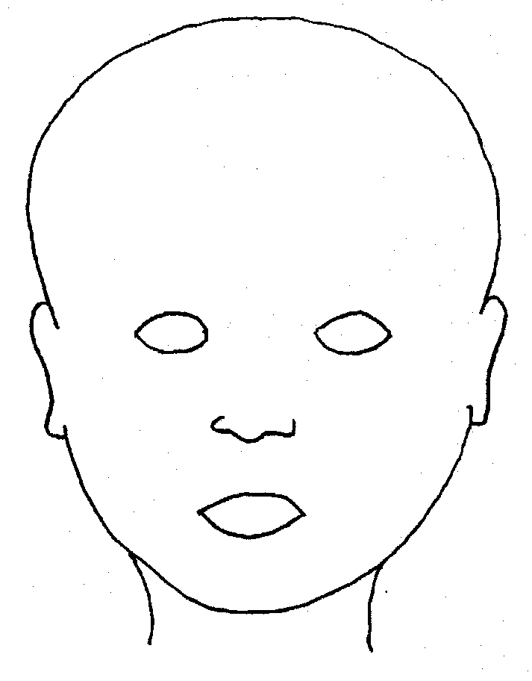 |  | 
FRONT |  | BACK
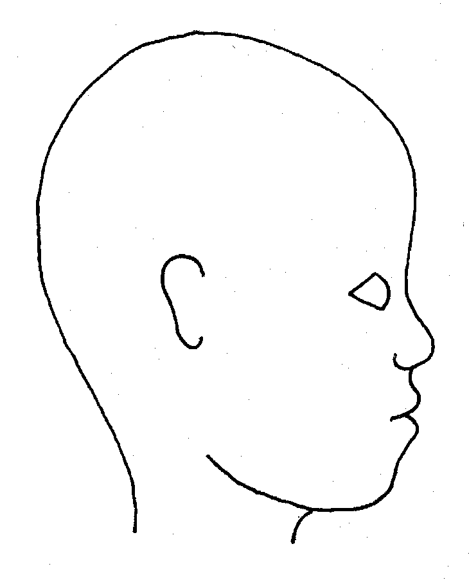 |  | 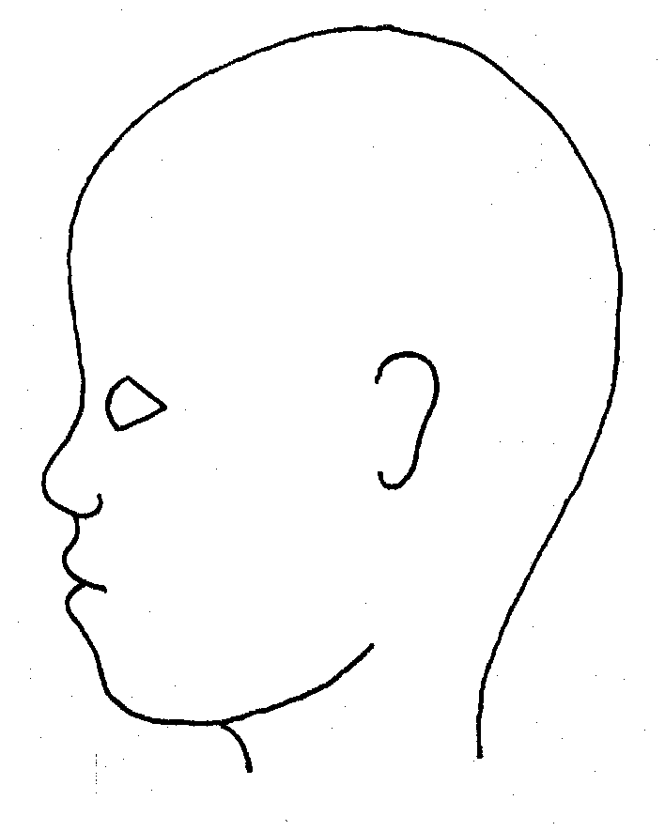
RIGHT |  | LEFT
Name of student: |  |  |  | Date and time of observation:
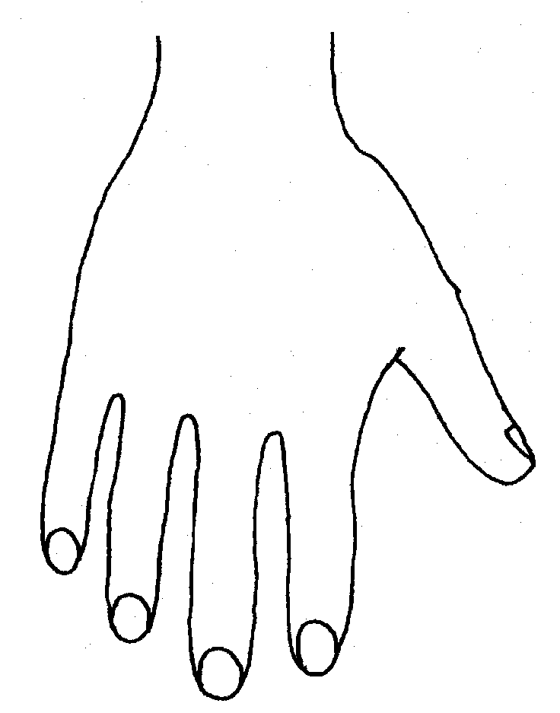 |  |  | 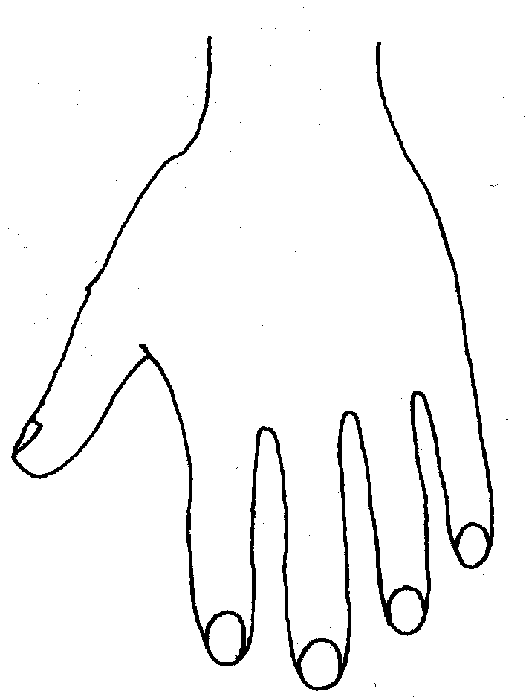
R |  |  | L


BACK


Name of student: ................................................... Date and time of observation: ........................................
R BOTTOM L
R TOP L
  INNER RIGHT |  |   INNER LEFT
OUTER LEFT
  OUTER RIGHT |  | 

APPENDIX 6 Home incident or injury form

HOME ACCIDENT OR INJURY FORM
This form should be completed when a parent/carer informs us that a student has sustained an injury or had an accident outside of school

Date Accident/Injury Reported:

Name of student:
Class/Year Group:

Person Reporting Incident:
Relationship to student:

Date Accident Occurred:
Place of Accident:

Description of injury (complete body map if needed):

Brief detail of how the accident occurred:

Witnessed by:

First Aid Treatment given: | Yes No

Was Medical advice sought? | Yes No
If yes, when and where?

Signed by parent/carer:

Member of staff accident reported to:

APPENDIX 7 – Information CP File/guidance
INFORMATION/FRONT SHEET for CHILD PROTECTION FILE/RECORD
Full Name:  Gender: |  |  | DOB:  Ethnicity: |  |  |  | Class/Form: |  |  | Additional needs:
Home Address: |  |  |  |  |  |  | Telephone:  E mail:
Status of file and dates:

OPEN
CLOSED
TRANSFER
(include details of school/college transferred to)
Any other child protection records held in school relating to this student or a child closely connected to him/her?
YES/NO WHO?

Members of household
Name | Relationship to child |  |  |  | DOB/Age |  |  |  | Tel No
Significant Others (relatives, carers, friends, child minders, etc.)

Name | Relationship to child |  |  |  |  |  | Address |  |  |  | Tel No
Other Agency Involvement

Name of officer/person |  | Role and Agency |  | Status of Child i.e. EHA/CIN/CP/LAC |  |  |  | Tel No/email |  |  | Date

APPENDIX 8 Chronology of significant events guidance
Chronology of Significant Events
Name: | Student Class/Form:

Suggestions below on how to complete this:
Incident logs |  |  |  | S47 Enquiries/ Social Care involvement
Bullying incident |  |  |  | CP Case Conference details
Racist, homophobic or hate incidents |  |  |  | Accommodation Episode/De-Accommodation
Early Help Assessment opened/closed |  |  |  | LAC
Encompass |  |  |  | Placement Moves
SEND |  |  |  | Significant events for child eg. Medical examination, change of school/college etc.
Referral made to Social Care |  |  |  | Key planning meetings and Decision making
Significant Family Event e.g. Birth or Death, |  |  |  | Legal Actions
Changes in household |  |  |  | Telephone call to parents reporting concerns
Professional/Family/Public Concerns |  |  |  | Strategy meeting held
 | Pupil  No. | Date | Detail of Significant Event |  |  | Witness or  Document  Reference

APPENDIX 9: Transfer of safeguarding records guidance
TRANSFER OF SAFEGUARDING RECORDS
This form should be completed when a student moves to another setting and there are safeguarding concerns and records to transfer.

Student’s name:
DOB:
Previous surnames or aliases:
Name of people with parental responsibilities:
Name of social worker/lead professional:
Information and files transferred (to include chronologies and assessments)
NB: Parental consent is needed to transfer Early Help Assessments

Name of sending school
Name of receiving school/college
Passed to (name)
Date of first entry in file
Date of last entry in file
Status: (please tick)
Single Agency Support
Early Help
Child in Need
Child Protection
Looked After Child
Privately Fostered Child
Transferred by: | Received by:
Name:  Position:  Signed:  Date: | Name:  Position:  Signed:  Date:

APPENDIX 10 : Managing professional allegations flow chart
Managing Professional Allegations (schools/colleges)
Local Authority Designated Officer (LADO)

‘First Steps’ (for schools & colleges)

Concern/Allegation raised
Try not to question the victim/witness, just fully record the initial account and what you observed

Do not wait to act if the child is at risk of significant harm; contact Police or Children’s Social Care
Concern/Allegation is passed to the Head Teacher
(Chair of Govs/trustees if allegation is against HT)

Head Teacher considers if the person who works with children has:
- behaved in a way that has harmed a child or may have harmed a child
- possibly committed a criminal offence against or related to a child
- behaved towards a child or children in a way that indicates he or she may pose a risk of harm if they work regularly or closely with children
- behaved or may have behaved in a way that indicates they may be unsuitable to work with children

Yes
No
Criteria met?

Head Teacher makes a referral to LADO within one working day
E-mail Referral Form to Collette.Morris@oldham.gov.uk
or for consultation/discussion call 0161 770 8870
01204 337474
LADO provides advice and guidance if needed. Head Teacher agrees / decides if internal action is required.
Record action, rationale and relevant outcomes.

Head Teacher & LADO agree next steps
(This could include intervention from Social Care and Police)

Oldham LADO – Colette Morris Tel – 0161 770 8870 collette.morris@oldham.gov.uk Ladowebpage

LADO Webpage

An Initial Consideration meeting/ Professional Strategy Meeting is held

No further LADO action required

APPENDIX 11: Tracking form – allegation/concern raised against staff
Tracking Form
Allegation/concern raised against Staff

When an allegation/concern is identified brief details should be obtained and passed to the Head Teacher as soon as possible.
Date: |  | Time
Allegation/Concern made by:

Who the allegation/concern is made against:

NB: The subject of the allegation should not be informed without first seeking advice
Allegation/concern first received by:

Brief details of the allegation:

Date of alleged/concern incident:
Does this allegation involve a restraint? | YES / NO / NYK
Case manager appointed and to complete tracking form

Allegations which appear to meet the criteria should be referred to LADO within 24 hours ( see Note 1)

Does this appear to meet the criteria for a LADO referral? | YES / NO
If no, are you recording the incident as a Low-Level Concern? | YES / NO
Referred to LADO: | YES / NO Date:
Advice given:

Date:
Action to be taken:

Suspension should never be automatic but should be considered and rationale given for decisions made. See Appendix B | Decision to suspend YES / NO / NA

Information gathered about the allegation
Staff witnesses | Account taken | Copy forwarded to LADO
1.
2.
3.
Student witnesses
1.
2.
3.
4
Plan of setting/classroom etc
Chronology of events
1st Aid log

Full details gathered
Student name:
Date of Birth
Address:

Is the student known to Social Care? | YES / NO
Does the student have Special Educational Needs? | YES / NO If yes - details
Has the student raised previous concerns? | YES / NO If yes - details
Staff full name:

Date of Birth:
Address:

Has this person raised concerns before?

Informing others
Have parents of the student been informed?
Details of response

Staff members should be informed of the allegation ASAP - on advice from LADO
Has the staff member been informed? | YES / NO
Name of Key person nominated to feedback to them:
Outcome of LADO consultation
Does this meet LADO criteria: | YES / NO
Further action required:

Professional Strategy Meeting to be held: | YES / NO /NA
Professional Strategy Meeting date:
Attended by Case Manager: | YES / NO / NA
Minutes received: | YES / NO /NA
Outcome: – please circle | Unfounded Unsubstantiated  False Substantiated  Malicious
The information will be referred to in any future reference | YES/NO
Disciplinary investigation to be held: | YES / NO / NA
Staff member informed of outcome: | YES / NO
Parents informed of outcome (no info about the staff member should be shared): | YES / NO
Chair of governors informed: | YES / NO /NA
Trust Safeguarding Lead informed: | YES / NO /NA
Details added to overview table: | YES / NO
Outcome:

Lessons learned:

Note 1 - Criteria for managing allegations

An allegation may relate to a person who works with children who has:

- Behaved in a way that has harmed, or may have harmed, a child
- Possibly committed a criminal offence against or related to a child
- Behaved towards a child or children in a way that indicates they may pose a risk of harm to children
- Behaved or may have behaved in a way that indicates they may not be suitable to work with children

APPENDIX 12 – Role of designated teacher
The Role of the Designated Teacher for Children Looked After (CLA) within the school
The Designated Teacher has a leadership role in promoting the educational achievement of every CLA on the school’s roll. The role should make a positive difference by promoting a whole school culture where the personalised learning needs of every CLA matters and their personal, emotional and academic needs are prioritised.

The Designated Teacher has lead responsibility for helping school staff to understand the things which can affect how CLA learn and achieve. Everyone involved in helping CLA achieve should:
- Have high expectations of CLA’s involvement in learning and educational progress
- Be aware of the emotional, psychological and social effects of loss and separation from birth families, the reasons for that separation and that some children may find it difficult to build relationships of trust with adults because of their experiences
- Understand the reasons which may be behind a CLA’s behaviour, and why they may need more support than other children but the teacher should not allow this to be an excuse for lowering expectations of what a child is capable of achieving
- Understand how important it is to see CLA as individuals rather than as a homogeneous group and to not publicly treat them differently from their peers
- Appreciate the importance of showing sensitivity about who else knows about a child’s looked after status
- Create a shared understanding between teachers, carers, social workers and most importantly, depending on age and understanding, the child him or herself of what everyone needs to do to help them to achieve their potential
- Have the level of understanding of the role of social workers, virtual school heads (or equivalent) in local authorities and how education – and the function of the PEP – fits into the wider care planning duties of the authority which looks after the child.
In promoting the educational achievement of looked after students the Designated Teacher will:
- Contribute to the development and review of whole school policies to ensure that they do not unintentionally put CLA at a disadvantage
- Make sure, in partnership with other staff, that there are effective and well understood school procedures in place to support a CLA’s learning. An account should be taken of the child’s needs when joining the school and of the importance of promoting an ethos of high expectations about what he or she can achieve
- Promote a culture in which CLA believe they can succeed and aspire to further and higher education
- Promote a culture in which CLA can discuss their progress and be involved in setting their own targets, have their views taken seriously and are supported to take responsibility for their own learning
- Be a source of advice for teachers at school about differentiated teaching strategies appropriate for individual students who are looked after
- Make sure the school makes full use of Assessment for Learning (AfL) approaches to improve the short- and medium-term progress of CLA and help them and their teachers understand where they are in their learning, where they need to go and how to get there
- Make sure that CLA are prioritised in any selection of students who would benefit from one-to-one tuition and that they have access to academic focused study support
- Promote good home-school links through contact with the child’s carer about how they can support his or her progress by paying attention to effective communication with carers. In particular, they should make sure that carers understand the potential value of one-to-one tuition and are equipped to engage with it at home
- Have lead responsibility for the development and implementation of the child’s PEP within school in partnership with others as necessary.

APPENDIX 13 Referral quick guide
Quick Guide to making a referral
PRACTITIONERS QUICK GUIDE TO MAKING A REFERRAL TO MASH
Parents and carers should be contacted. The concerns and actions to be taken should be discussed. Your Designated Safeguarding Lead will consider whether in telling parents/carers/child you are placing the child or any other children at further risk which can’t be managed. If in any doubt make the referral and seek the advice of The Integrated Front Door. You should record this discussion and decision making in your records.

You can override consent as you are taking action to safeguard a child

Make sure you have all relevant information available this should include basic details about the child, what your concerns are and why you have them at this time and a summary of your involvement with the child/family – and whether there is an Early Help Assessment in place. When having this discussion it may be useful to use Oldham Safeguarding tool Is this Significant harm?

You should ensure that you record a summary of the discussion and the outcome of it and provide this to the DSL who will store it appropriately– the DSL will include a rationale for decision about whether or not to refer to Oldham MASH.
*If TAS school consultation should be had with TAS Social Worker*

You need to consider whether urgent action is needed – i.e. the child is at immediate risk of death or has significant injuries; if this is the case
immediate medical treatment and police involvement should be sought and then follow this process.
In most cases there will be sufficient time to follow this process; when considering if you have concerns that warrant referral to The Integrated Front Door you should use the tools available on Oldham Safeguarding Children Partnership website- https://www.child.mash@oldham.gov.uk

At the end of the call you should know what is going to happen next, the timescales for action and what your role in this will be. When making a referral refer to Useful information when Making a Child Referral.
If MASH does not agree that social work involvement is needed you should listen to their reasoning for this and their advice about alternative action – including recommendations to use early help processes; if at the end of this you still do not agree then you should refer to Greater Manchester guidance on Escalation and Resolving professional differences.
You should ensure that the child and their family continues to be supported and kept safe while awaiting resolution.
If you know there is an Early Help Assessment and Plan open but you are not the Lead Professional, you should tell the Lead Professional about the action you have taken and why as soon as possible; if you are not sure if there is an Early Help Assessment you can check with the Early Help Access Point who will let you know and share details of the Lead Professional where one is identified – it would be good practice to share this information with the Lead Professional. If you are the current Lead Professional making the referral and there is an Early Help Assessment and Plan in place, this should be updated to include the referral information - this helps to avoid duplication and gives the social worker the best possible information from which to start their assessment. Remember to also send a secure copy to the Early Help team at child.mash@oldham .gov.uk
If at immediate risk telephone 0161 770 7777
Clearly state you are making a referral, this will avoid confusion
Make sure you record who you are talking to, make sure you provide a clear account of your concerns and why you are contacting Oldham MASH.
You will receive a response to a referral within 24hrs. If you do not receive a response, you must contact Oldham MASH again. Record all action taken.

Consult with your
Designated Safeguarding Lead (DSL)

You have a concern

Tell the
parents/carers/
child about the referral

Refer to the
Oldham MASH

Appendix 14 Encompass flow chart

USEFUL CONTACTS:-
- Safeguarding in Education Team
0161 770 7777
- Police – Domestic Abuse Unit
0161 856 5589 or 0161 8565504
- Oldham MASH
0161 770 7777
- Early Help Team
0161 770 7777
- OE Teachers' National Helpline on 0204 513 9990
- Fortalice- 01204 365 677
- Endeavour- 01204 394842

Record actions and decision making
Outcomes could include, Early Help, referral to support agencies, parental support
Use professional judgement and consider whether Early Help Assessment is needed or referral to Children’s Social Care

Appendix 15 Child on Child Abuse Flowchart
Ensure that students are clear about the next steps when an incident is reported.
Child makes a disclosure

Reassure the child and ensure they feel believed and safe

DSL to ensure all children are safe and the alleged perpetrator(s) is supervised whilst an investigation is carried out.
Inform DSL and record on CPOMS/recording system (delete as appropriate)

Has significant Harm Threshold been met?

No
Inform parents (unless this would place the child at risk) and implement a safety plan, which will include support for both victim and alleged perpetrator (s)

Yes
Inform parents (unless this would place the child at further risk) and refer to Oldham MASH 0161 770 7777 await strategy meeting for further actions. Safety Plan to be implemented, which will include support for both victim and alleged perpetrator (s).
Do not question the alleged perpetrator (s) at this stage unless advised to do so by police or social care

Consider if the incident needs reporting to the police on 101
Refer to NCPCC Guidance – When to call the police www.npcc.police.uk.
If there is immediate danger call 999
Does the alleged victim/victim’s parents wish to report to the police?

The alleged victim’s views should be considered throughout

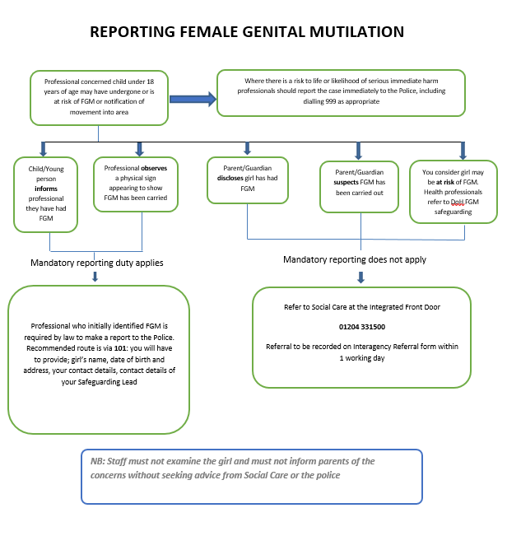
Appendix 16 FGM Flow Chart

Appendix 17 Statement of Staff Commitment to the Forward As One Safeguarding & Child Protection Policy

To be completed annually BY ALL STAFF and kept in Personnel Files

Staff Member:………………………………………Post:……………………………..

Line Manager:………………………………………………………

I have read and understood the standards and guidelines outlined in the 2025 Safeguarding & Child Protection Policy.
I agree with the principles contained therein and accept the importance of implementing the policies and practices whilst working at St John’s C.E. Primary School.
I confirm that I have:
- Received a copy of Safeguarding & Child Protection Policy
- Had the opportunity to read and discuss the policy and procedure with my Line Manager
- Discussed and recorded training requirements for ongoing action.

Signed (Staff)………………………………………………………………………

Signed (Line Manager)……………………………………………………………

Date …………………………………….

Appendix 18 Criminal records self-declaration form



Criminal records self-declaration form (academies)
To be completed annually in September BY ALL STAFF
As part of our duty to safeguard pupils, we need to check whether you are barred from working with children, or whether you have convictions that would make you unsuitable to work with children. Please complete the following form as accurately as possible.
Note: you are not required to disclose convictions or cautions that are ‘protected’, as defined by the Rehabilitation of Offenders Act 1974 (Exceptions) Order 1975 (as amended in 2013). If you’re not sure whether one of your convictions is ‘protected’, you can check here.

Name
Role

Self-declaration
Yes/No
Are you barred from working in regulated activity with children (i.e., are you included on the Disclosure and Barring Service Children’s Barred List)?
Do you have any unspent conditional cautions or convictions under the Rehabilitation of Offenders Act 1974?
Do you have any adult cautions (simple or conditional) or spent convictions that are not protected as defined by the Rehabilitation of Offenders Act 1974 (Exceptions) Order 1975 (Amendment) (England and Wales) Order 2020?
Have you committed an offence overseas which would have resulted in disqualification if it had occurred in the UK?
Are you subject to a section 128 direction?
Have any orders relating to the care of children, as set out in schedule 1 of the Childcare (Disqualification) and Childcare (Early Years Provision Free of Charge) (Extended Entitlement) (Amendment) Regulations 2018, been made in respect of you?
This includes, but is not limited to:
- Orders disqualifying you from caring for children
- Orders disqualifying you from private fostering
- Any refusal of an application for you to be registered in relation to a children’s home
- Care/child protection orders issued in respect of a child in your care
Have you been convicted of committing, or been given a caution, reprimand or warning since 6 April 2007 for, any offences set out in regulation 4 and schedules 2 and 3 of the Childcare (Disqualification) and Childcare (Early Years Provision Free of Charge) (Extended Entitlement) (Amendment) Regulations 2018?
This includes, but is not limited to:
- Any offence against or involving a child
- Any sexual offence
- Any violent offence, i.e. murder, manslaughter, kidnapping, false imprisonment, actual bodily harm (ABH), or grievous bodily harm (GBH)
Do the police or children’s social care have your name and/or information on file for any reason?
If you answered ‘yes’ to any of the questions above, please provide further information.

I confirm that the information above is accurate to the best of my knowledge, and that I will make the school aware of any changes in my circumstances that may affect the answers I’ve provided above, or my suitability for the job.

Signed: _________________________________________ Date: ___________________________

