



Learning & Teaching

Strategy

Quality
,

the FA1 way…

September
2022
-
2023

‘Learning today for a better tomorrow’

 |  | Contents:
• | FA1 Learning & Teaching Rationale | Page 3
• | Flipped Learning – using Technology | Page 4
• | Memory & Remembering More | Page 5
• | The Learning Process | Page 6
• | Rosenshine’s Principles of Instruction | Page 7
• | FA1 Learning & Teaching Model | Page 8
• | FA1 Learning & Teaching Blue-print | Page 9
• | Language of Learning Glossary | Page 13
• | FA1 Learning & Teaching RAG  Heatmap | Page 14
• | Bibliography & Sources | Page 15

FA1 – Learning & Teaching – ‘Our Why’

At Forward As One CE Multi Academy Trust, our moral purpose is to improve the life chances and education of all our children. We believe in collaboration, together, as #OneTeam for the betterment of education in each school community. Through an engaging curriculum and Learning & Teaching model, our #OneMission is to inspire all our children for them to learn and thrive. We place our children at the heart of every decision – they simply come first, second and third. As #OneFamily through partnership, we can achieve so much for our children as they learn and grow. We are deeply committed to ensuring we can deliver the best educational outcomes – and this strategy is fundamental to this commitment.

‘Quality, the FA1 Way - sets out our approach to Learning & Teaching, the beating heart of our schools and our core business as Leaders of Learning’

Our approach to Learning & Teaching is deeply rooted within educational research, contributing towards our commitment to support our Teachers and Leaders in being evidence-informed practitioners. Our Learning & Teaching model is built upon the foundation of a positive learning culture, which is rolemodelled by all adults within school. We firmly believe powerful learning can only take place once routines, systems and learning behaviours are embedded. Similarly, before a child can assimilate and process their learning we need to ensure their primary needs and learning behaviours are prioritised and nurtured.

‘Every Teacher and Leader needs to improve – not because they are not good enough, but because they can be even better’

The FA1 Learning & Teaching model is a blue-print model for highly effective learning to take place, to enable our children to know more, remember more – resulting in them being able to do more. This strategy aims to support Leaders & Teachers in creating and embedding effective habits, which cumulatively, overtime will lead to powerful, life-long learning.

Moving Forward As One – in striving for quality learning & teaching…


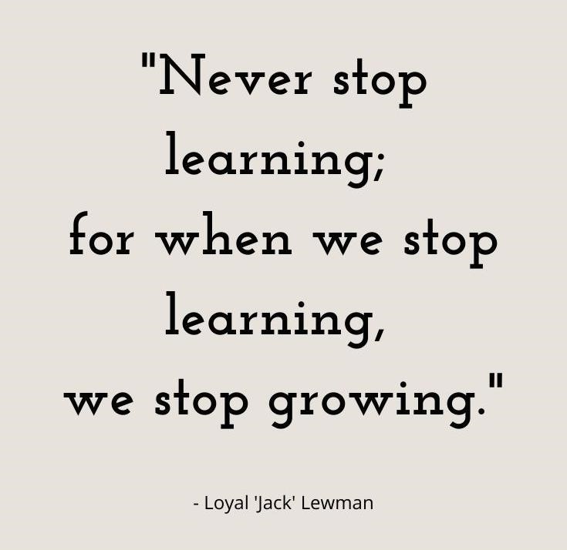

Flipped Learning

Flipped classroom is a “pedagogical approach in which direct instruction moves from the group learning space to the individual learning space, and the resulting group space is transformed into a dynamic, interactive learning environment where the Teacher guides students as they apply concepts and engage creatively in the subject matter” (The Flipped Learning Network, 2014).

‘Technology will never replace great teachers, but technology in the hands of great teachers is transformational’ George Couros

We utilise 1:1 devices through the use of iPads for all children in KS2. Our digital strategy is built around 3 core areas: Stability, Usability and Pupil Engagement. The Flipped Learning classroom deepens children’s learning and gives them the opportunities to engage in learning beyond the classroom. We believe passionately in preparing our children for their next stages of education – this includes the ever-changing digital world and how digital technologies can support and enhance everyday life.

Through our Teachers being Apple Educators and through the professional development of the Ed-Tech
Demonstrator programme, Teachers utilise Apple Technology to enhance learning and teaching. Through modelling, screen-sharing, visualising – teaching can be truly transformational. A balanced workload is important to us at FA1, utilising technology enables workload to be reduced through the platform of MS Teams and children having access to learning resources within their Class Teams.

‘Technology gives children keys that open doors and release their creativity’ – Dsdigital

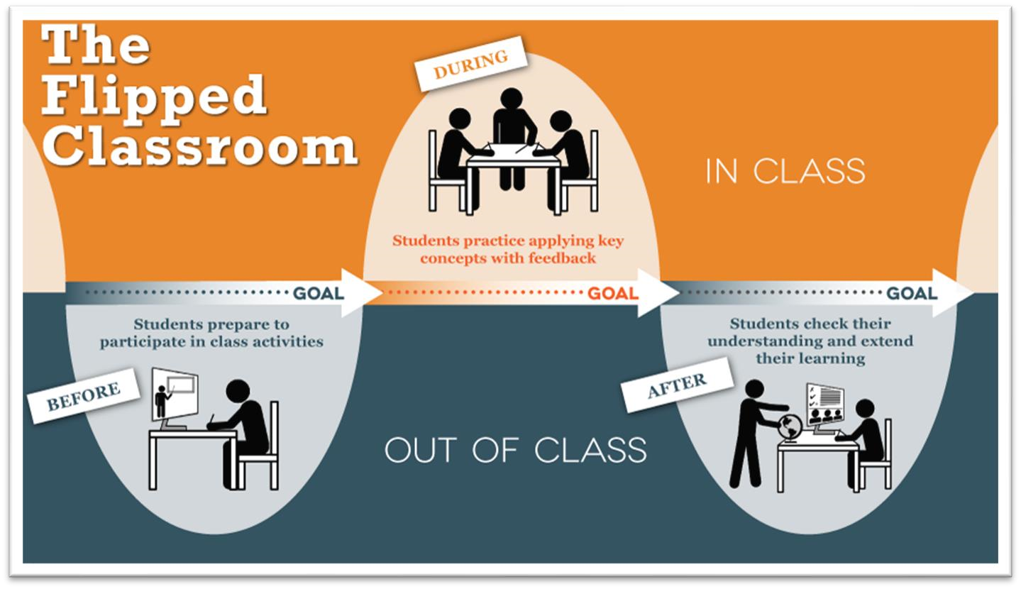

Memory & Remembering More

‘Learning involves a lasting change in children’s capabilities or understanding’

For us to ensure our children ‘remember more’ and there is a lasting change in their capability or understanding, it is essential we have a secure understanding of Memory. The Learning Environment plays a crucial part in the learning process – the learning environment should enable learning, through careful scaffolding, use of resources and worked examples. The learning displays play a vital role in enabling learning and establishing high expectations by displaying quality examples of children’s work. Attention is the process of selecting what to think about next, it is the gatekeeper of our memory and the ultimate currency of our classrooms. The Working Memory is limited, it can only attend to small ‘chunks of information’ at any one time, before it becomes overloaded – we know this as ‘cognitive overload’. The Long-Term Memory is infinite – in order for information/knowledge to be committed to the long-term memory it needs to be learned, revisited and retrieved in order to be committed to memory. As children learn, practise, and retrieve – they become more fluent in their learning, their learning becomes more accessible and automatic – we know this as ‘automaticity’.

‘Simple Memory Model’
Daniel Willingham
• | Attention is the gatekeeper of learning – the ultimate currency in our classrooms
• | Working Memory:  - Limited Space – only 3 or 4 ‘chunks’ of information can be held here for a short time  - Keep it Simple – the more complex information the more likely we are to overload the working memory – ‘cognitive overload’  - Prior knowledge helps avoid ‘cognitive overload’
• | Long-Term Memory:  - ‘Schemas’ are webs of inter-connected information & knowledge – we create these when children learn, practice and remember what they have been taught

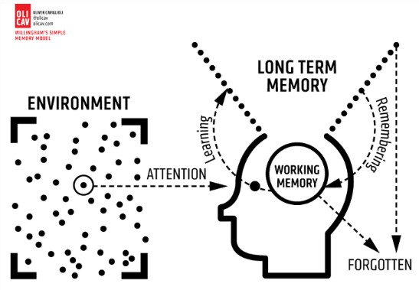
‘The Learning Process’ Professor Paul Howard Jones

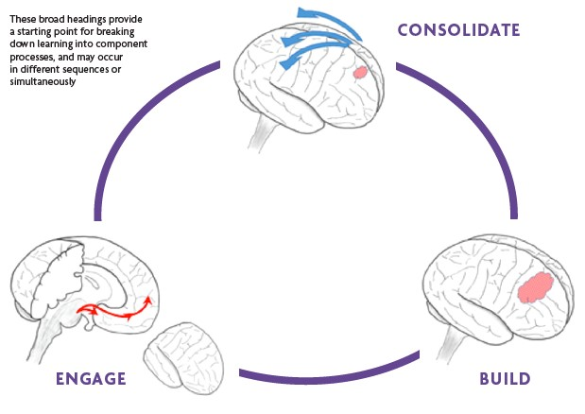

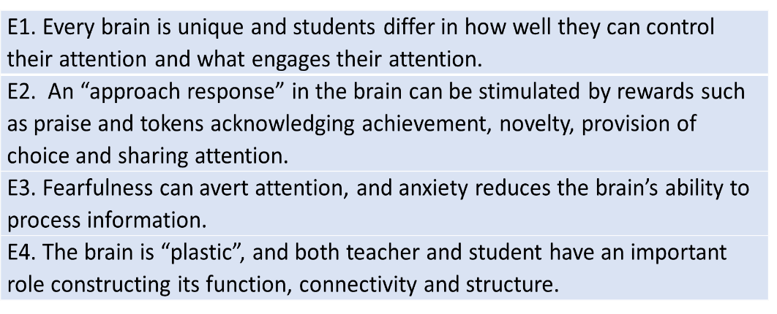

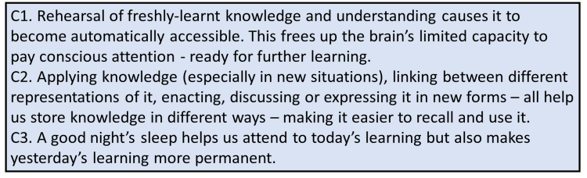

B1. To be meaningful and lasting, new knowledge must build on prior
knowledge. A child
’
s developing brain requires more support in
making connections to prior knowledge.

B2. Clear, concise instruction and minimizing distraction can aid
communication and
student understanding of new knowledge by
reducing unnecessary load on working memory.

B3. Our Mirror Neuron System helps us read each other
’
s minds. We
communicate understanding and emotions (e.g. confidence and
enthusiasm) both consciously and unconsciou
sly.

FA1 Learning & Teaching Model

Our Learning & Teaching model is based upon the core principles of the OLEVI ‘DR ICE’ model. DR ICE is focussed on creating a profound thinking and learning experience, encouraging Teachers to become more courageous, reflective, and action-orientated practitioners. We use the DR ICE model as a lens to view Learning & Teaching – both reflecting on our own practices and others.

DR ICE is the common ‘language of learning’ across FA1 – creating a culture of continual, deep learning and a lens through which we view Learning & Teaching.


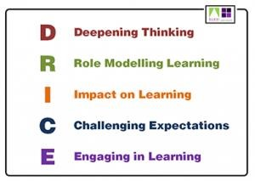
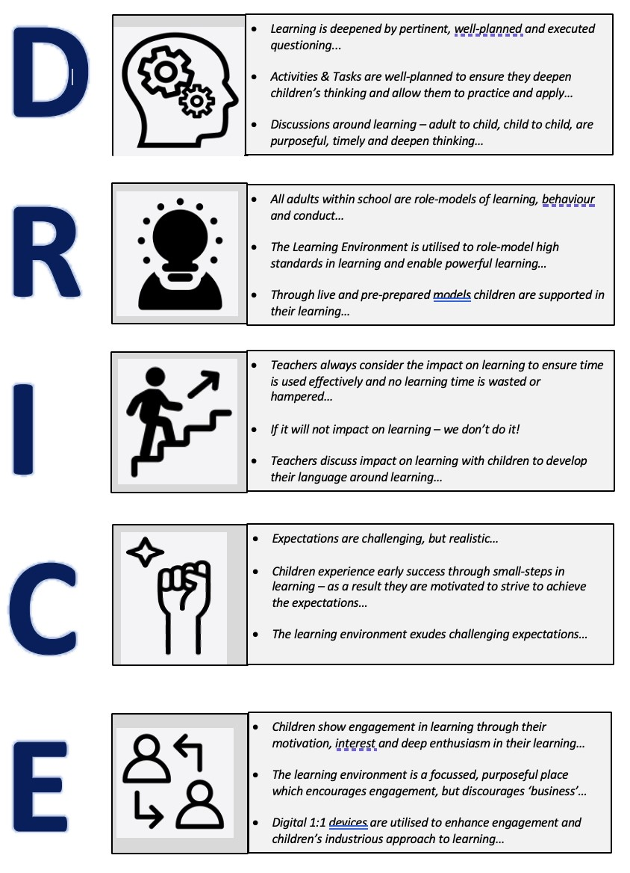

 | 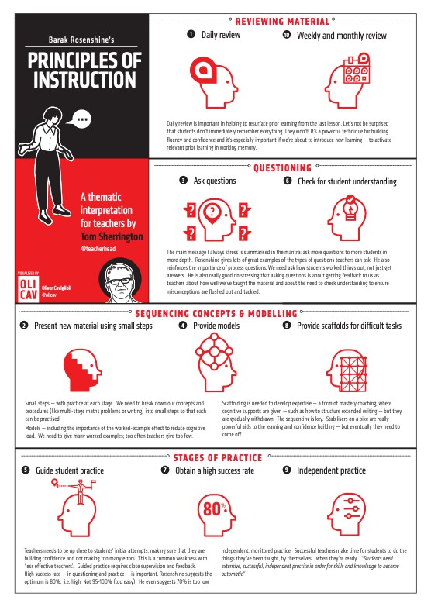
  ‘Rosenshine’s Principles of Instruction’
  Barak Rosenshine
  Are the bedrock of our pedagogy and practice, now more than ever. Considering the key elements of: Reviewing material/knowledge, questioning, sequencing concepts/modelling, and stages of practice will provide us with an evidence-based approach in which to build upon children’s learning. Our learning around ‘Cognitive Science’ needs to be utilised here – we know children need to experience ‘desirable difficulty’ to make their learning permanent – through retrieval and consolidating we will transfer and commit knowledge to the long-term memory which, in turn, will increase children’s automaticity.
  - Daily Review
  - Presenting new material using small steps
  - Guiding student practice
  - Ask questions
  - Guide student practice
  - Check for student understanding
  - Obtain a high success rate
  - Provide scaffolds for difficult tasks
  - Independent practice
  - Weekly and monthly review
FA1 Learning & Teaching – Blueprint

Our ‘Blueprint’ links our DR ICE principles and language of learning to pedagogical strategies. The blueprint supports the ‘knowing and doing gap’ – for example, we may know what ‘engagement in learning’ looks like, but how do we do, or create this, within the classroom? The blueprint has been built around our DR ICE
Principles and the Engage – Build – Consolidate model to ensure we have consistent learning practices across the Trust which are conducive to effective learning.
‘Our children are only as brilliant as we allow them to be’


Engage

Build

Consolidate

•

Entry routine

•

Retrieval Starter

•

V for Vision

•

Silent Signals

•

High Participation/Think
Ratio

•

Cold
-
Calling

•

I do
–

We do
–

You do

•

Bite
-
Sized, small steps

•

Live modelling

•

Worked model examples

•

Pause points

•

Retrieval Practice

•

Responding to
marking/feedback

•

Self & Peer Assessment

•

Exit Tickets

•

Half
-
Termly quizzes

FA1 Learning & Teaching – Blueprint
Our ‘Blueprint’ links our DR ICE principles and language of learning to pedagogical strategies. The blueprint supports the ‘knowing and doing gap’ – for example, we may know what ‘engagement in learning’ looks like, but how do we do, or create this, within the classroom? The blueprint has been built around our DR ICE Principles and the Engage – Build – Consolidate model to ensure we have consistent learning practices across the Trust which are conducive to effective learning.

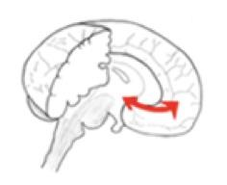  Engage  •  Entry routine  •  Retrieval Starter  •  V for Vision  •  Silent Signals  •  High Participation/Think  Ratio
  Links to DR ICE
  Role-Modelling Learning
  Challenging Expectations
  Engaging in learning
  Pedagogical Strategies
  - Teacher/TA – welcomes children at the classroom door in order to set the climate for learning before children enter
  - Entry routine – established expectations of entry into the classroom/lesson so learning commences immediately and there is no lost learning
  - Retrieval Practice at the start of the lesson to ensure that pre-requisite learning has retained before moving on with new content
  - High participation & think ratio for all children to ensure they are engaged from the beginning of the lesson
  - ‘V of Vision’ – scanning to ensure that all children are engaged and focussed in learning
  - Use of Silent Signals [Team Stop, Magnet Eyes, 1-2-3] – to gain attention immediately with no lost learning as a result
  What does this look like in practice?
  The Teacher greets the class before they enter the classroom to establish and set high expectations before children enter the learning environment. The entry routine is established, and children know the habit of engaging straight away in a retrieval practice activity which ensures their participation is high (as they are working independently) and think ratio is high (as they are retrieving previously taught knowledge). The adults are scanning the classroom to ensure all children are engaged in learning and intervening with any children who may need it.
Links to DR ICE
Deepening Thinking
Role Modelling Learning Impact on Learning
Challenging Expectations
Engagement in Learning

Pedagogical Strategies
- Cold-calling ‘no hands-up’ to ensure questioning is well targeted, misconceptions can be easily identified and as a result children’s engagement levels are high

- I do, We do, You do used to teach new learning in small steps, ensuring learning is scaffolded and deliberately modelled and Teacher’s guide student practice and allow time for independent practice

- Teach new materials in small, ‘bite-sized’ steps - using the iPad and/or Flip chart to model live examples so children are clear on the ‘model of good’ and can practice and apply.

- Pre-prepared worked examples are utilised in the Learning Environment to support children’s progress and small steps in learning.

- Pause Points are used after new learning or concept are introduced to enable children to process the learning, assimilate it and retrieve it before moving into independent practice. Teacher’s use Pause Points as a formative assessment opportunity – to check children’s knowledge & understanding.

What does this look like in practice?
The Teacher utilises cold-calling throughout the lesson, to ensure questioning is targeted, specific and reveals misconceptions as well as deepening learning. This ensures children have high-participation ratio as they always have to be prepared to answer a question. The I do, We do, You do approach ensures teaching is chunked into small steps, ensuring that learning is scaffolded and deliberately modelled – giving children the opportunity to be guided through practice leading to independent practice. Pause-Points are utilised in every lesson after new learning or a new concept is introduced. This ensures children have the time and space to assimilate their learning, avoiding cognitive overload of the working memory. Teachers learn from children’s responses in PausePoints and use these responsively within the lesson to adapt teaching appropriately.





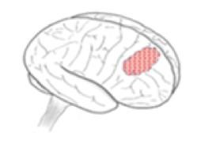
- Cold Calling
- I do – We do – You do
- Bite-sized, small steps
- Live modelling
- Worked model examples
- Pause points

Build

-

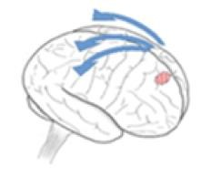  Consolidate  •  Retrieval Practice  •  Responding to  marking/feedback  •  Self & Peer Assessment  •  Exit Tickets  •  Half  -  Termly quizzes
  Links to DR ICE
  Deepening Thinking
  Impact on Learning
  Challenging Expectations
  Engagement in Learning
  Pedagogical Strategies
  - Retrieval opportunities – to support children in embedding and committing new learning to the long-term memory. Ensuring that knowledge and understanding is secure before moving on.
  - Responding to marking & feedback to consolidate learning – by children responding to comments/feedback, editing and correcting or re-drafting their work in order to consolidate understanding.
  - Self-Assessment/Peer-Assessment to assess learning and give opportunities for children to consolidate their learning and learn from their mistakes and misconceptions.
  - Exit Tickets - Spaced Practice Retrieval – leaving space and time between new learning and retrieving the knowledge/understanding (more than 1 week).
  What does this look like in practice?
  Teachers know consolidation is crucial to ensure there is a lasting change in children’s knowledge and capabilities. Retrieval opportunities are built into each lesson – on entry and exit, to support children in embedding and committing new learning to the long-term memory. Retrieval supports Teachers in understanding when there has been impact on learning and how to adapt lessons accordingly. Teacher’s use marking and feedback skilfully to enable children to respond to their work in a meaningful way. Through annotations, editing, correcting or re-drafting, children have the valuable opportunity to consolidate their learning. Self/Peer assessment is utilised so children can learn from their mistakes and misconceptions. Exit tickets are utilised to build on retrieval through spaced practice, meaning Teachers leave space (more than 1 week) to ensure knowledge that has been taught previously is secure, this is the case for previous year groups.

 | Language of Learning – Glossary
•  • | Retrieval  Spaced Practice Retrieval | is where bringing information to mind increases learning and retention  is where bringing information to mind – from the past (last week, half term, term or year) increases learning and retention
• | Exit Tickets | Is where children take a retrieval task away, after a lesson to complete, based on the learning within the lesson
• | Cold-Calling | Step 1) Pose the Question Step 2) Give thinking time 3) Name the child
• | I do – We do – You do | Is where the Teacher first models deliberately, the Teacher then remodels with specific explanation - guiding student practice, before then applying independent practice
• | Small-bite sized steps | Introducing learning in small, chunks – which are sequenced so children understand each step
• | Pause Points | Are opportunities for children to assimilate and process their learning within the lesson – responding to a pause point question, utilising this as an opportunity for formative assessment
• | Cognitive Overload | When the working memory is overloaded with information
• | Entry Routine | The routine in place for children entering the classroom and commencing learning
• | Pre-Requisite Learning/Knowledge | Previous knowledge which children have learnt earlier in the year or in a previous year-group/key stage
• | High Participation & Think Ratio | Children are highly involved in learning and their thinking on a deep level about the learning
• | V of Vision | Children sat/stood in a V shape – where the Teacher can see all children by scanning effectively
• | Silent Signals | Hand signals which are silent and act as a cue for behaviours/transitions
• | Desirable Difficulty | Is when a task is challenging – but not too challenging, children experience success but the challenge is increased throughout
• | Automaticity | When children’s knowledge/information is retrieved instantly and rapidly – e.g – Times tables/Phonemes
• | Schemas | Interconnected web of knowledge/information which builds, grows and makes connections
• | Working Memory | A limited capacity which can only hold 4 or 5 pieces of information at any one time
• | Long Term Memory | An infinite capacity – which can hold knowledge and information once it has been consolidated and embedded

Learning & Teaching – RAG Heatmap
Context…

Secure
Refine
Needs Support


Engage

Entry Routine |  | Entry Routine |  | V for Vision

Silent Signals |  | High  Participation |  | High Think Ratio

Build

  Cold-Calling
  I do – We do – You do |  | Bite-Sized small steps

Live Modelling |  | Worked model examples
Pause Points

Consolidate

Retrieval Practice |  | Responding to  Marking/Feedback |  | Self & Peer Assessment

Exit Tickets |  | Half-Termly Quizzes

