Year 2 - Homework Grid – Autumn Term 2026
Spelling Challenge  Make sure you know how to spell all the Year 1 common exception words (see list) as well as practicing your spelling every week. If you know the Year 1 words start learning the Year 2 words.  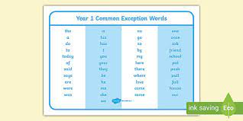 | PE Challenge  How many times can you throw and catch a ball in a row? Can you beat your score?   | Maths Challenge  Make sure you can write your numerals the correct way.  Learn your number bonds to 10 and then to 20 so you know them off by heart. I have set some games on Purple Mash to help you with this. | Science Challenge  We are learning about living things and their habitats.  Choose a microhabitat – this could be a rock, log, plant, a pile of leaves, grass ect…- and record what creatures you can find.  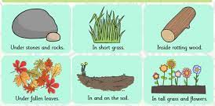
Date completed: | Date completed: | Date completed: | Date completed:
DT Challenge  In DT we are learning about levers. Can you go on a lever hunt in your home or local area and write a list of the levers you find.  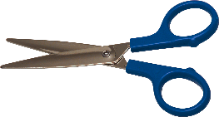 scissors  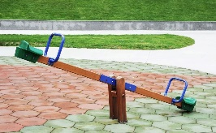 seesaw | Writing Challenge  Can you write your full name (first name and surname) with all the letters formed correctly and capital letters at the start of each of your names. If you can do this then write me a sentence about your favourite animal. | Geography Challenge  Would you prefer to live in a hot or cold place? Write a sentence to say where you’d prefer to live and why.  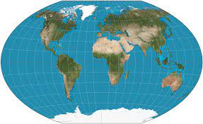 | ICT Challenge  On Purple Mash explore 2 paint a picture and use the tools to create your own picture.  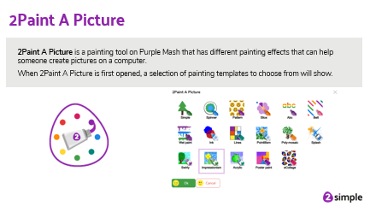
Date completed: | Date completed: | Date completed: | Date completed:

