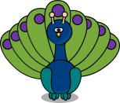 **Peacocks Autumn Term 1 Newsletter**

Welcome to the Peacock Class Newsletter.

As ever we have a busy half term ahead, so listed below are the topics and areas of study we will be covering.

**English:** We arepracticing forming our letters correctly and looking at correctly writing sentences using the correct punctuation and spellings. We will also look at what a sentence is, the parts of a sentence and how to join sentences using conjunctions. We will be writing a non-chronological report about minibeasts to link with Science.

**Phonics:** We are starting with level 6 phonics and will be learning that y can say igh, dge and ge saying j, adding es to words ending in y, gn saying n, kn saying n, adding ing and ed to words ending in y and wr saying r.

**Maths:** We are learning our number bonds to 20, correctly forming all numerals and looking at the place value of numbers.

**Science:** Living things and their habitats

**Geography:** 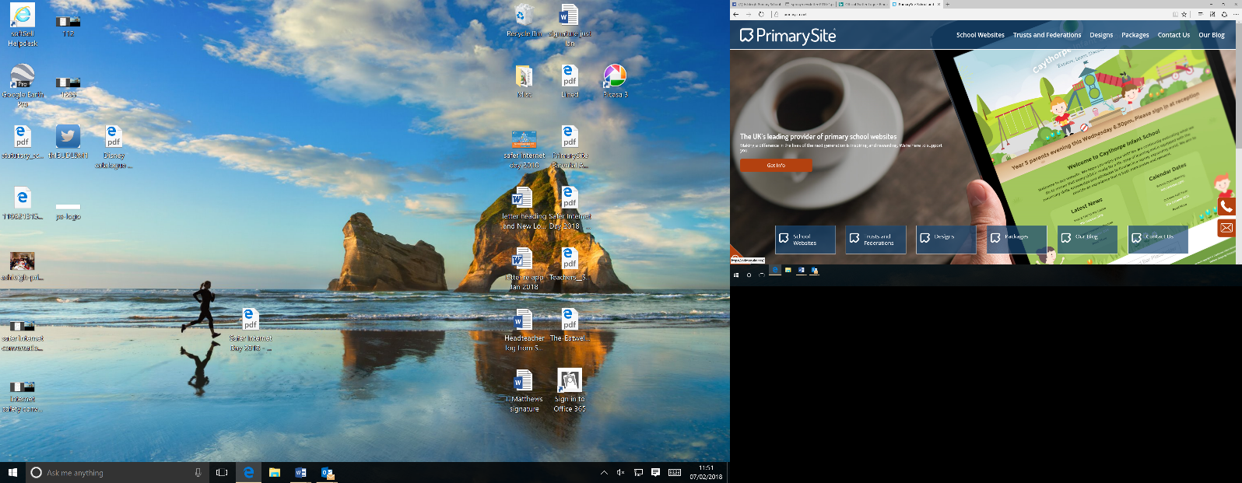Our wonderful world – hot and cold places

**DT:** Mechanisms – making Ferris wheels

**RE**: The Church: Why is the church a special place for Christians?

**Music**:

**Computing:** Coding

**PSHE**: VIPs – our relationships

**PE:**  20th Century Playground Games and Bounce ball

*PE Kit - please ensure that your child has their PE kit in school and if your child has earrings please cover them with plasters before school on Tuesdays and Thursdays.*

If you have any interest or expertise in any of the areas mentioned above we would love to hear from you. Or if you are interested in listening to children read we would greatly appreciate your help.

**Reading at home** – it is essential that children read at home every night, even when they are fluent readers, as it helps them to understand phrasing and punctuation in English. Please remember to fill in reading records if you read with your child including what page they have read up to or if they have finished the book. Reading books should be in school daily. We aim to change them every Monday. We will read with children whenever possible throughout the week.

**Water bottles**- these need to be named and taken home at the end of every day. Please return them filled with water. Children can refill them during the day if necessary.

**Homework**

Homework will be handed out at the start of every half term and should be completed by the end of that half term’s holiday. Children can return their books to school to be marked whenever they have completed a piece of homework.

Children will usually get 10 spellings to copy out daily and spelling tests are every Monday. We will let you know your child’s score by writing it on the top of the spelling sheet. Spellings can also be practiced on Spelling Shed.

To support the learning of number facts some games have been set on Purple Mash and it is part of this half terms homework. The more they practice the quicker they will become at learning these facts. If you require your child’s Purple Mash log in please email [lisa.lomax@ashleigh.blackburn.sch.uk](mailto:lisa.lomax@ashleigh.blackburn.sch.uk).

We have also introduced a new online handwriting programme called letterjoin last year which will support your child with correct letter formation and joining letters when we start this in the coming weeks. Log in details are: Username:**kh11176** Password: home

**Library** – Our library slot is on Monday mornings so library books need to be returned every Monday.

**Dates for your diary:**

Wednesday 17th September – Meet the Teacher 3.40-4.15

Wednesday 24th September – Outdoor learning – please bring outdoor clothing and suitable footwear

Wednesday 8th October – Open evening

Please do come and see me if you have any questions. Often mornings can be very busy, but I am always happy to speak after school, meetings permitting. Alternatively, please leave a message with the office or you can send me an email at [lisa.lomax@ashleigh.blackburn.sch.uk](mailto:lisa.lomax@ashleigh.blackburn.sch.uk).

Thank you

Mrs Lomax