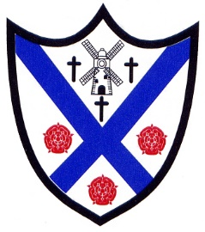

School Term 2026/27

Autumn Term 2026

Starts: Thursdays 3 September 2026
Half term: Monday 26 October- Friday 30 October 2026
Ends: Friday 18 December 2026

Spring Term 2027
Starts: Tuesday 5 January 2027
Half term: Monday 15 February - Friday 19 February 2027
Ends: on Thursday 25 March 2027

Summer Term 2027
Starts: Monday 12 April 2027
May Day: Monday 3 May 2027
Half term: Monday 31 May - Friday 4 June 2027
Ends: Wednesday 21 July 2027
Total number of openings – 190
INSET Days (Staff only)
Tuesday 1 September 2026
Wednesday 2 September 2026
Friday 23 October 2026
Monday 4 January 2027
Thursday 6 May 2027

