


BRIERLEY CE PRIMARY SCHOOL
COMPUTING CURRICULUM PATHWAY

Year 5

Year 4

Early Years

Year 6

Year
1

Year 3

Secondary School

Creating Media: Stop Motion

Key

Creating Media: History of Computers

Data Handling: Big Data 2
Autumn 1st half term

Autumn 2nd half term

Spring 1st half term

Spring 2nd half term

Summer 1st half term

Programming: Intro into Python

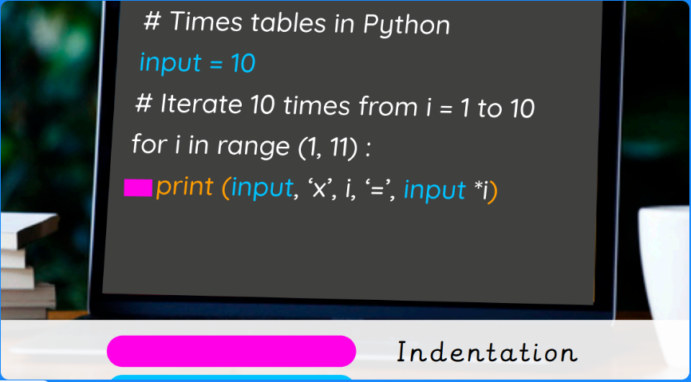

Online Safety: Navigating the Internet in a safe and Respectful Way

Computing Systems and Networks: Bletchley Park
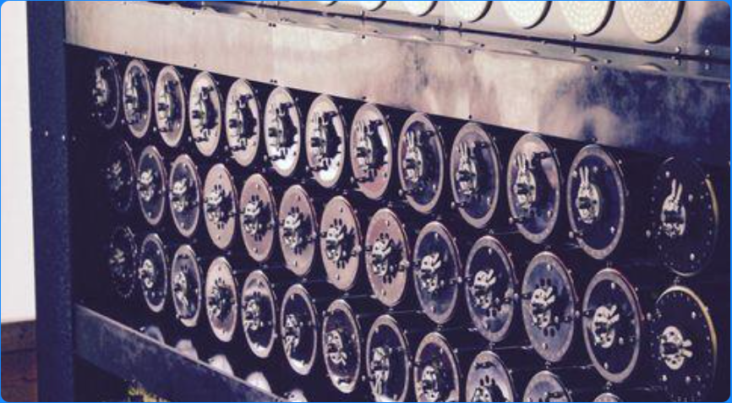

Summer 2nd half term

Skills Showcase: Mars Rover 2

Data Handling:
Big Data 1

Data Handling: Mars Rover 1

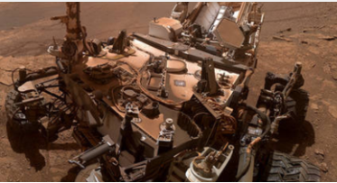

Creating Media: Stop Motion Animation


Programming 1: Music

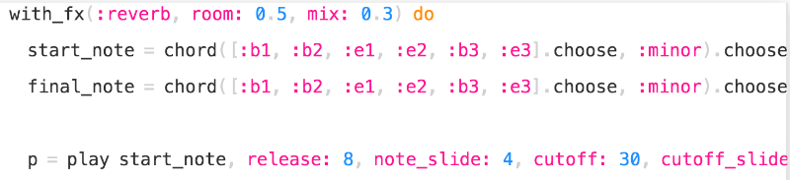

Computing Systems and Networks: Search Engines

Online Safety: Potential Online Dangers

Further Coding with Scratch


Programming 2: Computational Thinking
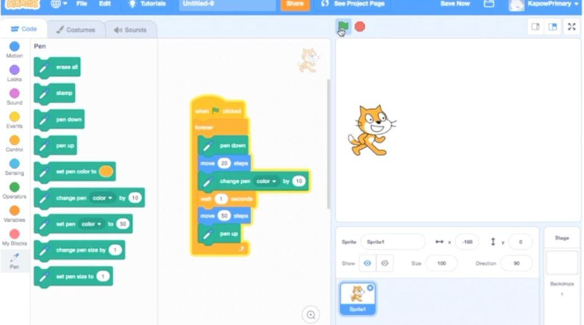
Creating Media: Website Design

Skills Showcase:
HTML

Improving Mouse Skills: Logging in

Online Safety: Navigating the Internet

Data Handling: Comparison cards databases

Creating Media: Video Trailers
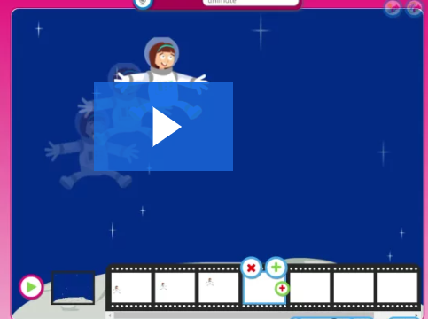

Computing Systems and the Networks 2: Emailing

Programming: Scratch

Computing Systems and Networks: Networks and the Internet
Online Safety:
Fake news, privacy settings etc.
Computing Systems and Networks: What is a computer?
Online Safety: What Happens when I Post Online?

Creating Media: Digital Imagery
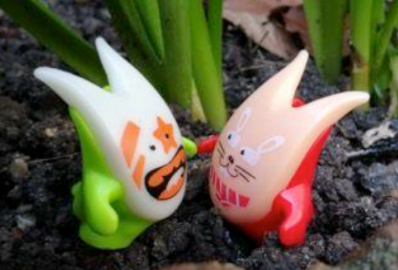

Creating Media: Digital Imagery
Data Handling: Introduction into Data
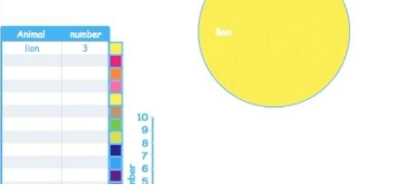

Programming 2:
Bee- Bot

Online Safety: Using the Internet Safely
Data Handling: Introduction into Data

Programming 2: Bee-Bots
Programming: All about Instructions

Programming: Scratch Jnr
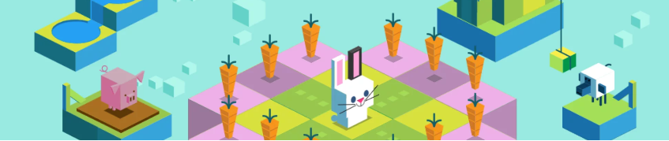
Computing Systems and Networks: Exploring hardware

Computing Systems and Networks: Using a Computer

Year 2

Computing Systems and Networks: Word Processing
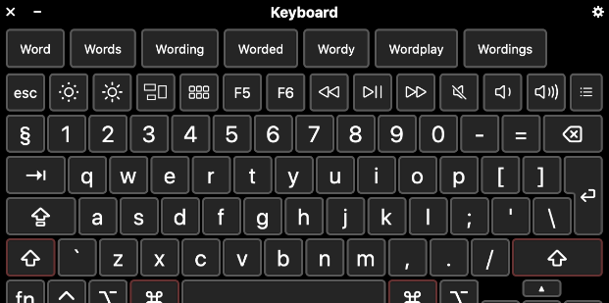
Computing Systems and networks: Collaborative Learning

Programming: Alogorithms and debugging

