

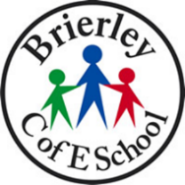
BRIERLEY CE PRIMARY SCHOOL
SCIENCE CURRICULUM PATHWAY

Year 5

Year 4

Early Years

Year 6

Year
1

Year 3

Secondary School

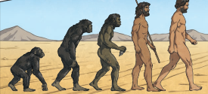
Evolution

Key

Autumn 1st half term

Reproduction

Autumn 2nd half term

Spring 1st half term

Spring 2nd half term

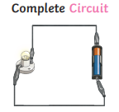
Summer 1st half term

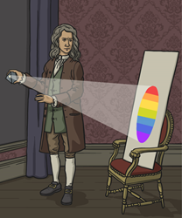
The Human Body

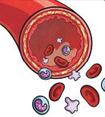
Classification of Living Things
Summer 2nd half term

Electricity

Electricity

Light

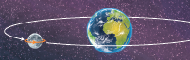

Forces

Astronomy

Materials

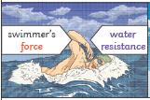
Living Things and their Habitats

The Human Body

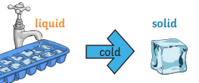
Sound
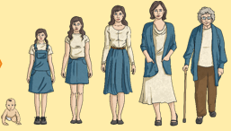
Electricity

Ecology
States of Matter
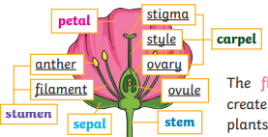
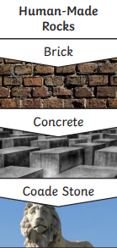
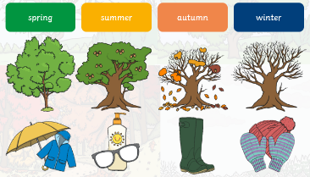
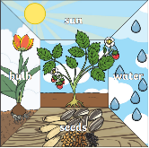
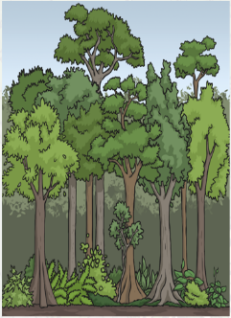
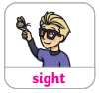
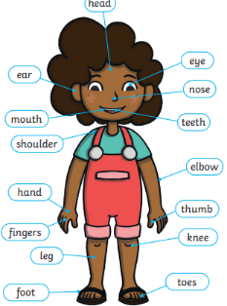
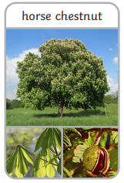
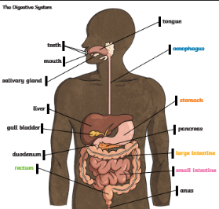
Forces and Magnets

Human Body
Autumn
Woodland Animals
Body & Senses

Forces
Changing States of Matter
Earth and Space
Animals and their Needs

Animals Including Humans – My Body

Growing and Changing (Plants, Animals and Humans)

Cycles of Nature

Materials and Magnets
Astronomy

Changing States of Matter

Seasons and Weathers

Plants – Identifying Plants
Animals Including Humans
Electricity

Light
Plants
Rocks

The Human Body
Materials and Matter
Plants
Taking Care of the Earth

Year 2

Living Things & Their Environments

Classification of Plants and Animals
Summer
Sun Safety

