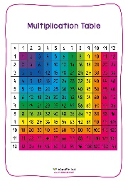
As Writers, we will draw on our own research to write a biography of Charles Dickens who is our class author.
We will also write a character based narrative about Miss Havisham from the great classic novel ‘Great Expectations’
In addition, we will explore some of the issues that affect children across the globe to write a discursive piece on ‘What I want to stand for.’
As readers we will read Dickens’ Great Expectations along with a beautiful picture story full of clues and mysteries to get our brains working.
We will continue to develop our love of reading by reading and sharing a variety of books that are interesting and carefully chosen.
We will also continue to build upon our handwriting and presentation skills in all areas of the curriculum.

As Mathematicians we will:
Dig deep into our understanding of Times Tables and practice them until we know them all!
Learn new arithmetic rules and methods
Place Value will be our main focus for the first two weeks
Following this, we will focus heavily on the Four Operations – addition, subtraction, multiplication and division.
We will take a SATS baseline test in the first week them work in small groups to make lots of progress.

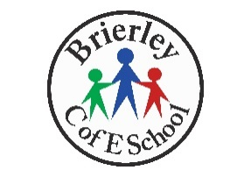
Class Dickens
Autumn 1

We will continue to celebrate and value similarities and differences between ourselves and others from a wide variety of cultures and backgrounds through our ‘Value of the Term’. This half term we are focussing on ‘Koinonia’, teaching children the tools they need to respond to the challenges of childhood and navigate them successfully.

Bringing the Team Together


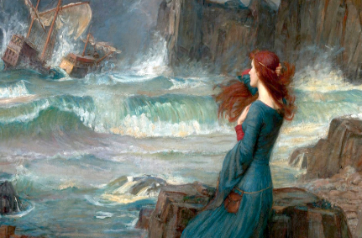
Please make sure that your child has the correct PE kit and all jewellery has been removed.
OUR PE DAY IS WEDNESDAY

As Historians we will be able to:
Answer our enquiry question – How can we learn from the past? By examining propaganda and different people’s experiences of WW1.
Explain the causes of WW1 and how people understood these causes in Britain, certain parts of Europe and Germany.
Explain how different people in our local area experienced WW1.
Explore different sources of evidence from the period 1914-1918
Use the correct historical vocabulary.

In RE we will learn about the Kingdom of God, how the church was founded in community and charitable support for each other.
Our Christian value for this half term is Community

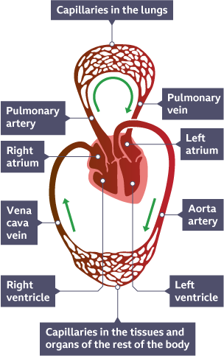
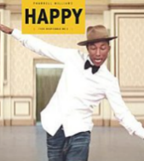
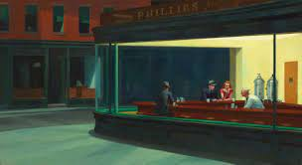
CV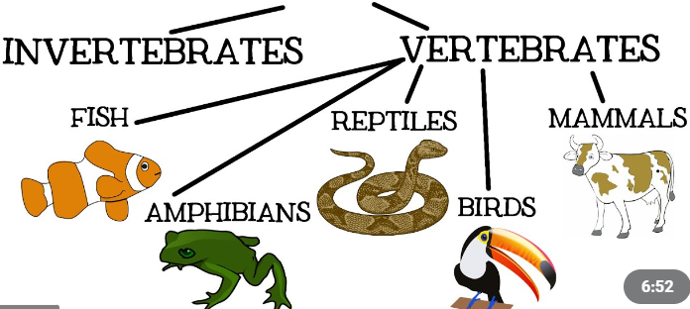
How can I help my child?
Ensure they have access to the online platforms:

Sats companion
Rollama
Mathsbot

Read with your child as often as possible and encourage them to ask for help when they need it.

As Musicians we will be learning about how the song ‘Happy’ by Pharrell Williams is put together in pulse and timbre so we can appreciate it using correct musical vocabulary
We will then learn how to perform it using the glockenspiel and by singing.

As Artists, we will be looking at a variety of artistic techniques, beginning with Claude Monet’s impressionism.
Following this, we will begin to use the system of zentangle pattern making
The half-term will culminate in an analysis and evaluation of Edward Hopper’s mesmerising work.
Use appropriate language to describe what we skills we have learnt.

As Scientists we will learn about the human circulatory system
They will learn about the functions of the heart, the components of blood and blood vessels. They will also learn about how the heart rate is affected by exercise, smoking and certain drugs.
Every half term children develop their science ‘working scientifically’ skills through an investigation day.
This half term children will investigate and make simple observations, and perform simple tests

Don’t forget…
Homework will be set each Friday and must be submitted by the following Thursday to make sure your child gets the help they need.
Thank you

As Technology users we will:
Explain that codes can be used for a number of different reasons and decode messages.
Explain how to ensure a password is secure and how this works.
Create a simple website with information about Bletchley Park including the need to build electronic thinking machines to solve cipher codes.
Explain the importance of historical figures and their contribution towards computer science.

