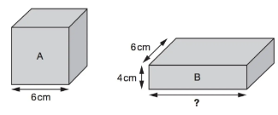
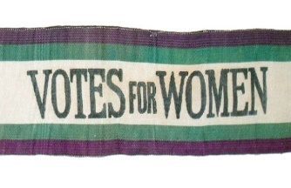
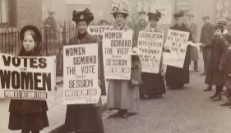
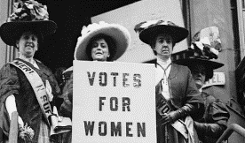
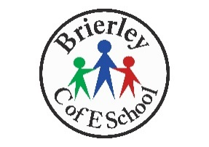
As Writers, we will write a balanced argument on whether or not the school day should be lengthened.
As readers we will complete Goodnight Mister Tom by Michelle Magorian, and read a wide range of texts from different authors to prepare for our Sats Reading paper. We will also learn about Sonnets and how they are written using Iambic Pentameter, then compose our own based on our choice of two mythological star crossed lovers from text, stage or screen.
We will continue to develop our love of reading a range of text types, and will also continue to build upon our handwriting and presentation skills in all areas of the curriculum.

Class Dickens
Spring 2
As Mathematicians we will:
Review what we have learned in the autumn and spring term so far in preparation for our Sats Assessments.
Secure our understanding of arithmetic rules and methods
Continue to review our understanding of the Four Operations – addition, subtraction, multiplication and division.
We will take a mock SATS test in the last few weeks to check our progress.

We will continue to celebrate and value similarities and differences between ourselves and others from a wide variety of cultures and backgrounds through our ‘Value of the Term’ – Endurance. Endurance is important for us right now as we prepare to face the challenges of Sats and all the other hard work that comes with being a Y6 leader of school.

Boosting
up!
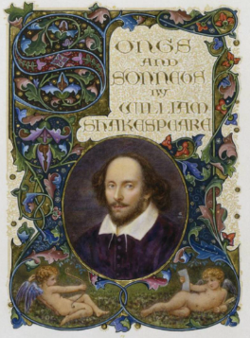
Please make sure that your child has the correct PE kit and all jewellery has been removed.
OUR PE DAY IS WEDNESDAY

As Historians we will be able to:
Explore the history of women who fought for the vote.
We will begin our topic by exploring why women wanted the vote and questioning what they wanted to vote for. We will do this by revisiting our learning about the Industrial Revolution to understand how many people’s lives changed during this period. We will also explore how towns and cities emerged quickly as factories, coal mines and new railways were built, but the conditions in which people had to live were often cramped and unclean. From this point we look at the differences between the Suffragettes and the Suffragists, why each group of women demanded the vote and their experiences of achieving it.

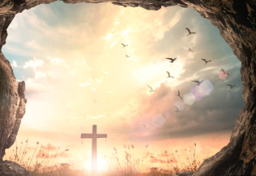
In RE we will ask the question – what does Salvation mean to Christians?
We will explore Jesus’ experience of the crucifixion and resurrection and discuss the many reasons why Christians believe he was brought back from the dead to save us.

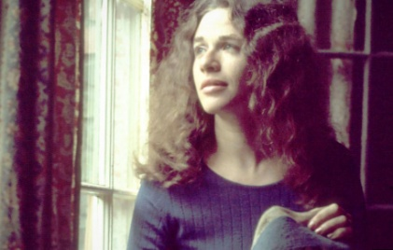
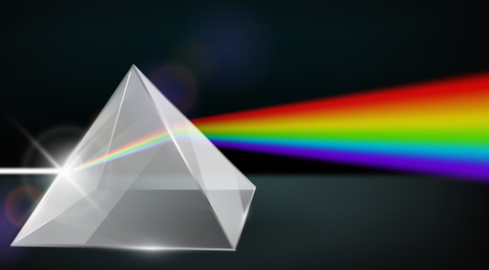
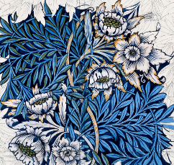
As Artists, we will be learning about William Morris
Our first lesson will be an immersion into William Morris’ famous prints from what we have and use in school to what we can buy easily on the High Street. We will then look closely at the everyday-ness of Morris’ subject matter – the hedgerows, riverbanks and ordinary plants that we have around us. We will then explore Morris’ block printing technique.
We will then design and create our own block print for assessment.

CV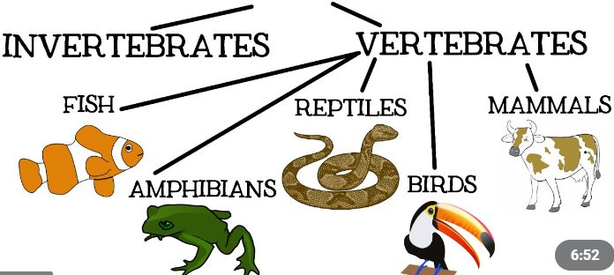
How can I help my child?
Ensure they have access to the online platforms:

Sats companion
Rollama
Mathsbot
Maths Frame
Spelling Frame
Read with your child as often as possible and encourage them to ask for help when they need it.

As Musicians we will be learning about a song written by Carole King – You’ve Got a Friend.
We will then learn how to perform it using the glockenspiel and other instruments, building up our skills ready for a class performance.

As Scientists we will learn about light
We will begin our unit by recapping on our understanding of what we learned in Year 3. We will then focus on five main questions throughout this unit:
- What are natural and artificial sources of light
- How does light travel?
- What are shadows?
- How is light reflected?
- How does the eye work?

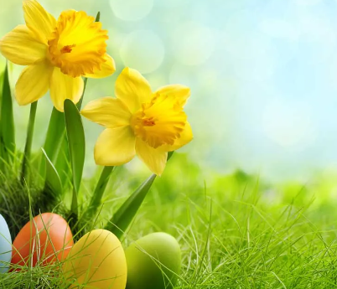
Keep a look out on the website for information about what we are learning in class.
Don’t forget…
Homework will be set SATS Companion each week and must be submitted by the following Thursday to make sure your child gets the help they need.
Thank you

As Technology users we will:
- Understand why barcodes and QR codes were created.
- Create (and scan) our own QR code using a QR code generator website.
- Explain how infrared can be used to transmit a Boolean type signal.
- Explain how RFID works, recall a use of RFID chips, and type formulas into spreadsheets.
- Take real-time data and enter it effectively into a spreadsheet.
- Presenting the data collected as an answer to a question.
- Recognising the value of analysing real-time data.
- Analyse and evaluate transport data and consider how this provides a useful service to commuters.

