Kooth Engagement
Lead Newsletter

We are still here
Welcome to our last newsletter of the year! Over the Christmas period our team are still here to support your young people.

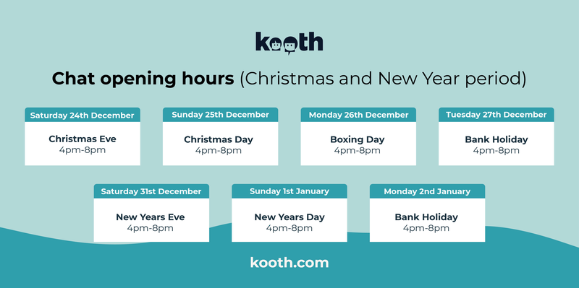

The theme of the month
We are still here throughout December for young people to access support from our team.

The website is open 24/7 so young people are still able to read the magazine, complete the activities and talk to their peers and take part in our live forums. Everything stays the same other than our chat times.

Visit Our Promotion Hub Here


What's on in December!

Support and materials for schools
Please see below all of the resources that are available over the December and Christmas period.
Please see below some resources for you to share to raise awareness of the free, safe and anonymous support available to your students and young people. You can find more resources, including digital assets to share on your social media pages at promote.kooth.com

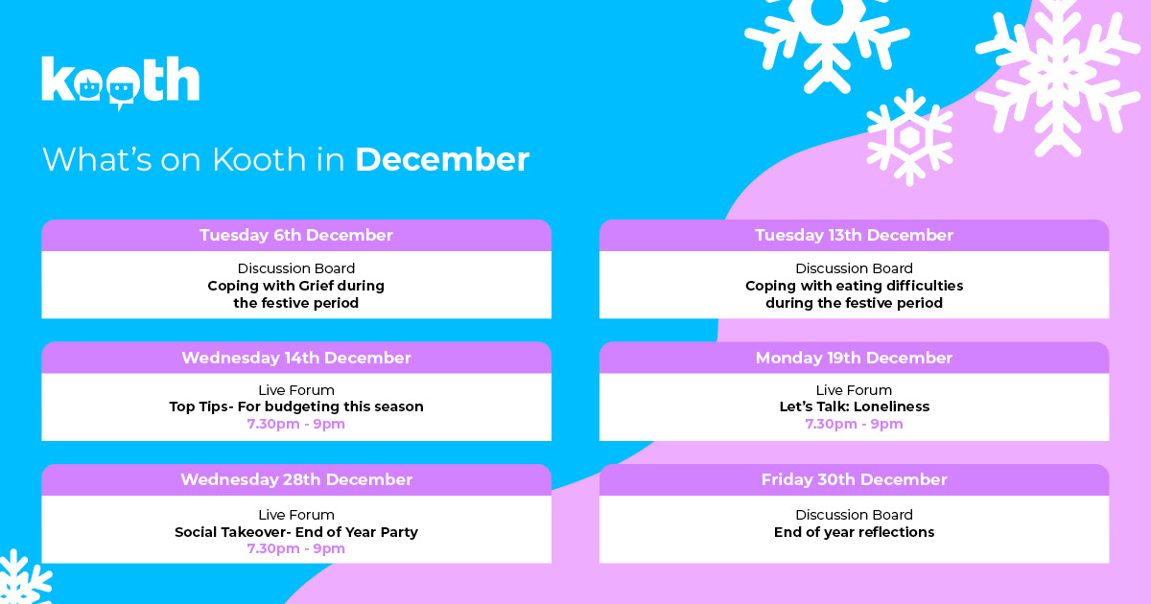

Support for young people
Winter Wellbeing for young people 12th December 9.30am
Winter wellbeing session for young people
Kooth and Help for Heroes announced a new partnership with coverage in Charity Today
Read here

Support for parents and carers

Please share these information documents with parents and carers.
Frequently asked questions
Mini activities brochure
Parents and cares brochure
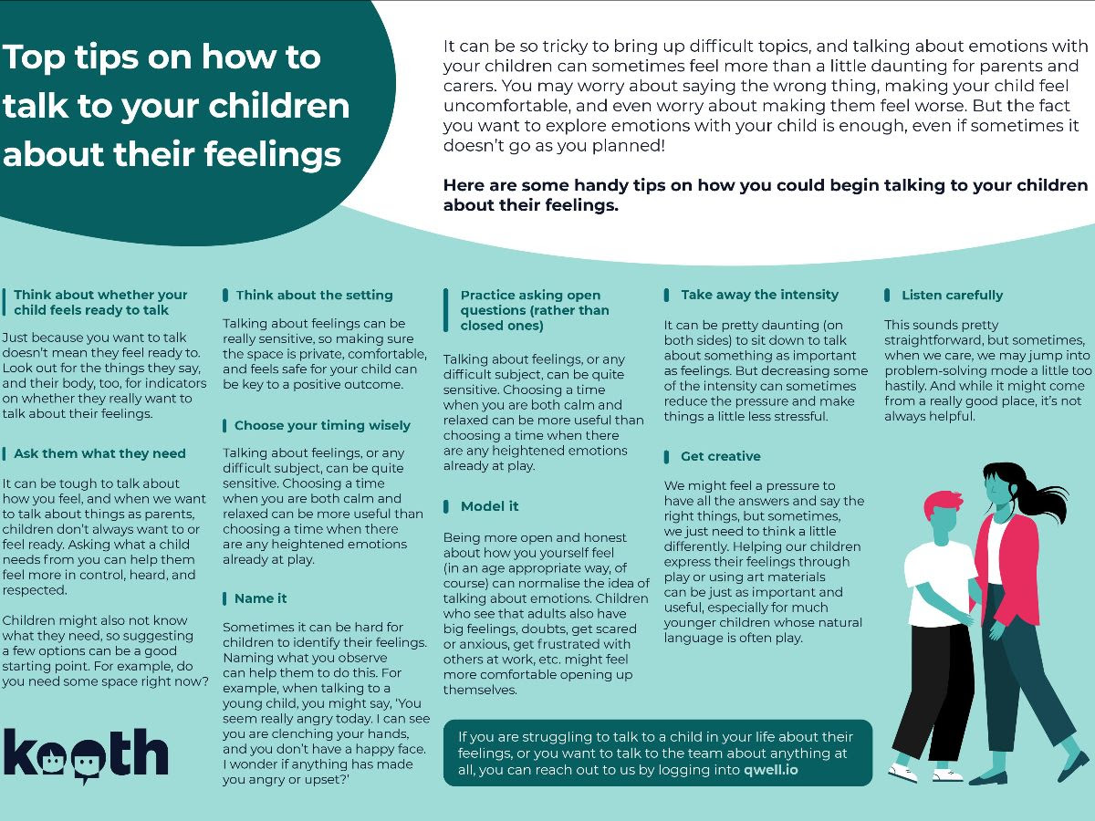

Kooth webinars for Parents and Carers in December
Please use the Eventbrite booking form to register for this webinar on the 6/12/22 from 6-7pm Here

Get in touch with us
Engagement Lead: Heather Hook
To book a session with us or request resources, email kel@kooth.com

