 | Autumn 1  (7 weeks 3 days) | Autumn 2  (7 weeks) | Spring 1  (6 weeks) | Spring 2  (4 weeks 4 days) | Summer 1  (6 weeks 3 days) | Summer 2  (6 weeks)
Cross-curricular theme |  |  | Geography – UK Places  Lakes | Romans  Non-Fiction | History - Romans | Science – mini beasts, food chains
Enrichment e.g. visitor, visitor author, poet
Core Text | 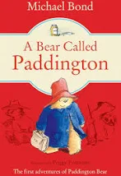  A Bear Called Paddington | 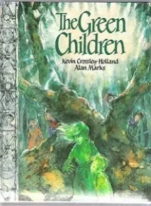  The Green Children | 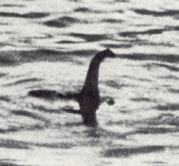  The Loch Ness Monster | Information Texts: Tri-Fold Leaflets  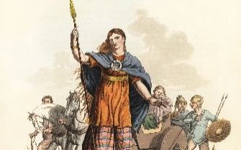  Boudicca | 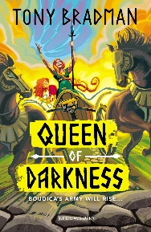  Queen of Darkness | 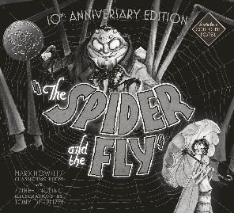  The Spider and the Fly
Linked Texts | Best-Loved Paddington Stories by Michael Bond  The Complete Adventures of Paddington by Michael Bond | The Weed by Quentin Blake The Green Ship by Quentin Blake A House That Once Was by Julie Fogliano and Lane Smith Grandpa Green by Lane Smith | Website articles  Non-Chron report | Horrible Histories: Rotten Romans by Terry Deary Ancient Rome by DK Eyewitness So You Think You’ve Got it Bad? A kid’s Life in Ancient Rome by Chae Strathie 1066 and Before That – History Poems by Brian Moses and Roger Stevens | Land of the Gods by Sally Prue Queen of Darkness by Tony Bradman Revolt Against the Romans by Tony Bradman History Cheat Sheets | Aesop’s Fables by Malorie Blackman A Collection of Favourite Aesop’s Fables by Randall and Gardner Charlotte’s Web by E.B. White James and the Giant Peach by Roald Dahl Spinderella by Julia Donaldson
Poetry |  |  |  |  |  | The Spider and the Fly
Unit and skills | Genre/Text:  Narrative based on a model text with innovated plot structure.  Weeks/Timescale:  3-4 weeks  Reading Skills  Draw inferences around characters’ thoughts, feelings and  actions, and justify with evidence from the text.  Listen to and discuss a range of fiction.  Explain the meaning of unfamiliar words by using the context.  Sequence and discuss the main events in stories.  Use dictionaries to check meanings of words they have read.  Writing skills  Explore, identify and create complex sentences using a range of  conjunctions e.g. when, before, after, while, until.  Use the comma to separate clauses in complex sentences  where the subordinate clause appears first e.g. Before I get  dressed in a morning, I have a wash.  Use past tense for narrative.  Identify, generate and effectively use noun phrases, e.g. the blue  butterfly with shimmering wings (for description).  Generate and select from vocabulary banks e.g. noun  phrases …  Use inverted commas to punctuate direct speech (speech marks).  Improvise, create and write dialogue.  Plan and discuss what to write about, e.g. story mapping,  collecting new vocabulary, key words and ideas.  Read and analyse narrative in order to plan and write their own  versions. Discuss and record ideas for planning using a range of formats e.g.  chunking a plot, story maps. Create and develop plots based on a model.  Proofread to check for errors in spelling, grammar and punctuation. Proofread to check for errors in spelling, grammar and punctuation in  own and others’ writing. | Genre/Text:  Fiction  Weeks/Timescale  4 weeks  Writing Skills  Explore and identify main and subordinate clauses in complex sentences.  Explore, identify and create complex sentences using a range of conjunctions e.g. since, until, before, after, although, as.  Read and analyse non-fiction in order to plan and write own versions.  Identify and discuss the purpose, audience, structure, vocabulary and grammar of non-fiction.  Discuss and record ideas for planning, e.g. boxing up a text type  Generate and select from vocabulary banks e.g. technical language appropriate to text type.  Group related material into paragraphs. | Genre/Text:  Information Booklet  Weeks/Timescale  2 weeks  Writing Skills  Explore and identify main and subordinate clauses in complex sentences.  Explore, identify and create complex sentences using a range of conjunctions e.g. since, until, before, after, although, as.  Read and analyse non-fiction in order to plan and write own versions.  Identify and discuss the purpose, audience, structure, vocabulary and grammar of non-fiction.  Discuss and record ideas for planning, e.g. boxing up a text type  Generate and select from vocabulary banks e.g. technical language appropriate to text type.  Group related material into paragraphs.  Use headings and sub headings to organise information.  Proofread to check for errors in spelling, grammar and punctuation in own and others’ writing. | Genre/Text:  Information texts  Weeks/Timescale  4 weeks 4 days  Writing Skills  Explore and identify main and subordinate clauses in complex sentences.  Explore, identify and create complex sentences using a range of conjunctions e.g. since, until, before, after, although, as.  Read and analyse non-fiction in order to plan and write own versions.  Identify and discuss the purpose, audience, structure, vocabulary and grammar of non-fiction.  Discuss and record ideas for planning, e.g. boxing up a text type  Generate and select from vocabulary banks e.g. technical language appropriate to text type.  Group related material into paragraphs.  Use headings and sub headings to organise information.  Proofread to check for errors in spelling, grammar and punctuation in own and others’ writing. | Genre/Text:  Historical Narrative  Weeks/Timescale:  6 weeks 3 days  Writing Skills:  Explore, identify and create complex sentences using a range of  conjunctions e.g. when, before, after, while, until.  Use the comma to separate clauses in complex sentences  where the subordinate clause appears first e.g. Before I get  dressed in a morning, I have a wash.  Use past tense for narrative.  Identify, generate and effectively use noun phrases, e.g. the blue  butterfly with shimmering wings (for description).  Generate and select from vocabulary banks e.g. noun  phrases …  Use inverted commas to punctuate direct speech (speech marks).  Improvise, create and write dialogue.  Plan and discuss what to write about, e.g. story mapping,  collecting new vocabulary, key words and ideas.  Read and analyse narrative in order to plan and write their own  versions. Discuss and record ideas for planning using a range of formats e.g.  chunking a plot, story maps. Create and develop plots based on a model.  Proofread to check for errors in spelling, grammar and punctuation. Proofread to check for errors in spelling, grammar and punctuation in  own and others’ writing. | Genre/Text:  Poetry  Weeks/Timescale:  6 weeks  Writing Skills  Use present perfect form of verbs using have and had to indicate a completed action  Explore, identify and create complex sentences using a range of conjunctions e.g. because, if, so, although  Explore and identify main and subordinate clauses in complex sentences.  Read and analyse poems in order to plan and write their own.  Identify and discuss the purpose, audience, structure, vocabulary and grammar of poems.  Discuss and record ideas for planning e.g. boxing up  Group related material into paragraphs. Proofread to check for errors in spelling and punctuation in own and others’ writing.
Scaffolded Purpose and Audience | Purpose  Children’s own Paddington adventure story (scaffolded)  Audience  To their table partners | Purpose  Children write their own narrative based on a familiar plot  Audience  To read aloud to an adult | Purpose  To tell others about the Loch ness Monster (letter)  Audience  To peers in other classes | Purpose  To write an information paragraph about Boudicca  Audience  To peers in class | Purpose  To write children’s own whoosh story  Audience  To read aloud to an adult in class. | Purpose  To write a persuasive letter  Audience  To take a copy home to parents or carers.
Independent Purpose and Audience | Purpose  Children’s own Paddington adventure story (scaffolded)  Audience  Peers in the class | Purpose  Children write their own innovated narrative based on a familiar plot  Audience  To write for a display within the school community | Purpose  To inform others about the Loch Ness Monster  (information booklet)  Audience  School community | Purpose  To create a Tri-fold information leaflets about Roman Britain  Audience  To peers in class | Purpose  To write an innovated narrative based on a familiar plot  Audience  To be published on our school website. | Purpose  To write a narrative story inspired by poetry  Audience  To be published on our class webpage
Weekly short independent writing opportunities within the unit | Paddington description  Summary of the story  Speech and thought bubbles from Paddington at different points in the story. | Conversation to speech  Predictions  True/false quiz  Role on the wall | Fun Facts about the Loch Ness Monster  True/False quiz | Job application  Blackout poem  Top Trumps card  Talk Like an Expert documentary/script | Artefact Session True? Say why Impressions of leaders/ characters Boudicca's Speech Character profiles Top Trumps cards Celtic Warrior poem/ song/ speech | Magazine interview Prepositions song CSI report Menus Dream/daydream
Cross-curricular writing opportunities | Geography – capital cities  UK Places
Core Text | 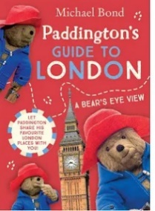  Non-fiction – a newcomer’s information leaflet/guide to London |  | Mimi and the Mountain Dragon  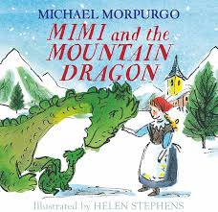
Unit and skills | Genre/Text:  Non-fiction  Weeks:  3 weeks  Writing Skills:  Listen to and discuss a range of non-fiction.  Discuss their understanding of the text.  Use dictionaries to check meanings of words they have read.  Explore, identify and create complex sentences using a range of  conjunctions e.g. when, before, after, while, until. Explore and identify main and subordinate clauses in complex  sentences.  Use the comma to separate clauses in complex sentences where the subordinate clause appears first, e.g. Before I get dressed in a  morning, I have a wash.  Read and analyse non-fiction in order to plan and write their own  versions.  Discuss and record ideas for planning using a range of formats e.g.  boxing- up.  Identify and discuss the purpose, audience, structure, vocabulary  and grammar of non-fiction.  Use headings and subheadings to organise information.  Group related material into paragraphs.  Use the determiner a or an according to whether the next word  begins with a consonant or vowel e.g. a rock, an open box.  Proof-read to check for errors in spelling, grammar and punctuation  in own and others’ writing.  Discuss and propose changes with partners and in small groups. |  | Genre/Text:  Stories with fantasy settings  Weeks:  4 weeks  Writing Skills:  Explore, identify and create complex sentences using a range of conjunctions, e.g. subordinating conjunctions to show time - when, later, after, after that, before, meanwhile, first of all, following this, eventually, next (recap and extend from Y3 Key Learning).  Explore, identify and create complex sentences using a range of conjunctions, e.g. subordinating conjunctions to show cause and effect – because, if, therefore, as a result, this causes, which causes, consequently.  Use commas to mark clauses in complex sentences.  Discuss and record ideas for planning, e.g. text map, non-fiction bridge, boxing-up text types to create a plan.  Use paragraphs to organise writing in non-fiction text.  Link ideas across paragraphs.  Generate and select from vocabulary banks, e.g. subordinating conjunctions to show time; subordinating conjunctions to show cause and effect; technical language appropriate to explanations.
Scaffolded Purpose and Audience | Purpose  Children’s own leaflet/guide/spotter card based on key landmarks around London  Audience  For their peers in class - presentations |  | Purpose  To write an innovated story based on a plot.  Audience  Classroom peers
Independent Purpose and Audience | Purpose  This independent outcome will require children to use a similar model and writing template to the scaffolded outcome, but be themed around different landmarks.  Audience  School community - display |  | Purpose  To write an innovated story based on a plot.  Audience  School community
Weekly short independent writing opportunities within the unit | Fun Facts about the landmarks  True of false quiz |  | Setting description  Character description  Prediction
Cross-curricular writing opportunities | Geography

