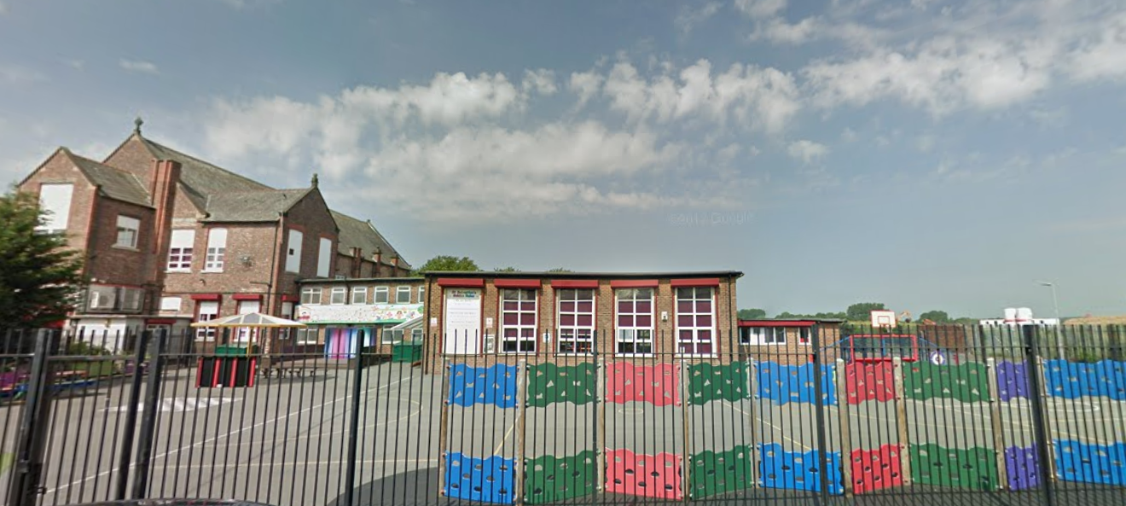
‘Keeping Christ at the heart of all we do’
St. Sebastian’s R.C. Primary School

Curriculum Overview
Year 6 Spring

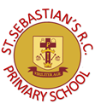
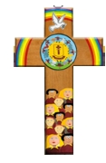
Class Information
Reading – regular reading at home is essential to build up your child’s vocabulary and pace. Please try to read for at least twenty minutes each evening and sign your child’s reading record daily.

Times tables – the rapid recall of multiplication facts is vital for accessing the mathematic curriculum. Regular practise at home is invaluable to prepare your child for lessons in school. Children should access TTRS from home daily.

Spellings – our in-class spelling practise can be supported at home using a weekly spelling shed.

P.E – our P.E days are Monday and Wednesday. Children need to arrive at school wearing their PE kit and plain black trainers.
English | Narrative: In our narrative writing, we will study the Grimm Brother’s Fairy tales and use them to produce a piece of narrative writing with a twist.  Non-Fiction: Using suffragists as an inspiration, we will write an informative and persuasive speech about the environment.
Maths | We will begin the term by exploring ratio and proportion. The children will learn what a ratio is, how it links with fractions and learn to solve ratio and proportion problems. We will then move on to study algebra. The children will learn how to form expressions and use formulae; this will then lead to solving 1- and 2-step equations. Later in the Spring term, we will explore fractions, decimals and percentages. The children will explore the equivalence between fractions, decimals and percentages as well as calculate percentages of amounts. We will finish the spring term by completing a statistics topic.
Religion | We will be thinking about the journey from Galilee to Jericho. They will consider why the Transfiguration is an important event. The children are familiar with the greatest commandment – they will investigate parables such as the good Samaritan to identify how it can be applied.
Science | In Science, we will continue to study Light. The children will explore how light travels and then link this understanding to how objects can be seen. We will then move on to explain why shadows have the same shape as the objects that cast them. Later in the Spring term, we begin by exploring electricity; we will investigate parallel and series circuits.
Geography | In Geography, we will look at World Trade and the economy. We will look at where common products we use every day come from, and how globalisation has changed the economical landscape, debating the positives and negatives of global trade.
History | In History, we will be thinking about the effects of the second world war on other European countries. We will compare the experience to that of people in Britain. The children will consider the Kinder transport, the children will consider the role of propaganda in the second world war and impact it had on individuals.
Design & Technology | We will use our knowledge of electrical systems to design the circuit for a steady hand game. We will then use computer aided design to create a structure to house the electrical components of the game, while being strong enough to support the external components.
Art | As artists, we will be looking at the architectural features of the Byzantine period and how it has influenced architecture around the world. We will look at the mosaics used in Byzantine buildings and create our own tessellating geometric pattern to use as a background for an abstract representation of Byzantine influences in the modern world.
Computing | We will begin the Spring Term by continuing our coding topic. The children will design a playable game with a timer and a score. The children will plan and use selection and variables.  We will then move on to using spreadsheets. The children will build on their learning from year 5, using spreadsheets to calculate information and how to use spreadsheets to plan events.
Music | This term, we will focus on creative composition, and how musical styles connect us. We will listen and respond to a variety of genres, perform the song and then use technology to write sheet music for our own compositions based on the focus song. The social questions we will ask in music this term are ‘how does music improve our world?’ and ‘how does music teach us about our community?’
PSHE | This term, we will be using our chosen scheme of learning, Lifewise, to deliver our PSHE lessons. Our discussion points will range from ‘The Power of Speech’ to how our government functions.
PE | This term, we will learn and develop our dance skills. The children will be taught by a physical education specialist developing coordination and teamwork skills.

