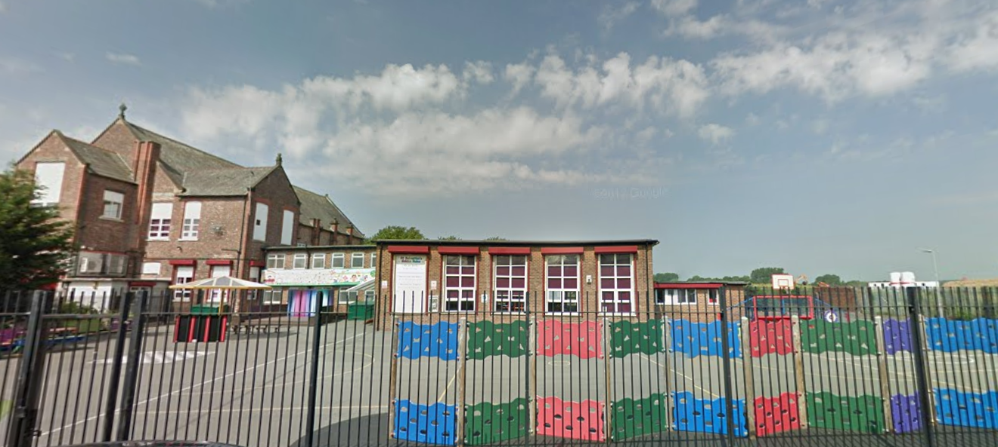
‘Keeping Christ at the heart of all we do’
St. Sebastian’s R.C. Primary School

Curriculum Overview
Year 5 Spring

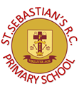
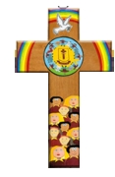
Class Information
Reading – regular reading at home is essential to build up your child’s vocabulary, pace and understanding. Please try to read for at least twenty minutes each evening and sign your child’s reading record daily. Encourage them to read from a variety of texts.

Times tables – the rapid recall of multiplication facts is vital for accessing the mathematic curriculum. Regular practice at home is invaluable to prepare your child for lessons in school. Children should access TTRS from home daily.

P.E – our P.E days are Monday and Wednesday. Children need to arrive at school wearing their PE kit and suitable footwear.
English | Narrative: In our narrative writing, we will study the book The Island and use it to produce a piece of our own narrative writing.  Non-Fiction: The Curiosity- we will use this to write an informative text.  Whole class guided reading takes place throughout the week using a different text each week.
Maths | In maths, we will begin a major fractions unit where we will learn to recognise equivalent fractions, convert between mixed numbers and improper fractions, compare and order fractions, and add and subtract them, including those involving mixed numbers. In our arithmetic sessions, we will continue to strengthen our skills in the four operations—addition, subtraction, multiplication and division—working up to multiplying 4‑digit numbers by 2‑digit numbers and dividing 4‑digit numbers where there is a remainder.
Religion | In RE, we will explore key Gospel stories and teachings, including the Greatest Commandment, the Transfiguration, the Parable of the Good Samaritan, the Beatitudes, and the Our Father, and how they guide Christians in living out their faith.
Science | In Science, we will be investigating properties and changes of materials. We will study reversible and irreversible changes such as burning, rusting and how bicarbonate of soda reacts with different liquids.
Geography | In Geography, we will be learning about Volcanoes and Earthquakes. We will be learning about the structure of the Earth, plate tectonics, how volcanoes are formed and why people live near them. We will look at how earthquakes happen and the effect that they have on people.
History | In History, we are studying the Slave Trade and the legacies it has left behind. We will also explore the long‑term impact of slavery on societies around the world, including its influence on culture, human rights and modern discussions about equality and justice.
Design & Technology | As designers, we will create our own structures by planning, designing, making and then evaluating how well they work.
Art | As artists, we will look at Pop Art and created some pieces influenced by Andy Warhol.
Computing | In Computing, we will continue using spreadsheets to calculate information and how to use spreadsheets to plan events. We will then be creating databases.
Music | This term we continue with our Ukelele lessons provided by MAPAS.
PSHE | We will be using our chosen scheme of learning, Lifewise, to deliver our PSHE lessons. Our discussion points will range from healthy eating and other ways in how we can keep our body healthy.
PE | In Spring 1, we will be learning the skills of hockey and applying them to a game and in dance, we will be using different dance styles to develop sequences and express a chosen mood. In Spring 2, we will be learning the learning the skills of netball and practise attacking and defending within a game.

