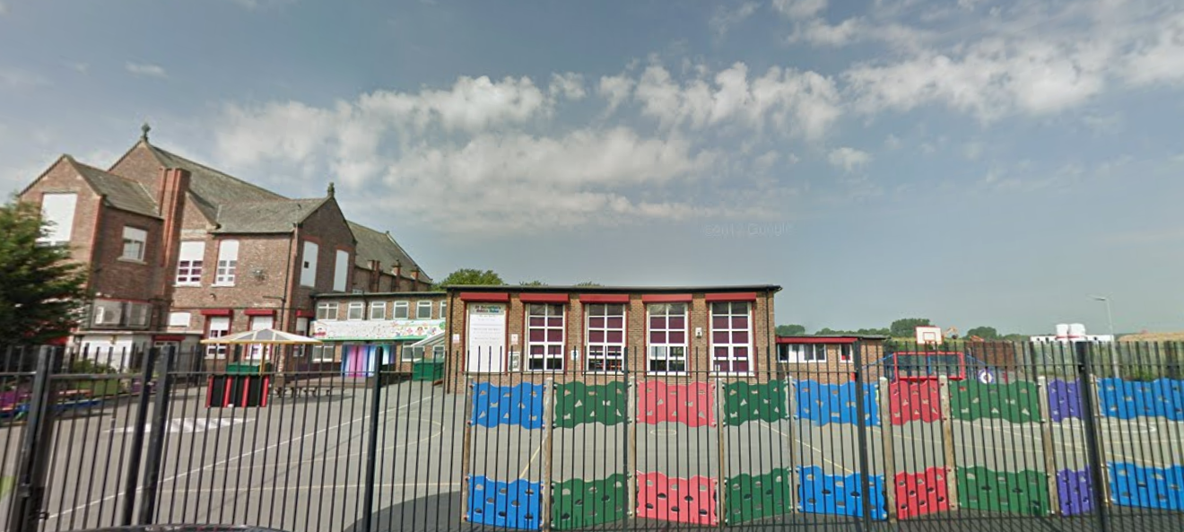
‘Keeping Christ at the heart of all we do’
St. Sebastian’s R.C. Primary School

Curriculum Overview
Year 5 Autumn

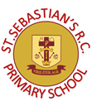
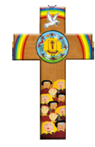
Class Information
Reading – regular reading at home is essential to build up your child’s vocabulary and pace. Please try to read for at least twenty minutes each evening and sign your child’s reading record daily. Encourage them to read from a variety of texts.

Times tables – the rapid recall of multiplication facts is vital for accessing the mathematic curriculum. Regular practice at home is invaluable to prepare your child for lessons in school. Children should access TTRS from home daily.

P.E – our P.E days are Monday and Wednesday. Children need to arrive at school wearing their PE kit and suitable footwear.
English | Narrative: We will be studying the text The Lost Thing and writing our own narrative.  Non-Fiction: We will be studying the text Children of the Benin Kingdom and writing a non-chronological report.
Maths | As mathematicians, we will focus on the place value up to 1,000,000. The children will partition, compare and order numbers and practice rounding numbers as well as investigating negative numbers and Roman numerals. They will move onto multiplication, including finding prime numbers, factors and square/cubed numbers.
Religion | The children will be exploring the covenants in the Bible. They will consider who made them, why they made them and the impact on the life today. The children will analyse scripture and contextualise the meaning.
Science | As scientists, the children will learn about the changes that human beings experience as they develop to late adulthood. They will compare the gestation periods of mammals, learn about the life cycle of a human being and explore the changes that occur during puberty.
Geography | The children will study mountains, including the biggest mountain ranges across the world and the highest peaks of the UK. We will particularly focus on the Himalayas and discover what mountain life is like. Additionally, the children will learn to read maps efficiently.
History | As historians, we will investigate the Kingdom of Benin from a range of historical sources. We will identify the characteristic features of the society and period through historical enquiry. The children will deduce information by looking at and interpreting artefacts.
Design & Technology | As designers, the children will analyse and evaluate a range of existing frame structures. The children will use their knowledge of how to strengthen, stiffen and reinforce 3-D frameworks to produce their own 3-D structure.
Art | As artists, we will explore the symbolic meanings behind the art and design of the ancient Benin civilisation. We will work in 2D form to create our own designs influenced by the art and craft of this African kingdom.
Computing | We will focus on internet safety and how to stay safe when playing online games. We will also be investigating coding by using numbers and spread sheets.
Music | As musicians, the children will learn to play some chords on the ukulele. They will also begin to read basic music.
PSHE | This term, we are focusing on RHE (relationships and health education), specifically looking at how the children are growing and changing and how this links to our emotions. We will also be looking at the British values of Democracy.
PE | This term, the children will learn the rules of Jag-Tag and apply this to a game. They will also be learning the different passes in basketball and learn how to successfully pass and defend in a game.

