Year 1
What I already know:
- When I was born
- The human lifecycle – stages from a baby to a child to an adult.
- That my family have grown up and changed.
- That I have grown and changed.
- Know some similarities and differences between things in the past and now.
What will help me with in the future:
Understand Equality- (Year 6 ) WW2 in Britain – stereotyping of men and women during WW2 and suffrage – gender stereotypes- stereotyping of black people linking to Rosa Parks (year 2 )– slavery (year 5)
Understanding Trade- where do our modern toys come from? Linking to traders like Vikings (year 4) Slave trade (year 5)

How have toys changed over time?
Key Vocabulary
Old | Belonging to the past.
Modern | Belonging to the present.
Past | It has already happened.
Equality | Everybody is treated the same and has the same rights.

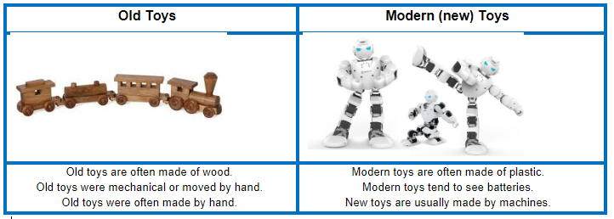

Disciplinary Concepts How Historians work

- Chronology
- Significance
- Cause and consequence
- Change and continuity
- Similarity and difference

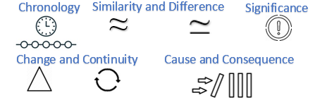
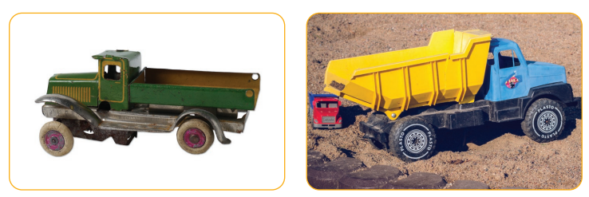
Democracy Rule Trade Warfare Knowledge
Substantive Concepts
The content knowledge

What will I learn?
- Toys have been around for thousands of years.
- Toys have changed and developed over the years.
- The way toys are designed and the materials used to make them have changed.
- The material, design and technology of a toy can give us clues about whether it is old or new.
- How to identify whether a toy is old or new.

