Key Vocabulary
colony | a country or area under the full or partial political control of another country and occupied by settlers from that country
empire | a large commercial organization owned or controlled by one person or group
kingdom | a ruler of any of several African peoples of western Nigeria a
Oba | country, state, or territory ruled by a king or queen
What I already know that will help me:
- Toys changed when countries traded materials.(Year !)
- Rosa Parks were significant people who fought for change and equality. (Year 2)
- The Romans built an empire through invasion.(Year 4)
What it will help me with in the future:
- Understand how the transatlantic slave trade began and deepen my understanding of inequality

Year 5 - Benin
How is the Kingdom of Benin different to Britain?

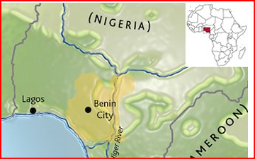

Empire Equality Trade People of significance and their impact
Disciplinary Concepts

- Chronology
- Significance
- Cause and consequence
- Change and continuity
- Similarity and difference

Substantive Concepts

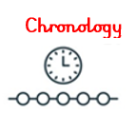
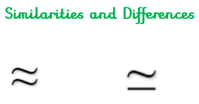

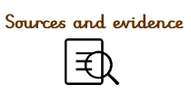
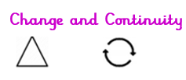
What will I learn?
- The political structure was led by the Oba who had absolute authority and no one dared to challenge him.
- The Benin Kingdom had a sophisticated social structure of professions and guilds. Job roles were well defined – farmers, potters, blacksmiths, crafts people, doctors, drummers, acrobats, dancers, soldiers and hunters.
- Benin art and sculpture made from ivory, brass and wood was very popular. There were established trade routes with Portugal in artwork, gold, ivory, and pepper.
- There was well-developed town planning. Engineering and the use mathematics underpinned the architecture of the city. Benin City was protected by a moat and walled fortifications.
- The invasion of Benin by British troops in 1897 resulted in the removal and exile of the reigning Oba Ovonramwen. He was replaced by British overrule who then made the Kingdom part of British Nigeria colony to add to the British Empire.

