Key Vocabulary
Air raid | An attack in which bombs are dropped from an aircraft to a ground target
Conscription | Compulsory enlistment into the armed forces.
Evacuation | Leaving a dangerous place and moving to somewhere safer.
Rationing | Only allowing people to have a fixed amount of something, e.g. food.
Year 6
What was the impact of the Second World War on our local area?
What will I learn?
- The Second World War was caused by a series of events that began at the end of WW1 with the treaty of Versailles.
- British children were evacuated from their homes due to the risk from German air raids.
- The roles of women changed significantly during the war as most men were conscripted into military service.
- Changes to the British food supply meant that rationing had to be implemented, limiting the amount of food each person was allowed to buy.
- What will this help me with in the future?
- In KS3 I will study:
- Why the world went to war in 1914 (WW1).
- Who or what was responsible for the outbreak of the Second World War in 1939.

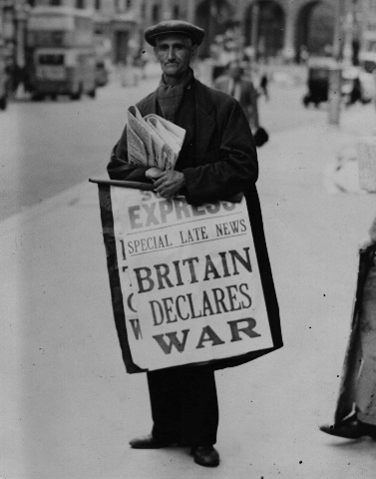
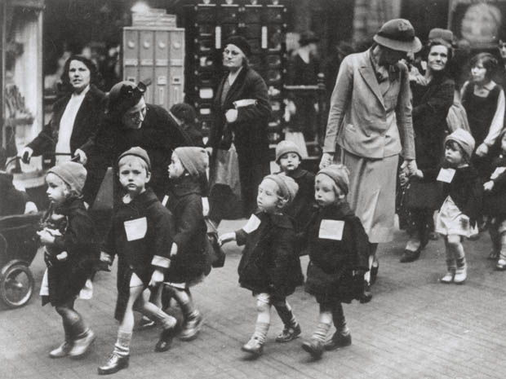

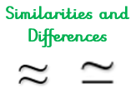

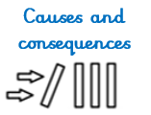
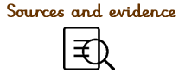
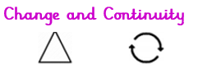
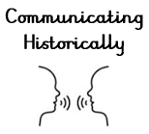
What I already know that will help me:
- The Industrial Revolution created jobs in factories and expanded the rail network around Great Britain.
- British colonies produced food, which was imported into Britain by boat.
Significant People
Trade
Equality
Substantive Concepts
The content knowledge

Disciplinary Concepts How Historians work

- Chronology
- Significance
- Cause and consequence
- Change and continuity
- Similarity and difference

