Key Vocabulary
century | A division of the Roman army made up of 80 soldiers and led by a centurion.
Emperor | A sovereign ruler of an empire.
Empire | A group of states or countries ruled over by a single monarch or a sovereign state.
Legion | The main unit of the Roman army Senate (a group of prestigious men who advised the consuls.
What I already know that will help me:
- Florence Nightingale, LS Lowry and Rosa Parks were significant people who fought for change and equality.
What will this help me with in the future?
Boudicca – links to equality and people creating change and how they approach it with Suffrage (in year 6)
Empire – Links to later in year 4 empires can become powerful because they had good traders like the Vikings.
Understanding is developed in year 5 When looking at the invasion of Benin- empires can have colonies-made slaves of people they rule.

Year 4
What was the legacy of the Romans?

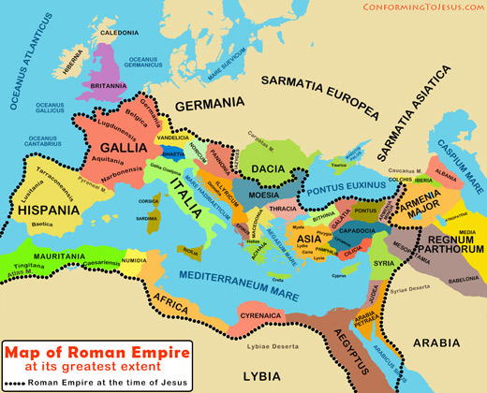




What will this help me with in the future...
- 43AD Romans invade Britain and it becomes part of the Roman Empire.
- 401-410AD The Romans withdraw from Britain: Anglo-Saxon migrants begin to settle.
- 61AD Boudicca leads the Iceni in revolt against the Romans.
- Romans influenced coins, trade, and road influences.
Change and Continuity
Similarities and Differences
Causes and consequences
Chronology
Disciplinary Concepts

- Chronology
- Significance
- Cause and consequence
- Change and continuity
- Similarity and difference

Empire Equality Trade People of significance and their impact
Substantive Concepts

