Sea
Science
Animals Including Humans

Key Vocabulary
Atrium – The upper chambers of the heart.
Circulatory System – The system that controls the flow of blood around the body.
Deoxygenated – Not containing oxygen.
Oxygenated – Containing oxygen.
Ventricle – The lower chambers of the heart.
Vessel – Tube which circulates blood through the body.
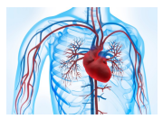
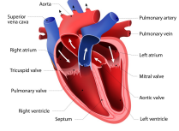

In Science we will investigate some key questions:
- What is the function of the heart?
- How does blood move through our bodies?
- What is in our blood?
- How are water and nutrients transported around our bodies?
- What affects our heart rate?
- What is the impact of drugs and alcohol on the human body?

