PSHE Long Term Plan Whole school

2-3
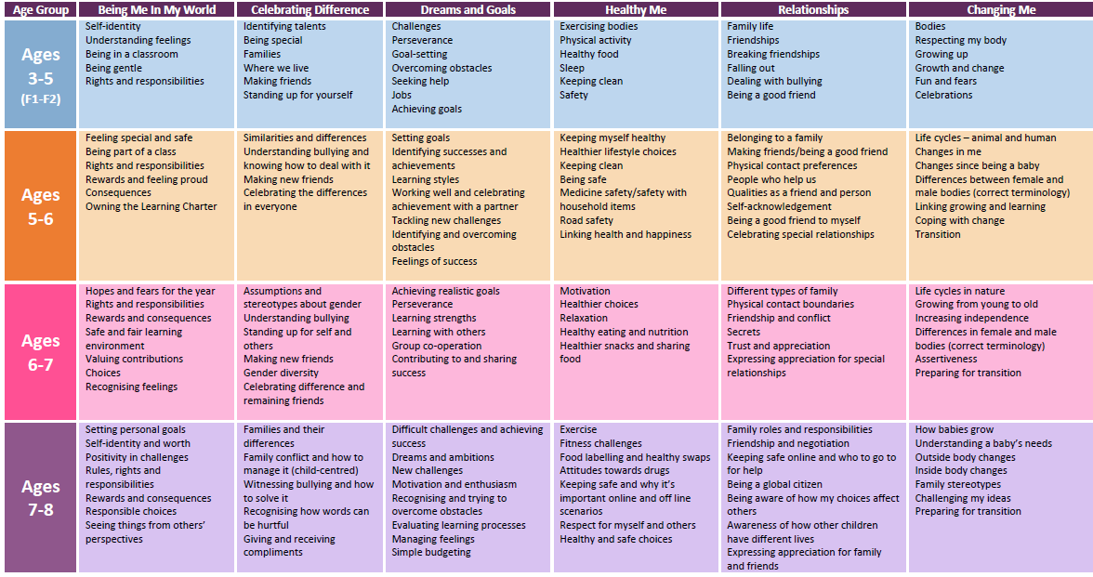 Year 3

