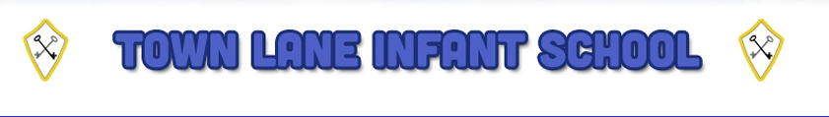
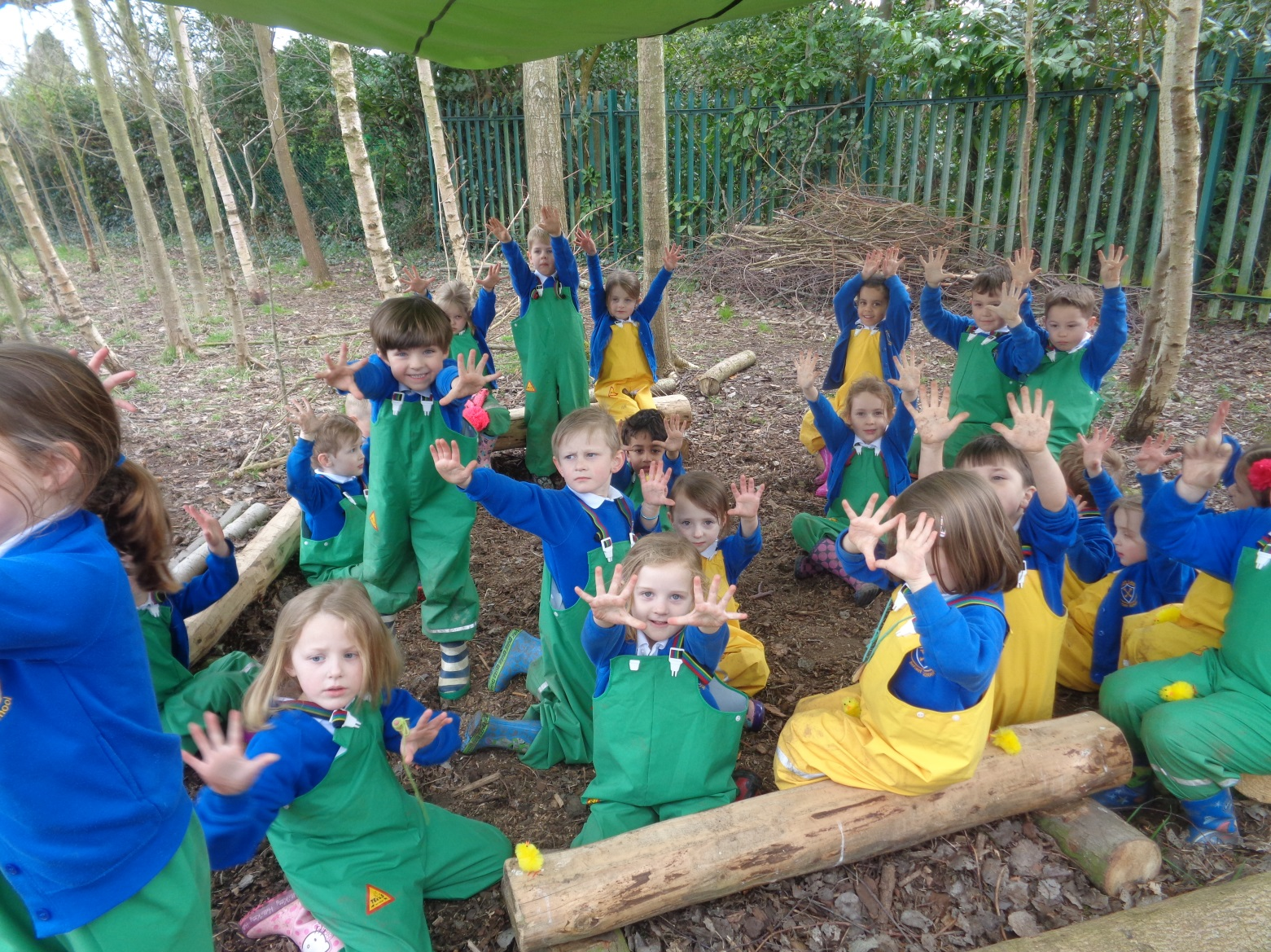
Forest School at Rosie’s Woods

Contents Page
Section 1:
Forest School Vision/Ethos
Where does the idea come from?
Who is a forest school for?
What is it like at our Forest School?
The 6 Principles of Forest School.

Section 2:
Wellbeing
Our Forest School Code of Conduct

Section 3:
Policies and Protocols.

Forest School Vision/Ethos
Our Forest School is an inspirational programme that offers our children regular opportunities to appreciate and enjoy their local woodlands. We aim to nurture an understanding and respect for natural places. Children experience nature at first hand through a series of engaging and achievable tasks. Our Forest School experience brings learning to life and improves a child’s ability to work co-operatively whilst offering them opportunities to take risks, make choices and initiate learning.
Where does the idea come from?
Forest schools originated in Sweden during the 1950s and were a way of teaching children about the natural world. The idea was adopted by Denmark as an important part of Early Years provision. The concept was introduced to Britain in 1995 by Bridgwater College and is being developed all over the country. We are the only school in our area to offer this to all our children on such a regular basis.
Who is a forest school for?
Everyone can benefit from Forest School. Forest School provides a valuable teaching tool for a wide range of curriculum subjects and is an excellent way to support and enrich the National Curriculum and engages children with a variety of needs and learning styles.
What is it like at our Forest School?
At the moment, our children attend Forest School for half a term every term. During these sessions, children experience all sorts of woodland activities that help them to build an understanding and appreciation of the woodland as well as learn together in a totally unique way. The fire circle is central to all that happens at Forest School. The fire is the focal point for discussing the day's activities and a place for socialising and sharing. The activities are always hands-on and will often require the use of tools a range of tools depending on the age of the children. As a group becomes more comfortable with living and working in the woodland the programme becomes more learner led and is a journey of discovery directed by the children.
Principles of Forest School:

Principle 1: Forest School is a long-term process of frequent and regular sessions in a woodland or natural environment, rather than a one-off visit. Planning, adaptation, observations and reviewing are integral elements of Forest School.

• Forest School takes place regularly, ideally at least every other week, with the same group
of learners, over an extended period of time, if practicable encompassing the seasons.

• A Forest School programme has a structure which is based on the observations and collaborative work between learners and practitioners. This structure should clearly demonstrate progression of learning.
• The initial sessions of any programme establish physical and behavioural boundaries as well as making initial observations on which to base future programme development.

Principle 2: Forest School takes place in a woodland or natural wooded environment to support the development of a relationship between the learner and the natural world.

• Whilst woodland is the ideal environment for Forest School, many other sites, some with only a few trees, are able to support good Forest School practice.

• The woodland is ideally suited to match the needs of the programme and the learners,
providing them with the space and environment in which to explore and discover.

- A Forest School programme constantly monitors its ecological impact and works within a sustainable site management plan agreed between the landowner/ manager, the forest school practitioner and the learners.

• Forest School aims to foster a relationship with nature through regular personal experiences in order to develop long-term, environmentally sustainable attitudes and practices in staff, learners and the wider community.

• Forest School uses natural resources for inspiration, to enable ideas and to encourage
intrinsic motivation.

Principle 3: Forest School aims to promote the holistic development of all those involved, fostering resilient, confident, independent and creative learners

• Where appropriate, the Forest School leader will aim to link experiences at Forest School to home, work and /or school education

• Forest School programmes aim to develop, where appropriate, the physical, social, cognitive, linguistic, emotional, social and spiritual aspects of the learner.

Principle 4: Forest School offers learners the opportunity to take supported risks appropriate to the environment and to themselves.

• Forest School opportunities are designed to build on an individual’s innate motivation,
positive attitudes and/or interests.

• Forest School uses tools and fires only where deemed appropriate to the learners and dependent on completion of a baseline risk assessment.

• Any Forest School experience follows a Risk–Benefit process managed jointly by the practitioner and learner that is tailored to the developmental stage of the learner.

5. Forest School is run by qualified Forest School practitioners who continuously maintain and develop their professional practice.

• Forest School is led by qualified Forest School practitioners, who are required to hold a minimum of an accredited Level 3 Forest School qualification.

• There is a high ratio of practitioner/adults to learners.

• Practitioners and adults regularly helping at Forest School are subject to relevant checks into their suitability to have prolonged contact with children, young people and vulnerable people.

• Practitioners need to hold an up-to-date first aid qualification, which includes paediatric (if appropriate) and outdoor elements.

• Forest School is backed by relevant working documents, which contain all the policies and procedures required for running Forest School and which establish the roles and responsibilities of staff and volunteers.

• The Forest School leader is a reflective practitioner and sees themselves, therefore, as a
learner too.

6. Forest School uses a range of learner-centred processes to create a community for development and learning

• A learner-centred pedagogical approach is employed by Forest School that is responsive to the needs and interests of learners.

• The Practitioner models the pedagogy, which they promote during their programmes
through careful planning, appropriate dialogue and relationship building.

• Play and choice are an integral part of the Forest School learning process, and play is
recognised as vital to learning and development at Forest School.

• Forest School provides a stimulus for all learning preferences and dispositions.

• Reflective practice is a feature of each session to ensure learners and practitioners can
understand their achievements, develop emotional intelligence and plan for the future.

• Practitioner observation is an important element of Forest School pedagogy. Observations feed into ‘scaffolding’ and tailoring experiences to learning and development at Forest School.

Section 2

Wellbeing

This section outlines expectations for the wellbeing of the participants and staff of forest school. It should be read as a series of protocols which must be adhered to.

Our Forest School Code of Conduct
Entering the Forest: We will enter the Forest respectfully and know that when at Forest School specific expectations are in place. We will explore, investigate, learn and play in a manner that will not damage our Forest environment. We understand that we share our Forest School with plants and animals and that when we are in our Forest School we are sharing the environment with them.

Boundaries: Before each session begins children are made aware of how far that they can explore and of any fixed boundary markers. If children move to explore hidden areas an adult should also move into the cover deep enough to be able to see the children but
allowing the children the freedom to explore independently. If you lose sight of a child shout
‘1,2,3, where are you?’ The children have been taught to respond ‘1,2,3, I’m over here’ through games that are practised regularly.

Lighting a fire: When lighting a fire the Forest School leader will take control of the operation and all accompanying adults will be briefed before we start. A lit fire will not be left unattended at any point. A fire may not be lit until it has been confirmed to all that our fire safety equipment is in place. Open fires will be built within designated fire circles.

Tree Climbing: An adult must be present when wanting to climb trees in the Forest School. The ground cover should be checked for ‘sharp objects’ and the tree identified as suitable for climbing. A visual check must be made for loose and rotten branches. Children are permitted to explore to their own limits or to a maximum height of 1.5m. Adults should be near enough to catch if a child should fall but far enough away to not be invasive to the children’s exploration

Carrying and Transporting Materials: Children are encouraged to roll, lift, drag and to pull materials, either by using their hands or by using ropes. We encourage safe lifting by bending our knees and keeping our back straight. Safe lifting should always be modelled by adults. Heavier objects should be rolled, lifted or carried by more people working together.

Rope and String Use: We encourage the collection and transportation of materials. We do not allow children to tie up each other. If a child has a good idea and wants to tie up something, for example a tarp or a swing, an adult should help them as needed, modelling appropriate knot tying and modelling how to talk through ideas and decisions.
Picking up and playing with stones: Stones may be picked up and transported. Children often like to make patterns and pictures with them. Stones may not be thrown. They may be dropped but thought must be given to whether it is safe to do so, i.e. what is beneath where
I am dropping it?

Using Tools: All tools have their own clear code of conduct for correct use which will include consideration of specific personal protective equipment, correct use of a specific body posture, and consideration of the appropriate types of activity that each tool may be used for. (See tool procedures).

Picking up and playing with sticks: Children can carry sticks shorter than their arm’s length but are encouraged to think about how close they are to other children. Sticks must be carried pointing towards the floor. Longer sticks may be dragged or carried with the help of another person when each person is at either end. Sticks must not be thrown.

Eating and Drinking: Nil by mouth policy for anything found in the Forest, unless this activity has been specifically planned for during the session (e.g. blackberry picking). Children must be reminded not to put their fingers or hands in their mouths or noses. When having drinks and snacks children will use wipes & water to clean their hands before consumption.

Collecting wood: Wood is collected for fire lighting purposes. It is collected in four thicknesses – matchstick sized, pencil sized, thumb sized and wrist sized. Sticks may be collected for creating pictures and patterns but should be collected sparingly so as not to disrupt creature habitats.

Clothing: It is important that all children and staff have appropriate clothing suitable for all weather conditions.
Forest School leader will ensure that they carry items of spare clothing in the kit bags. If any
child is considered inappropriately dressed for Forest School and alternative clothing cannot be found in school that child will remain at school

Winter: Vest or T-shirt long sleeved jumper, waterproof coat, socks, trousers, water proof trousers, wellies, hat, gloves and scarf.
Summer: T-shirt or top, light trousers, socks, trainers, shoes or wellington boots (sandals and flip-flops are not suitable), sunhat, sunglasses (if required). Participants are also responsible for providing their own insect repellent and sunscreen.

Toileting: Before a Forest School session, children will be given the opportunity to go to the toilet. While at Forest school the children will be allowed to utilise the Reception toilets when needed as it is a small distance from the wood they will be accompanied by a TA or teacher.

Walking up Procedure
Children are familiar with safe walking procedures. Staff will give instructions, such as single file walking, paired walking where applicable. During progressive sessions children are gaining skills in performing risk assessments and will become more aware of dangers of moving up to site.

Weather
Before the session use a local forecast to assess safety of running. The site should be assessed prior to taking out a group. Try and leave cancellation as late as possible. Below is a short outline of conditions that may lead to a cancellation of a session:
• A rough guide is don’t enter woods in winds of force 4 increasing to 5.
• In windy conditions keep a watchful eye on the surrounding tree branches.
• A rule of thumb is to leave the wood if substantial tree branches are blowing at 20 degrees or more.
• Be aware that it is possible for tree limbs and branches to drop on any day.
• Check Young Peoples clothing before going out on cold days.
• Carry spare clothing and a shelter sheet, such as a parachute.
• If the children are getting too cold either warm them up through exercise, shared shelter, sitting by the fire or going inside.
• In the case of extreme heat, children will be encouraged to drink plenty of water,
wear suitable clothing, seek shelter from the sun when necessary and staff will
monitor the situation and end session if necessary.
• Where children are distressed by extreme weather conditions a decision can be made to end a session either for that child or the in some cases the whole group. It is important to remember emotional wellbeing is important as physical wellbeing.

Daily Operating Procedure

What to do before the session
• Check that all risk assessments are in place, particularly the check list
• Assess the site for new hazards
• Set up activities
• Take up and check equipment
• Prepare snack and drink
• Ensure that there is correct staff/client ratio and that all staff are familiar with this handbook.

Before the walk up
• Register: Register to be completed by class teacher
• Check children are appropriately dressed
• Ensure children have water bottles
• Make sure children have been to the toilet.
• Head count of children.
• Remind them of the walk up rules.

What to do during the session
Ongoing risk assessment: Ongoing risk assessments to be carried out by a Forest school leader. Head count: carry out regular head counts, particularly when entering and leaving site. Run activities. Observe and evaluate.

What to do after the session
• Head count
• Tool Check and tools maintenance.
• Evaluation for next session the learning is reviewed and evaluated. Forest school leader will discuss any observations with the other adults who have attended the session and will review the session in general. Evaluate the plan for the session that has just been completed and then plan for the next session taking due consideration of all observations and comments made.

Section 3:
Policies and protocols:

As Town Lane Forest School operates as an integral part of the Infant School it is subject to the same policies of the school which can be found in full here:
http://www.townlaneinfantschool.eschools.co.uk/website

All staff and volunteers are asked to read the policies and pay particular attention to the following:

- Safeguarding Policy
- Health and safety policy
- Confidentiality policy
Safeguarding Statement
Town Lane Infant School is committed to the safeguarding of all pupils in our care. To that end, all staff, governors and volunteers will help keep our children safe by:

- Adhering to the school’s Child Protection and Safeguarding policy
- Providing a safe place for our children to learn and develop
- Ensuring that our behaviour does not make any child or member of the school community, uncomfortable or leave us vulnerable to accusation
- Having the children’s physical, emotional, and personal safety at the forefront of all we do.
- Immediately notifying the Head Teacher of any concerns, however trivial they may seem, in order to pull together a picture of any potential safeguarding issues.

All staff employed by the school, and volunteers who work in school for a set minimum of time as outlined in official guidance, will be subject to DBS checks. References will be sought and safer recruitment procedures adhered to at all times.

Code of Conduct:
Code of behaviour
Do keep to this code at all times.
Do treat everyone with dignity and respect.
Do set an example for others to follow.
Do treat all young people equally – do not show favouritism.
Do follow the recommended adult-to-young people ratios for activities.

Confidentiality
It is important never to repeat anything overheard or witnessed in school. If there are any concerns regarding a child/children please discuss with the designated teacher. A copy of the Confidentiality Policy is available

Equality and diversity:
We operate under the School’s policy on Equality and Diversity namely:

Equal Opportunities Statement: We promote equality and the building of a democracy in which all members have rights and responsibilities, and the same opportunity to benefit from, and take part, in the education provided by the school – within and beyond its premises. Diversity is valued as a rich resource that can contribute to the learning of all pupils and staff.

Disability Statement: Town Lane Infant School is proud to be an inclusive school. We offer access to a broad and balanced curriculum for all pupils regardless of disability. We strive to ensure all pupils can access, educationally and physically, all learning opportunities within and beyond the school. We aim to ensure that all users can access key learning areas, and will ensure that no user experiences any discrimination or reduced entitlement to learning due to being unable to physically access areas of the school.
As with any additional needs the school works closely with parents and appropriate outside agencies to ensure equality of access for all.
Every Child Matters: This Effective Learning policy demonstrates how we aim also to meet
the five outcomes outlined in the document ‘Every Child Matters – Change for Children
2004’ (DfES publication – 1088-2004, version 1.0); namely:

1. Be healthy
2. Stay safe
3. Enjoy and achieve through learning
4. Make a positive contribution to society
5. Achieve economic well-being

Behaviour protocol

Forest School aims to:
1. Build self-esteem, independence, motivation to learn whilst always maintaining a safe environment
2. Promote awareness, respect and care for other individuals and for the natural environment
3. Reinforce collaborative behaviour
4. Develop continuity of expectations and of approach to behaviour management both at
Forest School, in school and beyond
5. Develop awareness of acceptable behaviour and responsible behaviour in an outdoor environment
6. Develop in both children and adults a pride in their achievements.

In order that these aims are achieved, certain standards of behaviour must be sustained and reinforced across school. A copy of the school Behaviour Policy is available either through the school website or in the school office.

Supporting the Children to Listen and engage

• Use words children understand.
• Use the child’s name if you know it. If not, ask what it is.
• Make eye contact and get on the same level as the child.
• Speak calmly.
• Look and sound confident and be firm.
• Be friendly – smile!
• Have fun within limits.
• Listen to children – remember they learn by copying!
• Always do what you say you are going to do.
• Where appropriate take a child to the side and talk to them on a 1:1.
• Try clapping hands or rhyme motions to get the attention of the children.
• Raise hand and stand quietly to get attention.
• Explain why you are doing something.
• Apologise to a child if you are in the wrong. You earn their respect by showing you are prepared to do this.

How we encourage good behaviour:

• Adults should show an interest and listen to the children
• All children should be treated fairly and equally. Don’t label children and jump to the
wrong conclusions
• Give gentle reminders
• Adults should stay calm. This will help you to remain in authority and be effective
• Give praise frequently – it’s more effective than criticism
• Adults should recognise and reward good behaviour
• Adults should encourage children to take responsibility
• Adults should encourage children to apologise and be considerate and caring of
other people’s feelings
• Help children out of awkward situations which would prevent bad behaviour occurring
• Smile and appear happy; hence producing happy children
• Talk to pupils in informal situations
• Set high standards in all you do with pupils

Risk Protocol:
We encourage our children, in a safe and structured way, to take risks. Children learn by their mistakes and by being free to make them in a comfortable and safe surrounding. When appropriate children should be encouraged to “have a go” at an activity, take a risk and learn from their experiences.

We have a legal duty to carry out Risk Assessments but this does not mean that children have to miss out on a whole load of adventurous activity and fun! If the risk or potential harm from the activity is acceptable or can be managed/minimised and the benefits for the value in the activity outweigh the risk then that has to be a goer.

If risk in children’s lives is eliminated then not only do their environments become sterile
and boring but children will not want to be part of it. They will go and find the fun elsewhere or create their own, which could result in unwanted behaviour.

Children also need to learn how to assess risks and be responsible for their own safety, and this can be done by involving children in discussing an activity, highlighting what the risks are, how the risks can be reduced or substituted and what are the fun elements they will get out of the activity that outweighs the risks that are left. This exercise of consultation and participation with children also creates an equal relationship where children and young people feel they are listened to, their contribution is valued and that they are not constantly beholden to adults in the setting for the adults to give them the go ahead to do everything. They have a stake in the process too.

Risk benefit templates are no different from the usual risk assessments that are carried out
– apart from one important factor – we also record what the benefits of the activities to give a balanced holistic account of the activity. This provides us with the confidence and the means to provide a more risk taking play environment.

There are three main areas to think about once an activity has been identified

- Acknowledge what the benefits are – what benefits will the children gain? This could cover areas such as increased confidence, sense of achievement, freedom, physical development, contact with nature, trying out an activity that is usually seen as adult, social skills, fine motor skills/sharing skills. The lists goes on and remember to involve the children and if possible think about getting comments from parents or other people that may come to your setting.

- What are the risks – this needs child and adult input as you are looking at the obvious risks as well as the ones that are not so obvious. Many heads of mixed ages are better than one. You then need to think how you can remove or minimize the risk and how this will be communicated to staff, all children [being aware of the individual needs of the children] and the parents.

- Put safety measures in place that you have identified and record this – this will cover the likelihood of the risk happening, who could be harmed and what you are doing to reduce/eliminate. It will also need to record what to do if an accident/incident does occur.

Alongside dynamic risk assessment at Forest School we conduct four levels of Risk Analysis:

1) Site Assessment
2) Daily Check
3) Activity Risk benefit Assessment
4) Tool/resource Risk Benefit Analysis

Fire Protocol
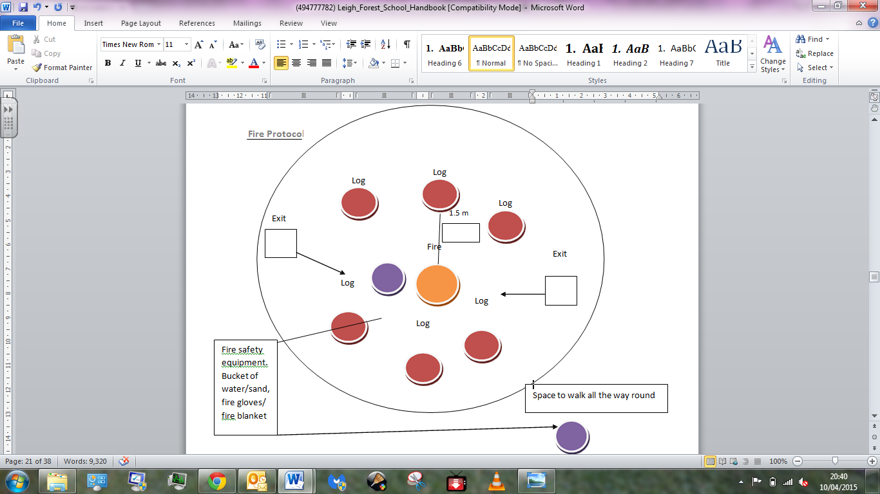

- Establish a fire area, checking for branches beforehand.
- Train young people how to approach and leave before lighting a fire.
- Don’t light in windy or very dry conditions.
- Keep fires approx 4m from any shelter built from easily combusting materials. If a shelter is designed to have an integral fire establish safety rules and multiple exits before use (check design with an expert and keep a record of this).
- Ensure fire kit, including fire resistant gloves and water, is close by.
- Respect position should be used when sitting around the fire.
- Never leave a fire unattended.
- No one may enter the fire circle perimeter unless invited to do so by an adult.
- There may be no running past the fire circle.
- No items must be carried and placed within the fire circle unless by an adult.
- If you wish to move around the fire to a new stool you must step out of the circle and walk around the outside of the log circle.
- Even when the fire is unlit we will treat it as if it is lit.

When Cooking

- Inform parents/carers of planned activity and gain permission. Check client group does not suffer from food allergies or that other reasons, such as religious reasons, do not permit individuals to handle or consume certain food types. Ensure you have up-to date information about allergies and religion.
- Food hygiene regulations should be followed.
- Risks assess working area and activity.
- Carry soap and water for hand washing.
- Split open food and check it is cooked before consumption.
- When cooking with a stick use green wood and remove bark before cooking using a knife and scraping action.
- Don’t re-heat cooked food.
- Avoid foods that need a lot of fat to cook in case of pan fire.
- Get young people to tuck in long hair and tie, roll up or fasten loose clothing.

Tool Protocol

Tools should be checked before and after each session and monitored when in use. Duct tape is carried to make safe any tools which break during the session. Only in the use of the bow saw should a glove be worn when using tools.

When introducing a new tool:

- Ask the children what it is and what it is for.
- Discuss uses for the tool at Forest School.
- Teach children the tool talk for each tool.
- Emphasise that all movements should be made in the direction away from the body.
- Keep the hand holding the wood as far away as possible from the blade.
- Always assume respect position –Low kneel.
- When passing tools, ensure eye contact is maintained. A useful script is:
- ‘This is a ……………... I am passing you the ’.
‘Thank you’.

Secateurs and Loppers

Using small chopping tools – secateurs, scissors, loppers
Benefit of  Activity | Hazards | Risks | Risk  Level | Control Actions | Revised  Risk Level
self-esteem,  confidence, knowledge of keeping safe, sense of achievement | Sharp blades | Serious injury—cuts, lacerations | High | Tool talk and  demonstration before pupils allowed to use tools.  Safety reminders at the beginning of each session.  Supervision at a distance required, close supervision if group leader  deems appropriate for individual child.  All tools to be kept in good working order.  Emergency procedures in place, first aid kit and mobile phones carried at all times. | Low

General information/Safety rules/Storage

Secateurs are used for cutting twigs and branches that are too thick to be cut by scissors. Loppers are used for cutting twigs and branches that are bigger than a 2p piece.
Secateurs should always have the safety lock in place when being carried. They should be carried by the handle, with the point towards the ground. One hand should be on each handle when using the loppers and ensure there is a safe working area. When using secateurs the working area should be clear of others. The other hand should be held well away from the blade.

Tool Safety Check

Examine handles and hinges. Spray with WD40 if stiff. Make sure there are no signs of damage or rusting.
Open the handles over your lap. Use a thumb to wipe the blades at a right angle, it should feel rough.
Ensure the locking and spring mechanisms on the secateurs are working properly.
Tool Maintenance and Cleaning

Use a cloth to wipe the blade clean and dry.
Oil the tool and sharpen with sharpening stone as required.

Vegetable Peelers

Benefit of  Activity | Hazards | Risks | Risk  Level | Control Actions | Revised  Risk Level
Self-esteem, confidence  knowledge of  keeping safe, sense of achievement | Sharp  blades | cuts,  lacerations | medium | Tool talk and demonstration before pupils allowed to use tools.  Safety reminders at the beginning of each session.  Supervision at a distance required, close supervision if group leader deems appropriate for individual child.  All tools to be kept in good working order.  Emergency procedures in place, first aid kit and mobile phones carried at all times. | Low

General information/Safety rules/Storage

This tool is used for whittling wood.
Children should be reminded of safety rules above. Peelers work best with green wood. Dead wood can be tricky, requiring children to use more pressure.
Peelers should be carried by the handle with the blade pointing down. Peelers are stored in the tool box.

Tool Safety Check

Check the handle, ensuring the grip is securely in place.
Wiggle the handle and blade to ensure they are attached securely together.

Tool Maintenance and Cleaning

To clean the peelers, run a gloved finger down each side to remove bark and dirt. On return to school, ensure the peelers are dry.

Bow-Saw

Benefit of  Activity | Hazards | Risks | Risk  Level | Control Actions | Revised  Risk Level
self-esteem,  confidence, knowledge of keeping safe, sense of achievement | Sharp blades | Serious injury—cuts, lacerations | High | Tool talk and  demonstration before pupils allowed to use tools.  Safety reminders at the beginning of each session.  Supervision at a distance required, close supervision if group leader  deems appropriate for individual child.  Always used hand over sawing technique  All tools to be kept in good working order.  Emergency procedures in place, first aid kit and mobile phones carried at all times. | Low

General information/Safety rules/Storage

When using a bow saw use the handover method. Bow saws should be used in pairs. Children should be kneeling seated at either side of the piece of wood, with their legs at a distance from the saw. The hand holding the wood should be away from the blade. Bow saws are carried at the side of the body with the teeth facing backwards. Guards should be on at all times when saw is not in use and when being carried and transported.

Tool Safety Check

Examine the handle for damage. Ensure the blade is firmly attached to the handle. Examine the blade for chips and replace when necessary. Check the blade cover for damage and replace when necessary.

Tool Maintenance and Cleaning

Dry the blade, guard and handle

Knife

Benefit of  Activity | Hazards | Risks | Risk  Level | Control Actions | Revised  Risk Level
self-esteem,  confidence, knowledge of keeping safe, sense of achievement | Sharp  blades | Serious  injury—cuts, lacerations | High | Tool talk and  demonstration before pupils allowed to use knives  Safety reminders at the beginning of each session.  Close supervision. All knives to be  kept in good working order.  Group leader to supervise and control access to knives.  Knife sign in and out book  Emergency procedures in place, first aid kit and mobile phones carried at all times. | Low

General information/Safety rules/Storage

Knives are used for whittling and other controlled wood work. Knives should always have safety cover on when being carried and not in use. Safe seated position (with Legs apart and elbow on knees) or kneeling position depending on the task should be used. The blood bubble criteria should be adhered to at all times. Knifes should be numbered kept in a secure box and signed out.

Tool Safety Check

Check the blade, handle and cover for any damage or rust. Check blade for sharpness. The blade should feel rough. Use the knife to test sharpness. Check that the handle is secure and that the blade does not wobble.

Tool Maintenance and Cleaning

Wipe the knife clean and dry. Rust needs to be sanded off. Sharpen when necessary using the sharpening stone. A sharp knife is safer than a blunt one.

Food and Drink Protocol:

The following protocol should be followed at Forest School:

The Forest School Leader will be responsible for checking that no member of the group has any listed allergy to any of the products; if they have, the Forest School Leader will use their discretion as to whether a substitute product or different activity will be most appropriate. Children will be taught, at an age appropriate time, reasons why berries and/or fruit from the woodland may not be eaten during Forest School sessions. They will be reassured that fruit from the woodland can be safe to eat, but can equally be dangerous and that adult (i.e. parent) supervision is very important in ensuring only the correct berries are eaten.
Main benefits:
• Self reliance
• Ecological awareness of inter-connectedness (e.g. weather & seasons, natural navigation, how they affect the plants, which insect, animal and bird species are directly reliant to certain species etc., and how our use of these plants affects the eco-system.)
• Team work
• Confidence building
• Direct inter-active relationship with the environment
• Understanding risk
• Enhance knowledge (naturalist)
• Empathy
• Development of sense (safe, successful gathering requires all physical senses)
• Education about sustainability – practical skills used in foraging, including pruning and coppicing
• Important and valuable supplement to modern diet as wild foods are rich in minerals, vitamins and nutrients quality largely absent from the modern diet. Many of these plant also help the body to de-toxify which is particularly valuable in modern times when we are bombarded by population.

Development of practical skills and tool use:
• Pruning, use of loppers, secateurs and pruning saw
• Coppicing
• Digging sticks, trowels etc. for roots
• Use of fire and cooking techniques Preparation of wild foods can involve many different processing techniques
• Development of understanding source of foods and the energy required in processing. This develops appreciation and relationships with nature.

Emergencies:
First Aid | 1: Follow the policy and procedures document. Ant illness or injury to be treated by a qualified first aider.  2: Check Dr –A-B-C, Administer First Aid.  3: Remove others in group from the situation, ensuring they are safe.  4: Notify school office and if necessary call for further assistance, or notify emergency services.  5: Have medical details available in medical bag, and notify parents/guardians as appropriate.  6: All accidents, however minor, must be written in the accident report book.  7: Follow up to parents as usual.
Missing Child.  (Majority of Forest school sessions will take place in secure school grounds.) | 1. On discovery of missing child use ‘1,2,3, where are you?’ procedure and recall rest of the group.  2. Activity for the rest of the group shall be suspended in order that up to two members of staff, including the Forest School Facilitator if appropriate may be released to conduct a search which shall last no more than five minutes. The rest of the Group will be kept in the learning area and sedentary activities such as having a snack, singing or sharing activity run by remaining adults.  3. The school will be informed so that they can contact the child’s parents and inform them of the situation.  4. Staff should corroborate details of the situation, including last known position of the missing child and any timings. These will be recorded on the Emergency Procedures Record Sheet
Death or Serious Incident | 1: Follow First Aid procedures  2: Remain with causality and remove others in group from the situation, ensuring they are safe.  3. Immediately notify school office  4. School to inform emergency services, specifically the police  5. The police will notify the parents/guardians/next of kin.  6. Gain advice on follow up from the police  7. Report to RIDDOR and Ofsted.
Stranger or Uninvited Person | 1. Challenge intruder, asking them to leave immediately. Escort them from the site.  2. Inform the School’s Office and Child  Protection Liaison Officer.  3. If a child is involved the police must be called, and the child/children involved are to be removed from situation and made to feel safe.  4. Parents/guardian should be briefed by Forest School Leader ASAP or in accordance with advice of the Police, ASAP.
Serious Behaviour Problems | Always adhere to school policy  1. Talk child involved down.  2. Remove other children from the area of risk, if it is deemed to be necessary.  3. Inform office and call for help as needed.  4. Debrief child after calm down period  5: . Log incident.  6. Inform parents/guardian  7. Create risk assessment, if necessary  8. Close supervision and monitoring of behaviour.
Emergency Procedure Protocol
All participants will be briefed in what to do in case of emergency. A whistle will be blown as a signal to stop what you are doing, gather with a member of staff, be silent and wait for instructions. The Forest School Leader will assess the situation, the nature and extent of the injury/accident. They will ensure that the rest of the group are safe from danger and are adequately supervised. They will attend to the casualty, giving first aid of necessary. An incident report will be completed later.

In case of injury
If anyone sustains an injury or illness which cannot be treated by first aid on site and requires medical assistance:
1. In serious cases, 999 should be dialed using a mobile phone carried by the Forest School Leader and then the school will be notified. The school will be responsible for notifying the parent.
2. The rest of the group will be supervised away from the incident and if in danger, will be
moved to safety.
3. One member of the staff will meet the ambulance at the site entrance and direct the crew to the incident site.
4. If the injured child is taken to hospital, one member of staff will go with them and the
child’s parent will be updated about the situation by the staff remaining at school.
5. In minor cases, the Forest School Leader will arrange to contact the parent of the injured child so they can be collected and taken to the hospital, doctor or home.

Home Contact: Reception at school 0151 608 1918
Emergency procedure and access details:
The site can be accessed via the carpark through a double gate.

Requesting Attendance by Emergency Services
• Dial 999 and ask for the emergency service. Be ready with the following information:

Telephone number (mobile number if call is made on a mobile – see above) Details of your location
A brief description of the problem (for example, if you are requesting an ambulance, you will need to describe the symptoms of the person who is injured/ill)
State that the crew will be met by at the entrance to the location to the
site.
Speak clearly and slowly and be ready to repeat the information if asked.

Site Name: Town Lane Infant School Address: Town Lane
Bebington, Wirral CH63 8LD
Grid reference: SJ 324851

If an emergency occurs where Forest School Leader is needed to administer first aid the remaining Forest School Leader will resume control of the group and the volunteers will support the continuation of the activity where possible. If this is not possible the children will be asked to return to the base camp. The remaining staff will run sedentary games. Where an emergency occurs which does not require first aid the emergency will be dealt with by a Forest School Leader.

