St James CE

Primary School


SEND Report

Introduction and Our School Approach:
At St James C of E Primary School, we use the definition for SEND and for disability from the SEND Code of Practice (2015). This states:
Special Educational Needs: A child or young person has special educational needs if he or she has a learning difficulty or disability which calls for special educational provision to be made for him or her.
  - A learning difficulty or disability is a significantly greater difficulty in learning than the majority of others of the same age.
  - Special educational provision means educational or training provision that is additional to, or different from, that made generally for others of the same age in a mainstream setting in England
  - Disability: Many children and young people who have SEND may have a disability under the Equality Act 2010 – that is ‘...a physical or mental impairment which has a long-term and substantial adverse effect on their ability to carry out normal day-to-day activities’. This definition includes sensory impairments such as those affecting sight or hearing, and long-term health conditions such as asthma, diabetes, epilepsy, and cancer.

Our School Approach

St James CE Primary School creates a positive SEND culture where all staff have a responsibility for each child with SEND and work together in the best interests of the child. We are ‘inclusive by design’ in all that we do. Inclusion, including support for children with SEND and those who are socioeconomically disadvantaged, is a collective responsibility embedded across all aspects of school life. This approach reflects the principles outlined in Every Child Achieving and Thriving (DFE, February 2026), with a focus on ensuring that every child can access the right support at the right time to achieve and thrive. We have high aspirations and expectations for all pupils, driven by our Christian Vision and values.

Our 10 ‘Inclusive Practice Principles’ are central to our ‘Inclusion by Design’ approach. They enable our Inclusion Strategy vision to be lived out and provide a clear framework for all school stakeholders to implement, embed and monitor inclusive practice in response to the changing needs of our pupils. All 10 principles hold equal importance and work as a cumulative whole to develop a strong, consistent and sustainable culture of inclusion.

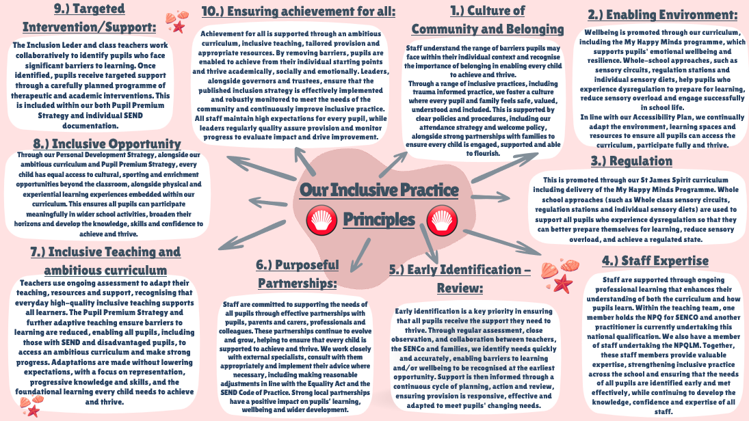

Quality-first teaching and inclusive practice is evident throughout the whole school (both in our classrooms and during intervention sessions) as teaching and learning is adapted, modified and personalised to ensure all children make progress. This report demonstrates our approach to SEND that we as a whole school have adopted in our everyday practice.
Our school adopts the Graduated Approach cycle of Assess, Plan, Do, Review (APDR). This approach ensures we can have early identification of SEND, assess an individual child’s needs effectively, plan how we can best meet their needs and most importantly review the impact we are having on a child and their progress and plan for further reasonable adjustments necessary to help the child.
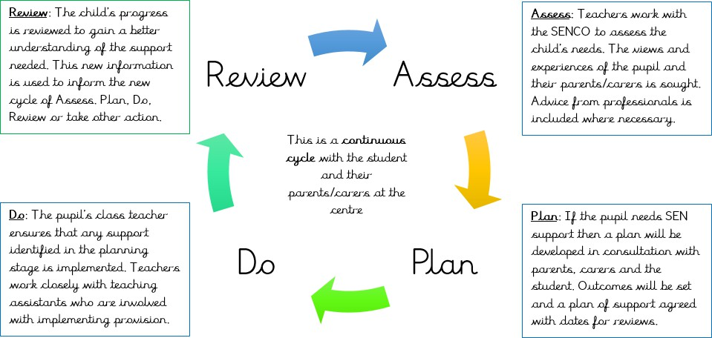

Special Educational Needs Information:
The SEND Code of Practice 2015 lays out four main areas of SEND. Children with SEND needs will generally fit into one or more of these areas. Below are the four areas and the provision in place at our school:

Communication and Interaction
Communication and interaction conditions may include children and young people who have speech, language and communication needs. They may have difficulty in communicating with others and/or they may have difficulty saying what they want to or understanding what is being said to them. Children may also be delayed in using language and difficulties in social communication such as autism.
The school works closely with and makes effective use of guidance from Speech and Language Therapists to put into place effective strategies to enable students to succeed within their classrooms. We provide 1:1 support to deliver intervention recommended by Speech and Language Therapists. We also support pupils with autism through our highly trained teachers and teaching assistants who have completed training on support pupils with ASD. Further whole school training will take place this year through the Autism in Schools Project. We support pupils through adaptive teaching methods and scaffolded learning, targeted intervention programmes, and individualised targets.

Cognition and Learning
Cognition and learning difficulties can affect children’s ability to learn and do well at school. Specific learning difficulties (SpLD) include a range of conditions such as dyslexia, dyscalculia and dyspraxia. A

child may also be described as having ‘moderate’ or ‘severe’ learning difficulties depending on the degree of need and the impact this has on their lives. Learning difficulties cover a wide range of needs. Pupils with moderate learning difficulties (MLD) may need extra support in some areas of the curriculum and those with severe learning difficulties (SLD) are likely to need support in all areas of the curriculum and have associated difficulties with mobility and communication.

Social, Emotional and Mental Health
Pupils experiencing social, emotional, and mental health difficulties may be:
- withdrawn or isolated
- hyperactive and lack concentration
- immature in relation to social skills
- displaying behaviour that challenges which could be arising from other complex special needs

They may have disorders such as attention deficit hyperactive disorder (ADHD) or attachment disorder and may be frustrated and struggle with school routines and relationships.
For some children, difficulties in their social and emotional development can mean that they require additional or different provision. We support these children through Emotional Support Sessions and social skills groups. We involve outside agencies such as CAMHS (Child and Adolescent Mental Health Service), Barnardo’s or the Community Paediatrician if necessary. We also access support from the St Helens Mental Health Support Team, where appropriate, and other external agencies.

Sensory and Physical
Children with sensory or physical needs may have a disability, such as;
- physical disability
- vision impairment
- hearing impairment
- multi-sensory impairment (both hearing and vision difficulties)
- dyspraxia
- They may also need specialist equipment to access learning and other opportunities available to their peers.

Where required, the school works closely with outside agencies including Occupational Therapy and Physiotherapy teams, to provide support for children in our school who have sensory or physical difficulties. Where necessary, we make adaptations to the curriculum or environment in order to make lessons and learning opportunities accessible to students. We hold regular meetings with these agencies and the parents to review the equipment and approaches that are in place.

Identification of Special Educational Needs:
Our school strives to identify children with special educational needs as early as possible. The earlier their needs are met barriers to learning can be broken down and progress can be made. Here are the ways in which we identify SEND in our school:
- Information passed on from nursery or previous school during transition to our school.

- Termly formative assessments and on-going summative assessments by the class teacher
- Use of the LDST SEND toolkit to determine what level a child is working at if under age-related expectations
- Observations by the class teacher and SENCO.
- Interventions having limited impact on a child’s progress.
- Information gathered from parents.
- Referrals to external agencies when required and their specialist assessments.

When teachers identify a potential SEND need, staff may complete an internal pupil support form which is monitored by the SENCO (Miss Lauren McDonald). This form allows teachers to inform the SENCO of their concerns, potential barriers to learning, provision that has been put in place already – and the impact this has had – and to request next steps from the SENCO.
All pupils are rigorously tracked in order to inform our planning and teaching. If there are any concerns regarding progress or if any child requires extra support, then this is identified by staff at the earliest opportunity and swiftly acted upon.
If you are concerned about any area of your child’s development, please speak to your child’s class teacher in the first instance. They may be able to provide you with further information about what the school can provide.
At St James C of E School, we are committed to working together with all members of our school community. This local offer has been produced with pupils, parents/carers, governors, and members of staff. The best people to contact this year are:
If you have specific questions about the St Helens Local Offer, please visit the St Helens Council Website. Alternatively, if you think your child may have Special Educational Needs please speak to their class teacher or contact Miss Lauren McDonald (SENCO) on 01744 678545 or by email stjameshaydock@ldst.org.uk

4a. How the school evaluates the effectiveness of its provision for pupils of SEND:
Termly assessments are carried out and each class teacher analyses their data. A pupil progress meeting is held for each class. This is an opportunity for the class teacher, Head teacher and SENCO to discuss every child in detail and the progress they have made. For any children who have made limited progress, interventions and next steps will be agreed for the following term. These next steps are adding onto the school’s provision map which is monitored by the trust’s Inclusion lead termly.
We have internal processes for monitoring quality of provision. These include learning walks, lesson observations, intervention observations, pupil interviews, book scrutiny, pupil progress meetings and data analysis. As a school we follow a specific Assess-Plan-Do-Review cycle to support the progress of children:

Assess
A clear picture of the child’s needs is drawn up. Performance data, parental comments, the pupil’s views, class teacher notes and observations from professionals may all be used to analyse what support and intervention will be needed. Barriers to learning will be highlighted and discussed.

Plan
At all stages, intervention and support will be planned to maximise the impact on the child’s learning. Adjustments may be made to plans and parents will be consulted about what they can do at home to support progress. Helping Hands Plans will be shared with all those adults working with the child.

Do
The class teacher will work closely with teaching assistants and parents to ensure that plans are followed and that appropriate learning opportunities are presented. The SENCO will support the class teacher where needed in finding ways to address targets in the classroom. The class teacher will build evidence of the child’s strengths and weaknesses and will, with the support of the SENCO, continue to track progress to fully monitor the impact of any interventions.

Review
At all stages, planning for the child is subject to review. For children receiving additional funding, review dates will be set by the Local Authority in line with their review panel calendar. For children on plans, review dates will be added onto the plans and communicated with parents. Additional parents’ evening meetings and other meetings with parents and children may also be used to discuss children’s progress towards identified targets. During reviews, the quality and impact of intervention and support will be discussed and any changes to future provision will be proposed.

Individual Support Plans are used in our school to document the above cycle and at three points during the school year (termly), parents are invited into school to discuss in-depth the targets that have been set for their child; any problems they may be experiencing and what specific support can be put in place. The plan may include how the school and any other agency (if required) intend to support the child by carrying out an agreed intervention over a set period.
Some other examples of the assessing and reviewing process at St James Church of England Primary are:
- Termly data tracking that is discussed in pupil progress meetings
- Observations of children by SENCO
- Regular discussions between class teacher and SENCO
- Two Parents Evening meetings a year and an end of year written report
- Parents able to ring and book an appointment to discuss any concerns
- Annual ECHP reviews
- Individual Support Plans are reviewed every term through discussions with parents
- In EYFS, regular supervision meetings are held to discuss vulnerable children and next steps as a school to support them and their families

The impact of all interventions is measured and monitored closely. If, following interventions a child’s progress continues to give cause for concern, their class teacher and/or the SENDCo will discuss next steps with the child’s parent/carer. If it is felt a child requires further additional support school will discuss the pathways to more specialist support/provision.
We currently liaise with the following professionals and outside agencies in order to help us support pupils with SEND:

TESSA
Inclusion Officers (LA and TRUST) Speech therapists
Educational Psychologist Literacy Support Service TESSA Autism
Behaviour Improvement Team Local Authority Inclusion team School nurse
Asthma/allergy teams Occupational therapists Healthy Living Team
CAMHS (Child Mental Health Service)
SMHT (School Mental Health Nursing Team) Paediatric clinics
Pupil Disability Team Language Outreach Support Physiotherapy
Portage and Pre-School Service Social Services
Education Welfare Officer
EHAT Team
Pupils and Young People’s Well-Being Panel
Parent/Carer SEND voluntary groups; Listen 4 a Change, IASS

Where appropriate, the SENCO may arrange for formal, professional assessments (e.g. Educational Psychologists) or referral to outside agencies (e.g. Speech and Language Therapists). When recommended by professionals, the SENCO will seek additional funding to enable pupils to access increased, targeted support across the curriculum.

4b. The school’s approach to teaching pupils with SEND:
Provision for pupils with SEND includes but is not limited to:
- Quality First Teaching, with appropriate adaptive teaching including use of the quality first teaching toolkit
- Support staff deployed effectively during lessons
- Personalised provision through time limited interventions delivered by highly trained staff
- Personalised provision through adapted resources
- Personalised timetables where required and agreed with parents
- Peer support and opportunities for networking where appropriate
- Specialist equipment/resources and reasonable adjustments made to suit the child’s needs
- Lessons have a focus on over-learning to support with retention
- Support from external services such as Educational Psychologist, Speech and Language Therapist, behaviour specialists and Occupational Therapist
- Equipment and supporting resources used when necessary, such as concentration cushions, tangle toys, writing aids and laptops to record their work

4c. How the school adapts the curriculum and learning environment and additional support for pupils with SEND
All pupils with SEND have access to a wide breadth of curriculum. All pupils with SEND access quality first teaching which is scaffolded to meet their needs to ensure they are fully immersed in key learning along with their peers. SEND pupils may receive adaptations based on their starting points, to ensure they can mee the same end points as their peers. The curriculum /learning environment may be adapted by:

  - pre- and post- learning support to reinforce and embed new learning
  - adapted teaching resources
  - appropriate choices of texts and topics
  - access arrangements for tests and or examinations
  - knowledge planners to support children to learn key facts
  - Seating positions for children with SEND are carefully planned
  - additional adult support
  - resources such as voice recorders, vocabulary prompts and visual aids are often used

4d. How the school enables pupils with SEND to engage in the activities of the school (including physical activities) together with children who do not have special educational needs:
School will always plan for main events that involve physical activities and ensure that all children can be included. Sports days and school residential trips are carefully planned to make sure all our children with SEND can attend and achieve. When required, individual risk assessments may be put into place and procedures are discussed with parents.
The school’s accessibility plan is carefully reviewed and is available on the website. A disabled toilet is available. All classroom doors are wide enough for wheelchair access and ramps are in place for three external entrances at various locations around the school. There are disabled car parking spaces on the car park. Any parent with a disabled child should contact Mrs Briers, Head of School, for further information regarding admission arrangements.
School have a specialist PE company, Full of Beans, that teach P.E lessons and support the school’s teachers in delivering P.E lessons. This is to ensure that weekly P.E. sessions are also adapted and all children can access them.
Our school’s Christian Values also ensure that all children are included and feel part of physical activities. All our children are encouraged to be good citizens who are encouraging, forgiving and develop positive friendships. This helps all pupils feel supported and encouraged to try activities and all feel a sense of achievement afterwards.
School believe that all children should be part of something ‘bigger’ than a member of their class within the school and so all children are encouraged to be part of our Journey Leaders initiative.
All pupils with SEND have access to extra-curricular activities to enhance an ambitious curriculum. SEND pupils may receive additional support or intervention in order to access their activities. The school monitors the take-up of extra-curricular clubs by pupils with SEND and actively seek to ensure that they are aware and have access to the clubs.

4e. Support that is available for improving the emotional, mental and social development of pupils with SEND:

Pupils are well supported by:
- a clear policy regarding behaviour and expectations (code of conduct) that all children adhere to
- an anti-bullying policy that is supported by all staff
- targeted support for individual pupils
- access to the St. Helens Mental Health Support Team (MHST). This team visits the school one day per week and is available to support children with low level worry/anxiety management
- PSHE lessons including MyHappyMinds taught and built upon in all aspects of school
- Barnardo’s workshops for whole school
- Pupil Voice questionnaires
- Staff awareness and training of ACES.
- Staff awareness and training of ASD through the Autism in Schools programme
- Social Stories

Name and contact details of the SEN Coordinator (SENCO):
Name: Miss Lauren McDonald
Email address: stjameshaydock@ldst.org.uk
Telephone Number: 01744678545
SEN Governor: Mrs Audrey McNulty

Information about the expertise and training of staff in relation to children and young people with SEND and about how specialist expertise will be secured:
All staff in the school receive on-going training to meet the needs of all the children attending the school. Time is given through staff meetings and twilights for training to be shared to the rest of the team.
This may include Speech and Language, Dyslexia Training, ASC (autistic spectrum condition), and awareness training, ACES (Adverse Childhood Experiences). Training provided responds to the needs of the children and staff at any given time.

Qualification/programme | Staff members
NPQ SEND | Lauren McDonald  Rhyann Warbrick
NPQ SEND | Tina Briers (in progress)  Jennifer Young (in progress)

Information about how equipment and facilities to support children and young people with SEND will be secured:
The school’s SEND budget is allocated to meet the needs of the children on the SEND Register. The progress and attainment of all children is tracked, and resources are allocated according to need.
Our notional SEN Budget this year was spent towards the following:
  - Teaching Assistants
  - Improving our sensory spaces and Calm Corners
  - Regulation Station resources
  - Individual resources to meet need, as detailed in EHC plans

Where required, pupils with SEND access additional adult support to ensure they access the curriculum. This provision ensures reiteration of information, provides alternative approaches to the delivery of the curriculum content, or may where appropriate, allow pupils to work in a low distraction area away from their usual working environment.

The arrangements for consulting and involving parents of children with SEND and young people with SEND about the education of their child:
There are many ways throughout the year where the school consults with parents and pupils with SEND regarding their education. The school welcomes an open-door policy for all their families and believe that as well as formal points in the year where arrangements take place via the monitoring schedule, it is also important to remember that for some pupils and families, extra arrangements will be made dependant on current need.

Action | Who? | Frequency
Pupil portraits | Class teacher and pupil | Annually/ when interests and behaviours  change
Individual Support Plans | Child, Class teacher,  Parents and SENDCO | Termly
Early Help Assessments | Pastoral and  Safeguarding Lead, Parents, SENDCo and relevant outside agencies | At various times throughout the year. Typically, every 6-8 weeks for each family
Meetings after  assessments from external agencies | SENCo, parents and  relevant external agencies. | As and when required throughout the year
Transition days | Pupils, supported by TA | Annually in the summer term for Y6 pupils with  SEND
EHC Annual reviews | Class teacher, SENDCo,  Parents, child, relevant | Annually

external agencies,
Inclusion officer.
Stay and Play in  Foundation Stage | Parents and their young  children. | Termly

Arrangements by the governing body or the proprietor relating to the treatment of complaints from parents of pupils with SEND concerning the provision made at the school
For further information or to discuss any concerns, please contact Miss Lauren McDonald, Special Educational Needs Coordinator (SENCO) in the first instance via the following email address: stjameshaydock@ldst.org.uk
We have an up-to-date complaints policy which is available on our school website.
Our aim is to provide an open and welcoming environment where every child feels safe and happy, but should you have any cause for concern or complaint please inform us immediately so that we can address the problem as soon as possible.

The contact details of support services for the parents of pupils with SEND, including those for arrangements made in accordance with Section 32:
A fully comprehensive list of support services can be found on the St Helens Council website: https://new.sthelens.gov.uk/SEND
The IASS service offers parents/carers, pupils and young people information, advice and support on:
- matters relating to their disabilities, health and social care
- the law in relation to SEN and disability, health and social care
- gathering, understanding, and interpreting information and applying it to your situation the take-up and management of personal budgets

The school’s arrangements for supporting pupils with SEND in a transfer between phases of education or in preparation for adulthood and independent living:
Our school works closely with pupils, parents and other agencies and settings to ensure a smooth and successful transition for pupils. This includes transitions where: children enter the school; children move between key stages in our school; children move to a new year group in our school and children leaving our school to enter a new provision or secondary school.

Below are some arrangements in place to support transitions:
  - On entry to Nursery, parents will be invited to look around the school and meet significant staff. Children will also be invited to a stay and play before they start. The number of sessions will be dependent on what is appropriate for each pupil.
  - Our Reception class teacher carries out telephone consultations to speak to each family individually and stay and play sessions for the cohort are organised in the summer term for the teacher to meet the children entering our school. Parents then have the opportunity to meet with the Reception teacher in September, prior to their child starting school.
  - The SENCO and Reception class teacher will visit the child in their nursery setting if SEND has already been identified by the nursery.
  - Information is gathered from their nursery setting to ensure the correct provision can be planned for and put into place straight away.
  - Where necessary, we will support pupils moving to new settings and key stages by making opportunities available to them to attend the new setting/ classroom.
  - Where necessary we may develop a transition plan in partnership with parents, the pupil, the new setting and specialist staff supporting the child to ensure that they enjoy a smooth transition.
  - For children in Year 6, a SENCO transition meeting takes place each summer term where information is passed to the receiving secondary school.
  - In-house transition meetings are held in the summer term for information to be passed onto the new class teacher.
In our school we recognise that transition planning can take place both before and after the transition. Therefore, we plan a lot before the change, but we also consider planning transition afterwards. For example, children may be sent to their previous teacher with work they are proud of in order to keep that contact with that trusted adult.

Information on where the Local Authority’s Local Offer is published:
A fully comprehensive list of support services can be found on the St Helens Council website: https://new.sthelens.gov.uk/SEND

