




SEND Policy 2026-2027

Learn, Love and Achieve, Together with Jesus

OUR TRUST’S PRAYER
Heavenly Father
Let peace, friendship and love grow in our schools Send the Holy Spirit to give:
Excellence to our learning Love to our actions and Joy to our worship
Guide us to help others So that we may all
Learn, Love and Achieve, Together with Jesus.
Amen

Our Christian Vision is:

This policy is underpinned by our Christian vision:

‘Journeying Together to Live, Learn and Laugh with the Love of God'

Do everything in Love' Corinthians 16:14’

At St James CE Primary School, we are committed to ensuring that every child achieves and thrives, regardless of their starting point or any barriers they may face. Guided by our Christian vision, ‘Journeying Together to Live, Learn and Laugh with the Love of God’, we nurture a culture of community and belonging where every child is welcomed, valued and respected. We believe that high standards and inclusion go hand in hand, and that every child should have access to an ambitious curriculum, high-quality teaching and meaningful opportunities to flourish.

Our Inclusion by Design approach is built around a strong universal offer for all pupils, with adaptive teaching at the heart of classroom practice. We are committed to identifying and removing barriers to learning, participation and wellbeing through evidence-informed approaches, reasonable adjustments and early intervention. By designing provision that works for the widest range of learners from the outset, we ensure that all children can engage successfully in school life.

Through high-quality professional development, our staff continually develop the knowledge, skills and confidence needed to create inclusive classrooms and respond effectively to pupils' needs. We provide calm, safe and nurturing environments that promote belonging, engagement, emotional wellbeing and readiness to learn. We work in partnership with families, governors, external agencies and the wider community to ensure that children receive the support they need at the right time.

Guided by the words, ‘Do everything in love’ (1 Corinthians 16:14), we are committed to enabling every child to participate fully in school life, develop independence and achieve their aspirations. Alongside academic success, we prioritise wellbeing, personal development and positive relationships, ensuring that every child feels valued, supported and empowered to thrive as part of our school family.

This reflects our commitment of ‘Journeying Together to Live, Learn and Laugh with the Love of God’, ensuring that inclusion remains at the heart of our school community. Guided by our mission and the words ‘Do everything in love’ (1 Corinthians 16:14), we strive to create an environment where every child feels valued, supported and empowered to achieve their ambitions, flourish in their learning and reach their full potential.

School Aims
In order to achieve our school aims, we will constantly reflect the Christian ethos of our school in our relationships with our children, their families, our staff, the church and the wider community.

Aims

Our aims are:
- To create an inclusive environment that meets the special educational needs of each child.
- To ensure that the special educational needs of children are identified, assessed and provided for.
- To make clear the expectations of all partners in the process (including parents, children).
- To identify the roles and responsibilities of staff in providing for children’s special educational needs.
- To enable all children to have full access to all elements of the school curriculum.
- To actively involve pupils in a sensitive and non-stigmatising way in the individual education plan (pupil passport) process to promote improved confidence and self-image.

Our ten ‘inclusive practice principles’ are central to our ‘Inclusion by Design’ approach. They allow our inclusion strategy vision to be lived out and provide a clear framework to achieve our aims. All ten principles hold equal importance and work as a cumulative whole to develop inclusive practice.

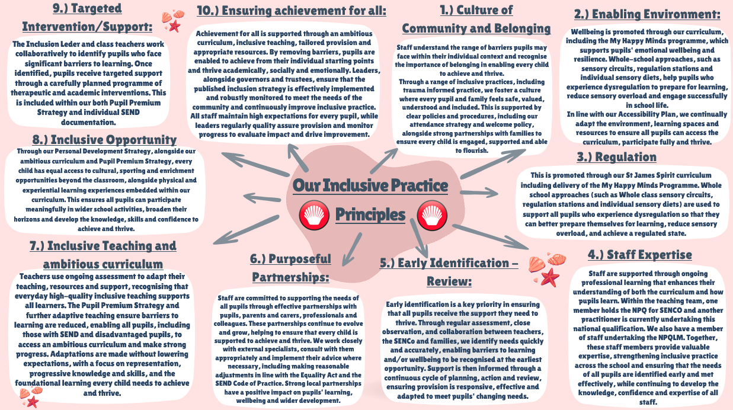

Policy Rationale and Legislation
The most recent Special Educational Needs and Disabilities (SEND) Code of Practice came into effect on the 1st of September 2014 and was further updated in January 2015. This and the Children and Families Act 2014, have a focus on greater cooperation between education, health and social care and a greater focus on the outcomes which will make a real difference to how young people live their lives. This policy complies with this guidance which was updated in May 2015.

The 2015 SEND Code of Practice states that:
“A child or young person has SEN if they have a learning difficulty or disability which calls for special educational provision to be made for them. A child of compulsory school age or a young person has a learning difficulty or disability if he/she:
  - has a significantly greater difficulty in learning than the majority of others of the same age: or
  - has a disability which prevents or hinders him/her from making use of facilities of a kind generally provided for others of the same age in mainstream schools or mainstream post16 institutions”
Though there is a lot of overlap between the groups, children who have special educational needs do not necessarily have a disability; disabled children do not necessarily have special educational needs. The use of the terms SEN and SEND in this report reflect this interrelationship; each are utilised according to their relevance.
Early identification of needs and the timely provision of appropriate support, together with high aspirations, can help ensure that the vast majority of children who have SEND can achieve their full potential and make a successful transition into adulthood.
At St James CE Primary School, we aim to provide a coordinated structure and framework for the provision for SEND throughout the school. This will not only support the class teachers in providing the appropriate provision but will also make them aware of the various agencies, provided by the Local Authority, which can be called upon for advice and assistance.

Responsibility for Co-ordination of Inclusion and SEND Provision:

Role of the SENCO:
The name of the special needs co-coordinator (SENCO) who is responsible for the day-to-day operation of this policy is Miss Lauren McDonald (SLT) who has a duty to:
- Liaise with and advise fellow teachers and staff.
- Communicate with the parents of children with SEN and Disabilities.
- Liaise with other professionals such as Educational Psychologists, Medical experts and Social Services to provide the best learning opportunities for all children.
- To ensure that the St Helens Graduated Approach is followed in relation to the identification and provision for special educational needs.
- Maintain a current record of number of pupils with SEND
- Monitor progress of SEND pupils and ensure provisions specified in Statements/EHC plans are in place
- Organise/deliver relevant SEND training as per our CPD overview.
All staff will be kept up to date on SEND policies and changes to the framework. Performance management opportunities should ensure staff members have access to and are encouraged to attend relevant courses to keep up to date with current initiatives and procedures, to ensure the highest level of teaching of children with SEND.

Role of Class Teacher (alongside Support Staff):
- To be initially responsible for the identification of children experiencing specific difficulties
and to bring this to the attention of the Executive Headteacher/Acting Headteacher and SENCO.
- To use his/her skills, knowledge and insight to provide a programme of work appropriate to
the child's needs (underpinned by Quality First Teaching).
- To be responsible for keeping records, assessing and monitoring the child's progress.
- To enter tracking data for pupils accessing intervention programmes for the attention of the
SENCO.

In addition to the above, the Governors have also undertaken the following responsibilities to ensure that:
- The school has a clearly defined policy document relating to the provision for pupils with special educational needs.
- The school has an identified teacher to report to the governors on the implementation of this policy.
- There is an identified governor (Mrs Audrey McNulty) with a special interest and responsibility for SEND.
- Relevant updates are discussed each term in the Headteacher's report.

Admissions Arrangements
The admission policy at St James CE Primary School follows the guidelines recommended by the Local Authority (LA) and the school is open to all children regardless of their abilities or disabilities. No pupil will be refused admission to school based on his or her special educational need. In line with the SEN and Disability Act, we will not discriminate against disabled children, and we will take all reasonable steps to provide effective educational provision.
We recognise the intrinsic value of every child, and we aim to meet all children’s needs.

Facilities for Vulnerable Pupils
We publish our SEND information report on our school website, and any changes to provision of specialist facilities will be amended within this report.

Resources
The resources at St James CE Primary School are allocated to and amongst children with SEND according to their individual needs. Additional support may take the form of equipment, either purchased for sole use or borrowed on long term loan, the use of support teachers to enable the class teacher to give individual or small group tuition, or the provision of an extra teacher or TA to give daily support in specific year groups where it is thought this will be particularly beneficial.
Subject Champions and Curriculum Leaders will also liaise with the SENCO when determining SEND support materials.

Identification of Pupils’ Needs
Our school strives to identify children with special educational needs as early as possible. The earlier their needs are met, then barriers to learning can be broken down and progress can be made. Here are the ways in which we identify SEND in our school:
- Information passed on from nursery during transition to our school.
- Termly summative assessments.
- On-going formative assessments by the class teacher.
- Observations by the class teacher and SENDCo.
- Interventions having limited impact on a child’s progress.
- Information gathered from parents.
- Referrals to external agencies when required and their specialist assessments.
All pupils are rigorously tracked in order to inform our planning and teaching. If there are any concerns regarding progress or if any child requires extra support, then this is identified by staff at the earliest opportunity and swiftly acted upon. This includes termly pupil progress meetings and supervision processes.

Graduated Approach:
Our school will follow a graduated approach. Early identification is a key priority in ensuring that all pupils receive the support they need to thrive. Through regular assessment, close observation, and collaboration between teachers, the SENCo, and families, potential barriers to learning are identified as early as possible. The four-step cycle below can then take place. Details of this can be found via the following link: https://new.sthelens.gov.uk/media/335125/st-helens-graduated-approach.pdf

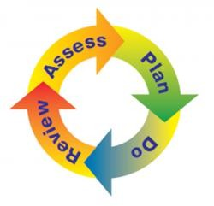
At any stage of the process, from the early identification stage through to the move to an EHCP, the school adheres to the same cycle of effective provision. All children receive inclusive quality first teaching in our school, and most will make expected progress. For those who do not, the class teacher will identify a child’s need and decide for any adjustments or interventions. This is a four-part process which is described in the graduated approach for St Helens:
- Assess
- Plan
- Do
- Review

Assess:
A clear picture of the child’s needs is formulated. This can be through; performance data, parental comments, the pupil’s views, class teacher notes or observations from professionals. This is then used to analyse what support and intervention will be needed. Barriers to learning will be highlighted and discussed. For some pupils, a SEND Toolkit assessment will be undertaken, and this baseline will inform the rest of the four-step process.

Plan:
At all stages, intervention and support will be planned to maximise the impact on the child’s learning. Adjustments may be made to plans and parents will be consulted about what they can do at home to support progress. Plans will be shared with all those adults working with the child.
Do:
The class teacher will work closely with teaching assistants and parents to ensure that plans are followed and that appropriate learning opportunities are presented. The SENCO will support the class teacher where needed in finding ways to address targets in the classroom. The class teacher will build evidence of the child’s strengths and weaknesses and will, with the support of the SENCO, continue to track progress to fully monitor the impact of any interventions.

Review:
At all stages, planning for the child is subject to review. For children receiving additional funding, review dates will be set by the Local Authority in line with their review panel calendar. For children who require an Individual Support Plan, termly review dates will be communicated with parents. Additional parents’ evening meetings and other meetings with parents and children may also be used to discuss children’s progress towards identified targets. During reviews, the quality and impact of intervention and support will be discussed and any changes to future provision will be proposed.
Individual Support Plans are used in our school to document the above cycle and at three points during the school year (at the end of each term), parents are invited into school to discuss in-depth the targets that have been set for their child; any problems they may be experiencing and what specific support can be put in place. The plan may include how the school and any other agency (if required) intend to support the child by carrying out an agreed intervention over a set period.

Other examples of the assess/review parts of the process at our school are:
- Termly data tracking that is discussed in pupil review meetings
- Observations of children by SENCO
- Regular discussions between class teacher and SENCO
- Two Parents’ Evening meetings a year and an end of year written report
- Parents able to ring and book an appointment to discuss any concerns.
- Annual EHCP reviews
- Individual Support Plans are reviewed every term through discussions with parents
- In the EYFS, regular supervision meetings to discuss vulnerable children and next steps as a school to support them and their families
- The impact of all interventions is measured and monitored closely. If, following
interventions a child’s progress continues to give cause for concern, their class teacher and/or the SENCO will discuss next steps with the child’s parent/carer. If it is felt a child requires further additional support school will discuss the pathways to more specialist support/provision.

Provision and Support
Provision can be on an individual or small group basis and can be in any curriculum area, according to the child's needs. All children have full access to the National Curriculum. This may be delivered at a variety of levels, depending on a child’s current levels of development.
Where pupils are identified as having special educational needs, the school provides for these additional needs in a variety of ways. Provision for SEND pupils includes:
- Quality First Teaching
- Use of LDST SEND Toolkit
- support staff deployed effectively during lessons
- personalised provision through time limited programmes
- personalised provision through adapted resources and interventions (1:1 or small group work)
- Interventions carried out by TAs and class teachers
- Personalised timetable and/or curriculum where required and agreed with parents
- Peer support and opportunities for networking where appropriate
- Specialist equipment/resources and reasonable adjustments made to suit the child’s needs
- Lessons have a focus on over-learning to support with retention

- Support from external services such as Educational Psychologist, Speech and Language
Therapist, behaviour specialists and Occupational Therapist
- Equipment and supporting resources used when necessary, such as concentration cushions, tangle toys, writing aids and laptops to record their work

EHCP (Education, Health and Care Plan) Process
School or parents can request a statutory assessment for an EHCP (Education, Health and Care Plan) from the Local Authority. During the assessment, the local authority will consider if the pupil requires provision beyond what the school can offer. A request for a Statutory Assessment does not inevitably lead to an EHCP. An EHCP may state that an alternative educational setting is more appropriate to the pupil’s needs.
An EHCP will include details of learning objectives for the child. These are used to develop targets and establish provision. EHCPs must be reviewed annually, in accordance with the SEN Code of Practice (2015). This will also consider whether any amendments need to be made to the description of the pupil’s needs, or the provisions of the EHC plan. The pupil’s view is taken into account prior to the meeting and where appropriate the pupil may attend part or all of the meeting. Parents and all relevant professionals will be invited to this annual review. The review will focus on what the child has achieved as well as identifying any difficulties that need to be resolved. The SENCO will organise these reviews and invite the relevant people.

Professionals from Outside Agencies:
The school draws on a range of expertise from external agencies. Our SENCO and wider staff team are dedicated in supporting all pupils’ needs through effective partnerships with parents, the LA local offer and outside agencies including MHST, TESSA Autism, and Behaviour Improvement Team. Partnerships are continually evolving and growing!
Our overall aim is to provide early identification of children with special educational needs and disabilities. In addition, we will provide extra support using the expertise of staff, the use of additional resources and enlisting the help of the child's parents. We will also apply for the advice or assistance of outside agencies if the school feels that it cannot provide the necessary level of support or the required level of expertise.

Working in Partnership with Parents:
Our school policy is to encourage parents to participate actively in their children's education. In addition to this the parents of children with SEND are encouraged to approach school at any time regarding concerns that they may have about their child's progress. They are also encouraged to give additional support and understanding at home and are advised throughout on the special programmes provided for their child. Parents are also involved in the registration of a concern and in the regular reviews of their child's progress, as outlined in the procedures in the Code of Practice.

Involvement of Pupils:

We recognise that all pupils have the right to be involved in making decisions and exercising choice as stated in the code of practice. Where appropriate all pupils are involved in monitoring and reviewing their progress.
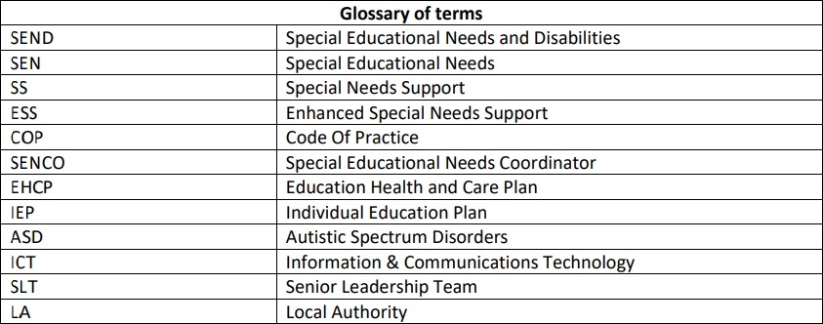

Monitoring and review
This policy is monitored by the governing body and will be reviewed annually.

To be reviewed: July 2027

Policy Author | Lauren McDonald
Policy Approver | Governing Body
Current Policy Version | July 2026
Policy Effective From | September 2026
Policy Review Date | July 2027

