

FIRST AID POLICY

St James CE Primary School

OUR TRUST PRAYER

Heavenly Father,
Let peace, friendship and love grow in our schools.
Send the Holy Spirit to give
excellence to our learning,
love to our actions and
joy to our worship.
Guide us to help others,
so that we may all
Learn, Love and Achieve, Together with Jesus.
Amen

First Aid Policy

Policy Statement
This policy is designed to promote the health, safety and welfare of pupils, staff and visitors to this school through the provision of first aid equipment and trained personnel in accordance to the requirements of the Health and Safety (First Aid) Regulations 1981.

At our school, the first aid appointed lead is Debra Robinson.

The Aims of the Policy

The aim of providing first aid is to save lives and to ensure that minor injuries and illnesses do not escalate into major ones. The aim of this policy is to ensure that:

- We are compliant with all relevant legislation
- a person is appointed to take charge of first aid arrangements
- staff nominated as first aiders receive up-to-date training by a suitably recognised organisation
- suitably stocked and marked first aid containers are available at all appropriate locations throughout the school
- all members of staff are fully informed with regard to the first aid arrangements
- all staff are aware of hygiene and infection control procedures
- written records are maintained of any accidents, injuries, diseases or dangerous occurrences. Reports are undertaken as required under the reporting of Injuries, Diseases and Dangerous Occurrences Regulations 2013. Compliance Education, school’s Competent Person, will be involved with all RIDDOR reports/investigations
- first aid arrangements are regularly reviewed and assessed to maintain adequate first aid provision
Procedure

First aid provision will be available at all times while people are on the school premises and also off the premises while on school visits.

Risk Assessment

In accordance with the school’s Health and Safety Policy, the annual risk assessment of all school buildings and facilities will pay particular attention to:

- Practical activities
- The use of machinery
- Storage of hazardous substances
- The use of equipment for sports and physical education

From this assessment a judgment will be made as to how many trained first aiders are required to provide an effective and safe response to accidents and injuries.

A judgment will also be made as to how many fixed and portable first aid containers should be available and where they are to be located.

Specific consideration will be given to staff or students who have special health needs or disabilities.

In determining the level of provision, the Senior Leadership team will consider:

- the provision during lunch times and breaks
- the adequacy of the provision to account for staff absences
- the provision of first aid for off-site activities and school trips
- the provision for practical lessons and activities, e.g. science, pond dipping, forest school and physical education.

Qualification and Training

Whilst the Health and Safety (First Aid) Regulations 1981 does not require employers to provide first aid for anyone other than their own employees, we as a school will consider the need to provide first aid provision for our non-employees such as pupils, students and visitors by conducting a First Aid Assessment.
Our first aid provision will be available whilst people are on our school premises. It will also be available when staff, pupils and students are working elsewhere on school activities including any off-site activity such as educational visits.
All school first aiders hold a certificate of competence that is valid for three years.
Refresher training and retesting of competence will be arranged at least three months before certificates expire.
The school will consider interim refresher training to maintain first aiders' basic skills and keep them up to date with changes, where necessary, e.g. adrenaline pen, CPR and defibrillator training.

Schools are encouraged to identify a senior mental health lead. This role should include having strategic oversight of the whole school or college approach to mental health and wellbeing. They will support their school or college to make the best use of existing resources and effort to help improve the wellbeing and mental health of pupils, students and staff.
https://assets.publishing.service.gov.uk/media/625ee6148fa8f54a8bb65ba9/Mental_health_and_behaviour_in_schools.pdf

Early Years Foundation Stage (EYFS)

At least one person who has a current Paediatric First Aid Certificate will be on school premises and available at all times when children are present and will accompany children on outings.
All newly qualified staff with Level 2 or 3 childcare qualification (on or after 30th June 2016) must also have either a full Paediatric First Aid or an Emergency Paediatric First Aid certificate within three months of starting work in order to be included in the required staff to child ratios.
https://assets.publishing.service.gov.uk/government/uploads/system/uploads/attachment_data/file/1170108/EYFS_framework_from_September_2023.pdf

Forest School/Woodland

At least one member of our Forest School staff will hold an Outdoor First Aid Certificate and will be present during the forest school lesson.

The appointed lead does not necessarily have to be one of the certificated first aiders.
The appointed lead will:
- line manage the team of first aiders, monitoring their training and competencies
- look after the first aid equipment, restocking first aid containers when required and replacing out of date materials
- ensure that an ambulance or other professional medical help is summoned when appropriate
- undertake regular risk assessments and liaise with the Head as appropriate
- ensure that all accidents and injuries are appropriately recorded
- ensure that all members of full time and temporary staff are familiar with the school's first aid provision.

First Aid Materials, Equipment and Facilities
First Aid container will be available and be easily accessible.
As a minimum there will be at least one fully stocked first aid container. Additional first aid containers will be strategically located around the school close to hand washing facilities and close to distant sports fields and playgrounds.
Our main first aid container contains the following items:
- a leaflet giving general advice on first aid – HSE information is available
- 20 individually wrapped sterile adhesive dressings (assorted sizes)
- 2 sterile eye pads
- 2 individually wrapped triangular bandages (preferably sterile)
- 6 safety pins
- 6 medium sized individually wrapped sterile unmedicated wound dressings.
- 2 large sterile individually wrapped unmedicated wound dressings.
- 3 pairs of disposable gloves
Portable first aid containers will be available for all school trips and for sporting and other activities that take place over 200 metres from school buildings.
Our travelling first aid container contains the following items:
- a leaflet giving general advice on first aid – HSE information is available
- 6 individually wrapped sterile adhesive dressings.
- 1 large sterile unmedicated dressing
- 2 triangular bandages individually wrapped and preferably sterile.
- 2 safety pins
- individually wrapped moist cleansing wipes
- 2 pairs of disposable gloves
Our minibus first aid container contains the following:
- 10 antiseptic wipes, foil packed.
- 1 conforming disposable bandage (not less than 7.5 cm wide)
- 2 triangular bandages
- 1 packet of 24 assorted adhesive dressings
- 3 large sterile unmedicated ambulance dressings (not less than 15.0 cm × 20.0 cm)
- 2 sterile eye pads, with attachments
- 12 assorted safety pins
- 1 pair of rustless blunt-ended scissors
Schools are encouraged to purchase an automated external defibrillator (AED) as part of its first aid equipment. Our school defibrillator (AED) is located in the staff room.
Where it is known that staff or students engaged in and out of school activity have specific health needs or a disability, the contents of the first aid container will include the resources to meet these specific needs, e.g. a supply of insulin or an adrenaline-pen.
As a school we provide a non-teaching room/area that can be used for medical examinations and treatment of pupils, for short term care of sick or injured pupils and a providing a private area in which our pupils with complex needs can go. The room/area has a wash basin and is close to a toilet.

Information and Notices

First aid notices giving the location of first aid containers and the names of members of staff who are certificated first aiders will be prominently displayed in all classrooms and office area.
The EYFS Framework requires a list of staff first aiders to be displayed or staff Paediatric certificates displayed and made available to parents.

The school will make every effort to ensure that first aid notices are clear and easily understood by all.

Information on the school's first aid provision will be included in the staff handbook.

Information on the school's first aid provision will be provided in the induction pack given to new and temporary staff.

Hygiene and Infection Control

All staff will:
- follow basic hygiene procedures
- be aware as to how to take precautions to avoid infections, e.g. HIV and AIDS.
All staff will have access to single use disposable gloves and hand washing facilities.
The school will ensure adequate and appropriate stock levels of PPE is provided for all staff:
- Gloves – Are to be worn to protect your hands
- Face Masks/Coverings – Are worn to protect/prevent the spread of a respiratory virus when close contact with another person cannot be avoided.
- Eye Protection or Shields – Are worn when there is a risk of bodily fluids splashing up into your face.
- Aprons – Are worn to protect your clothing from becoming soiled.

Disposable gloves will be worn at all times when dealing with blood or other body fluids or when disposing of dressings or other potentially contaminated equipment.
Instructions on the disposal of all used dressings or equipment will be included in the first aid containers

Recording Accidents and Injuries

All accidents and injuries will be recorded in a written or electronic form and such records will be kept for a minimum of three years.
In some cases, a record maybe kept longer, if the injury is deemed significate enough to imply the injury may cause the student problems in the future as a student has up until their 21st birthday to make a claim.
The record of any first aid treatment given by first aiders and other appointed persons will include:
- the date, time and place of the incident
- the name and class of the injured or ill person
- details of the injury or illness and what first aid was given
- what happened to the student or member of staff immediately afterwards (e.g. went home, resumed normal duties, went back to class or went to hospital)
- the name and signature of the first aider or person dealing with the incident.

Serious or significant incidents will be reported to parents by direct contact with the parent or carer.
In an emergency involving outside medical professionals or services the Headteacher or the appointed person will follow the school’s established procedures for contacting a parent or carer.

Reporting Accidents to the HSE

The following types of accidents will be reported to the HSE as required under the Reporting of Injuries, Diseases and Dangerous Occurrences Regulations 2013:
http://www.hse.gov.uk/pubns/edis1.pdf
Accident - Employees
- accidents resulting in death or major injury (including those that result from physical violence)
- accidents that prevent the injured person from doing their normal work for more than seven days
- work-related disease that affects an employee and that a doctor confirms in writing.
- Fractures, other than to fingers, thumbs and toes
- Amputation
- Any injury likely to lead to permanent loss of sight or reduction in sight
- Any crush injury to the head or torso causing damage to the brain or internal organs
- Serious burns (including scalding) which cover more than 10% of the body or cause significate damage to the eyes, respiratory system or other vital organs.
- Any scalping requiring hospital treatment
- Any loss of consciousness caused by head injury or asphyxia.
- Any other injury arising from working in an enclosed space which: leads to hypothermia or heat-induces illness or requires resuscitation or admittance to hospital for more than 24 hours.

Accident - Students and Visitors

- The death of the person which arose out of or in connection with a work activity
- An injury that arose out of or in connection with a work activity and the person is taken directly from the scene of the accident to the hospital for treatment.

The responsible person at the school will consider whether the incident was caused by:
- a failure in the way a work activity was organised (e.g. inadequate supervision of a field trip);
- the way equipment or substances were used (e.g. lifts, machinery, experiments etc); and/or
- the condition of the premises (e.g. poorly maintained or slippery floors)

Submitting a Report and Accident Investigation

Any incident subject to RIDDOR, will be reported to HSE’s Incident Contact Centre without delay. Compliance Education is responsible for reporting all incidents subject to RIDDOR.

All incidents will receive an appropriate level of investigation by staff who have attended accident reporting and investigation training. An accident investigation is performed in order to prevent similar accidents in the future. Compliance Education will be an integral part of any investigation in its capacity as Competent Person.

Additional advice and guidance regarding what is reportable under RIDDOR, along with support in investigating serious incidents is available from Compliance Education.

APPENDIX A
ADMINISTRATION OF MEDICINES POLICY

Asthma

St James CE Primary

Asthma

Asthma is a condition that affects small tubes (airways) that carry air in and out of the lungs. When a person with asthma comes into contact with something that irritates their airways (an asthma trigger), the muscles around the walls of the airways tighten so that the airways become narrower and the lining of the airways becomes inflamed and starts to swell. Sometimes, sticky mucus or phlegm builds up, which can further narrow the airways. These reactions make it difficult to breathe, leading to symptoms of asthma.

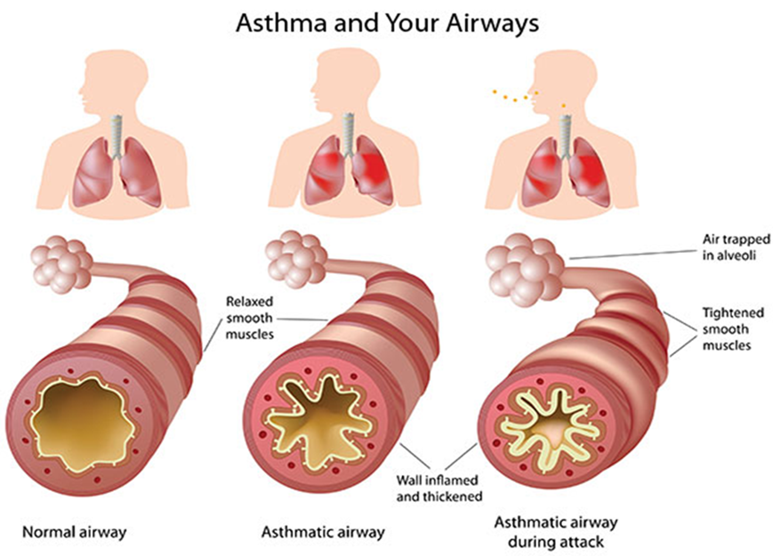

As a school, we recognise that asthma is a widespread, serious, but controllable condition. This school welcomes all pupils with asthma and aims to support these children in participating fully in school life. We endeavour to do this by ensuring we have:
- an asthma register
- up-to-date asthma policy,
- an asthma lead,
- all pupils with immediate access to their reliever inhaler at all times,
- all pupils have an up-to-date asthma action plan,
- an emergency salbutamol inhaler
- ensure all staff have regular asthma training
- promote asthma awareness pupils, parents/carers and staff.

Asthma Register

We have an asthma register of children within the school, which we update yearly. We do this by asking parents/carers if their child is diagnosed as asthmatic or has been prescribed a reliever inhaler. When parents/carers have confirmed that their child is asthmatic or has been prescribed a reliever inhaler we ensure that the pupil has been added to the asthma register and has:

- an up-to-date copy of their personal asthma action plan,
- their reliever (salbutamol/terbutaline) inhaler in school,
- permission from the parents/carers to use the emergency salbutamol inhaler if they require it and their own inhaler is broken, out of date, empty or has been lost.

Asthma Lead

This school has an asthma lead Mrs Debra Robinson. It is the responsibility of the asthma lead to manage the asthma register, update the asthma policy, manage the emergency salbutamol inhalers (please refer to the Department of Health Guidance on the use of emergency salbutamol inhalers in schools, March 2015) ensure measures are in place so that children have immediate access to their inhalers.

https://assets.publishing.service.gov.uk/government/uploads/system/uploads/attachment_data/file/416468/emergency_inhalers_in_schools.pdf

Medication and Inhalers

All children with asthma should always have immediate access to their reliever (usually blue) inhaler. The reliever inhaler is a fast-acting medication that opens up the airways and makes it easier for the child to breathe.

Some children will also have a preventer inhaler, which is usually taken morning and night, as prescribed by the doctor/nurse. This medication needs to be taken regularly for maximum benefit. Children should not bring their preventer inhaler to school as it should be taken regularly as prescribed by their doctor/nurse at home. However, if the pupil is going on a residential trip, we are aware that they will need to take the inhaler with them so they can continue taking their inhaler as prescribed.

Children are encouraged to carry their reliever inhaler as soon as they are responsible enough to do so. We would expect this to be by key stage 2. However, we will discuss this with each child’s parent/carer and teacher. We recognise that all children may still need supervision in taking their inhaler.

For Younger children, reliever inhalers are kept in the classroom in a Yellow First Aid bag which is clearly visible to staff and children.

School staff are not required to administer asthma medicines to pupils however many children have poor inhaler technique or are unable to take the inhaler by themselves. Failure to receive their medication could end in hospitalisation or even death. Staff who have had asthma training and/or administering medication training and are happy to support children as they use their inhaler, can be essential for the well-being of the child. If we have any concerns over a child’s ability to use their inhaler, we will refer them to the school nurse and advise parents/carers to arrange a review with their GP/nurse. Please refer to the Administering Medicines policy for further details about administering medicines.

Asthma Action Plans

Asthma UK evidence shows that if someone with asthma uses personal asthma action plan, they are four times less likely to be admitted to hospital due to their asthma. As a school, we recognise that having to attend hospital can cause stress for a family. Therefore, we believe it is essential that all children with asthma have a personal asthma action plan to ensure asthma is managed effectively within school to prevent hospital admissions.
https://www.asthma.org.uk/advice/child/life/school/

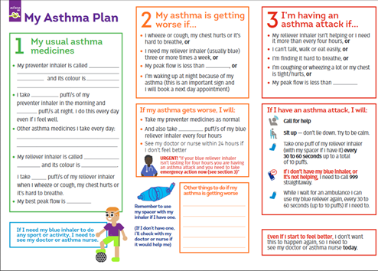

Staff training

Staff will need regular asthma updates. This training can be provided by the school nursing team and/or Compliance Education.

As of the 1st of September 2021. Paediatric First Aid Course should incorporate basic training on how to ‘Help a baby or child having: a diabetic emergency; an asthma attack; an allergic reaction; meningitis; and/or febrile convulsions. Therefore, the school will check our training provider meets Early Years Foundation Stage Statutory Criteria. Annex A

https://assets.publishing.service.gov.uk/government/uploads/system/uploads/attachment_data/file/974907/EYFS_framework_-_March_2021.pdf
School Environment

The school does all that it can to ensure the school environment is favourable to pupils with asthma. The school has a definitive no-smoking policy. Pupil’s asthma triggers will be recorded as part of their asthma action plans and the school will ensure that pupil’s will not come into contact with their triggers, where possible.

We are aware that triggers can include:
- Colds and infection
- Dust and house dust mite Pollen, spores and moulds
- Feathers
- Furry animals
- Exercise, laughing
- Stress
- Cold air, change in the weather
- Chemicals, glue, paint, aerosols
- Food allergies
- Fumes and cigarette smoke

As part of our responsibility to ensure all children are kept safe within the school grounds and on trips away, a risk assessment will be performed by staff. These risk assessments will establish asthma triggers which the children could be exposed to and plans will be put in place to ensure these triggers are avoided, where possible.

Exercise and activity

Taking part in sports, games and activities is an essential part of school life for all pupils. All staff will know which children in their class have asthma and all PE teachers at the school will be aware of which pupils have asthma from the school’s asthma register.

Pupils with asthma are encouraged to participate fully in all activities. PE teachers will remind pupils whose asthma is triggered by exercise to take their reliever inhaler before the lesson, and to thoroughly warm up and down before and after the lesson. It is agreed with PE staff that pupils who are mature enough will carry their inhaler with them and those that are too young will have their inhaler labelled and kept in a box at the site of the lesson. If a pupil needs to use their inhaler during a lesson they will be encouraged to do so.

There has been a large emphasis in recent years on increasing the number of children and young people involved in exercise and sport in and outside of school. The health benefits of exercise are well documented and this is also true for children and young people with asthma. It is therefore important that the school involve pupils with asthma as much as possible in and outside of school. The same rules apply for out of hours sport as during school hours PE.

When asthma is affecting a pupil’s education

The school are aware that the aim of asthma medication is to allow people with asthma to live a normal life. Therefore, if we recognise that asthma is impacting on their life as a pupil, and they are unable to take part in activities, tired during the day, or falling behind in lessons we will discuss this with parents/carers, the school nurse, with consent, and suggest they make an appointment with their asthma nurse/doctor. It may simply be that the pupil needs an asthma review, to review inhaler technique, medication review or an updated Personal Asthma Action Plan, to improve their symptoms. However, the school recognises that pupils with asthma could be classed as having disability due to their asthma as defined by the Equality Act 2010, and therefore may have additional needs because of their asthma.

Emergency Salbutamol Inhaler in school

As a school we are aware of the guidance ‘The use of emergency salbutamol inhalers in schools from the Department of Health’ (March 2015) which gives guidance on the use of emergency salbutamol inhalers in schools (March 2015). A summary of the key points from this document can be found below.

https://assets.publishing.service.gov.uk/government/uploads/system/uploads/attachment_data/file/416468/emergency_inhalers_in_schools.pdf

As a school we are able to purchase salbutamol inhalers and spacers from community pharmacists without a prescription.

We have 9 emergency kit(s), which are kept in Reception classroom, Year 1 classroom, Year 2 classroom, Year 3 classroom, Year 4 classroom, Year 6 classroom, on the minibus and Seashells club so they are easy to access. Each kit contains:

- A salbutamol metered dose inhaler.
- At least two spacers compatible with the inhaler.
- Instructions on using the inhaler and spacer.
- Instruction on cleaning and storing the inhaler.
- Manufacturer’s information.
- A checklist of inhalers, identified by their batch number and expiry date, with monthly checks recorded.
- A note of the arrangements for replacing the inhaler and spacers.
- A list of children permitted to use the emergency inhaler:
- A record of administration

We understand that salbutamol is a relatively safe medicine, particularly if inhaled, but all medicines can have some adverse effects. Those of inhaled salbutamol are well known, tend to be mild and temporary are not likely to cause serious harm. The child may feel a bit shaky or may tremble, or they may say that they feel their heart is beating faster.

We will ensure that the emergency salbutamol inhaler is only used by children who have asthma or who have been prescribed a reliever inhaler and for whom written parental consent has been given.

The school’s asthma lead and team will ensure that:
- On a monthly basis the inhaler and spacers are present and in working order, and the inhaler has sufficient number of doses available.
- replacement inhalers are obtained when expiry dates approach.
- Replacement spacers are available following use.
- The plastic inhaler housing (which holds the canister) has been cleaned, dried, and returned to storage following use, or that replacements are available if necessary. Before using a salbutamol inhaler for the first time, or if it has not been used for 2 weeks or more, shake and release 2 puffs of medicine into the air.

Any puffs should be documented so that it can be monitored when the inhaler is running out. The inhaler has approximately 200 metered puffs, so when it gets to 150 puffs having been used we will replace it.

The spacer cannot be reused as there is a risk of cross-infection therefore, the spacer will be disposed of or assigned to the child for future personal use.

The inhaler can be reused, so long as it hasn’t come into contact with any bodily fluids. Following use, the inhaler canister will be removed and the plastic inhaler housing and cap will be washed in warm running water, and left to dry in air in a clean safe place. The canister will be returned to the housing when dry and the cap replaced.

Spent inhalers will be returned to the pharmacy to be recycled.

As spent inhalers count as waste for disposal the school has a legal responsibility to register as a lower-tier waste carrier. (Free of charge)

https://www.gov.uk/register-renew-waste-carrier-broker-dealer-england

The emergency salbutamol inhaler will only be used by children:
- Who have been diagnosed with asthma and prescribed a reliever inhaler OR who have been prescribed a reliever inhaler AND for whom written parental consent for use of the emergency inhaler has been given.

The name(s) of these children will be clearly written in our emergency kit(s). The parents/carers will always be informed in writing if their child has used the emergency inhaler, so that this information can also be passed onto the GP.

Common ‘day to day’ symptoms of asthma

As a school we require that children with asthma have a personal asthma action plan which can be provided by their doctor / nurse. These plans inform us of the day-to-day symptoms of each child’s asthma and how to respond to them in an individual basis. We will also send home our own information and consent form for every child with asthma each school year (see last page). This needs to be returned immediately and kept with our asthma register.

However, we also recognise that some of the most common day-to-day symptoms of asthma are:
- Dry cough
- wheeze (a ‘whistle’ heard on breathing out) often when exercising
- Shortness of breath when exposed to a trigger or exercising
- Tight chest

These symptoms are usually responsive to the use of the child’s inhaler and rest (e.g. stopping exercise). As per Department of Health Document, they would not usually require the child to be sent home from school or to need urgent medical attention.

Asthma Attacks

The school recognises that if all of the above is in place, we should be able to support pupils with their asthma and hopefully prevent them from having an asthma attack. However, we are prepared to deal with asthma attacks should they occur.

All staff will receive an asthma update annually, and as part of this training, they are taught how to recognise an asthma attack and how to manage an asthma attack.

The department of health Guidance on the use of emergency salbutamol inhalers in schools (March 2015) states the signs of an asthma attack are:

- Persistent cough (when at rest)
- A wheezing sound coming from the chest (when at rest)
- Difficulty breathing (the child could be breathing fast and with effort, using all accessory muscles in the upper body)
- Nasal flaring
- Unable to talk or complete sentences. Some children will go very quiet
- May try to tell you that their chest ‘feels tight’ (younger children may express this as tummy ache)

If the child is showing these symptoms, we will follow the guidance for responding to an asthma attack recorded below. However, we also recognise that we need to call an ambulance immediately and commence the asthma attack procedure without delay if the child:

Appears exhausted | Is going blue
Has a blue/white tinge around lips | Has collapsed

It goes on to explain that in the event of an asthma attack:
- Keep calm and reassure the child
- Encourage the child to sit up and slightly forward
- Use the child’s own inhaler – if not available, use the emergency inhaler
- Remain with the child while the inhaler and spacer are brought to them
- *Shake the inhaler and remove the cap
- *Place the mouthpiece between the lips with a good seal, or place the spacer mask securely over the nose and mouth.
- *Immediately help the child to take two puffs of salbutamol via the spacer, one at a time.(1 puff to 5 breaths)
- If there is no improvement, repeat these steps* up to a maximum of 10 puffs
- Stay calm and reassure the child. Stay with the child until they feel better. The child can return to school activities when they feel better.
- If you have had to treat a child for an asthma attack in school, it is important that we inform the parents/carers and advise that they should make an appointment with the GP
- If the child has had to use 6 puffs or more in 4 hours the parents should be made aware and they should be seen by their doctor/nurse.
- If the child does not feel better or you are worried at ANYTIME before you have reached 10 puffs, call 999 FOR AN AMBULANCE and call for parents/carers.
- If an ambulance does not arrive in 10 minutes give another 10 puffs in the same way
- A member of staff will always accompany a child taken to hospital by an ambulance and stay with them until a parent or carer arrives

References

- Asthma UK website School Policy Guidelines
https://www.asthma.org.uk/advice/child/life/school/
- BTS/SIGN asthma Guideline
https://www.brit-thoracic.org.uk/quality-improvement/guidelines/asthma/
- Department of Health (2014) Guidance on the use of emergency salbutamol inhaler in schools
https://assets.publishing.service.gov.uk/government/uploads/system/uploads/attachment_data/file/416468/emergency_inhalers_in_schools.pdf
- Early Years Foundation Stage Statutory Guidance effective 1st September 2021
https://assets.publishing.service.gov.uk/government/uploads/system/uploads/attachment_data/file/974907/EYFS_framework_-_March_2021.pdf

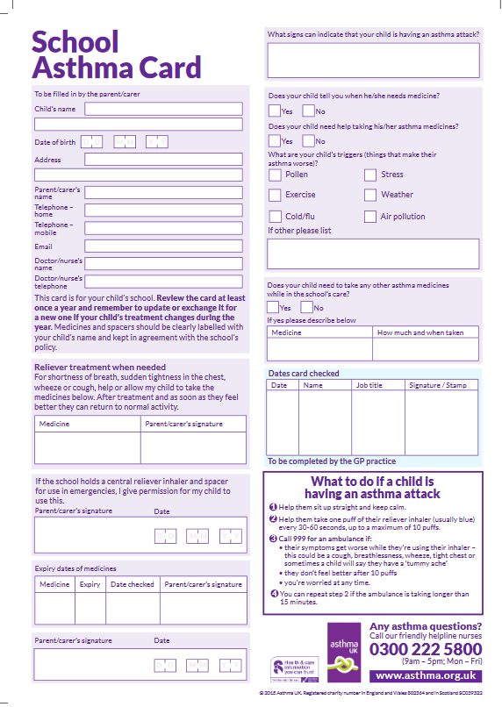

APPENDIX B
ADMINISTRATION OF MEDICINES POLICY

Anaphylaxis

St James CE Primary School

Anaphylaxis

Anaphylaxis is a severe and often sudden allergic reaction which may be life-threatening and must be treated immediately. Allergic reactions occur when a person’s immune system responds inappropriately to a food or substance that it wrongly perceives as a threat.

What causes an anaphylaxis reaction?

The common causes of allergies and anaphylaxis among children include:
- Peanuts
- Fish/seafood
- Milk
- Eggs
- Tree nuts (such as almonds, walnuts, cashew nuts, brazil nuts)
- Wheat
- Kiwifruit
- Less commonly, other foods

Non-food causes include wasp or bee stings, natural latex (rubber), penicillin or any other medicines.

Most healthcare professionals consider an allergic reaction to be anaphylaxis when it involves a difficulty in breathing or affects the heart rhythm or blood pressure. Any one or more of the following symptoms may be present. These are often referred to as the ABC symptoms:

Airway | Breathing | Consciousness/Circulation
Persistent cough  Vocal changes (hoarse voice)  Difficulty in swallowing  Swollen tongue | Difficult or noisy breathing  Wheezing (like an asthma  attack) | Feeling lightheaded or faint.  Clammy skin  Confusion  Unresponsive/unconscious  (due to a drop-in blood  pressure)

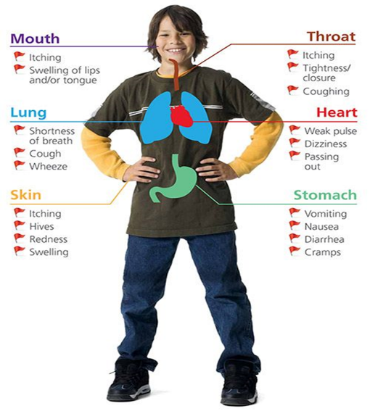

This school welcomes all pupils with allergies/anaphylaxis and aims to support these children in participating fully in school life, which could include ensuring that a child with a food allergy is able to eat a school lunch. We recognise the seriousness of this condition, but with accurate and comprehensive information we feel their condition can be managed.
We endeavour to do this by ensuring we have:
- all pupils have an up-to-date allergies and anaphylaxis healthcare plan
- an allergies and anaphylaxis register
- up-to-date allergies and anaphylaxis policy,
- an allergies and anaphylaxis lead,
- all pupils with immediate access to their adrenaline auto-injectors at all times,
- an emergency adrenaline auto-injector
- ensure all staff have regular anaphylaxis and adrenaline training
- promote anaphylaxis awareness pupils, parents/carers and staff.
- practical measures to eliminate or reduce the allergen in school.

Anaphylaxis Healthcare Plan

To comply with our statutory duty to support pupils with medical conditions. The school will complete a Healthcare Plan with all pupils known to suffer from Anaphylaxis or who have been prescribed an Adrenaline Auto-injector.
The school Healthcare Plan ensures the school is effectively supporting a pupil’s medical condition by providing clarity about the child’s condition, what the child is allergic to, recognising the first signs of allergic reaction and what to do in an emergency.
Pupils parents/guardians, relevant staff, and if necessary, healthcare professionals will be consulted.

Our Healthcare Plan includes the following information:

- The child’s details
- Contact details – Telephone and mobile numbers of parent or guardian and any other emergency contact details.
- Contact details of family GP
- The child’s allergies – A list of the specific allergies and what to avoid
- A list of possible symptoms
- Prescribed Medication
- Details of Emergency Procedure – Including an assessment of symptoms, when and how to administer medication, contact numbers and the ambulance procedure
- Who can help? – A list of staff members who have been trained
- Consent and agreement – A parent or guardian must give written consent for staff to take responsibility for administering medication.

https://www.gov.uk/government/publications/supporting-pupils-at-school-with-medical-conditions--3

Anaphylaxis Register

We have an anaphylaxis register of children within the school, which we update yearly. We do this by asking parents/carers if their child is diagnosed with anaphylaxis or has been prescribed an adrenaline auto-injector. When parents/carers have confirmed that their child is anaphylaxis or has been prescribed an adrenaline auto-injector we ensure that the pupil has been added to the anaphylaxis register and has:

- an up-to-date copy of their personal anaphylaxis healthcare plan,
- their adrenaline auto-injectors Epi-Pen, Jext, Emerade is with them in school,
- permission from the parents/carers to use the emergency Epi-Pen, Jext, Emerade adrenaline auto-injector if they require another dose before the emergency services arrive

Anaphylaxis Lead

This school has an anaphylaxis lead Debra Robinson. It is the responsibility of the anaphylaxis lead to manage the anaphylaxis register, update the anaphylaxis policy, manage the emergency Epi-Pen, Jext, Emerade adrenaline auto-injector (please refer to the Department of Health Guidance on the use of adrenaline auto-injectors in schools, September 2017) ensure measures are in place so that children have immediate access to their adrenaline auto-injector.

https://assets.publishing.service.gov.uk/government/uploads/system/uploads/attachment_data/file/645476/Adrenaline_auto_injectors_in_schools.pdf

Access to a child’s Adrenaline Auto-injector

All children with anaphylaxis should always have immediate access to their adrenaline auto-injector. The adrenaline auto-injector medication acts on the whole body to block the progression of the allergic response. It constricts the blood vessels, leading to increased blood pressure, and decreased swelling.

Children are encouraged to carry their adrenaline auto-injectors as soon as they are responsible enough to do so. We would expect this to be by key stage 2. However, we will discuss this with each child’s parent/carer and teacher. We recognise that all children may still need supervision in administering their adrenaline auto-injector.

For Younger children, Adrenaline Auto-injectors are kept in the classroom in a Yellow First Aid bag and this is clearly visible to staff and children.

School staff are not required to administer adrenaline auto-injector to pupils however the school understands that in an emergency a failure to administer the child’s medication could end in hospitalisation or even death. Therefore, the school will ensure an adequate number of staff have had adrenaline auto-injector training and/or administering medication training and are happy to support children. Please refer to the Administering Medicines policy for further details about administering medicines.

Emergency Adrenaline Auto-injector in school

Legislation which came into effect in 2017 enables schools in the UK to buy Adrenaline Auto-injector (AAIs) without a prescription for emergency use on children who are at risk of anaphylaxis.

Adrenaline Auto-injector are intended for use in emergency situations when an allergic individual is having a reaction consistent with anaphylaxis, as a measure that is taken until an ambulance arrives. Therefore, unless directed otherwise by a healthcare professional, the spare Adrenaline Auto-injector should only be used on pupils known to be at risk of anaphylaxis, where both medical authorisation and written parental consent for use of the spare Adrenaline Auto-injector has been provided.

We have 2 emergency kit(s), which are kept in the Reception Office First Aid Box, so it is easy to access.

Each kit contains:

- A pre-loaded Adrenaline Auto-injector.
- Instructions on using the device(s).
- Instruction on cleaning and storing the Adrenaline Auto-injector
- Manufacturer’s information.
- A checklist of Adrenaline Auto-injector, identified by their batch number and expiry date, with monthly checks recorded.
- A note of the arrangements for replacing the Adrenaline Auto-injector.
- A list of children to whom the Adrenaline Auto-injector can be administered:
- A record of administration

Adrenaline Auto-injectors are available in different doses, depending on the manufacturer. The Resuscitation Council (UK) recommends that healthcare professionals treat anaphylaxis using the age-based criteria, as follows:

- For children age under 6 years: a dose of 150 microgram (0.15 milligram) of adrenaline is used (e.g. using an Epipen Junior (0.15mg), Emerade 150 or Jext 150 microgram device).
- For children age 6-12 years: a dose of 300 microgram (0.3 milligram) of adrenaline is used (e.g. using an Epipen (0.3mg), Emerade 300 or Jext 300 microgram device)

Once an Adrenaline Auto-injector has been used it cannot be reused and must be disposed of according to manufacturer’s guidelines. Used Adrenaline Auto-injector can be given to the ambulance paramedics on arrival or can be disposed of in a pre-ordered sharps bin for collection by the local council.

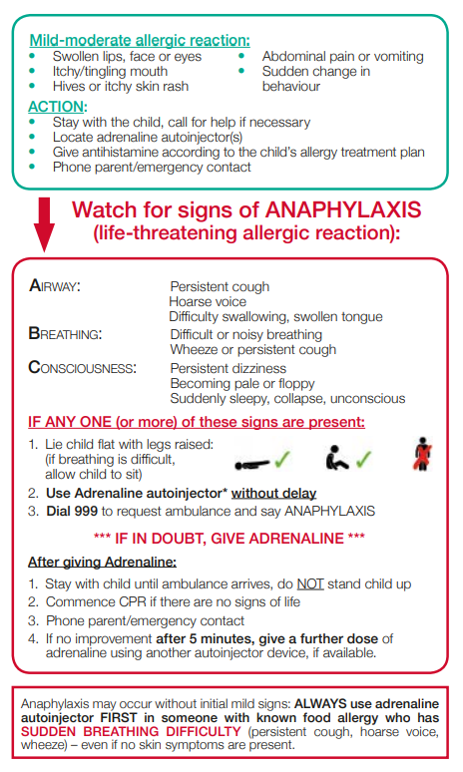

School trips including sporting activities

Schools should conduct a risk-assessment for any pupil at risk of anaphylaxis taking part in a school trip off school premises, in much the same way as they already do so with regards to safe-guarding etc.

Pupils at risk of anaphylaxis should have their Adrenaline Auto-injector with them, and there should be staff trained to administer Adrenaline Auto-injector in an emergency. Schools may wish to consider whether it may be appropriate, under some circumstances, to take spare Adrenaline Auto-injector obtained for emergency use on some trips.

Staff training

Severe anaphylaxis is an extremely time-critical situation: Delays in administering adrenaline have been associated with fatal outcomes. Therefore, it is important that as many of our staff are trained in how to administer an Adrenaline Auto-injector.

As of the 1st of September 2021. Paediatric First Aid Courses should incorporate basic training on how to ‘Help a baby or child having: a diabetic emergency; an asthma attack; an allergic reaction; meningitis; and/or febrile convulsions. Therefore, the school will check our training provider meets Early Years Foundation Stage Statutory Criteria. Annex A
https://assets.publishing.service.gov.uk/government/uploads/system/uploads/attachment_data/file/974907/EYFS_framework_-_March_2021.pdf

School Environment

The school does all that it can to ensure the school environment is favourable to pupils with anaphylaxis. The school has a definitive no-nut policy. Pupil’s anaphylaxis triggers will be recorded as part of their anaphylaxis healthcare plans and the school will endeavour that pupil’s will not come into contact with their triggers, where possible.

As part of our responsibility to ensure all children are kept safe within the school grounds and on trips away, a risk assessment will be performed by staff. These risk assessments will establish anaphylaxis triggers which the children could be exposed to and plans will be put in place to ensure these triggers are avoided, where possible.

Food prepared on site - Lunch

All food and drink provided in our school meet the national food standards in England. All school lunches are cooked by our school caterer, whish is St Helens Council.

Our school caterer, St Helens Council comply with School Food Standards to ensure that food provided to pupils in school is nutritious and of high quality; to promote good nutritional health in all pupils; protect those who are nutritionally vulnerable; and promotes good eating behaviours.

Reasonable adjustments are made to the menu to reflect medical, dietary, and cultural needs of our pupils.
To comply with the EU Food Information for Consumers Regulation information is made available listing all allergenic ingredients contained within the food and drinks we serve.

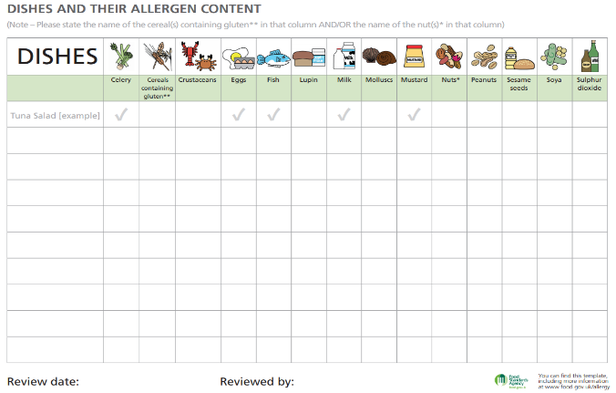

Food prepared on site – eg Breakfast club.

Food prepared for the breakfast club is provided by the school and consist of low-risk foods e.g. toast, muffins, crumpets and a selection of drinks.

Food prepared off site (Packed Lunches, Birthday celebrations and festive treats)

All parents providing a packed lunch for their child are made aware of any known allergens and are asked to co-operate with the school.

A “no sharing” policy is in place, for when children bring food from home, and every
effort is taken to ensure that allergic children do not take or accept food from another child's packed lunch.

A “treat box” of known allergen-free treats is provided by the child’s parents, to ensure that they are included in all special occasions.

Children with known allergens are encouraged to check with an adult before eating or before taking part in certain activities. Just a “is that okay for me?” will make the adult think again, and also teach the child awareness of their allergy and develop good management techniques.

References

- Department of Health Guidance on the use of adrenaline auto-injectors in school
https://assets.publishing.service.gov.uk/government/uploads/system/uploads/attachment_data/file/645476/Adrenaline_auto_injectors_in_schools.pdf
- Department of Education Allergy Guidance for schools 17th November 2020
https://www.gov.uk/government/publications/school-food-standards-resources-for-schools/allergy-guidance-for-schools
- Department of Education Supporting Pupils with Medical Conditions at School
https://assets.publishing.service.gov.uk/government/uploads/system/uploads/attachment_data/file/803956/supporting-pupils-at-school-with-medical-conditions.pdf
- Department of Education School food in England
https://assets.publishing.service.gov.uk/government/uploads/system/uploads/attachment_data/file/788884/School-food-in-England-April2019-FINAL.pdf
- Department of Education School Food Standards
https://www.gov.uk/government/publications/school-food-standards-resources-for-schools
- Anaphylaxis Campaign
https://www.anaphylaxis.org.uk/information-training/our-factsheets/
- Early Years Foundation Stage Statutory Guidance effective 1st September 2021
https://assets.publishing.service.gov.uk/government/uploads/system/uploads/attachment_data/file/974907/EYFS_framework_-_March_2021.pdf

Extraction from the EYFS Statutory Guidance effective from 1st September 2021

Annex A: Criteria for effective Paediatric First Aid (PFA) training

- Training is designed for workers caring for young children in the absence of their parents and is appropriate to the age of the children being cared for.
- Following training an assessment of competence leads to the award of a certificate.
- The certificate must be renewed every three years.
- Adequate resuscitation and other equipment including baby and junior models must
- be provided, so that all trainees are able to practice and demonstrate techniques.
- The emergency PFA course should be undertaken face-to-face71 and last for a minimum of 6 hours (excluding breaks) and cover the following areas:

- Be able to assess an emergency situation and prioritise what action to take
- Help a baby or child who is unresponsive and breathing normally
- Help a baby or child who is unresponsive and not breathing normally
- Help a baby or child who is having a seizure
- Help a baby or child who is choking
- Help a baby or child who is bleeding
- Help a baby or child who is suffering from shock caused by severe blood loss
- (hypovolemic shock)

- The full PFA course should last for a minimum of 12 hours (excluding breaks) and cover the elements listed below in addition to the areas set out in paragraph 5 (the emergency PFA training elements outlined in paragraph 5 should be delivered face to face).

- Help a baby or child who is suffering from anaphylactic shock
- Help a baby or child who has had an electric shock
- Help a baby or child who has burns or scalds
- Help a baby or child who has a suspected fracture
- Help a baby or child with head, neck or back injuries
- Help a baby or child who is suspected of being poisoned
- Help a baby or child with a foreign body in eyes, ears or nose
- Help a baby or child with an eye injury
- Help a baby or child with a bite or sting
- Help a baby or child who is suffering from the effects of extreme heat or cold
- Help a baby or child having: a diabetic emergency; an asthma attack; an allergic
- reaction; meningitis; and/or febrile convulsions

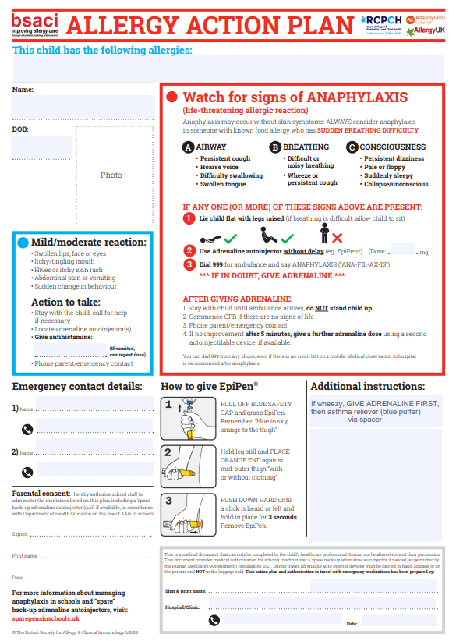

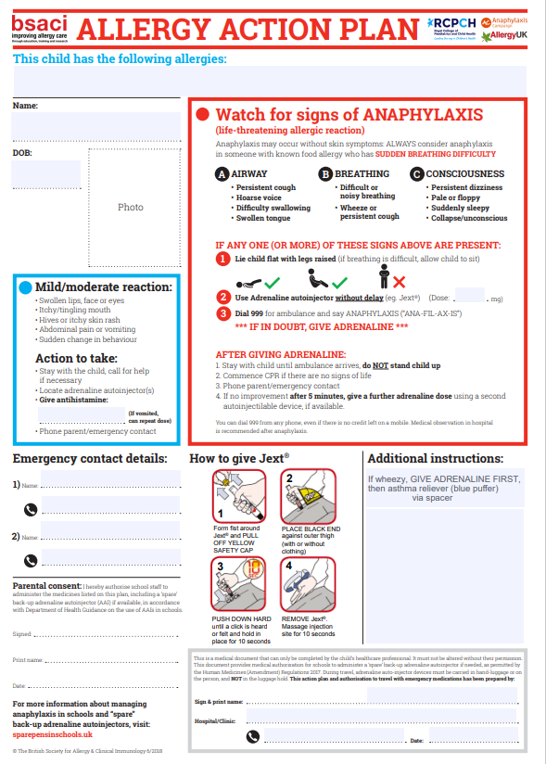

Review Schedule
Policy Author | Trust Corporate Services Director (TCSD)
Policy Approver | Audit and Risk Committee
Current Policy Version | 1.2
Policy Effective From | December 2025
Policy Review Date | By 31 December 2026

Revision Schedule
Version | Revisions | By whom
1.0 | Original document produced | TCSD and Compliance Education
1.1 | Significant updates to Qualifications and Training, Early Years and First Aid Materials. Addition of Compliance Education role as Competent Person in relation to accident reporting. | Operations Lead and Compliance Education

