All applications that go live on the internet can be dangerous.
Parent/carer supervision, knowledge and awareness is the best way to prevent exposure to dangerous content and behavior online. Knowing the worst apps to look out for is a great start.
If you are the one who sets up your child’s phone/device account, you can also set restrictions such as placing password protection on the app store, preventing unwanted downloads in the first place.

The following applications have been researched as some of the most dangerous for our children!!!
Applications and age | Dangers | Applications and age | Dangers
IMVU: age 13+  3D Avatar creator & chat to make friends  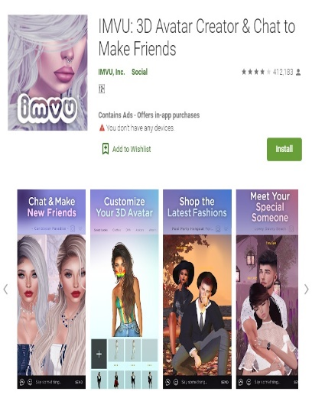 | Avatar-based games and apps like IMVU are especially dangerous for children and teens. Role-playing of all kinds, usually sexual, takes place in a virtual world with virtual characters. Users can chat with others all across the world while interacting with their avatars. These chat rooms are unmoderated, and bullying is happening. | Tumblr: age13+  Blogging application  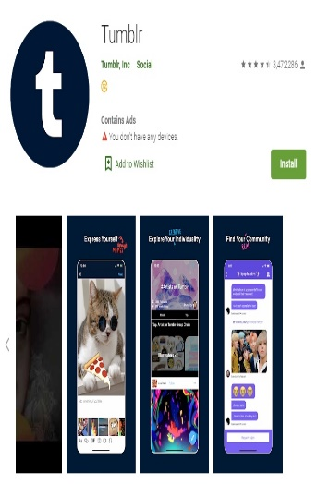 | Tumblr is very popular with teenagers in their high school years. users can share content of all kinds from their own personal page. The platform tends to lean towards darker themes of anxiety, depression, drug use and self-harm. topics including body image, sexuality and relationships. In addition, all profiles are public and sexual content is easily accessed on the site. Profiles are not verified or monitored, making it easier for adults and predators to message kids
Roblox: age 10+  Gamming application   | The purpose of Roblox is for players to interact and make friends, by wandering around the online world and talking with other players. The chat is unmoderated and there is no control over the types of people or age limits of those playing. Children are susceptible to being targeted by online predators | Snapchat age13+  Pictures and videos  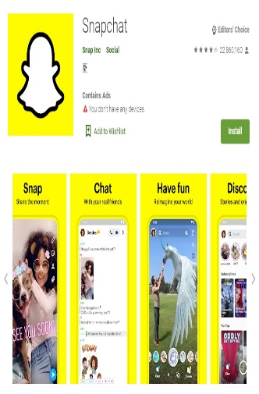 | Snapchat has much attention in the media due to the nature of its disappearing messages. Snapchat allows users to send temporary text messages and media content to their friends. Many kids and teens secretly use the app to evade the watchful eye of parents who monitor their text messages. Kids can also use the app to send each other photos and videos they don’t want parents or teachers to see. For example, a user may send out nude photos of a classmate to all of their school friends because they know it leaves no trace
Chatspin: age 13+  Random video chat, talk to strangers  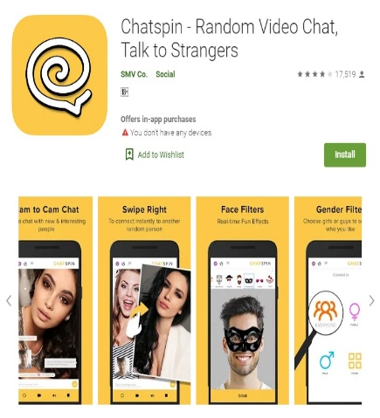 | Random video chat apps have become a popular pastime with many bored young adults and teenagers, This app matches users with random live video feeds from other people. Children can easily be exposed to real-time sexual content in a matter of seconds, including unwanted sexual advances by adult predators. These random webcam apps and websites like Chat Roulette are extremely dangerous and inappropriate for anyone under the age of 18. | Tinder: age 18+  Dating application  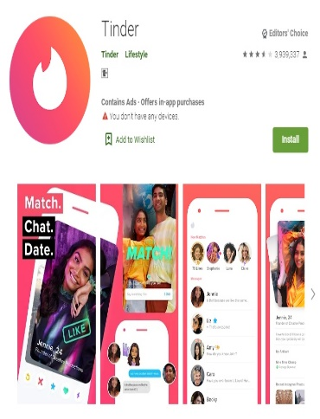 | Teenagers, especially those with some independence such as jobs Tinder is wildly popular with many young adults and promises to match users with the dating partners of their dreams. Apps like Tinder are known as hook up sites and also used by predators. Often these sites fail to have consistent or effective age verification measures, leaving teens vulnerable. Even if they are only connecting with others their own age, the casual sex culture encouraged by this application is probably something you don’t want your teenager involved in.
KiK: age 13+  Messaging application  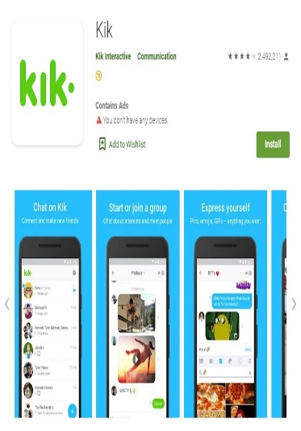 | Kik is a messaging app incredibly popular in recent years especially with teenagers. As a mostly anonymous app, users do not have to verify any information to create an account and username. This makes it very easy for predators to get easy access to children and it is very common for people on Kik to lie about who they are. Photos and videos can be sent through the app as well, making Kik a very popular platform for anonymous sexting and sexual predators. | Instagram: age13+  Photos and Videos  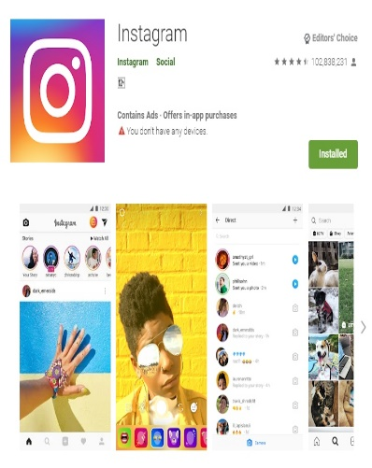 | Instagram connects users primarily using hashtags, and profiles consist of photos and videos only. Finding inappropriate content posted by strangers is shockingly easy using these hashtags. Instagram is also a common platform used by pedophiles to contact young children and teens. Of the 3 most popular social media apps, Instagram is the most dangerous for kids simply because their demographic is on it. Instagram is more visual than the other brands, making it much easier for your children to be exposed to sexual content and other inappropriate images.
Whisper: age13+  Social platform- chat  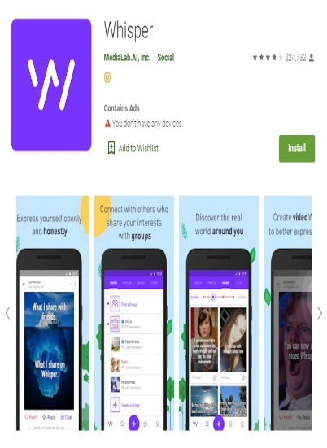 | The Whisper app is heavily marketed to young adults and teens, describing itself as a place for people to share their secrets. With no names, locations, ages or any information needed to create an account, there is no user verification. One recent count found that there were over 1 million users of the app who self-identified as being 15 years old. As an anonymous social platform, Whisper is an extremely dangerous app for kids and teenagers. Many of the posts are centered around sexual behavior and even soliciting sex. | Tik Tok: age13+  Videos  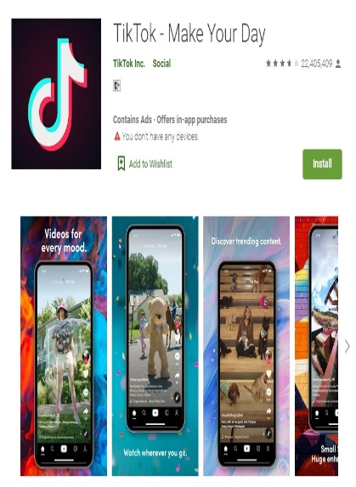  SAID TO BE TO THE MOST DANGEROUS | Tik Tok is said to be one of the most dangerous due to the nature of the content and its explosive popularity. While younger children and even teenagers may not have heard of the other apps on this list, most kids these days have heard about TikTok. Peer pressure is often a great factor in your children’s decisions online. TikTok shows users short viral videos covering a wide variety of topics and pop culture memes. Because of this, many videos are not appropriate for children and teens. Videos showing profanity, violence, sexual content and other inappropriate behavior. In addition, the lack of effective privacy settings on the app makes it possible for any stranger to message, the platform takes no steps to verify age. Many online predators use this to meet young children.
Amino: age13+  Chat application   | The Amino App encourages young users to explore their interests and connect with people who have similar passions. However, those virtual Amino communities are uncensored and everyone using the chat app is anonymous. Many online predators use this to meet young children. | 7 Cups: age13+  Online therapy platform  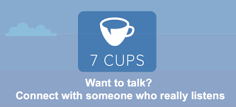 | 7 Cups is a website which provides online therapy and free support to people experiencing emotional distress by connecting them with trained listeners. The listener, trained in active listening, interacts with the person seeking help via an anonymous and confidential chat. Anyone can become a listener, there is no vetting process. Reviews have indicated that vulnerable young people are using the service for emotional support only to be spoken to inappropriately by their so called listener.
Omegle: age13+  Omegle is a free online chatting service   | Omegle is very transparent when it comes to dangers on the site. It clearly states, “Predators have been known to use Omegle, so please be careful.” This indicates their awareness of who may be going on their site. In fact, some people call Omegle a “predator’s playground” because users don’t have to reveal their real identities and it allows them to talk to kids with very few restrictions. | Ask FM:   | Ask.fm is an anonymous question and answer platform website used regularly by lots of young people around the world. It allows anyone to post anonymous comments and questions to a person’s profile and is increasingly being used as a means to communicate abusive, bullying and sexualised content.
House Party: Age 13 +   | House parties, while often seen as social events, carry several potential dangers, including alcohol-related risks like excessive drinking, impaired driving, and potential for drink spiking. Other risks include drug use, injuries from fights or falls, and exposure to inappropriate or upsetting content, such as cyberbullying or explicit material. In online settings, like Houseparty, there's also a risk of strangers joining, sharing personal information, and content being recorded and shared without consent. | Zoomerang: Age 13 +   | A hit among the younger crowd, Zoomerang offers a platform for crafting and sharing short videos, replete with catchy music, trendy filters, and eye-catching special effects.  The app’s limited privacy controls can inadvertently open up young users’ videos to comments and views from unknown individuals.  Exposure to potential cyberbullying, online predators, and unsuitable content is a pressing concern given the platform’s open nature.

