

FOMBA will be opening the ‘Elfridges’ store again this year and we need your help to stock the shelves!

Children are invited to wear festive/Christmas clothing on Friday 5th December.
In exchange for this we are asking for donations of the following:
EYFS - sweets, chocolates and biscuits
Y1 & 2 - women's items (gift sets, toiletries etc)
Y3 & 4 men's items (toiletries, gift sets etc)
‘Elfridges’ will open its doors during the school day on Monday 15th December
Tickets will be available to purchase via parent mail
*****************************************************************************************
Y5 & 6 will be supporting The Brick Project’s - Wrap up Wigan campaign this year and are invited to wear festive/ Christmas clothing on Friday 5th December for donations of warm clothing to support families and individuals facing hardship this winter.


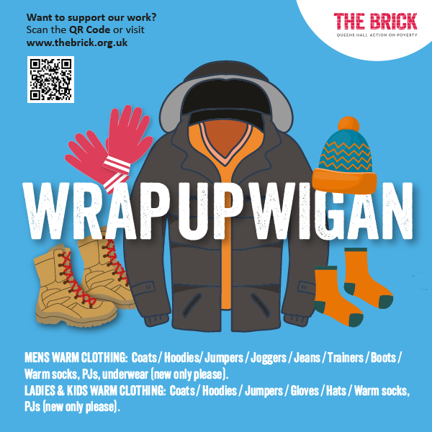
MEN’S WARM CLOTHING
🧥 Coats
👕 Hoodies / Jumpers
👖 Joggers / Jeans
👟 Trainers / Boots
🧦 Warm socks, PJs, underwear (new only please)

LADIES’ & KIDS’ WARM CLOTHING
🧥 Coats
👕 Hoodies / Jumpers
🧤 Gloves / Hats
🧦 Warm socks, PJs (new only please)

