Home Learning Year 3 – 6/01/26
Writing
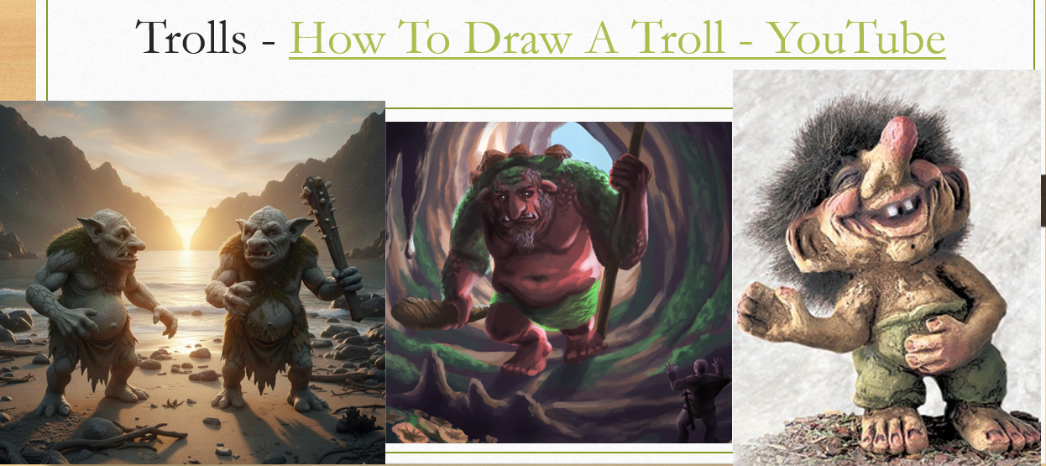
For our next writing cycle, we are going to be looking at a story about trolls. We would like you to have a go at drawing and labelling a troll. A YouTube link is listed below if you would like to watch it but feel free to create your own troll.
How To Draw A Troll - YouTube
Remember to label all of his features ( bulging eyes, leathery skin, yellow fangs) and add some personality traits too (cruel, mean, selfish)!
We will be drawing our trolls too and would love to see your ideas when we are back in school.

Maths
We really need you to practise the 3 times table as much as possible while you are at home.
Please play the following games, with permission from parents, focussing on the 3s.
https://www.topmarks.co.uk/maths-games/daily10
https://www.topmarks.co.uk/maths-games/hit-the-button
You can also go onto your tt rockstars account.
This is also a song to help you.
https://www.youtube.com/watch?v=9XzfQUXqiYY&list=RD9XzfQUXqiYY&start_radio=1
Once you have practised and then practised some more, complete the quiz and bring the results in for us to see.
https://www.youtube.com/watch?v=8is-AlfrzlM

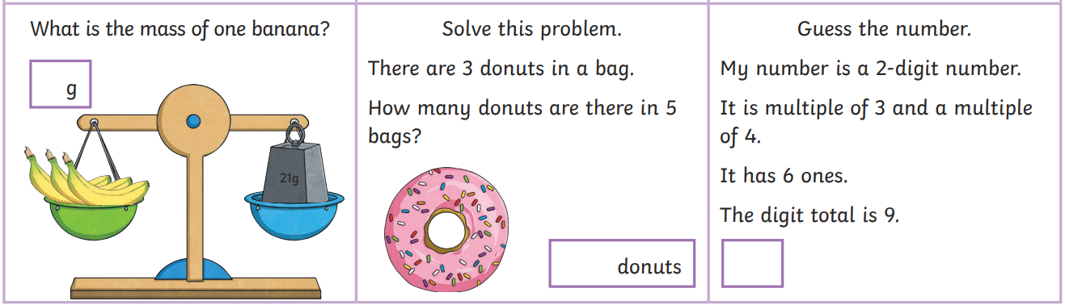
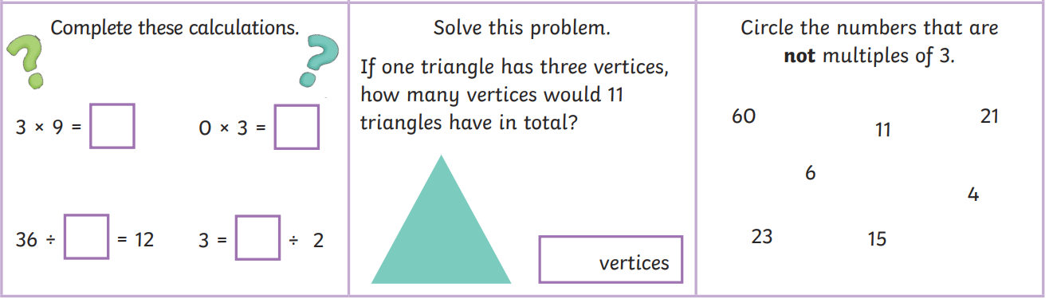
Geography
In this term, we learn all about mountains and volcanoes.

Could you do some research into whether there are any mountains in the UK? If you find any, could you record what are they called and where would you find them?
Then, take a look at some of the famous mountains around the world.
FAMOUS MOUNTAINS IN THE WORLD - YouTube

