

Newhampton Church of England
School Federation
Phonics & Early Reading Policy

Newtown Church of England Primary School
&
Welshampton Church of England Primary School

Agreed by the FGB -- 2022
Review by

Values and Vision
Growing together in strength, love and wisdom, we shine.
“Let your light shine” Matthew 15:16

‘Let your light shine’ encapsulates the school’s commitment to provide an enriching education which is deep and broad. Pupils will be equipped for life in all its fullness through our Christian values of strength, love and wisdom.

Learning will be a journey of fun and adventure, broadening the horizons of our pupils and inspiring them to be the best they can be. Within a nurturing environment, we will support our pupils to give them the strength to flourish as confident, resilient and independent members of society.

Christian character illuminates all aspects of school life, where everyone is understood and valued. At the heart of our safe and inclusive schools, pupils will be kind, patient and respectful - developing a love of one another, a love of learning and a love of life itself.

The aspirational curriculum will foster curious and creative thinkers, who will be encouraged to maximise every opportunity and be proud of their achievements. Pupils will find joy in seeking knowledge and learning new skills, as they grow together on their journey through childhood.

Our schools are forward-thinking and outward-looking. We will continuously improve and evolve together, in order to inspire pupils who leave our schools feeling excited and ready for the future.

Contents

Introduction
Intent
Implementation
Nursery
Reception and Year 1
Ready Steady Go
Teaching Reading
Home Reading
Reading for Pleasure and Enjoyment
Impact
Assessment:
Formative
Summative
Statutory
Ongoing Assessment for Ready Steady Go

Introduction
At Newhampton Church of England Schools Federation, we are proud to offer our pupils a text rich learning environment where imagination and creativity can be fuelled. Through our rigorous approach to teaching phonics, we ensure pupils develop the skills and knowledge which they need in order to develop as confident readers who possess a love of books. We have high expectations regarding learning and believe that phonics and reading are key to accessing all areas of our curriculum, enabling pupils to become successful learners and lifelong readers. It is essential that our approach to teaching phonics and reading is accessible to ALL learners, regardless of background. We are committed to giving our children the best possible start to their school life, which will ensure success in the future.

Intent
At Newhampton Federation, we believe that all our children can become fluent, confident and competent readers and writers. To ensure this happens we teach using the Department for Education validated programme Ready Steady Phonics. This is a synthetic, systematic phonics programme based upon the Letters and Sounds 2007. We follow the Ready Steady Phonics progression document which systematically develops children’s understanding of the phonics code and builds upon previous learning in an incremental manner as they move through school.
The programme develops children’s ability to blend and segment using their current phonics knowledge, allowing early success and increasing their confidence in reading. As a result, the children in the Newhampton Federation are able to tackle unfamiliar words using their phonics knowledge.
At Newhampton Federation, we also model and apply the skills taught in the discrete phonics session into reading and writing across other areas of the curriculum, demonstrating contextual application of the skills taught.
We have a strong focus on language development as we recognise that speaking and listening are crucial skills which underpin reading and writing.
At Newhampton Federation, we also want our children to be able to read for meaning and pleasure and to be able to view themselves as lifelong readers. The matched decodable readers provided by Ready Steady Phonics support this and provide engaging, meaningful texts for children to decode and discuss for understanding. Development of comprehension is promoted within the Ready Steady Phonics Guided Reading Sessions and these are built on further as the children move through our school.
We have a skilled Phonics and Early Reading Ambassador in our school who is responsible for Ready Steady Phonics, monitoring and supporting practitioners’ practice and for ensuring fidelity to the programme.

Implementation
Nursery
In the Newhampton Federation, we provide a balance of adult and child-led activities which meet the curriculum, expectations in ‘Communication and Language’ and ‘Literacy’. These include:
- Sharing high quality stories, poems and non-fiction,
- Learning a range of songs and nursery rhymes,
- High quality language interactions,
- A range of quality listening activities, moving toward oral segmenting and blending by the end of nursery.
Reception and Year 1
The programme begins in Week 2 of Reception.
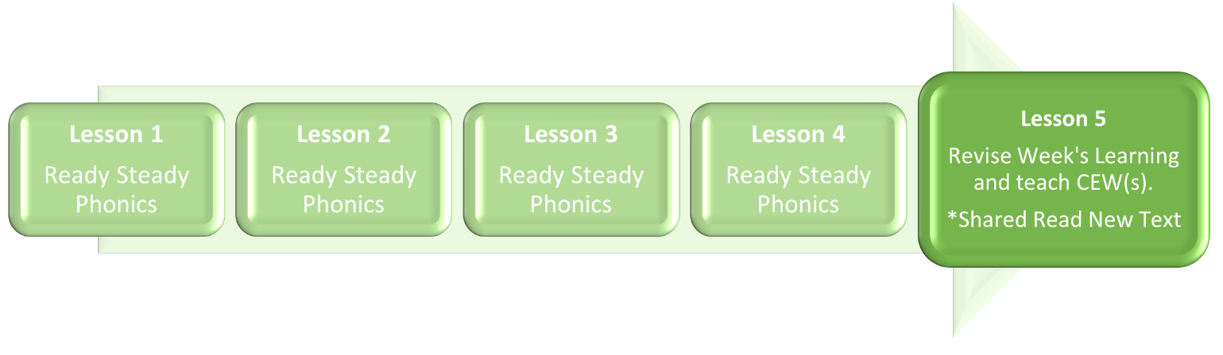
Each week of Ready Steady Phonics contains five lessons. The week’s teaching focus is covered in the first four lessons. The fifth session serves to consolidate prior learning to ensure that new phonics subject skills and knowledge are embedded. Accordingly, we have a clear understanding of where our children are performing and whether they require any further teaching in order to allow them early success.

All daily sessions follow a clearly defined, research-informed teaching sequence:
- Revisit and Revise: To activate prior knowledge by seeing and saying previously taught grapheme phoneme correspondences (GPC) using flashcards and common exception words (CEW).
- Teach: To introduce the next GPC in order to systematically build upon children’s phonic knowledge; to integrate with words containing previously taught GPCs; to teach the formation of new GPCs; to blend words containing new GPCs; to teach new common exception words (fifth lesson only) by decoding known GPCs and identifying the ‘tricky’ part.
- Practise: In workbooks, children practice letter formation; reading and spelling common exception words; blending to decode words containing new GPCs; segmenting to spell words containing new GPCs.
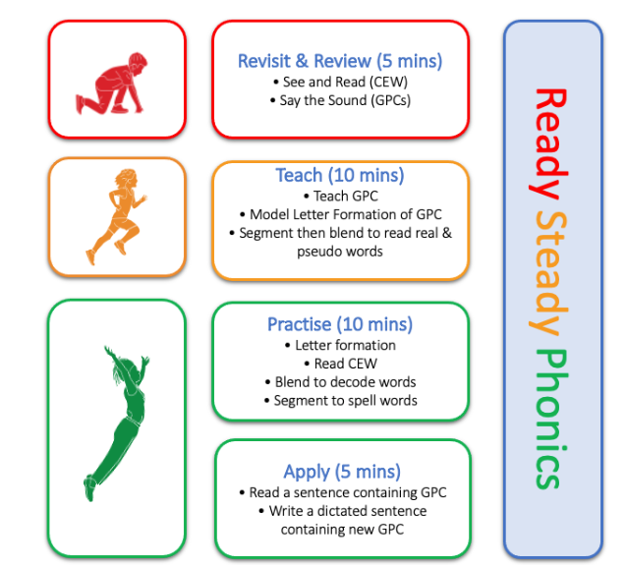
- Apply: Children read and write 100% decodable words, phrases and sentences, ensuring decoding skills are securely embedded.

The Ready Steady Phonics progression document gives clear, high expectations about what is to be taught and when.
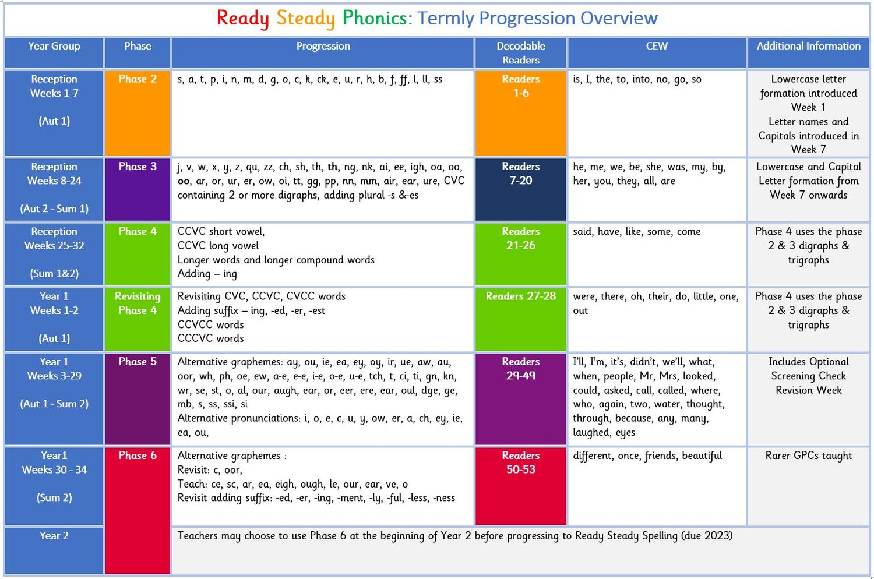

Ready Steady Go
Any child who is identified as requiring additional support will receive immediate intervention through Ready Steady Go sessions. These are in addition to their daily Ready Steady Phonics lesson. The sessions are fifteen to twenty minutes long and are delivered three to five times each week, depending on the area of difficulty identified.
The sessions use the same procedures, resources and materials as Ready Steady Phonics but with more repetition and scaffolding with a fully trained adult.
Regular phonics lessons using the Ready Steady Phonics materials are also timetabled for any children in Years 2 - 6 for children who are not fluent in decoding, or who have not passed the phonics Screening Check in Year 2. The Ready Steady Assessments are used to clearly identify the gaps in knowledge for these children so that the appropriate teaching can be put in place by a trained adult.
Children with common and specific difficulties are taught in small groups or 1:1 using the Ready Steady Phonics materials.

Teaching Reading
Children read texts that align directly to the Ready Steady Phonics progression document. These are available as physical copies and on-line.
The teaching of reading takes place through:
- A shared read of the decodable text, led by a trained adult at some point following the Friday session.
- A guided read of the decodable text will take place with a trained adult.
- This book will also be used for 1:1 or independent reading for consolidation and in order to to develop confidence.
- Books utilised cover fiction, non-fiction and rhyme.

Home Reading
Physical decodable reading books aligned to the progressions of Ready steady Phonics are taken home every day. Remote access to the Ready Steady Phonics online reading books is given once these have been shared with the children in class. Our pupils are expected to read each day in order to practise and consolidate their skills in phonics. This is monitored by the class teacher and the Early Reading and Phonics Ambassador.
Support for parents on how to listen to and support their child in reading a phonically decodable book is provided on our website; within our Home School Journals; and via the Ready Steady Phonics Website (Parent/Carers section).
Reading for Pleasure and Enjoyment
Improves Wellbeing:
“Reading for pleasure has social benefits … and can make people feel more connected to the wider community. Reading increases a person’s understanding of their own identity, improves empathy and gives them an insight into the world view of others,” (The Reading Agency 2015).
Improves Academic Success:
“Students with more positive attitudes towards reading are more likely to read at or above the expected level for their age,” (Clark 2014).
Improves Knowledge and Understanding:
“I read for pleasure and that is the moment I learn the most,” M Attwood - Author.
At Newhampton Federation, we immensely value reading for pleasure and enjoyment and understand the value which this can bring to children. To encourage our children to engage with and have a love of books we:
- Read to our children every day with each class having a timetabled, daily story session of fifteen minutes. We carefully choose the books that we share in order to ensure children experience a wide range of texts. These include fiction, non-fiction, poetry, stories from other cultures and books that reflect our local community.
- Using the ‘Steps to Read’ programme from Literacy Counts, each class participates in a daily shared read which serves to teach the children all aspects of word reading and comprehension through the use of high-quality fiction, non-fiction and poetry texts. The units utilised link to other areas of our foundation curriculum such as science, history or geography.
- All classrooms have an inviting book corner which encourages a love of reading. The books within these areas cover a wide range of genres and are carefully selected to link with class topics, recently read story books and to reflect the children’s interests. Our children are encouraged to use the books purposefully.
- In Nursery and the Early Years Foundation Stage, children have access to the reading corner each day during their child-initiated time. The books on offer are continually refreshed.
- Children from Reception onwards have a Home School Journal. The parent/carer records comments to share with the adults in school and the adults write or record in these on a regular basis to ensure communication between home and school.
- As the children progress through the school, they are encouraged to write their own comments within their Home School Journals and to keep a list of the books and authors that they have read.
- The Federation’s school libraries are made available for all classes to use. Children are able to select texts to take home to share with their parents/carers, to be read to, to talk about, or to read for pleasure.
- Children across our school have regular opportunities to engage with a wide range of Reading for Pleasure events such as book swaps, paired or buddy reads, librarian visits, author visits and workshops, national events including World Book Day, etc.
- Children across both keystages are encouraged to participate in our reading award scheme in which pupils achieve sequential certificates intended to value and reward their efforts for reading at home.

Impact
Assessment
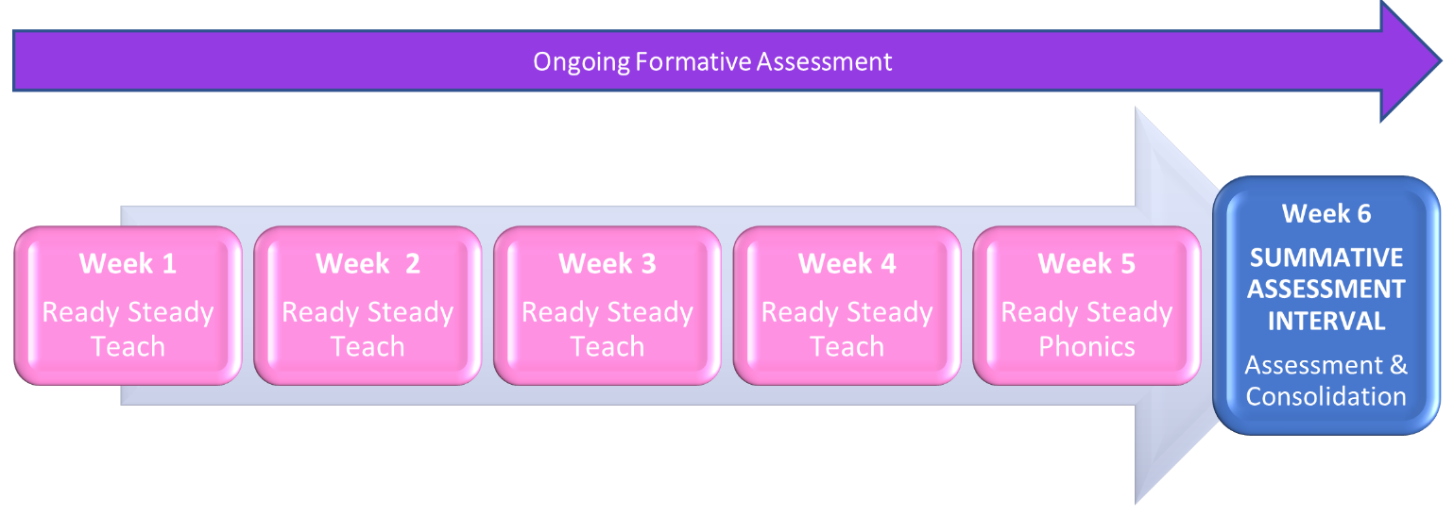

This diagram indicates a typical half term structure of 5 weeks’ progressive teaching, followed by a week of consolidation and summative assessments.

Formative Assessment:
Ongoing, daily formative assessment is integral to Ready Steady Phonics. Workbooks have a dedicated, daily opportunity to record formative assessment which is required to be reinforced in the additional Ready Steady Go sessions.
The weekly Friday sessions allow opportunities to review and identify gaps in learning, enabling early identification of children who make progress less quickly and require subsequent additional Ready Steady Go sessions. These will include children’s attainment in grapheme-phoneme correspondences, letter formation, blending words, segmenting words and the reading and spelling of Common Exception Words.
Practitioners’ ongoing observation of children during their phonics lessons will inform gaps in learning, broader application of phonics skills and their knowledge across the curriculum.

Summative Assessment:
Regular five or six weekly assessments take place as identified in the Ready Steady Phonics progression document. These weeks will be used to assess progress and to identify children who need further individual or group support.
The assessments are shared with the Senior Leadership Team and the Phonics and Early Reading Ambassador to narrow attainment gaps between different groups of children, with a focus on the bottom 20%.
Children from Year groups 1 – 6 are assessed in reading each term using age-appropriate, child-friendly NFER standardised assessments. These offer an age-appropriate level of challenge designed to help build pupils' familiarity with more formal assessment. The results of the assessments enable practitioners to identify areas of strength and any potential learning gaps and are shared with the Federation’s Senior Leadership Team, the Assessment Ambassador, the Keystage 2 Reading Ambassador and the Phonics and Early Reading Ambassador.

Statutory Assessment:
All children in Year 1 will sit the Phonics Screening Check. Any child not passing the check will be required to re-sit this in Year 2.
Year 2 children will sit the Statutory Assessment Tests in Reading towards the end the Year. These will be used to inform gaps in learning.

Ongoing Assessment for Ready Steady Go:
Children in Years 2 - 6 will be assessed through ongoing formative assessment for Ready Steady Go, as well as through the regular Ready Steady Phonics summative assessments.

Prepared by Mrs V Peile
September 2022

