

Newhampton Church of England
Schools Federation

Presentation Policy

Newtown Church of England Primary School
&
Welshampton Church of England Primary School


Values and Vision
Growing together in strength, love and wisdom, we shine.
“Let your light shine”
Matthew 5:16

‘Let your light shine’ encapsulates the school’s commitment to provide an enriching education which is deep and broad. Pupils will be equipped for life in all its fullness through our Christian values of strength, love and wisdom.

Learning will be a journey of fun and adventure, broadening the horizons of our pupils and inspiring them to be the best they can be. Within a nurturing environment, we will support our pupils to give them the strength to flourish as confident, resilient and independent members of society.

Christian character illuminates all aspects of school life, where everyone is understood and valued. At the heart of our safe and inclusive schools, pupils will be kind, patient and respectful - developing a love of one another, a love of learning and a love of life itself.

The aspirational curriculum will foster curious and creative thinkers, who will be encouraged to maximise every opportunity and be proud of their achievements. Pupils will find joy in seeking knowledge and learning new skills, as they grow together on their journey through childhood.

Our schools are forward-thinking and outward-looking. We will continuously improve and evolve together, in order to inspire pupils who leave our schools feeling excited and ready for the future.

Introduction
At Newhampton we are committed to providing all pupils with the highest of expectations and pride in everything we do – both of ourselves and of the pupils. To create a clear and consistent set of guidelines for the presentation of pupils’ learning.

Objectives
- To motivate everyone to present their work in the best possible way.
- To enable pupils to recognise work that is presented to a high standard.
- To ensure each child knows the standard of presentation that is expected of them.

For Teachers
- To have the highest of standards of presentation across the school.
- To provide a baseline for judging acceptable standards of presentation.

Expectations for Teaching Staff
- Remember – you are the most important role model for presentation and high expectations! Use the resources available to you, e.g. on the whiteboard – lines and grids to model good practice.
- All handwriting which is on display for the pupils – on the interactive whiteboard, books, flip charts, display – should be legible, consistently formed and neat (handwriting policy to follow)
- All pupils’ work must be marked using the agreed Feedback Policy.
- When sticking work/labels/headings in books ensure they are straight and cut to size.
- Make sure that pupils clear work surfaces and the floor before leaving the room to reduce waste of resources and promote a pride in their environment.
- Be a discerning user of sheets – only use when absolutely necessary - if you are using sheets to support your learning ensure they are cut neatly to size and glued in straight
- Landscape sheets that are used should be stuck in are facing out. (The top of the sheet should be in the centre of the book)

Expectations for Pupils
Pencils and Pens
- Pencils should be used in all maths books and in draft work if appropriate.
- All straight lines in books and on paper should be drawn in pencil.
- All drawings should be done in pencil.
- All children in KS1 to use a pencil.
- Children will be given a ‘pen licence’ when teachers feel handwriting is consistently of a high quality. Pupils will then have the option of then using a pen or a pencil.
- Pens must be blue fibre tip. No ballpoint, biros or felt pens should be used.

Expectations for Layout:
- Every piece of work starts on a new page.
- Every piece of work has a glued in Learning Objective – this should be specific to the task and expectation.
- Page headers as exemplified below. We should be able to see clear sequencing of a subject / unit by flicking from one header to the next.
Key Stage 1 - Header
Date: Tuesday 14th February 2023
LO: To identify properties of different materials |  |  | Me | Teacher
I can describe how different materials feel
I can begin to use the vocabulary of properties
Supported | Guided | Independent

Year 3 and Year 4 Header
Date: Tuesday 14th February 2023
LO: To identify properties of different materials | Me | Teacher
I can describe how different materials feel
I can begin to use the vocabulary of properties
My reflection: I really found this work tricky. |  | Supported  Guided  Independent

Year 5 and Year 6 Header
Tuesday 14th February 2023 (handwritten)
LO: To identify properties of different materials (handwritten)
I can describe how different materials feel
I can begin to use the vocabulary of properties
My reflection: Could I have some help with subordinated clauses. |  | Supported  Guided  Independent

- Every header is completed by the pupil at the end of the lesson. This includes tick or cross for each I can statement and either a smiley, sad or straight face within the circle. The teacher will fill in the header before the next lesson.
- A copy of a blank header should also be stuck on to the top of the Feedforward Sheet.
- Paragraphs - miss a line and start each new paragraph against the margin.
- If a pupil makes a mistake, they are to draw one neat pencil line through the mistake and start again – do not over-write. Don’t be afraid to start afresh on a new line.
- All corrections in purple.
Specific Layout in Specific Books
Layout in English
- To support clarity of sequencing – building to an end point - each learning objective in writing books must indicate which stage of the learning sequence you are on.
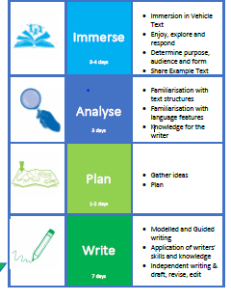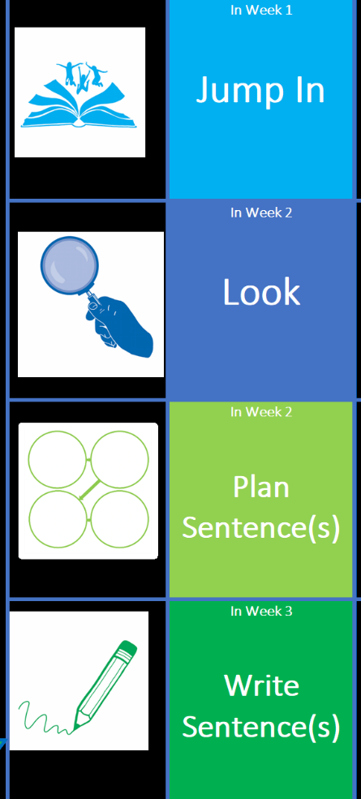
Immerse Date: Tuesday 14th February 2023
LO: To make predictions about the text |  |  | Me | Teacher
I can make clear predictions and support my reasons.
I can begin to use the vocabulary of properties
Supported | Guided | Independent

Layout in Mathematics (Blue Books)
- Date written in figures – Year 5/6 dates will always be in Roman Numerals. Underlined in pencil. No LO required. The date of the Blue Book work will correlate with the date in maths books.
- All numbers must be written neatly and clearly with one digit to each square.
- Each calculation and subsequent answer must be clearly numbered but also distinguishable from workings out/notes.

Classroom Organisation and Resources
- Pupils should have easy access to the appropriate equipment: rulers, pens, pencils, colouring pencils.
- Pupils and staff should check the floor and other surfaces before leaving the room e.g. at break time, for equipment not in the correct place. A room should never be left disorganised or untidy.

Outcomes of Presentation Policy
- Pupils of all abilities will present their work to the highest possible standard increasing their confidence and self-esteem.
- There is consistency across the school in terms of the standard of presentation expected. This is engrained.
- Progression in presenting work between each class is evident and understood by all pupils and adults.
Monitoring of Presentation Policy
- The Headteacher will monitor books through book looks and learning walks.
- Headteacher’s stickers rewarded for exemplary work.
- Regular book looks by staff, including subject ambassadors, will ensure the policy is being adhered to.
- The Presentation Policy will lead to good practice in facilitating effective feedback, learning and teaching.

Standards and expectations for all pupils are those of the best.
Those standards and expectations come from staff.

