School Asthma Policy

School Name Holly Grove School
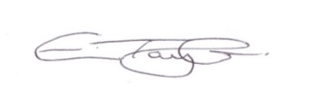
Headteacher Eve Taylor
Asthma Champion Rebecca Whittaker

Date policy last reviewed: | Spring 2026
Agreed by Governors: March 2026
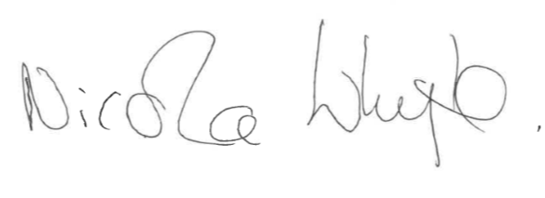
Nicola Whyte

To be reviewed: | Spring 2027

The asthma friendly schools (AFS) programme sets out clear, effective partnership arrangements between health, education, and local authorities for managing children and young people with asthma at primary and secondary schools.

We are an asthma friendly school and have gained asthma friendly status for our care of students with asthma. This means we advocate inclusion, are clear on our procedures and have designated Asthma Leads to ensure these are adhered to. We commit to the audit of our procedures yearly.
We welcome parents and pupils’ views on how we can continue to improve and build upon our standards.

The school recognises that asthma is a prevalent, serious but manageable condition and we welcome all pupils with asthma. This policy was drawn up in consultation with parents, students, School Nurses, Local Authority, School Governors, and health colleagues.

We ensure all staff are aware of their duty of care to pupils. We have a “whole school” approach to regular training, so staff are confident in carrying out their duty of care.

Contents:
Statement of intent

Legal framework

Roles and responsibilities
- Asthma
- Asthma Register
- Asthma Champion
- Medication and Inhalers
- Personalised Asthma Action Plans (PAAP) (Appendix 1)
- School Environment
- Exercise and physical activity
- When asthma is affecting a pupil’s education
- Emergency Salbutamol Inhaler in school
- Common ‘day to day’ symptoms of asthma
- Asthma Attacks
- Whole school training
- References and Useful resources
Appendix 1 | Personalised Asthma Action Plans (PAAP)
Appendix 2 | Emergency Asthma Kit Checklist
Appendix 3 | Emergency Asthma Action Plan
Appendix 4 | How to help a child use their spacer

Statement of intent
Holly Grove School recognises that asthma is a serious but controllable condition and welcomes all pupils with asthma. This policy sets out how the school ensures that pupils with asthma can participate fully in all aspects of school life including physical exercise, school trips and other out-of-school activities. It also covers how the school enables pupils with asthma to manage their condition effectively in school, including ensuring immediate access to reliever inhalers where necessary.

Legal framework
This policy has due regard to all relevant legislation and statutory guidance including, but not limited to, the following:
- Equality Act 2010
- DfE ‘Supporting pupils at school with medical conditions’
- Asthma UK ‘Asthma at school and nursery’
- DfE ‘First aid in schools, early years and further education’
This policy operates in conjunction with the following school policies:
- Complaints Policy
- Supporting Pupils with Medical Conditions Policy
- First Aid Policy

Roles and responsibilities
The governing board has a responsibility to:
- Ensure the health and safety of staff and pupils is protected on the school premises and when taking part in school activities.
- Ensure that this policy, as written, does not discriminate against any of the protected characteristics, in line with the Equality Act 2010.
- Handle complaints regarding this policy as outlined in the school’s Complaints Policy.
- Ensure this policy is effectively monitored and updated.
- Report any successes and failures of this policy to the headteacher, members of school staff, local health authorities, parents and pupils.
- Provide indemnity for teachers and other members of school staff who volunteer to administer medicine to pupils with asthma in need of help.

The headteacher has a responsibility to:
- Create and implement this policy with the help of school staff, school nurses, local guidance and the governing board.
- Ensure this policy is effectively implemented and communicated to all members of the school community.
- Arrange for all members of staff to receive training on supporting pupils with asthma. Ensure all supply teachers and new members of staff are made aware of this policy and provided with appropriate training.
- Monitor the effectiveness of this policy.
- Ensure that first aiders are appropriately trained regarding asthma, e.g. supporting pupils to take their own medication and caring for pupils who are having asthma attacks.
- Delegate the responsibility to check the expiry date of spare reliever inhalers and maintain the school’s asthma register to a designated member of staff.
- Report incidents and other relevant information to the governing board and LA as necessary.
All school staff have a responsibility to:
- Read and understand this policy.
- Know which pupils they come into contact with have asthma.
- Know what to do in the event of an asthma attack.
- Allow pupils with asthma immediate access to their reliever inhaler.
- Inform parents if their child has had an asthma attack.
- Inform parents if their child is using their reliever inhaler more than usual.
- Ensure pupils with asthma have their medication with them on school trips and during activities outside of the classroom.
- Ensure pupils who are unwell due to asthma are allowed the time and resources to catch up on missed school work.
- Be aware that pupils with asthma may experience tiredness during the school day due to their night-time symptoms.
- Be aware that pupils with asthma may experience bullying due to their condition and understand how to manage these instances of bullying.
Pupils with asthma where appropriate, have a responsibility to:
- Tell their teacher or parent if they are feeling unwell due to their asthma.
- Treat the school’s and their own asthma medicines with respect by not misusing the medicines and/or inhalers.

- Know how to gain access to their medication in an emergency.
- Know how to take their asthma medicine.
All other pupils where appropriate, have a responsibility to:
- Treat other pupils, with or without asthma, equally, in line with the school’s Behaviour Policy.
- Understand that asthmatic pupils will need to use a reliever inhaler when having an asthma attack and ensure a member of staff is called immediately.
Parents have a responsibility to:
- Inform the school if their child has asthma.
- Ensure the school has a complete and up-to-date information for their child.
- Inform the school of the medication their child requires during school hours.
- Inform the school of any medication their child requires during school trips, team sports events and other out-of-school activities.
- Inform the school of any changes to their child’s medicinal requirements.
- Inform the school of any changes to their child’s asthmatic condition, e.g. if their child is currently experiencing sleep problems due to their condition.
- Ensure their child’s reliever inhaler (and spacer where relevant) is labelled with their child’s name.
- Ensure that their child’s reliever inhaler and spare inhaler are within their expiry dates.
- Ensure their child catches up on any school work they have missed due to problems with asthma.
- Ensure their child has regular asthma reviews with their doctors or asthma nurse (recommended every 6-12 months).
- Ensure their child has a written Personal Asthma Action Plan at school to help the school manage their child’s condition.

- Asthma
Asthma is a condition that affects small tubes (airways) that carry air in and out of the lungs. When a person with asthma comes into contact with something that irritates their airways (an asthma trigger), the muscles around the walls of the airways tighten so that the airways become narrower, and the lining of the airways becomes inflamed and starts to swell. Sometimes, sticky mucus or phlegm builds up, which can further narrow the airways. These reactions make it difficult to breathe, leading to symptoms of asthma.
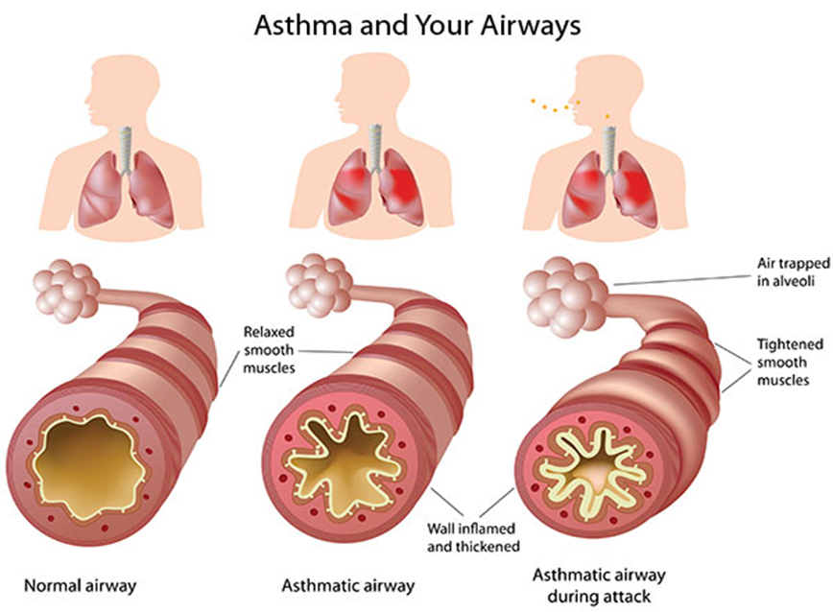
As a school, we recognise that asthma is a widespread, serious, but controllable condition. This school welcomes all pupils with asthma and aims to support these children to participate fully in school life. We endeavour to do this by ensuring we have:
- an asthma register
- an up-to-date asthma policy,
- an asthma champion,
- all pupils with immediate access to their reliever inhaler at all times,
- all pupils with asthma have an up-to-date personalised asthma action plan (PAAP),
- an emergency asthma kit with salbutamol inhaler/spacer
- all staff have regular asthma training,
- promotion of asthma and management of the condition to pupils, parents, and staff.

- Asthma Register
We have an asthma register of children within the school, which we update termly. When parents/carers have confirmed that their child is asthmatic or has been prescribed a reliever inhaler we ensure that the pupil has been added to the asthma register and has:
- an up-to-date copy of their personal asthma action plan
- their reliever (BLUE) inhaler in school,
- Consent from the parents/carers to use the emergency salbutamol inhaler if they require it.

- Asthma Champion
This school has an asthma champion who is the lead in school and is named above. It is the responsibility of the Asthma Champion to manage the asthma register, update the asthma policy, and to ensure children have immediate access to their inhalers. We also have nominated staff in classes to support the Asthma Champion.
The Champion will also manage the emergency asthma kits (please refer to the Department of Health Guidance on the use of emergency salbutamol inhalers in schools. March 2015).
The Asthma Champion will also ensure the AFS Standards are completed yearly and liaise with the school nursing team for any support and advice.

- Medication and Inhalers
All children with asthma should have immediate access to their reliever (usually blue) inhaler at all times. The reliever inhaler is a fast acting medication that opens up the airways and makes it easier for the child to breathe (Source: Asthma and Lung UK).
Some children will also have a preventer inhaler, which is usually taken morning and night, as prescribed by the doctor/nurse. This medication needs to be taken regularly for maximum benefit. Children should not bring their preventer inhaler to school as it should be taken regularly as prescribed by their doctor/nurse at home. However, if the pupil is going on a residential trip, we are aware that they will need to take the inhaler with them so they can continue taking their inhaler as prescribed. (Source: Asthma and Lung UK).
Children are encouraged to carry their reliever inhaler where appropriate, depending on their level of need. However, we will discuss this with each child’s parent/carer and teacher. We recognise that all children still need supervision in taking their inhaler.
For all children, reliever inhalers are kept in yellow bags with the relevant documents, in class medical cupboards unless they are moving about school or out on a trip in which case the inhaler will travel with them.

- Personalised Asthma Action Plans (PAAP) (Appendix 1)
Asthma UK evidence shows that if someone with asthma uses a personal asthma action plan, they are four times less likely to be admitted to hospital due to their asthma. As a school, we recognise that having to attend hospital can cause stress for a pupil and their family. Therefore, we believe it is essential that all children with asthma have a personal asthma action plan to ensure asthma is managed effectively within school to prevent hospital admissions. (Source: Asthma and Lung UK)
Child Asthma Action Plan
childrens-asthma-plan_may22_cc_editable.pdf
- School Environment
The school does all that it can to ensure the school environment is favourable to pupils with asthma. The school has a definitive no-smoking policy. Pupil’s asthma triggers will be recorded as part of their asthma action plans and the school will ensure that pupils will not come into contact with their triggers, where this is possible.
We are aware that triggers can include:
- Colds and infection
- Dust and house dust mite
- Pollen, spores and moulds
- Feathers
- Furry animals
- Exercise, laughing
- Stress
- Cold air, change in the weather
- Chemicals, glue, paint, aerosols
- Food allergies
- Fumes and cigarette smoke (Source: Asthma and Lung UK)

As part of our responsibility to ensure all children are kept safe within the school grounds and on trips away, a dynamic risk assessment will be performed by staff. These risk assessments will establish potential asthma triggers which the children could be exposed to and plans will be put in place to ensure these triggers are avoided, where this is possible.

- Exercise and physical activity
Taking part in sports, games and activities is an essential part of school life for all pupils. All staff will know which children in their class have asthma from the school’s asthma register. (Source: Asthma and Lung UK)
Pupils with asthma are encouraged to participate fully in all activities. Where applicable, school staff will ensure pupils take their reliever inhaler before the lesson, where this is known to be a trigger. Their inhaler will be taken up in the yellow bag and kept at the site of the lesson. If a pupil needs to use their inhaler during a lesson they will be encouraged and supported to do so.
There has been a large emphasis in recent years on increasing the number of children and young people involved in exercise and sport in and outside of school. The health benefits of exercise are well documented and this is also true for children and young people with asthma. It is therefore important that the school involve pupils with asthma as much as possible in and outside of school. The same rules apply for out of hours sport as during school hours PE. (Source: Asthma and Lung UK)

- When asthma is affecting a pupil’s education
The school are aware that the aim of asthma medication is to allow people with asthma to live a normal life. Therefore, if we recognise that asthma is impacting on their life as a pupil, and they are unable to take part in activities, tired during the day, or falling behind in lessons we will discuss this with parents/carers, the school nurse, with consent, and suggest they make an appointment with their asthma nurse/doctor. It may simply be that the pupil needs an asthma review, to review inhaler technique, medication review or an updated Personalised Asthma Action Plan, to improve their symptoms. However, the school recognises that Pupils with asthma could be classed as having disability due to their asthma as defined by the Equality Act 2010, and therefore may have additional needs because of their asthma.

- Emergency Salbutamol Inhaler in school
As a school we are aware of the guidance ‘The use of emergency salbutamol inhalers in schools from the Department of Health’ (March 2015) We have summarised key points from this policy below.
As a school we are able to purchase salbutamol inhalers and spacers from community pharmacists without a prescription.
We have three emergency kits, one of which is kept in the Physical Wellbeing Room, one in the main school office and one in Class Michael’s Kitchen Room, so they are easy to access.
There are also ‘Emergency Asthma Kit checklist’ (Appendix 2) for you to use.
Each kit contains:
- A salbutamol metered dose inhaler
- A plastic spacer compatible with the inhaler
- Copy of ‘Emergency Asthma Action Plan’ (Appendix 3)
- Copy of ‘How to help a child use their spacer’ (Appendix 4)
- A checklist of inhalers, identified by their batch number and expiry date, with termly checks recorded
- A copy of ‘record of emergency inhaler administration’ (i.e. when the inhaler has been used).
We understand that salbutamol is a relatively safe medicine, particularly if inhaled, but all medicines can have some adverse effects. Those of inhaled salbutamol are well known, tend to be mild and temporary are not likely to cause serious harm. The child may feel a bit shaky or may tremble, or they may say that they feel their heart is beating faster.
We will ensure that the emergency salbutamol inhaler is only used by children who have asthma or who have been prescribed a reliever inhaler, and for whom written parental consent has been given.
The school’s asthma lead will ensure that:
- On a termly basis the inhaler and spacers are present and in working order, and the inhaler has sufficient number of doses available;
- replacement inhalers are obtained when expiry dates approach;
- Replacement spacers are available following use;
- The plastic inhaler housing (which holds the canister) has been cleaned, dried and returned to storage following use, or that replacements are available if necessary. Before using a salbutamol inhaler for the first time, or if it has not been used for 2 weeks or more, shake and release 2 puffs of medicine into the air
Any puffs should be documented on the ‘Record of emergency inhaler’ form so that it can be monitored when the inhaler is running out.
The spacer cannot be reused. We will replace spacers following use. The inhaler can be reused, so long as it hasn’t come into contact with any bodily fluids. Following use, the inhaler canister will be removed and the plastic inhaler housing and cap will be washed in warm running water, and left to dry in air in a clean safe place. The canister will be returned to the housing when dry and the cap replaced.
The emergency salbutamol inhaler will only be used by children:
- Who have been diagnosed with asthma and prescribed a reliever inhaler OR who have been prescribed a reliever inhaler AND for whom written parental consent for use of the emergency inhaler has been given.
The name(s) of these children will be clearly written on our Asthma register. The parents/carers will always be informed if their child has used the emergency inhaler, so that this information can also be passed onto the GP.

- Common ‘day to day’ symptoms of asthma
As a school we require that children with asthma have a personal asthma action plan which can be provided by their doctor / nurse. These plans inform us of the day-to-day symptoms of each child’s asthma and how to respond to them in an individual basis. We will also send home our own information and consent (yellow) form for every child with asthma each school year. This needs to be returned immediately and kept with our asthma register.
However, we also recognise that some of the most common day-to-day symptoms of asthma are:
- Dry cough
- wheeze (a ‘whistle’ heard on breathing out) often when exercising
- Shortness of breath when exposed to a trigger or exercising
- Tight chest
These symptoms are usually responsive to the use of the child’s inhaler and rest (e.g. stopping exercise). As per DOH document; they would not usually require the child to be sent home from school or to need urgent medical attention.

- Asthma Attacks
The school recognises that if all of the above is in place, we should be able to support pupils with their asthma and hopefully prevent them from having an asthma attack. However, we are prepared to deal with asthma attacks should they occur.
All staff will receive an asthma update annually, and as part of this training, they are taught how to recognise an asthma attack and how to manage an asthma attack. In addition, an ‘Emergency Asthma Plan’ guidance will be displayed in the staff rooms.
The DOH Guidance on ‘The use of emergency salbutamol inhalers in schools’ (March 2015) states the signs of an asthma attack are:
- Persistent cough (when at rest)
- A wheezing sound coming from the chest (when at rest)
- Difficulty breathing (the child could be breathing fast and with effort, using all accessory muscles in the upper body)
- Nasal flaring
- Unable to talk or complete sentences. Some children will go very quiet
- May try to tell you that their chest ‘feels tight’ (younger children may express this as tummy ache)
If the child is showing these symptoms, we will follow the guidance for responding to an asthma attack recorded below. However, we also recognise that we need to call an

ambulance immediately and commence the asthma attack procedure without delay if the child:

*Appears exhausted *is going blue
*Has a blue/white tinge around lips *has collapsed

It goes on to explain that in the event of an asthma attack:
- Keep calm and reassure the child
- Encourage the child to sit up and slightly forward
- Use the child’s own inhaler – if not available, use the emergency inhaler
- Remain with the child while the inhaler and spacer are brought to them
- *Shake the inhaler and remove the cap
- *Place the mouthpiece between the lips with a good seal, or place the mask securely over the nose and mouth
- *Immediately help the child to take two puffs of salbutamol via the spacer, one at a time. (1 puff to 5 breaths)
- If there is no improvement, repeat these steps* 30-60 seconds between doses, up to a maximum of 10 puffs
- Stay calm and reassure the child. Stay with the child until they feel better. The child can return to school activities when they feel better.
- If you have had to treat a child for an asthma attack in school, it is important that we inform the parents/carers and advise that they should make an appointment with the GP
- If the child has had to use 6 puffs or more in 4 hours the parents should be made aware and they should be seen by their doctor/nurse.
- If the child does not feel better or you are worried at ANYTIME before you have reached 10 puffs, call 999 FOR AN AMBULANCE and call for parents/carers.
- The Call handler will advise on further treatment whilst the ambulance is on its way.

- Whole school training
Staff will need yearly asthma updates. This training is provided by the school nursing team.
As a school community it is part of the AFS that pupil education will be incorporated into our RSHE curriculum.
This can be planned with involvement from our school nursing team.

- References and Useful resources

- Supporting pupils at schools with medical conditions. Department for Education, December 2015 https://www.gov.uk/government/uploads/system/uploads/attachment_d ata/file/638267/supporting-pupils-at-school-with-medical-conditions.pdf

- Guidance on the use of emergency salbutamol inhalers in schools. Department of Health. March 2015
https://www.gov.uk/government/uploads/system/uploads/attachment_d ata/file/416468/emergency_inhalers_in_schools.pdf

- London schools’ guide for the care of children and young people with asthma. Pre-school, primary and secondary school years. Healthy London Partnership. April 2016
https://www.myhealth.london.nhs.uk/system/files/HLPhttps://www.myhealth.london.nhs.uk/system/files/HLP-Schools asthma guide May 2016.pdfSchools%20asthma%20guide%20May%202016.pdf

- Healthy London Partnership. Asthma Friendly Schools https://www.healthylondon.org/resource/london-asthmahttps://www.healthylondon.org/resource/london-asthma-toolkit/schools/asthma-friendly-schools/toolkit/schools/asthma-friendly-schools/

- Asthma UK Website http://www.asthma.org.uk/

- Asthma/Viral induced wheeze action plan for children aged 5 years or under https://www.monkeywellbeing.com/wpcontent/uploads/2014/09/asthma-plan-v3.pdf

- Asthma action plan for children aged 6-11 years https://www.asthma.org.uk/globalassets/healthadvice/resources/children/child-asthma-action-plan.pdf

- Asthma action plan for children over the age of 12 years https://www.asthma.org.uk/globalassets/healthhttps://www.asthma.org.uk/globalassets/health-advice/resources/adults/adult-asthma-action-plan.pdfadvice/resources/adults/adult-asthma-action-plan.pdf
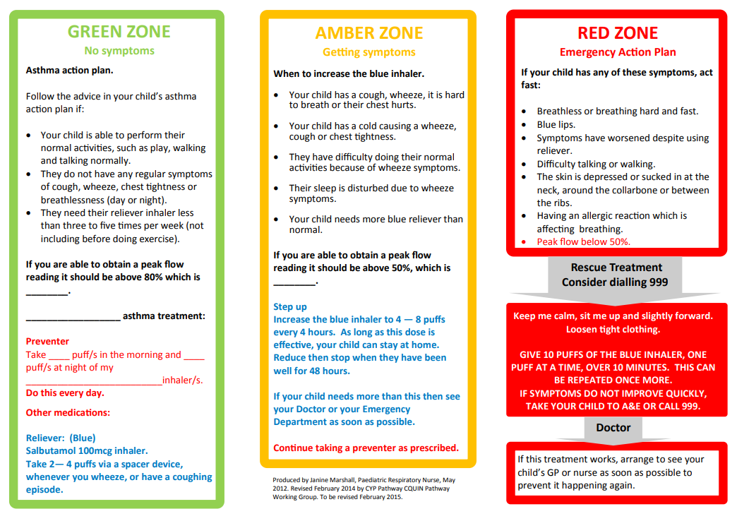
Appendix 2: Emergency Kit Checklist
Emergency Kit List Checklist

An emergency asthma inhaler kit should include: -
- A salbutamol metered dose inhaler
- A plastic spacer compatible with the inhaler
- Copy of ‘Emergency Asthma Action Plan’
- Copy of ‘How to help a child use their spacer’
- Manufacturer’s information including instructions on cleaning and storing the inhaler
- A checklist of inhalers, identified by their batch number and expiry date, with monthly checks recorded
- A note of the arrangements for replacing the inhaler and spacers
- The Asthma Register showing children permitted to use the emergency inhaler as detailed in their personalised asthma plans
- A copy of ‘record of emergency inhaler administration’ (i.e. when the inhaler has been used).

Your Asthma Champion is: Rebecca Whittaker

Appendix 3 Emergency Asthma Action Plan
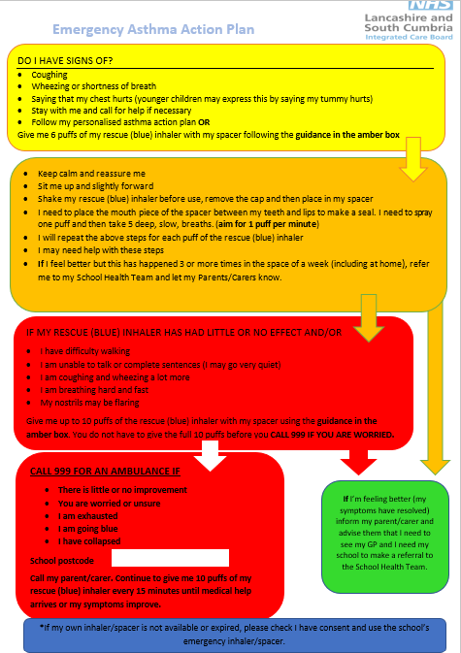

Appendix 4: How to use a spacer

How to use a spacer device
You should be shown how to help a child use their inhaler and spacer. If you're not sure you're doing it properly please seek advice from your asthma champion.
Explain to the child what's going to happen and what they need to do
- Explain to the child what's going to happen and what they need to do
- If it is a new spacer prime it with 2 puffs of the inhaler to coat the chamber
- Sit the child upright, not slouched
- Remove the cap and shake the inhaler – the child can help with this for 30 seconds
- Put the inhaler into the end of the spacer
- Place the mouthpiece between the child's teeth and lips, making a seal so no medicine can escape, or mask over the mouth and nose
- Press the canister once to put one puff of the child's inhaler medicine into the spacer
- Get them to breathe in and out of the mouthpiece five times counting slowly
- Repeat from step 2 for each puff of the inhaler needed, remembering to take out the inhaler and shake it before each puff
- Wait 30 seconds-1minute in between each dose, the canister needs to rewarm and you can shake whilst waiting
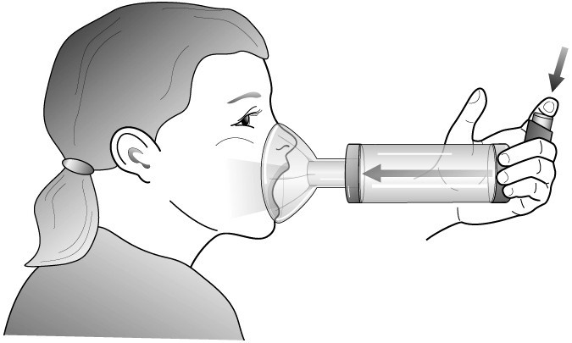

Follow the emergency asthma plan procedure included in this kit

