
Holly Grove School

Child-on-child Abuse Policy

Date policy last reviewed:  Approved by governors:  To be reviewed: | September 2025  12 Nov 2025  September 2026

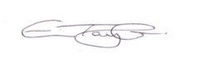
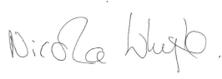
Eve Taylor – Headteacher
Nicola Whyte – Chair of Governors

Contents:
Statement of intent
- Legal framework
- Definitions
- Roles and responsibilities
- Types of child-on-child abuse
- A whole-school approach to tackling child-on-child abuse
- Protecting pupils with increased vulnerability to child-on-child abuse
- Channels for pupils to report abuse
- Staff identifying and reporting concerns
- Handling allegations of abuse against pupils
- Monitoring and review

Appendices
A – School Initial Action Flow Chart
B – Brook Sexual Behaviours Traffic Light Tool
C - Risk Assessment

Statement of intent
Holly Grove School is committed to safeguarding and promoting the welfare of every pupil, both inside and outside of the school premises, and is aware that abuse against children can be inflicted by other children. We implement a whole-school preventative approach to managing child-on-child abuse, ensuring that the wellbeing of pupils is at the forefront of all action taken.
This policy sets out a clear and consistent framework for delivering this promise, in line with safeguarding legislation and statutory guidance.
It will be achieved by:
- Creating a culture of mutual respect amongst all pupils.
- Teaching pupils about behaviour that is acceptable and unacceptable.
- Identifying and making provision for any pupil that has been subject to abuse.
- Ensuring that members of the governing board, the headteacher and staff members understand their responsibilities under safeguarding legislation and statutory guidance, are alert to the signs of child-on-child abuse, and know to refer concerns to the DSL.
- Ensuring that safeguarding policies and procedures are transparent, clear and easy to understand for staff, pupils and parents.

The DSLs in school are Eve Taylor (Headteacher), Nick Barrett (Pastoral Manager), Rebecca Taylor (Assistant Headteacher), Connor Moffatt (Assistant Headteacher), Aisling Carruthers (EYFS Leader) and Jenna Thresh (School Business Manager).

Legal framework
This policy has due regard to all relevant legislation and statutory guidance including, but not limited to, the following:
- Equality Act 2010
- Human Rights Act 1998
- Sexual Offences Act 2003
- The UK General Data Protection Regulation (UK GDPR)
- Data Protection Act 2018
- Voyeurism (Offences) Act 2019
- DfE (2023) ‘Working together to safeguard children’
- DfE (2025) ‘Keeping children safe in education 2025’ (KCSIE)
The policy also has regard to the following non-statutory guidance:
- DfE (2015) ‘What to do if you’re worried a child is being abused’
- DfE (2024) ‘Information sharing’
- Department for Science, Innovation and Technology, and UK Council for Internet Safety (2024) ‘Sharing nudes and semi-nudes: how to respond to an incident (overview)’
- Department for Science, Innovation and Technology, and UK Council for Internet Safety (2024) ‘Sharing nudes and semi-nudes: advice for education settings working with children and young people’
- National Police Chief’s Council (2020) ‘When to call the police: guidance for schools and colleges’
This policy operates in conjunction with the following school policies:
- Child Protection and Safeguarding Policy
- Regulation/Behaviour & Relationships Policy
- Data Protection Policy
- Anti-bullying Policy
- Exclusion Policy
- Online Safety Policy
- Staff Code of Conduct
- Acceptable Use Policy
- Children Missing Education Policy
- Reporting Low-level Safeguarding Concerns Policy

Definitions
“Child-on-child abuse” is defined, for the purposes of this policy, as any form of abuse inflicted by one child or a group of children, i.e. individuals under the age of 18, against another child or group of children. This policy covers child-on-child abuse both inside and outside of school and both in person and online.
“Harmful sexual behaviour” is defined as any sexual behaviour which:
- Does not observe and respect any individuals on the receiving end of the behaviour, e.g. touching someone without their consent.
- Is inappropriate for the age or stage of development of the pupil.
- Is problematic, abusive or violent.
- May cause developmental damage.
Please note: Harmful sexual behaviour can occur online and/or face-to-face, and can also occur simultaneously between the two.
This policy will use the following terms to describe pupils involved in child-on-child abuse:
- Victim(s) – the individual(s) against whom the abuse has, or has allegedly, been inflicted.
- Perpetrator(s) – the individual(s) exhibiting abusive behaviour against their peers.
- Alleged perpetrator(s) – individual(s) against whom a report of abusive behaviour has been made, where guilt has not yet been ascertained.
Please note: The use of the word ‘alleged’ does not mean that the pupil in question is not guilty of child-on-child abuse, that the school does not believe the allegation, or that the allegation will not be taken seriously. Staff will remember that the school has a legal duty of care to all perpetrators and alleged perpetrators who are pupils at the school, including a requirement to ensure they can access their education. Staff will also keep in mind that, in some cases, the abusive behaviour will have been harmful to the perpetrator as well. Victims will be reassured that use of the term ‘alleged perpetrator’ is not an attempt to discredit their allegation.
Staff will also be conscious of the fact that not everyone who has been subjected to abuse considers themselves a victim or would want to be described this way. Staff will be prepared to use any term which the individual child is most comfortable. Staff will think very carefully about terminology when speaking in front of pupils, and the use of appropriate terminology will be determined on a case-by-case basis.

Roles and responsibilities
The governing board has a duty to:
- Ensure that the school complies with its duties under the above child protection and safeguarding legislation.
- Hold the school to account for its obligations under the Human Rights Act 1998, the Equality Act 2010 and their local multi-agency safeguarding arrangements.
- Guarantee that the policies, procedures and training opportunities in the school are effective and comply with the law at all times.
- Guarantee that the school contributes to multi-agency working in line with the statutory guidance ‘Working Together to Safeguard Children’.
- Confirm that the school’s arrangements for handling child-on-child abuse take into account the procedures and practices of the LA as part of the inter-agency safeguarding procedures.
- Appoint a member of staff from the SLT to the role of DSL as an explicit part of the role-holder’s job description.
- Appoint one or more deputy DSLs to provide support to the DSL, ensuring that they are trained to the same standard as the DSL, and that the role is explicit in their job descriptions.
- Ensure that the DSL has the appropriate status and authority within the school to carry out the duties of the post.
- Ensure the DSL is given the additional time, funding, training, resources and support needed to carry out the role effectively.
- Make sure that pupils are taught about child-on-child abuse, including online, through teaching and learning opportunities, as part of providing a broad and balanced curriculum, as appropriate to their age and learning need.
- Ensure that staff members are appropriately trained to support pupils to be themselves at school, e.g. if they are LGBTQ+.
- Ensure the school has clear systems and processes in place for identifying possible risk of harm in pupils, including clear routes to escalate concerns and clear referral and accountability systems.
- Guarantee that there are procedures in place to handle pupils’ allegations against other pupils.
- Ensure that appropriate disciplinary procedures are in place, as well as policies pertaining to the behaviour of pupils.
- Ensure that procedures are in place to eliminate unlawful discrimination, harassment and victimisation in relation to child-on-child abuse.
- Make sure that pupils’ wishes and feelings are taken into account when determining what action to take and what services to provide to protect individual pupils.
- Guarantee that there are systems in place for pupils to express their views and give feedback.
- Ensure that all governors receive appropriate safeguarding and child protection (including online safety) training at induction that is regularly updated, in order to equip them with the knowledge to provide strategic challenge to test and assure themselves that the safeguarding policies and procedures in place are effective and support the delivery of a robust, whole-school approach to safeguarding – this training should include, amongst other things, the expectations and responsibilities on staff in relation to filtering and monitoring.
The headteacher has a duty to:
- Safeguard pupils’ wellbeing and maintain public trust in the teaching profession.
- Ensure that the policies and procedures adopted by the governing board, particularly concerning referrals of cases of suspected abuse and neglect, are followed by staff members.
- Provide staff, upon induction, with the Child Protection and Safeguarding Policy, Staff Code of Conduct, part one and, where appropriate, Annex A of the ‘Keeping children safe in education’ (KCSIE) guidance, the Behaviour Policy, the Children Missing Education Policy, online safety training, and the identity of the DSL and any deputies.
- Ensure staff receive training on recognising indicators of abuse and handling disclosures or concerns about a pupil.

The DSL has a duty to:
- Understand and keep up-to-date with local safeguarding arrangements.
- Act as the main point of contact with the three safeguarding partners and the child death review partner.
- Make the necessary child protection referrals to appropriate agencies.
- Understand when they should consider calling the police, in line with the National Police Chiefs’ Council (NPCC) guidance.
- Liaise with the headteacher to inform them of safeguarding issues and ongoing enquiries.
- Liaise with the deputy DSLs to ensure effective safeguarding outcomes.
- Act as a source of support for pupils who have been abused by, or who have abused, other pupils.
- Lead the school in taking a preventative approach to child-on-child abuse.
- Keep detailed, accurate, secure written records of safeguarding concerns, decisions made, and whether or not referrals have been made, and understand the purpose of this record-keeping.
Other staff members have a responsibility to:
- Safeguard pupils’ wellbeing and maintain public trust in the teaching profession as part of their professional duties.
- Provide a safe environment in which pupils can learn.
- Act in accordance with school procedures with the aim of eliminating unlawful discrimination, harassment and victimisation in relation to child-on-child abuse.
- Maintain an attitude of ‘it could happen here’ where safeguarding is concerned.
- Be aware of the signs of abuse and understand that children can be at risk of harm inside and outside of the school, inside and outside the home, and online.
- Adhere to the early help process and understand their role in it.
- Understand and adhere to the procedure to follow in the event that a child confides they are being abused by a peer (record on CPOMS using the appropriate category tag)
- Understand that children may not feel ready or know how to tell someone that they are being abused, and/or may not recognise their experiences as harmful.
- Understand that technology is a significant component in many safeguarding issues.
- Support social workers in making decisions about individual children, in collaboration with the DSL.
- Maintain appropriate levels of confidentiality when dealing with individual cases, and always act in the best interest of the child.
- Understand the importance of challenging inappropriate behaviours between children that are abusive in nature.
- Build trusted relationships with children and young people which facilitate communication.
- Keep detailed, accurate, secure written records of safeguarding concerns, decisions made, and whether or not referrals have been made, and understand the purpose of this record-keeping.

Types of child-on-child abuse
Staff will familiarise themselves with the forms that child-on-child abuse can take, including but not limited to:
Physical abuse
A form of abuse which may involve actions such as hitting, throwing, burning, drowning and poisoning, or otherwise causing physical harm to another child.
Sexual abuse
A form of abuse involving sexual activity between children – sexual abuse, for the purposes of this policy, is divided into two categories: sexual violence and sexual harassment.
“Sexual violence” encompasses the definitions provided in the Sexual Offenses Act 2003, including rape, assault by penetration, sexual assault, i.e. non-consensual sexual touching, and causing another child to engage in sexual activity without consent, e.g. forcing someone to touch themselves sexually.
“Sexual harassment” refers to any sexual behaviour that could violate another child’s dignity, make them feel intimidated, degraded or humiliated, and/or create a hostile, offensive or sexualised environment, including:
- Sexualised jokes, taunting or comments.
- Physical behaviour, e.g. deliberately brushing against someone.
- Online sexual harassment, including:
  - Upskirting.
  - Sexualised online bullying.
  - Unwanted sexual comments and messages, including on social media.
  - Sexual threats or coercion.
The “sharing of sexualised imagery” can also constitute sexual harassment – this refers to the consensual and non-consensual sharing between pupils of sexually explicit content, including that which depicts:
- Another child posing nude or semi-nude.
- Another child touching themselves in a sexual way.
- Any sexual activity involving another child.
- Someone hurting another child sexually.
Staff will be aware that children creating, possessing, and distributing indecent imagery of other children is a criminal offence, even where the imagery is created, possessed, and distributed with the permission of the child depicted, or by the child themselves. Incidents of sharing sexualised imagery will be handled in line with the Youth Product Sexual Imagery Policy and the Child Protection and Safeguarding Policy.
Bullying
Many kinds of behaviour can be considered bullying, and bullying can be related to almost anything.
Bullying is acted out through the following mediums:
- Verbally
- Physically
- Emotionally
- Online (cyberbullying)
Bullying will generally be handled in line with the Anti-bullying Policy; however, particularly severe instances will be handled in line with this policy and the Child Protection and Safeguarding Policy.
Online abuse
This involves the use of technology and the internet in order to harass, threaten or intimidate another child. Instances of online abuse will be managed in line with this policy, the Online Safety Policy and the Anti-bullying Policy.
Discriminatory behaviour
Discriminatory behaviour encompasses abuse inflicted on a pupil because of their protected characteristics, e.g. religion, ethnicity, gender, sexual orientation, culture, or any SEND. Discriminatory behaviour is never acceptable, and all cases will be handled in line with this policy and the Child Protection and Safeguarding Policy.
In accordance with the Equality Act 2010, schools will not tolerate unlawful discrimination against pupils because of any protected characteristics they may have.
Intimate partner abuse (Unlikely to occur within Holly Grove)
This involves a romantic partnership between children in which one or both partners are emotionally, physically or sexually abusive to the other (sometimes known as ‘teenage relationship abuse’). This could include:
- Repetitive insults.
- Controlling behaviour, e.g. preventing a child from socialising with others or deliberately isolating them from sources of support.
- Sexual harassment.
- Threats of physical or sexual abuse.
The school will manage intimate partner abuse in the same way as a case of abuse between any other children, i.e. via the processes outlined in the Handling allegations of abuse against pupils section of this policy, and in line with the Child Protection and Safeguarding Policy.

A whole-school approach to tackling child-on-child abuse
The school will continue to involve all members of the school community, including the governing board, staff, pupils, parents and other stakeholders, in creating a whole-school approach to child-on-child abuse.
The governing board will ensure that keeping children safe and protected from harm, including child-on-child abuse, is central to all policies and procedures implemented across the school. The school will ensure that procedures for handling child-on-child abuse are transparent, clear and understandable, and are readily accessible to any member of the school community who wishes to access them.
The school will implement a contextual approach to safeguarding pupils against child-on-child abuse, and will ensure that all procedures take into account incidents of child-on-child abuse that occur outside of school or online.
The headteacher will ensure that all staff receive adequate training on handling child-on-child abuse.
School culture
The school will prioritise cultivating a safe and respectful environment amongst pupils, and ensure that all pupils are aware that the school will adopt a zero-tolerance stance on child-on-child abuse of any kind.
The school will promote respectful interactions amongst pupils, and all staff will model appropriate and respectful behaviour. Staff will take care to avoid normalising harmful behaviour, particularly harmful sexual behaviour, e.g. by refraining from the use of phrases such as ‘boys will be boys’ or describing such behaviour as ‘just having a laugh’ or ‘part of growing up’, as these phrases can lead to a culture of unacceptable behaviours and normalised abuse.
The school will ensure that wider societal factors that exacerbate the problem of child-on-child abuse are reflected in its approach to creating a preventative culture. This means that individuals who are more likely to be abused, e.g. girls or SEND or who are at increased risk of acting as a perpetrator in abusive situations, e.g. due to abusive home situations or anger management issues, are given additional support from an early stage. The school will have a clear set of values and standards that will be upheld and demonstrated throughout all aspects of school life and will be underpinned by the school’s policies, procedures and curriculum.
The school will manage all early help and intervention for pupils that show early signs of harmful behaviour, or early signs of being the victim of harmful behaviour, in line with the Child Protection and Safeguarding Policy.
Early help
Upon receiving notice of a concern or incident, the DSL or deputy DSL will advise whether the children involved in a child-on-child abuse incident require referral or would benefit from early help. This will be decided on a case-by-case basis after thorough examination of the information available, with the aim of reducing the probability of a problem getting worse.
The rationale for the decision to introduce early help as opposed to a referral will be recorded on CPOMS.
The school will ensure that DSLs and deputy DSLs are suitably trained on the early help process and can access further support.
The school will manage all early help and intervention for pupils that show early signs of harmful behaviour, or early signs of being the victim of harmful behaviour, in line with the Child Protection and Safeguarding Policy.
Curriculum
The school maintains the position that education surrounding respectful and healthy attitudes and behaviour towards others is the best way to combat child-on-child abuse in the school. All staff, not just teaching staff, will be responsible for passing this knowledge on to pupils.
In order to prevent child-on-child abuse and address the wider societal factors that can influence behaviour, the school will educate pupils about abuse, its forms and the importance of discussing any concerns and respecting others through the curriculum and extra-curricular activities. This will be done on an individual basis taking into account the child`s age and developmental stage.
The school will also ensure that pupils are taught about safeguarding, including online safety, as part of a broad and balanced curriculum. The school will also teach a planned programme of evidence-based RSHE, delivered in regularly timetabled lessons and reinforced throughout the whole curriculum. Such content will be fully inclusive, age and stage of development appropriate (especially when considering the needs of all of our pupils with SEND), and tackle issues such as the following:
- Healthy and respectful relationships
- Boundaries and consent
- Stereotyping, prejudice and equality
- Different identities and relationships e.g. LGBTQ+
- Body confidence and self-esteem
- The concepts of, the laws relating to, and how to access support for the following:
  - Sexual consent
  - Sexual exploitation
  - Abuse
  - Grooming
  - Coercion
  - Harassment
  - Rape
  - Domestic abuse
  - So called honour-based violence, e.g. forced marriage or FGM
- What constitutes as sexual violence and sexual harassment and why these are always unacceptable
Pupils will be allowed an open forum to talk about concerns and sexual behaviour. They will be taught how to raise concerns with a trusted person including concerns about their friends or peers, and how a disclosure will be handled.
The curriculum will ensure that pupils of all ages are taught about and understand the concept of consent and its importance in an age-appropriate way.

Protecting pupils with increased vulnerability to child-on-child abuse
The school is aware that, while child-on-child abuse can be perpetrated by, and against, anyone, there are certain groups of pupils who are at an increased risk of being on the receiving end of child-on-child abuse.
Staff will be careful to acknowledge the increased risk certain pupils face while refraining from making assumptions about the nature of any reported, witnessed or suspected abuse. Staff will be aware that pupils who are generally at increased risk of abuse can also be perpetrators of abuse.
The school will ensure that action is taken, where possible, before major concerns arise; therefore, incidents of low-level abuse related to the characteristics of the below groups will be handled in line with early help procedures, which are laid out within the Child Protection and Safeguarding Policy and the Reporting Low-level Safeguarding Concerns Policy.
Girls
Staff will be aware that girls are more likely to be on the receiving end of child-on-child sexual abuse than their male counterparts, and that sexual violence and harassment against girls is very common and accounts for the majority of cases.
Taking into account that sexual harassment against girls is widespread in society, and largely based in gender inequality, the school will aim to encourage gender equality in all aspects of its operations. The school will aim to promote and nurture healthy attitudes and relationships amongst pupils of all genders, e.g. by challenging and working to deconstruct gender stereotypes in school.
Staff will challenge any incidents of misogynistic language or gender-based abuse, whether of a sexualised nature or not, as holding misogynistic viewpoints can make a pupil more likely to commit sexualised violence in the future.
LGBTQ+ pupils
Staff will be aware that pupils who are LGBTQ+, or are perceived to be LGBTQ+ whether they are or not, are more likely to be targeted by their peers, e.g. for discriminatory bullying.
The school will hold a zero-tolerance policy towards pupils using homophobic, biphobic or transphobic language, regardless of whether or not the language is being directed at another individual. Every staff member will be individually responsible for challenging such behaviour and making clear to all pupils that any abuse towards pupils who are LGBTQ+, or who are perceived to be, is unacceptable.
The school will ensure that it is able to provide a safe space for LGBTQ+ pupils to speak out and/or share their concerns with members of staff.
Pupils with SEND
Staff will be aware that pupils with SEND are at increased risk of child-on-child abuse, as they are three times more likely to be abused than their peers. All pupils at Holly Grove School have SEND and as a result are especially vulnerable to child on child abuse. The school will ensure that there are mechanisms in place to support our pupils in reporting abuse, with due regard that these pupils may face additional barriers to reporting abuse and that spotting signs of abuse in these pupils may be harder. Special consideration will be given to ensure these pupils are given a voice, through appropriate communication strategies as well as time to build trusting, nurturing relationships with key adults.
Staff will avoid assuming that changes in the behaviour of pupils with SEND are as a result of their needs or disability, and will report any concerns on CPOMS.
Black, Asian and minority ethnic (BAME) pupils
Staff will be aware that minority ethnic pupils, particularly black pupils, may be less likely to report abuse committed against them, and may be more likely to be misidentified as perpetrators of abuse.
The school will hold a zero-tolerance policy towards pupils using racist language, regardless of whether the language is being directed at another individual. Every staff member will be individually responsible for challenging such behaviour and making clear to all pupils that any abuse towards pupils from BAME backgrounds is unacceptable.
Staff will also be aware that BAME girls, BAME pupils with SEND, or BAME LGBTQ+, or perceived LGBTQ+ pupils, are likely to face increased abuse due to the intersection of these identities. Staff will be vigilant with regard to these pupils and the ways in which other pupils behave towards them, in order to ensure any incidents or potential incidents can be handled as soon as they occur.

Channels for pupils to report abuse
Pupils will be able to report incidents of child-on-child abuse or concerns about the behaviour of their peers through the following channels:
- Key Worker /Class Teacher
- Nurture/Thrive Sessions
- DSL – People who can help me

Pupils have their own, accessible Child on Child Abuse Policy and as part of their curriculum they will be taught how to recognise the signs of abuse. All channels for reporting abuse will be promoted and publicised throughout the school including in the pupil Child on Child Abuse Policy, Children`s Safeguarding Policy and on the Children`s Notice Board and all pupils will be made aware of how, and to whom, to report incidents of abuse. The school will also ensure pupils are aware of the type of behaviour that should be reported, to ensure that victims do not view their experience as ‘not serious enough’ to report.
The school will maintain a culture that promotes reporting abuse, whether the individual reporting is the victim, a bystander, or a friend or relative of the victim. Staff will address any incidents of pupils equating reporting abuse to ‘snitching’ or being a ‘tattle-tale’, and will convey to these pupils how important it is to report abuse to help tackle the wider problem of child-on-child abuse in schools.

Staff identifying and reporting concerns
As many of our children are non-verbal or have limited communication, it is vitally important that staff are trained to identify signs of child on child abuse.
Staff will receive safeguarding training as part of their induction, and annual refresher training. This training will include guidance on how to recognise indicators of child-on-child abuse of all kinds, and how to distinguish between behaviour, particularly sexual behaviour, that is developmentally appropriate and that which is harmful.
When identifying pupils at risk of potential harm or who have been harmed by their peers, staff members will look out for a number of indicators including, but not limited to, the following:
- Injuries in unusual places, such as bite marks on the neck, that are also inconsistent with their age
- Lack of concentration and acting withdrawn
- Knowledge ahead of their age, e.g. sexual knowledge
- Use of explicit language
- Fear of abandonment
- Depression and low self-esteem
- Changes to their social group e.g. spending time with older pupils, or social isolation
- Alcohol or substance misuse

Where a pupil is displaying signs of being impacted by child-on-child abuse, or perpetrating child-on-child abuse, staff will report this to the DSL as soon as is reasonably practical.
Staff will challenge all instances of abusive or harmful behaviour displayed by pupils that they witness or are reported to them. Staff will not wait for concerns or situations between pupils to escalate before intervening; minor or singular instances of abusive behaviour will still be brought to the attention of the DSL and the pupil will always be spoken to about their behaviour and disciplined, where appropriate, in line with the Regulation, Behaviour and Relationships Policy.
Staff will enforce the school’s policy that no known and substantiated incident of abusive or harmful behaviour between pupils will occur without consequences for the perpetrator(s), although these consequences will be decided on a case-by-case basis and will take into account the views of any victims involved, the context of the behaviour and the severity of the incident.
Staff will be aware that just because a victim of abusive behaviour does not report the behaviour or react to the behaviour negatively, this does not mean that the behaviour is not still harmful; staff will be made aware that some pupils will be uncomfortable challenging their peers on inappropriate behaviour, or may not be aware themselves that the behaviour is abusive.
Staff will ensure that both the perpetrator(s), or alleged perpetrator(s), and the victim(s) understand that such behaviour inflicted by or against them was unacceptable; staff will be made aware that failing to challenge a pupil on unacceptable behaviour can normalise that behaviour not just for the pupil in question, but for all pupils who see the behaviour going unchallenged.
Staff will remain cognisant that downplaying abusive behaviour can lead to a culture of unacceptable behaviour throughout the school and, as such, will treat all displays or reports of abusive behaviour with the utmost severity and sensitivity in order to reinforce to all pupils that such behaviour will not be tolerated, and to prevent further instances of this behaviour in the future.

Handling allegations of abuse against pupils (See Flow Chart Appendix A)
Staff will always, when handling an incident of alleged abuse, take the report of the victim seriously, reassure them, support them and work to keep them safe. Victims will never be made to feel like they are causing a problem by reporting any form of abuse, be made to feel ashamed, or have their experience minimised by staff at the school. Staff will be aware of the importance of not downplaying any reports of abuse; however, will ensure that they remain sympathetic, and observant of the duty of care, to both the alleged perpetrator(s) and victim(s).
If a friend of a victim makes a report or a member of staff overhears a conversation, staff will take action – they will never assume that someone else will deal with it, or wait for a disclosure. The basic principles remain the same as when a victim reports an incident; however, staff will consider why the victim has not chosen to make a report themselves, and the discussion will be handled sensitively and with the help of children’s social care where necessary. If staff are in any doubt, they will speak to the DSL. All staff will be aware that pupils may not feel ready or know how to tell someone that they are being abused, and/or they may not recognise their experiences as harmful. This will not prevent staff from having a professional curiosity and speaking to the DSL if they have any concerns.
Where an alleged incident took place away from the school or online but involved pupils from the school, the school’s duty to safeguard pupils remains the same and the incident will be treated equally as seriously and investigated in the same way as an incident that took place in school.
All staff will be trained to handle disclosures. Effective safeguarding practice includes:
- Never promising confidentiality at the initial stage.
- Only sharing the report with those necessary for its progression.
- Explaining to the victim what the next steps will be and who the report will be passed to.
- Recognising that the person the pupil chose to disclose the information to is in a position of trust.
- Being clear about boundaries and how the report will be progressed.
- Not asking leading questions and only prompting the pupil with open questions.
- Waiting until the end of the disclosure to immediately write a thorough summary. If notes must be taken during the disclosure; staff will ensure they remain engaged and not appear distracted.
- Understanding that victims may not disclose the whole picture immediately and may be more comfortable providing information on a step-by-step basis.
- Ensuring that dialogue is kept open and encouraged.
- Only recording the facts as the pupil presents them – not the opinions of the note taker.
- Where the report includes an online element, being aware of searching, screening and confiscation advice.
- Wherever possible, managing disclosures with two staff members present (preferably with the DSL or a deputy).
- Informing the DSL or deputy as soon as possible after the disclosure if they could not be involved in the disclosure.

Allegations of abuse against pupils with SEND will be handled with the best interests of the pupil in mind at all times.
Confidentiality
The school will only engage staff and agencies required to support the victim and/or be involved in any investigation. If a victim asks the school not to tell anyone about the disclosure, the school will not make this promise. The school will adhere to the principle that, even without the victim’s consent, the information may still be lawfully shared if it is in the public interest and protects children from harm.
The DSL will consider the following when making confidentiality decisions:
- Parents will be informed unless it will place the victim at greater risk
- If a pupil is at risk of harm, is in immediate danger or has been harmed, a referral will be made to children’s social care
- Rape, assault by penetration and sexual assault are crimes – reports containing any such crimes will be passed to the police
The DSL will weigh the victim’s wishes against their duty to protect the victim and others. If a referral is made against the victim’s wishes, it will be done so extremely carefully and the reasons for referral will be explained to the victim. Appropriate specialist support will always be offered.
Anonymity
There are legal requirements for anonymity where a case is progressing through the criminal justice system. The school will do all it can to protect the anonymity of children involved in any report of sexual violence or sexual harassment. It will carefully consider, based on the nature of the report, which staff will be informed and what support will be in place for the children involved. When deciding on the steps to take, the school will consider the role of social media in potentially exposing victims’ identities and facilitating the spread of rumours.
Risk assessment (See Appendix C)
The DSL or a deputy will make an immediate risk and needs assessment any time there is a report of sexual violence. For reports of sexual harassment, a risk assessment will be considered on a case-by-case basis. Risk assessments are not intended to replace the detailed assessments of experts, and for incidents of sexual violence it is likely that a professional risk assessment by a social worker or sexual violence specialist will be required.
Risk and needs assessments will consider:
- The victim, especially their protection and support.
- Whether there may have been other victims.
- The alleged perpetrator.
- Other pupils at the school, especially any actions that are appropriate to protect them.
- The time and location of the incident, and any action required to make the location safer.

Risk assessments will be recorded, either on paper or electronically, and kept under review in accordance with the school’s Data Protection Policy.
Taking action following a disclosure
The DSL or a deputy will decide the school’s initial response, taking into consideration:
- The victim’s wishes.
- The nature of the incident.
- The ages and developmental stages of the pupils involved (See Appendix B – Brook Sexual Behaviours Traffic Light Tool)
- Any power imbalance between the pupils.
- Whether the incident is a one-off or part of a pattern.
- Any ongoing risks.
- Any related issues and the wider context, such as whether there are wider environmental factors in a pupil’s life that threaten their safety and/or welfare.
- The best interests of the pupil.
- That sexual violence and sexual harassment are always unacceptable and will not be tolerated.

Immediate consideration will be given as to how to support the victim, alleged perpetrator and any other pupils involved.
For reports of rape and assault by penetration, the alleged perpetrator will be removed from any classes shared with the victim whilst the school establishes the facts. The school will consider how to keep the victim and alleged perpetrator apart on school premises, and on transport where applicable. These actions will not be seen as a judgement of guilt on the alleged perpetrator.
For reports of sexual violence and sexual harassment, the proximity of the victim and alleged perpetrator and the suitability of shared classes, premises and transport will be considered immediately. In all cases, the initial report will be carefully evaluated and the wishes of the victim, nature of the allegations and requirement to protect all children will be taken into consideration.
Where a pupil is found to have been involved in harmful sexual behaviour, e.g. non-consensually sharing indecent imagery of another pupil, the school will help the pupil to move forward from the incident by supporting them in adopting more positive behaviour patterns and attitudes.
Managing the report
The decision of when to inform the alleged perpetrator of a report will be made on a case-by-case basis. If a report is being referred to children’s social care or the police, the school will speak to the relevant agency to discuss informing the alleged perpetrator.
There are four likely outcomes when managing reports of sexual violence or sexual harassment:
- Managing internally
- Providing early help
- Referring to children’s social care
- Reporting to the police

Whatever outcome is chosen, it will be underpinned by the principle that sexual violence and sexual harassment are never acceptable and will not be tolerated. All concerns, discussions, decisions and reasons behind decisions will be recorded either on paper or electronically.
The following situations are statutorily clear and do not allow for contrary decisions:
- The age of consent is 16.
- A child under the age of 13 can never consent to sexual activity.
- Sexual intercourse without consent is always rape.
- Rape, assault by penetration and sexual assault are defined in law.
- Creating and sharing sexual photos and videos of children under 18 is illegal – including children making and sending images and videos of themselves.

Managing internally
In some cases, e.g. one-off incidents, the school may decide to handle the incident internally through behaviour and bullying policies and by providing pastoral support.
Providing early help
The school may decide that statutory interventions are not required, but that pupils may benefit from early help – providing support as soon as a problem emerges. This approach can be particularly useful in addressing non-violent harmful sexual behaviour and may prevent the escalation of sexual violence.
All staff will be aware of their local early help process and understand their role in it.
Referral to children’s social care
If a pupil has been harmed, is at risk of harm or is in immediate danger, the school will make a referral to children’s social care. Parents will be informed unless there is a compelling reason not to do so, e.g. if the referral will place the victim at risk. This decision will be made in consultation with children’s social care.
The school will not wait for the outcome of an investigation before protecting the victim and other children.
The DSL will work closely with children’s social care to ensure that the school’s actions do not jeopardise any investigation. Any related risk assessment will be used to inform all decisions. If children’s social care decides that a statutory investigation is not appropriate, the school will consider referring the incident again if they believe the pupil to be in immediate danger or at risk of harm. If the school agrees with the decision made by children’s social care, they will consider the use of other support mechanisms such as early help, pastoral support and specialist support.
Reporting to the police
Reports of rape, assault by penetration or sexual assault will be passed on to the police – even if the alleged perpetrator is under 10 years of age. Generally, this will be in parallel with referral to children’s social care. The DSL and deputies will follow the local process for referral.
Parents will be informed unless there is a compelling reason not to do so. Where parents are not informed, it is essential for the school to support the pupil with any decision they take, in unison with children’s social care and any appropriate specialist agencies.
The DSL and governing board will agree what information will be disclosed to staff and others, in particular the alleged perpetrator and their parents. They will also discuss the best way to protect the victim and their anonymity. The DSL will be aware of local arrangements and specialist units that investigate child abuse.
In some cases, it may become clear that the police will not take further action, for whatever reason. In these circumstances, the school will continue to engage with specialist support for the victim as required.
Bail conditions
Pupils against whom further action is taken by the police may be released under bail conditions or ‘released under investigation’ (RUI) in circumstances that do not warrant the application of bail. Where this occurs and the perpetrator returns to school, the school’s primary focus will be conducting an assessment of the risk the perpetrator poses to the victim or other pupils and staff at the school, both physically and in terms of trauma or emotional stress, and implementing any mitigating measures necessary to reduce the harm caused.
The school will work with children’s social care and the police to support the victim, alleged perpetrator and other pupils, especially witnesses, during criminal investigations. The school will seek advice from the police to ensure they meet their safeguarding responsibilities.
The school will liaise with police investigators to develop a balanced set of arrangements whereby both the alleged perpetrator and the victim can continue to receive a suitable education without compromising any ongoing investigations or the emotional state of the victim.
Managing delays in the criminal justice system
The school will not wait for the outcome, or even the start, of criminal proceedings before protecting the victim, alleged perpetrator and other children. The associated risk assessment will be used to inform any decisions made. The DSL will work closely with the police to ensure the school does not jeopardise any criminal proceedings, and to obtain help and support as necessary.
The end of the criminal process
Risk assessments will be updated if the alleged perpetrator receives a caution or is convicted. If the perpetrator remains in the same school as the victim, the school will set out clear expectations regarding the perpetrator, including their behaviour and any restrictions deemed reasonable and proportionate with regards to the perpetrator’s timetable. The school will ensure that the victim and perpetrator remain protected from bullying and harassment (including online).
Where an alleged perpetrator is found not guilty or a case is classed as requiring ‘no further action’, the school will offer support to the victim and alleged perpetrator for as long as is necessary. Staff will be aware that the victim is likely to be traumatised and the fact that an allegation cannot be substantiated does not necessarily mean that it was unfounded. The school will discuss decisions with the victim and offer support. The alleged perpetrator will also be offered ongoing support if needed, as they have also been through a difficult and upsetting experience.
The headteacher will carefully consider, on a case-by-case basis, whether allowing the victim and the alleged perpetrator to share classes or attend the same activities is conducive to either party’s effective education, and will implement alternative arrangements, in consultation with the DSL, where necessary.
Ongoing support for the victim
Any decisions regarding safeguarding and supporting the victim will be made with the following considerations in mind:
- The terminology the school uses to describe the victim
- The age and developmental stage of the victim
- The needs and wishes of the victim
- Whether the victim wishes to continue in their normal routine
- The victim will not be made to feel ashamed about making a report
- What a proportionate response looks like

Victims may not disclose the whole picture immediately and they may be more comfortable talking about the incident on a step-by-step basis; therefore, a dialogue will be kept open and the victim can choose to appoint a designated trusted adult.
Staff will be aware that victims may struggle in a normal classroom environment. Whilst the school will understand that it is important not to isolate the victim, the victim may wish to be withdrawn from lessons and activities at times. The school will ensure that this will only happen when the victim wants it to, not because it makes it easier to manage the situation. The school will provide a physical space for victims to withdraw to.
The school will be aware that victims may require support for a long period of time and will be prepared to offer long-term support in liaison with relevant agencies. The school will ensure that everything possible will be done to prevent the victim from bullying and harassment as a result of any report they have made. If the victim is unable to remain in the school, alternative provision or a move to another school will be considered – this will only be considered at the request of the victim and following discussion with their parents. If the victim does move to another school, the DSL will inform the school of any ongoing support needs and transfer the child protection file.
Ongoing support for the alleged perpetrator
Any decisions made regarding the support required for an alleged perpetrator will be made with the following considerations in mind:
- The terminology the school uses to describe the alleged perpetrator
- The balance of safeguarding the victim and providing the alleged perpetrator with education and support
- The reasons why the alleged perpetrator may have abused the victim – and the support necessary
- Their age and developmental stage
- What a proportionate response looks like
- Whether the behaviour is a symptom of their own abuse or exposure to abusive practices and/or materials
- What the outcome of the investigation was

When making a decision, advice will be taken from children’s social care, specialist sexual violence services and the police as appropriate. If the alleged perpetrator moves to another school, for any reason, the DSL will inform the destination school of any ongoing support needs and transfer the child protection file.
If the reported abuse is found to have taken place, the school will work with professionals, as required, to understand why the abuse took place and provide a high level of support to help the pupil understand and overcome the reasons for their behaviour and reduce the likelihood of them abusing again.
Disciplining the alleged perpetrator
Disciplinary action can be taken whilst investigations are ongoing and the fact that investigations are ongoing will not prevent the school reaching its own conclusion and imposing an appropriate penalty.
The school will make such decisions on a case-by-case basis, with the DSL taking a leading role. The school will take into consideration whether any action would prejudice an investigation and/or subsequent prosecution. The police and children’s social care will be consulted where necessary. The school will also consider whether circumstances make it unreasonable or irrational for the school to make a decision about what happened while an investigation is considering the same facts.
Disciplinary action and support can take place at the same time. The school will be clear whether action taken is disciplinary, supportive or both.
Shared classes
Once the DSL has decided to progress a report, they will again consider whether the victim and alleged perpetrator will be separated in classes, on school premises and on school transport – balancing the school’s duty to educate against its duty to safeguard. The best interests of pupils will always come first.
Where there is a criminal investigation into rape or assault by penetration, the alleged perpetrator will be removed from classes with the victim and potential contact on school premises and transport will be prevented.
Where a criminal investigation into rape or assault by penetration leads to a conviction or caution, in all but the most exceptional circumstances, this will constitute a serious breach of discipline and result in the view that allowing the perpetrator to remain in the school would harm the education or welfare of the victim and potentially other pupils.
Where a criminal investigation into sexual assault leads to a conviction or caution, the school will consider suitable sanctions and permanent exclusion. If the perpetrator remains at the school, the school will keep the victim and perpetrator in separate classes and manage potential contact on school premises and transport. The nature of the conviction or caution, alongside the wishes of the victim, will inform any discussions made.
Where a report of sexual assault does not lead to a police investigation, this does not mean that the offence did not happen or that the victim has lied. Both the victim and alleged perpetrator will be affected and appropriate support will be provided. Considerations regarding sharing classes and potential contact will be made on a case-by-case basis.
In all cases, the school will record its decisions and be able to justify them. The needs and wishes of the victim will always be at the heart of the process.
Working with parents
In most sexual violence cases, the school will work with the parents of both the victim and alleged perpetrator. For cases of sexual harassment, these decisions will be made on a case-by-case basis.
The school will meet the victim’s parents with the victim present to discuss the arrangements being put in place to safeguard the victim, and to understand their wishes in terms of support arrangements and the progression of the report.
Schools will also meet with the parents of the alleged perpetrator to discuss arrangements that will impact their child, such as moving them out of classes with the victim. Reasons behind decisions will be explained and the support being made available will be discussed. The DSL or a deputy will attend such meetings, with agencies invited as necessary.
Clear policies regarding how the school will handle reports of sexual violence and how victims and alleged perpetrators will be supported will be made available to parents.
Safeguarding other pupils
Pupils who have witnessed sexual violence, especially rape and assault by penetration, will be provided with support. It is likely that pupils will “take sides” following a report, and the school will do everything in its power to protect the victim, alleged perpetrator and witnesses from bullying and harassment.
The school will keep in mind that contact may be made between the victim and alleged perpetrator, and that harassment from friends of both parties could take place via social media, and will do everything in its power to prevent such activity.
As part of the school’s risk assessment following a report, transport arrangements will be considered, as it is a potentially vulnerable place for both the victim and alleged perpetrator. Schools will consider any additional support that can be put in place.

Monitoring and review
This policy will be reviewed annually by the DSL and the headteacher.
Any changes made to this policy will be communicated to all members of staff. All members of staff are required to familiarise themselves with all processes and procedures outlined in this policy as part of their induction programme.
The next scheduled review date for this policy is September 2026.

Appendix A –
School Initial Action Flow Chart

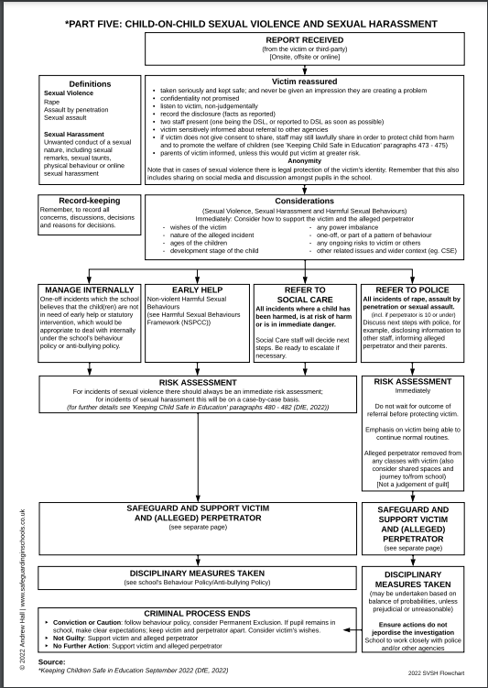
Appendix B
Student name: ___________________________________________________________________
Reason for selection: Chronological age / Developmental stage
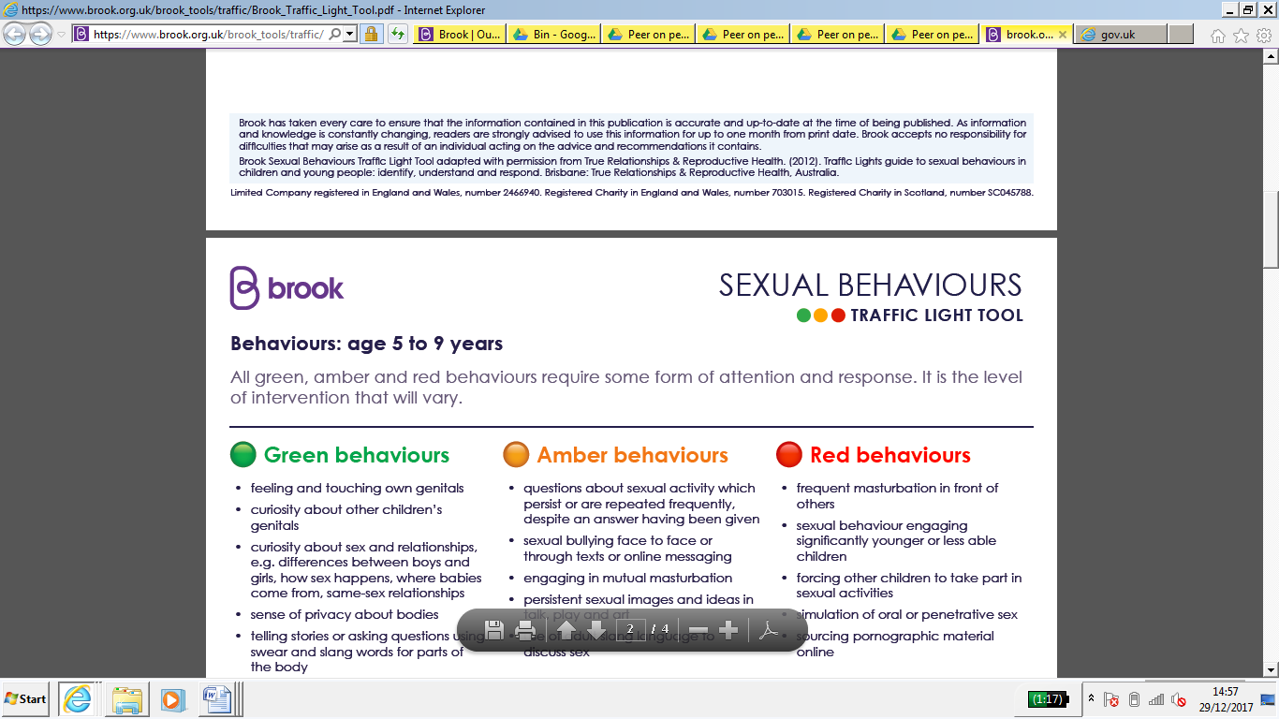
Completed by: ______________________________________ Date: _______________________

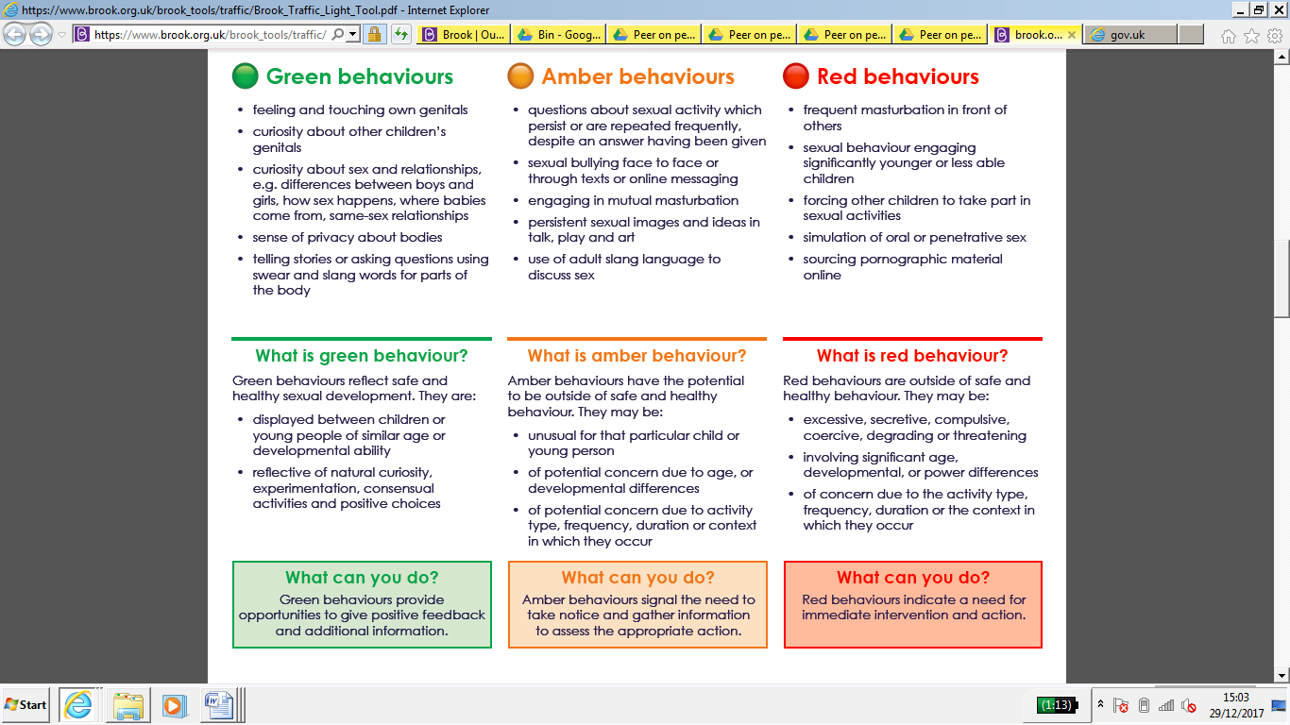

Student name: ___________________________________________________________________
Reason for selection: Chronological age / Developmental stage
Completed by: ______________________________________ Date: _______________________
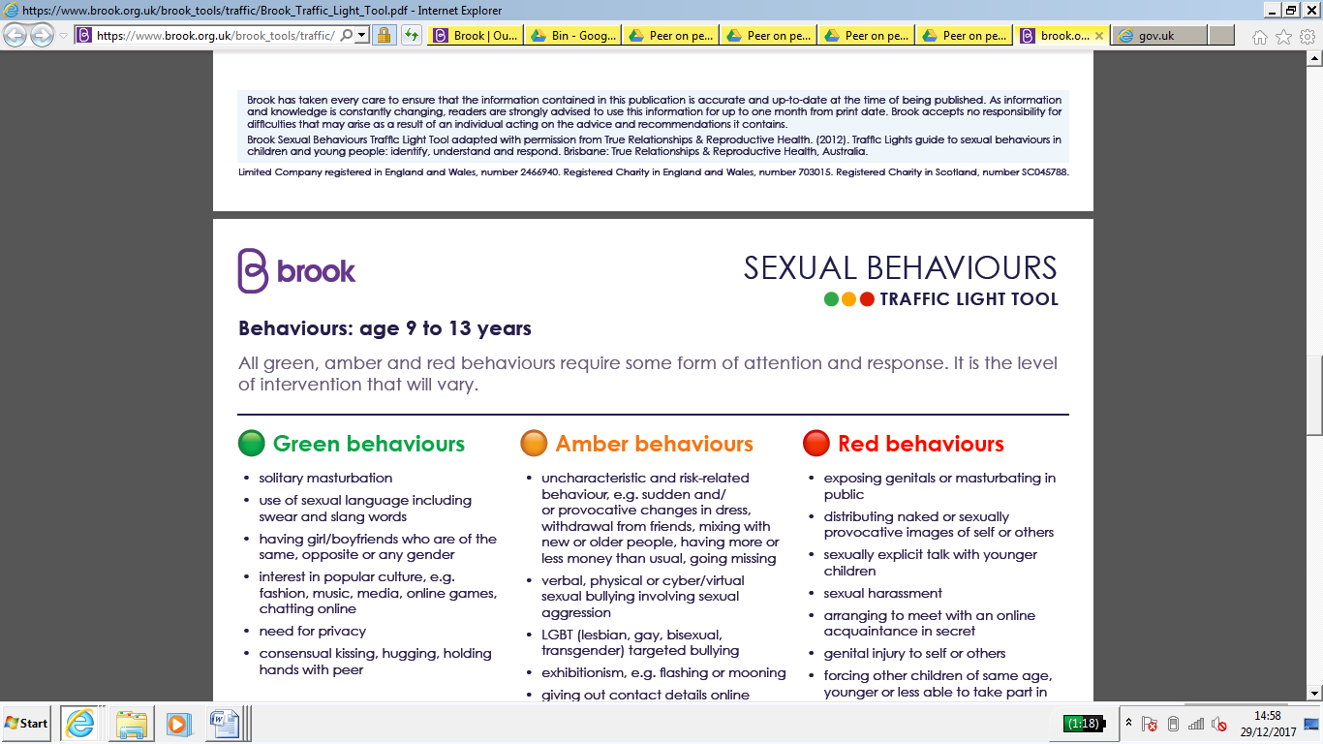

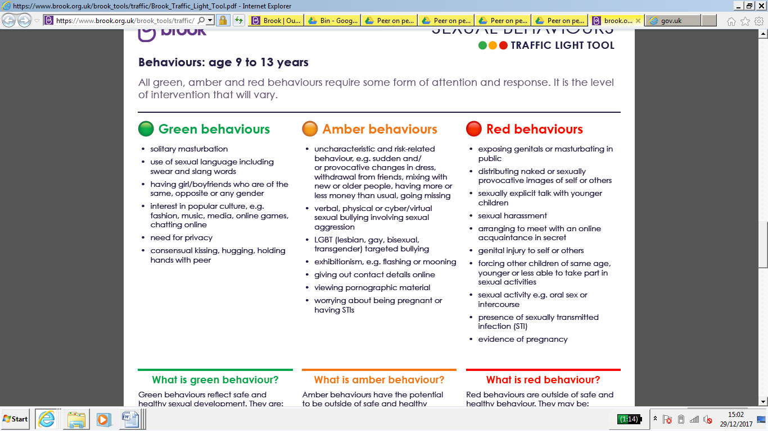

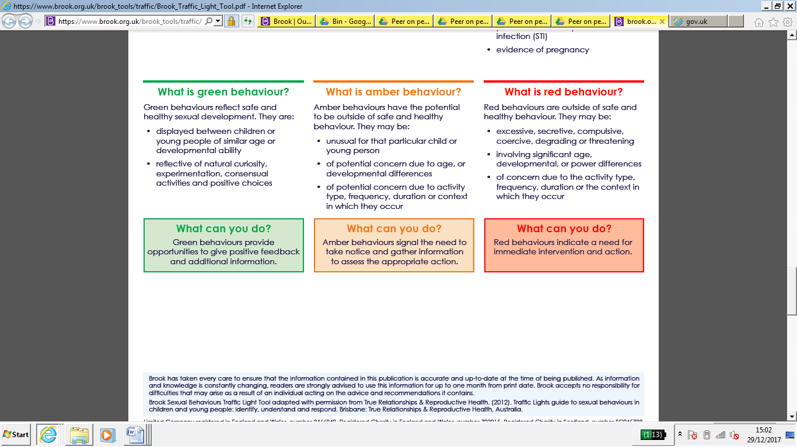


Appendix C -
Individual student risk assessment – Child on Child Abuse

Name(s) | Names of all pupils involved should be added here unless it is deemed appropriate to do a separate risk assessment for each pupil involved. | D.O.B.
Reason for risk assessment | Brief summary of allegation
Has violence been used or threatened? | Yes or no and with brief details
What kind of harm has been threatened or sustained previously? | Details of alleged incident triggering risk assessment
Is there a pattern of behaviour / risk? | Records (CPOMS) should be checked or any previous incidents which could indicate a pattern
Is there evidence to suggest it will be repeated or that there has been increase of risk? | Consideration should be given to the nature of the alleged incident and all pupils’ reactions to it. Increased risk could refer to risk of repeated or worsening incidents or to emotional risk through pupils involved being in contact with each other
Is there evidence to suggest premeditation? | Yes or no with brief details
Professionals / other adults involved and roles | Name, role and agency involved in the risk assessment – either directly or through their advice or opinions being taken into account - should be recorded here.
Intended outcome of risk assessment | This will include safe management of risk and should say whether the intention is for all parties to remain in school / classes or will be educated elsewhere.

Individual or group at risk | Nature of risk | Protective factors / controls normally in place | Risk rating ( severity x likelihood = risk) | Controls / actions needed | Modified risk rating ( severity x likelihood = risk)
Victim | Physical – risk of repeated assault or harassment  Physical – risk of retaliation by friends / family of perpetrator  Emotional – impact of assault or harassment  Emotional –aggravation of pre-existing physical or mental health concerns  Emotional – impact of ongoing investigation especially by outside agencies  Online – risk of harassment via social media | Staff and pupils adhering to Regulation Behaviour and Relationships Policy/Child on Child Abuse Policy  Staff and pupils adhering to Regulation Behaviour and Relationships Policy / Child on Child Abuse Policy  Support available from Nurture team  Support available from Nurture team and School Nurses  Support available from Nurture team  Support available DSLs/Nurture Team/Family Support Team/ICT Leader | 4 x 3 = 12  4 x 3 = 12  4 x 5 = 20  4 x 5 = 20  4 x 4 = 16  4 x 3 = 12 | Consideration of isolation or exclusion of perpetrator  Action taken to ensure wider knowledge of incident is understood and pupils are clear about expectations. Ongoing need to consider isolation or exclusion for others  Named person for nurture support, support plan agreed with victim and family. Consideration of support being sought from other agencies. Advice and guidance given to family  Named person for nurture support, support plan agreed with victim and family. Consideration of support being sought from other agencies. Advice and guidance given to family  Named person for nurture support, support plan agreed with victim and family. Consideration of support being sought from other agencies. Advice and guidance given to family  Named person for nurture support, support plan agreed with victim and family. Consideration of support being sought from other agencies. Advice and guidance given to family  Action taken to ensure wider knowledge of incident is understood and pupils/family are clear about expectations. Ongoing need to consider isolation or exclusion for others | 4 x 1 = 4  4 x 2 = 8  3 x 4 = 12  3 x 4 = 12  3 x 4 = 12  4 x 2 = 8
Alleged perpetrator | Physical – risk of retaliation by friends / family of victim  Emotional – impact of alleged incident  Emotional –aggravation of pre-existing physical or mental health concerns  Emotional – impact of ongoing investigation especially by outside agencies  Online – risk of harassment via social media  Media –risk of incident being reported in the media | Staff and pupils adhering to Regulation Behaviour and Relationships Policy Child on Child Abuse Policy  Support available from Nurture team  Support available from Nurture team and School Nurses  Support available from Nurture team/DSL  Support available from Nurture team/DSL/ Family Support Team/ICT Leader  Support available from DSL | 4 x 3 = 12  4 x 5 = 20  4 x 4 = 16  4 x 3 = 12  4 x 2 = 8  4 x 2 = 8 | Action taken to ensure wider knowledge of incident is understood and students/family are clear about expectations. Ongoing need to consider isolation or exclusion for others  Named person for nurture support, support plan agreed with perpetrator and family. Consideration of support being sought from other agencies. Advice and guidance given to family  Named person for nurture support, support plan agreed with perpetrator and family. Consideration of support being sought from other agencies. Advice and guidance given to family  Named person for nurture support, support plan agreed with victim and family. Consideration of support being sought from other agencies. Advice and guidance given to family  Action taken to ensure wider knowledge of incident is understood and students are clear about expectations. Ongoing need to consider isolation or exclusion  Action taken to ensure wider knowledge of incident is understood and pupils/family are clear about expectations. No comment made to press | 4 x 2 = 8  3 x 4 = 12  3 x 4 = 12  3 x 4 = 12  4 x 2 = 8  3 x 2 = 6
Other students | Physical – risk of assault or harassment  Emotional – impact of assault or harassment on friend / wider community  Emotional – impact of ongoing investigation especially by outside agencies  Online – risk of being a victim or perpetrator of harassment via social media | Staff and pupils adhering to Regulation Behaviour and Relationships Policy /Child on Child Policy  Support available from Nurture team/DSL/Family Support Team  Support available from Nurture team/DSL/Family Support Team  Support available from Nurture team/DSL/Family Support Team/ICT Leader | 4 x 3 = 12  4 x 3 = 12  4 x 5 = 20  4 x 4 = 16 | Consideration of isolation or exclusion of perpetrator  Action taken to ensure wider knowledge of incident is understood and pupils/families are clear about expectations. Ongoing need to consider isolation or exclusion for others  Action taken to ensure wider knowledge of incident is understood and pupils/families are clear about expectations. Support provided to anyone affected  Action taken to ensure wider knowledge of incident is understood and pupils/families are clear about expectations. Support provided to anyone affected. Ongoing need to consider isolation or exclusion for others | 4 x 1 = 4  4 x 2 = 8  3 x 4 = 12  3 x 4 = 12
Staff | Physical – risk of assault or harassment  Emotional – impact of receiving disclosure for staff involved including consideration of possible impact on pre-existing physical or mental health concerns  Emotional – impact of assault or harassment on wider community  Emotional – impact of ongoing investigation especially by outside agencies | Staff and pupils adhering to Regulation Behaviour and Relationships Policy  Support available from DSL/SLT & Education Support Employer Assist  Support available from DSL/SLT & Education Support Employer Assist  Support available from DSL/SLT & Education Support Employer Assist | 4 x 3 = 12  4 x 3 = 12  4 x 3 = 12  4 x 3 = 12 | Consideration of isolation or exclusion of perpetrator  Regular support offered as required. Consideration of involvement of support from other agencies as necessary (E.g. Employer Assist)  Regular support offered as required. Consideration of involvement of support from other agencies as necessary (E.g. Employer Assist)  Regular support offered as required. Consideration of involvement of support from other agencies as necessary (E.g. Employer Assist) | 4 x 1 = 4  3 x 2 = 6  3 x 2 = 6  3 x 2 = 6

 | Likelihood
Severity | Not likely (1) | Unlikely (2) | Possible (3) | Likely (4) | Highly likely (5)
Fatality (5) | 5 | 10 | 15 | 20 | 25
Major injury / harm (4) | 4 | 8 | 12 | 16 | 20
Moderate injury / harm (3) | 3 | 6 | 9 | 12 | 15
Minor injury / harm (2) | 2 | 4 | 6 | 8 | 10
No injury / harm (1) | 1 | 2 | 3 | 4 | 5

Overall risk rating
1 - 2 | 3 - 7 | 8 - 11 | 12 - 14 | 15 - 25
No risk | Minimal risk | Moderate risk | Serious risk | Major risk

Risk assessment completed by:
Signed: Name:

Role: Date:

Staff / other professionals consulted:

Proposed action, with controls as detailed above, can / cannot proceed.
Signed: Name

