
Holly Grove School

Admission Arrangements

Last updated: Summer 2026
Review Due: Summer 2028
Approved by Governors: June 2026

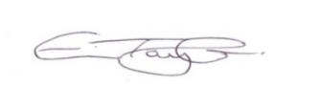
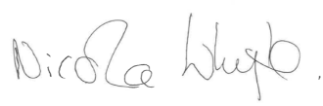
Eve Taylor – Headteacher
Nicola Whyte – Chair of Governors

All of the pupils who attend Holly Grove School have an Education Health & Care Plan (EHCP), which will have been issued following a Statutory Assessment.

All new requests for places at Holly Grove School are made through the EHCP Annual Review / Consultation Process (or a new EHCP process), which recommends that a special school would be the best type of provision to meet the identified needs of that child. This agreement needs to be made in conjunction with the Lancashire County Council EHCP team and based upon advice from their current school and other professionals such as an Educational Psychologist (EP).

Once this recommendation is indicated, the parent/carer can arrange a Non-Prejudicial Visit (NPV) to view Holly Grove School by contacting the School Office. This enables parents/carers to see first-hand what our school has to offer and if our setting is indeed best placed to meet the needs of their child. If after the visit, parents/carers support the request for a place at Holly Grove School, the LA will be notified, and in turn will approach the school to formally consult with us for a place.

Where the LA agrees to admit the child to Holly Grove School, the LA will inform both the school and their parents/carers, in writing of its decision. Prior to admission, the LA and previous school will provide Holly Grove School with any reports, assessments or other relevant documentation, relating to the child’s/young person’s needs.

Following the notification of placement, the Headteacher will write to the parents to:
- Notify them that a place has been offered,
- Organise transition days with the current school
- Send a Welcome Pack to Parents/Carers including a Parent’s Handbook,
- Notify them of the planned admission date.

