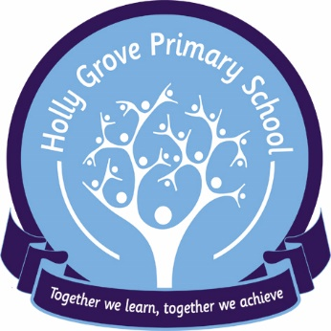
School Council Meeting
8th January 2026
MINUTES
Welcome | Pupils: Sofia, Mackenzie, Abdullah, Aadam, Sophie, Mia, Lucas C, Zaki  Staff: Katie R, Katie W, Rebecca, Dav, Rosie B  Absent – Bhryss, Theo T
Upcoming Events | NSPCC Number Day  Safer Internet Day  Children’s Mental Health Week (9th-13th Feb 2026)  World Book Day  Red Nose Day (KW to organise)
World Book Day Votes | The school council voted on what theme they would like for WBD. Options were: pjs, animals, Julia Donaldson and films. The winning theme with 8 votes was a PJ’s
Children’s Mental Health week ideas | Extra golden time, extra playtime, class yoga (cosmic yoga every morning), mindfulness at the end of each day. Joint class active sessions. Positive postbox – Dav, Mia and Lucas C to make postboxes. Positive notes to be posted. Notes picked out in assembly to be read out and some to be added to newsletter.  Friday – relaxed “share the love breakfast” with another class  Libby & Adam  Michael & Katie  Jenny & Aisling  Julie & Josh  Samantha & Leah  Courtney & Lizzy  (order themed food on snack)
School Council Ideas for Improvement | Themed dinners (KR to speak to JT)  Lunch Monitor - Zaki
Discussed | New equipment being purchased for playgrounds  What makes us happy at HG  Zaki – “everything and basketball”  Aadam – “playing with friends in PE”  Lucas – “being at HG makes me happy and going to nurture”  Sofia – “Science is fun”  Mia – “being on the school council”
Date of Next Meeting | 27th February 2026 @ 9:30am
Close of meeting.

