
Key Skills Document

Year 5 is an important year for developing children’s confidence, independence and fluency in reading and maths. The skills below are some of the key priorities we will work on throughout the year.
Parents can support children enormously through short, regular practice at home. Reading regularly, discussing books and practising key number facts can make a real difference.

📚 Reading
The key reading skills we will develop in Year 5 are:
- Fluency: Reading accurately, confidently and with expression.
- Comprehension: Finding information, summarising and identifying key points.
- Inference: Working out characters’ thoughts, feelings and motivations using evidence from the text.
- Vocabulary: Understanding new words, synonyms, antonyms and word meanings in context.
- Prediction: Using clues from the text to predict what might happen next.
- Authorial choice: Understanding why authors use particular words, phrases and techniques.
- Comparing texts: Identifying similarities and differences between characters, themes and ideas.
At home: Encourage your child to read for 15–20 minutes each day and talk about what they have read. Ask questions such as “How do you know?” and “Why do you think that?”

🔢 Maths
The key maths skills we will focus on are:
- Place value: Understanding numbers up to 1,000,000, rounding and comparing numbers.
- Addition & subtraction: Using written and mental methods accurately.
- Multiplication & division: Developing fluency with times tables up to 12 × 12 and using formal methods.
- Fractions: Finding equivalent fractions, comparing, ordering, adding and subtracting fractions.
- Decimals & percentages: Understanding the relationship between fractions, decimals and percentages.
Spellings
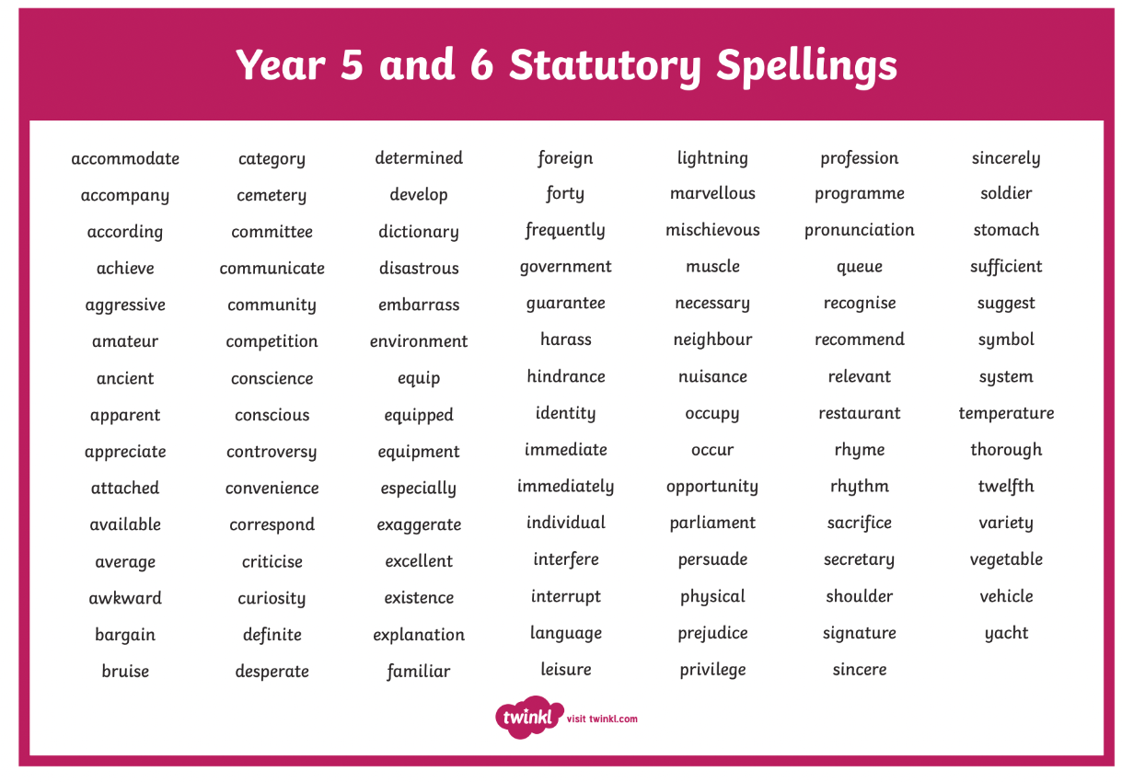
Spelling is a key skill for children especially when it comes to their literacy skills. Practising these statutory spellings with your child will positively impact their ability to embed them into their writing.

💡 A final message for parents
The most important thing is regular practice and positive encouragement.
Children do not need to get everything right immediately. Encourage them to:
- Have a go.
- Explain their thinking.
- Learn from mistakes.
- Ask questions.
- Persevere when something is difficult.
- Take pride in their progress.

Kind regards
Miss Fox, Miss Broderick and Miss Jordan.

