Dear Parents and Carers,

Firstly, we would like to welcome you to the Year 1 staff team.

We are really looking forward to the year ahead and getting to know your children.
Year 1 has two classes – Sparrows and Robins.

The teaching team in Sparrows comprises of:
- Mr Graham- Class Teacher
- Mrs Newton - TA
- Miss Johnson TA

The teaching team in Robins comprises of:
- Mrs James - Class Teacher
- Mrs Dogan - TA
- Miss Grogan - TA

The School Day
The main school gates open at 8:20am and children need to be in school, ready to learn by 8:30 am. Children arriving late will need to register at the school office.
School finishes at 3:00 pm. If you are booking holidays you will find the term dates for the next academic year on our school website.

Attendance
High attendance at school is not just valuable, it’s essential. It gives children the best possible chance of developing secure friendships, feeling safe, building on prior learning and succeeding academically. There is a proven link between high attendance and doing well at school.
At St Martins we promote the importance of high attendance in our weekly celebration assembly, awarding ‘Attendance Bear’ to the class with the highest attendance for that week.

As a school we strive for a goal of 100% attendance however we do recognise that there will be times when children are not well enough to be in school. If your child is unwell please contact the school office. If you have any concerns regarding the attendance of your child please contact Melanie Turl - Acting Deputy Teacher via School Spider.

Learning Narrative

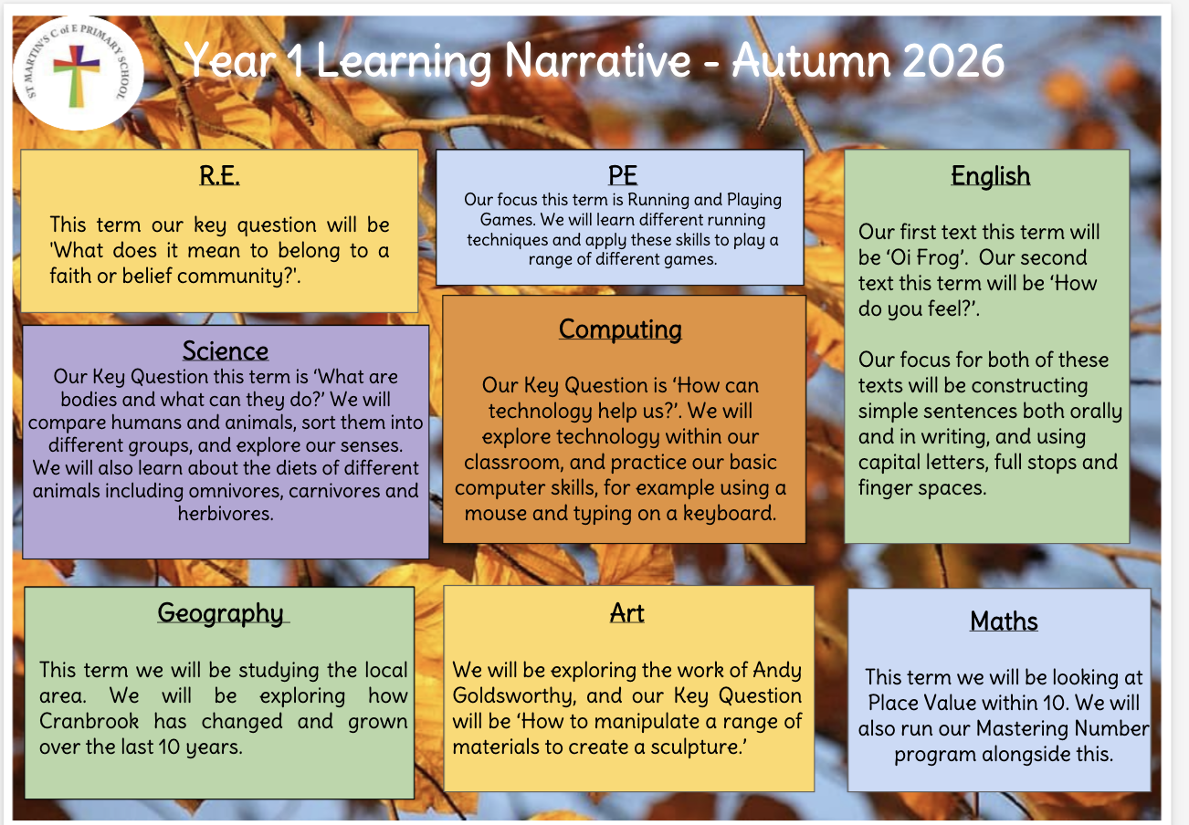

Home Learning

Reading

Your child will bring home their reading book each Wednesday for a celebratory read. They will have already read this book in school and will really benefit from reading it aloud to an adult at home.
This is really important because it helps to improve their fluency and comprehension. Books will need to come back into school every Friday.

P.E
Your child will have PE on Thursdays and Fridays.

On PE days, your child needs to come to school dressed in their PE kit.

PE kit should include:
- Black shorts
- T-shirt based on the children’s family learning group or plain white t-shirt.
- Black tracksuit bottoms
- Trainers
- School jumper to be worn over the top for warmth

Please speak to the office if you are unsure of your child’s family learning group.

Forest school
Sparrows and Robins will have forest school once a fortnight on alternate Tuesday afternoons. Children need to come to school wearing their forest clothes (long sleeved top and trousers). Please make sure that they also come to school with a suitable waterproof coat and wellies in a carrier bag. The children will then need to be collected from the forest at the end of the school day.

Belongings & Uniform
Please ensure that all personal items are labelled clearly. Even with the best intentions, children do lose things - having them named means that items can find their way back to the correct owner.

Fruit is provided daily for the children to have at breaktime, however you may wish to send in a healthy fruit snack of your own in a labelled container.

Could you also ensure your child brings in a labelled water bottle that is filled with water only.

Questions/Queries
At St. Martins we have an open-door policy so staff will be at their doors at the beginning and end of each day to answer any quick questions. If you have any queries that need to be discussed in more depth please contact the school admin team via School Spider and address your message ‘for the attention of ‘Year 1 Teachers’.

We look forward to a successful and happy year.

Mr Graham, Mrs James, Mrs Dogan, Miss Johnson, Mrs Newton and Miss Grogan

